EX.NO-1:
Create a simple cloud software application for Flight Reservation System using any Cloud Service Provider to demonstrate SaaS

FLIGHT BOOKING SYSTEM

AIM:
To develop a Flight Booking System using Zoho Creator that enables users to book flight tickets and automatically calculate the total fare, GST, and final payable amount.

PROCEDURE:
- Open Zoho Creator and sign in with your Zoho account.
- Click Create New Application and create an application named Flight Booking System.
- Create a Flight Booking form in the application.
- Add the required fields such as Passenger Name, Mobile Number, Email, Journey Date, Journey Time, Source Airport, Destination Airport, Flight Name, Seat Class, Number of Passengers, Ticket Price, Total Fare, GST (18%), and Final Amount.
- Configure dropdown fields for Source Airport, Destination Airport, Flight Name, and Seat Class with appropriate values.
- Set a default value for the Ticket Price field.
- Create a workflow to automatically calculate:
- Total Fare = Number of Passengers × Ticket Price o GST = 18% of Total Fare o Final Amount = Total Fare + GST
- Save the workflow and test it by entering sample booking details.
- Create a Flight Booking Report to display all booking records.
- Configure the report to display all input fields and calculated fields such as Total Fare, GST, and Final Amount.
- Save the application and verify that the calculations are accurate.

- Run the application by entering different booking details and confirm that the records are stored correctly in the report.
CODE:
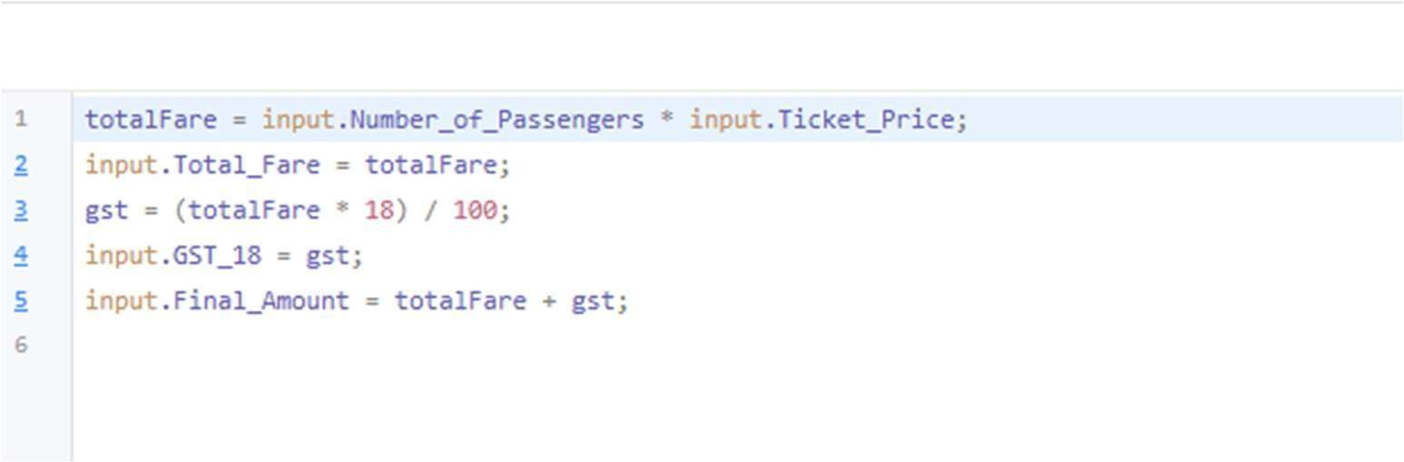

OUTPUT:
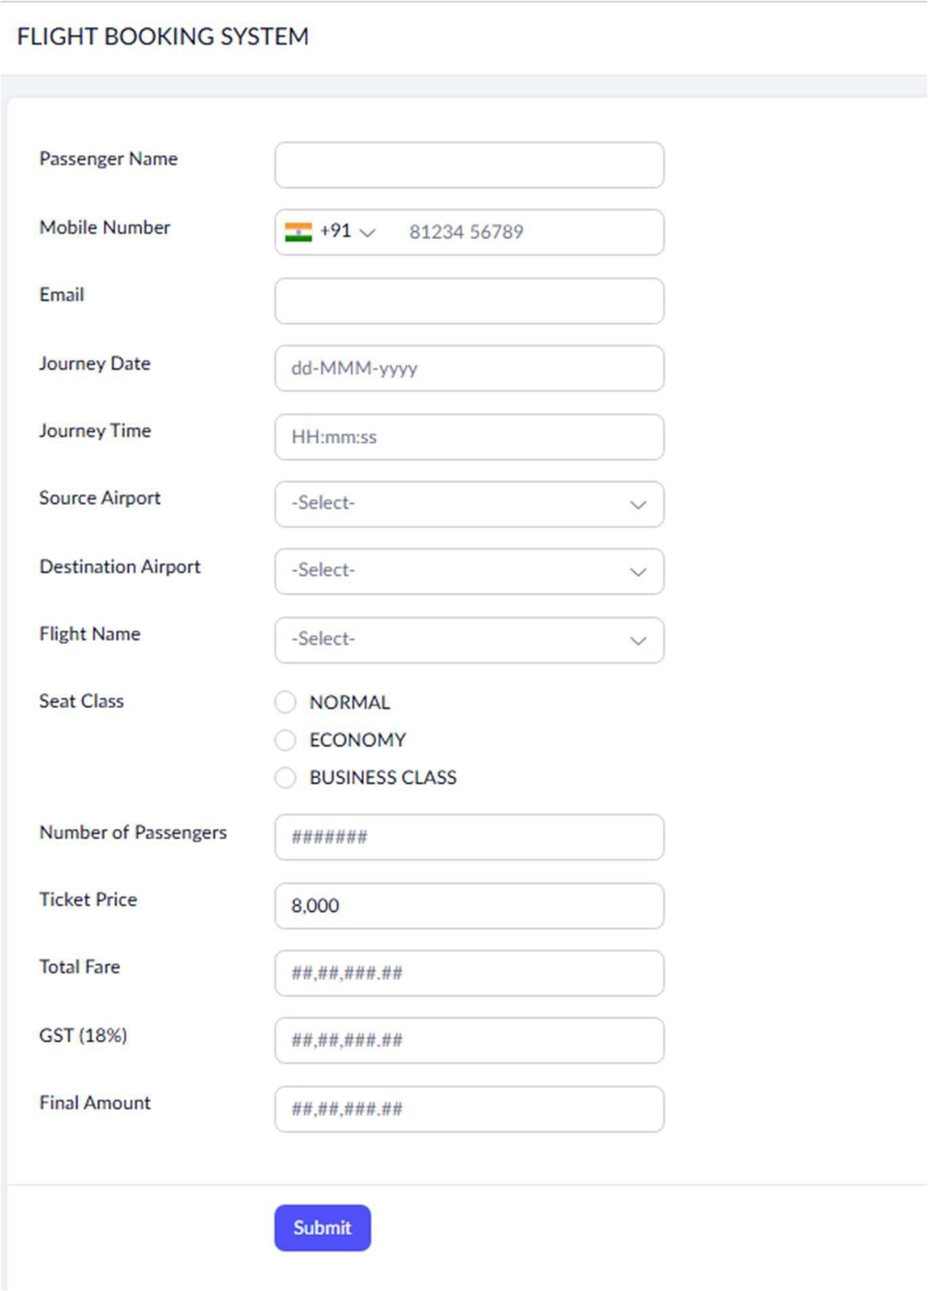
FLIGHT BOOKING SHEET:

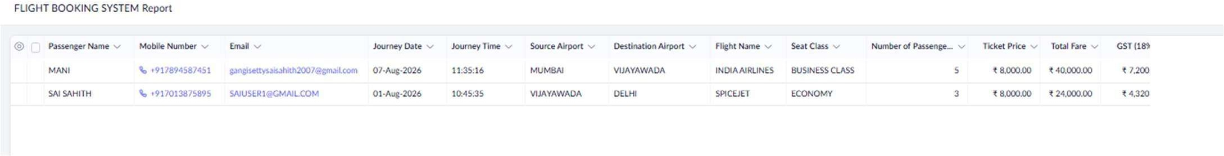

REPORT:

RESULT:
The Flight Booking System was successfully developed in Zoho Creator, allowing users to book flight tickets and automatically calculate the total fare, GST, and final amount accurately.

