EX.NO-03:

Create a simple cloud software application for Car Booking Reservation System using any Cloud Service Provider to demonstrate SaaS.
AIM:

To develop a Car Booking System in Zoho Creator for managing customer bookings and automatically calculating the total travel cost based on distance, toll charges, discounts, and driver expenses.

ALGORITHM:

- Open Zoho Creator and create a new application.
- Create a form named Car Booking.
- Add the required fields such as Passenger Name, Mobile Number, Journey Date, Journey Time, Number of Passengers, Trip Type, Distance (KM), Per KM Rate, From Address, To Address, Number of Toll Gates, Toll Gate 1, Toll Gate 2, Toll Gate 3, Driver Expense, Car Rent, Discount %, Discount Amount, Total Toll Cost, and Final Cost.
- Set the Per KM Rate field with a default value of ₹20.
- Create a workflow to automatically calculate: o Car Rent = Distance × Per KM Rate o Discount Percentage (5% for every 150 KM) o Discount Amount o Total Toll Cost
- o Final Cost = (Car Rent − Discount Amount) + Total Toll Cost + Driver Expense
- Save the workflow and test it by entering sample booking details.
- Create a Car Booking Report to display all booking records and calculated values.
- Add all required fields to the report, including calculated fields such as Car Rent, Discount %, Discount Amount, Total Toll Cost, and Final Cost.
- Save the application and verify that the calculations are performed correctly for different booking details.

- Deploy the application and use it to manage car bookings and automatically
- generate the final travel cost.

IMPLEMENTATION:
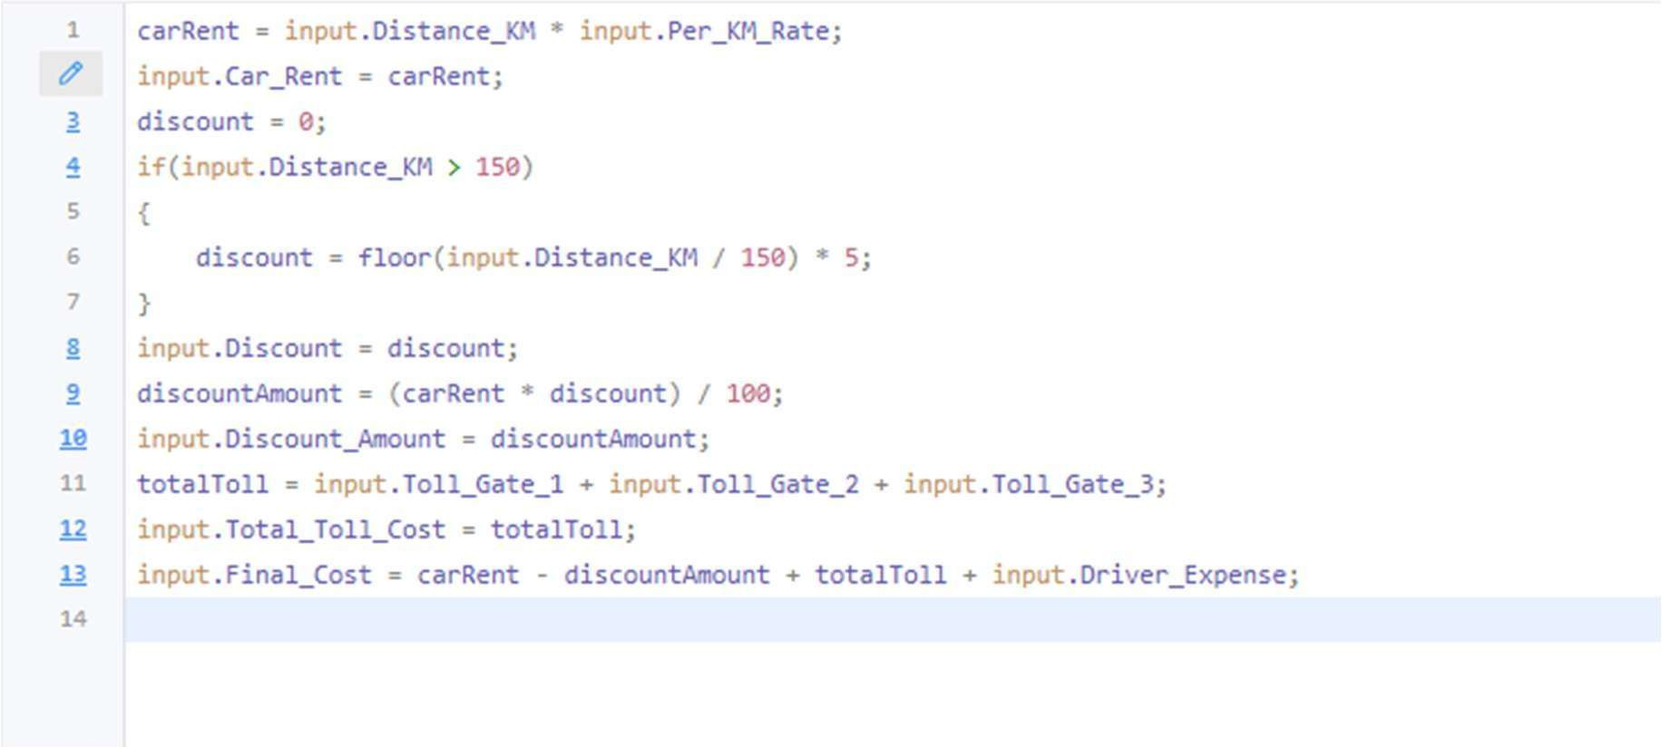


CAR BOOKING SHEET:

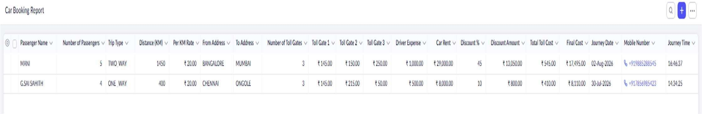

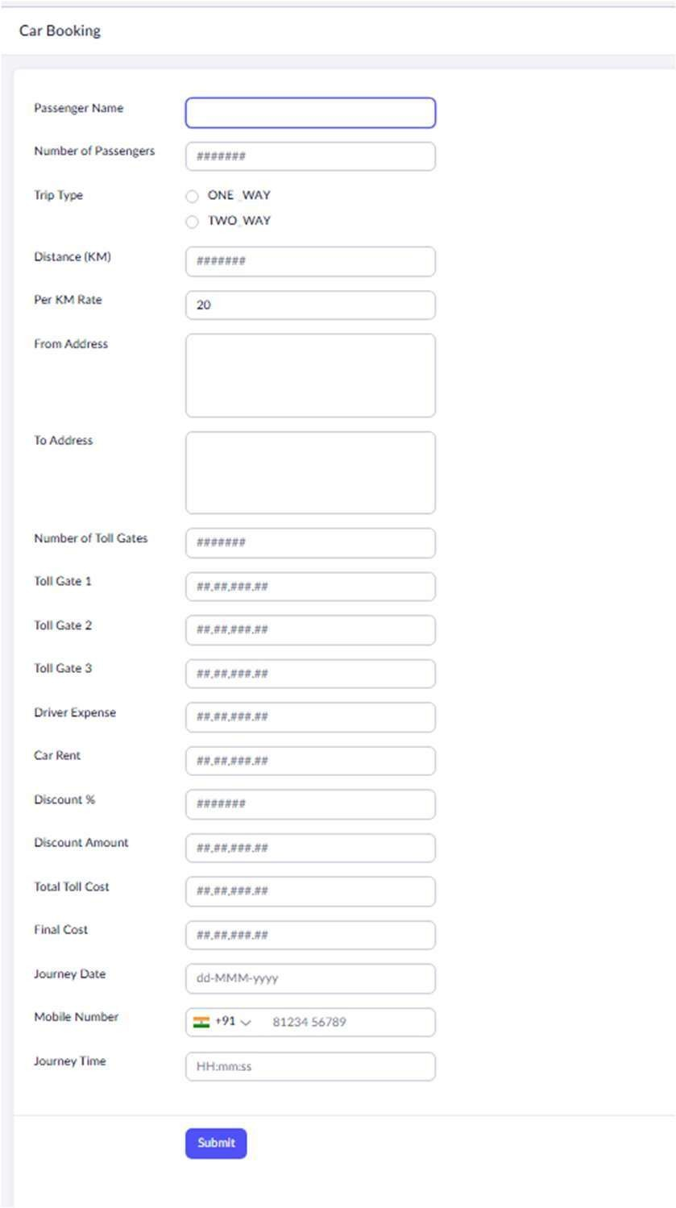

REPORT:

RESULT:

The Car Booking System was successfully developed in Zoho Creator, and the application accurately calculated the car rent, discount, toll charges, and final booking cost based on the user inputs.

