Cícatc a simplc cloud softwaíc applicatio⭲ foí LibíaíQ book ícscí:atio⭲ sQstcm foí SIMAľS libíaíQ usi⭲g a⭲Q Cloud Scí:icc Pío:idcí to dcmo⭲stíatc SaaS

AIM:

To develop a cloud-based Library Book Reservation System using Zoho Creator for managing book reservations and to demonstrate the Software as a Service (SaaS) cloud computing model.

ALGORITHM:

- Log in to the Zoho Creator cloud platform using a valid account.

- Create a new application named SIMATS Library Book Reservation System.

- Design a form to collect student and book reservation details.

- Add fields such as Student Name, Register Number, Department, Book Title, Author, Reservation Date, Return Date, Available Copies, and Status.
- Configure drop-down lists for Department, Book Title, and Reservation Status.

- Create a report to display all reservation records.

- Add a workflow to validate the availability of books before accepting a reservation.
- Configure the workflow to automatically set the reservation status after successful submission.
- Test the application by entering sample reservation details and verify that records are stored correctly.
- Publish the application and access it through a web browser to demonstrate the SaaS model.

IMPLEMENTATION:
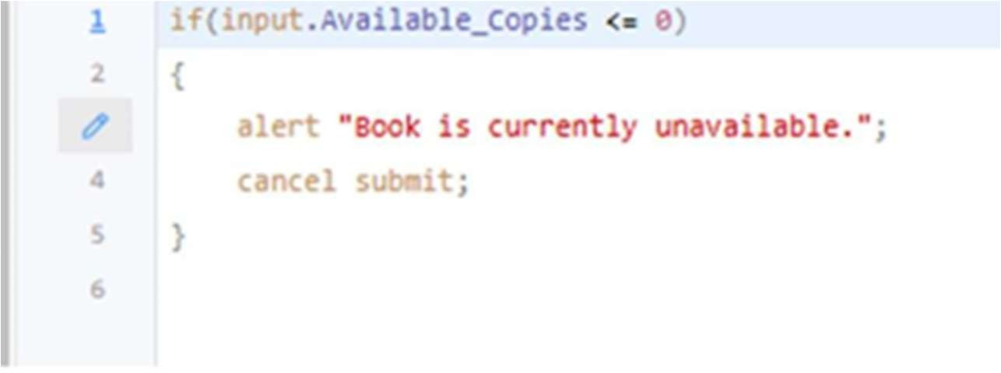

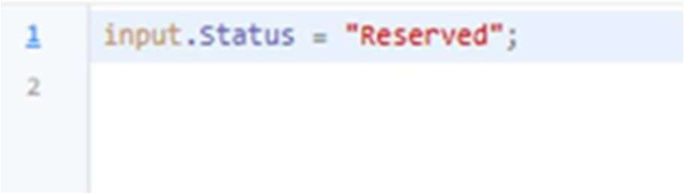

OUTPUT:

LIBRARY BOOK MANAGEMENT SYSTEM:
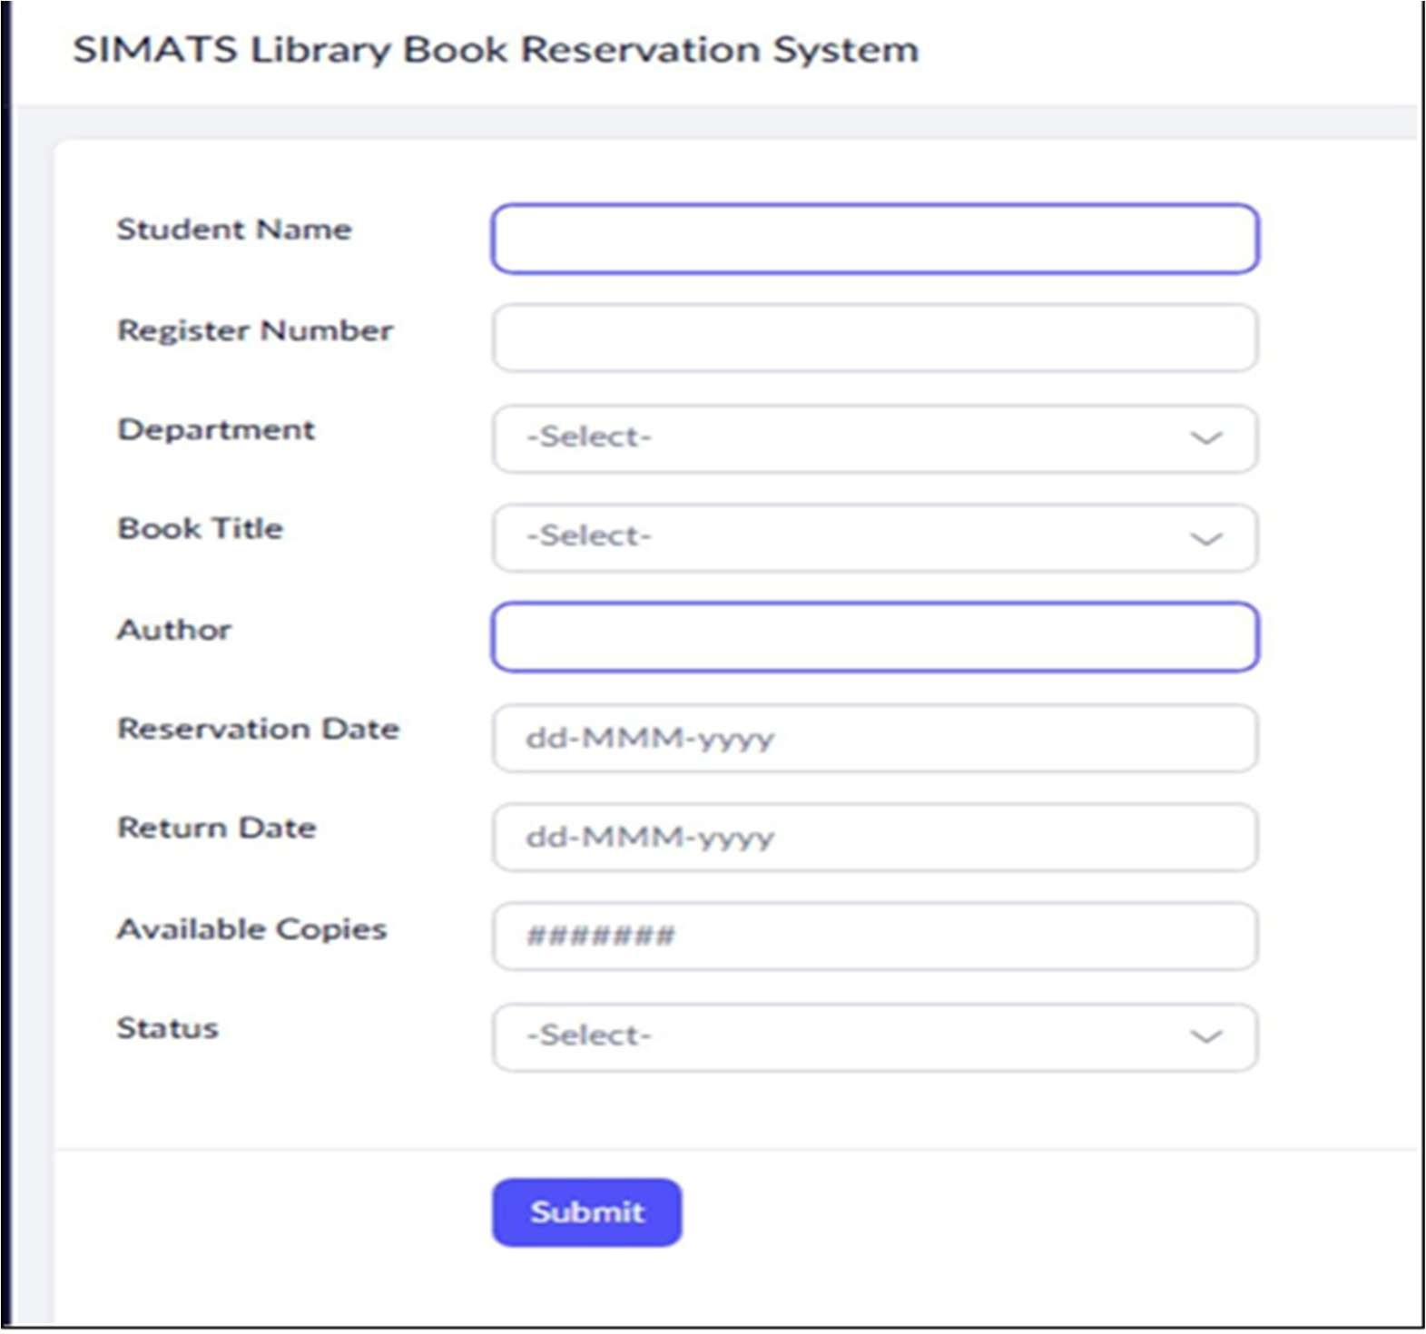

REPORT:
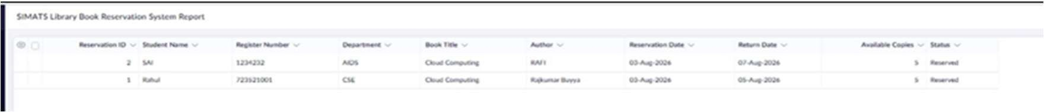
RESULT:

A simple SIMATS Library Book Reservation System was created using Zoho Creator. The application allows users to reserve books online and demonstrates the Software as a Service (SaaS) cloud model.

