EX.NO-2:

Create a simple cloud software application for Property Buying & Rental process (In Chennai city) using any Cloud Service Provider to demonstrate SaaS

AIM:

To develop a Property Management System using Zoho Creator for managing property details, owners, tenants, and rental information efficiently.

ALGORITHM:

- Log in to the Zoho Creator account.
- Create a new application named Property Management System.
- Design forms to store property, owner, and tenant details.
- Add appropriate fields such as property ID, address, owner name, and rent amount.
- Configure field validations to ensure accurate data entry.
- Create reports to display and search property records.
- Develop workflows for automatic calculations or notifications.
- Test the application by adding sample property records.
- Verify that data is stored and retrieved correctly.
- Save, publish, and test the application for proper functionality.

IMPLEMENTATION:

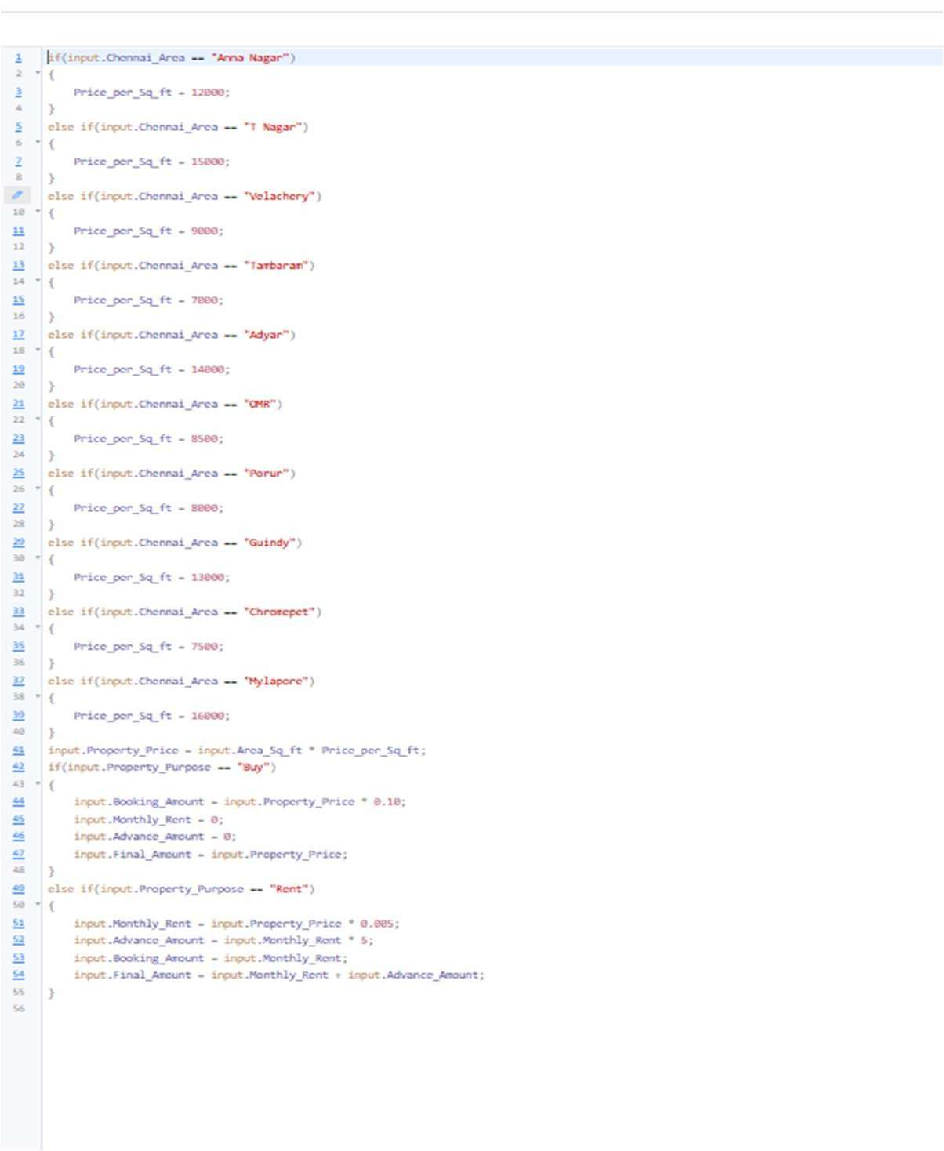
OUTPUT:
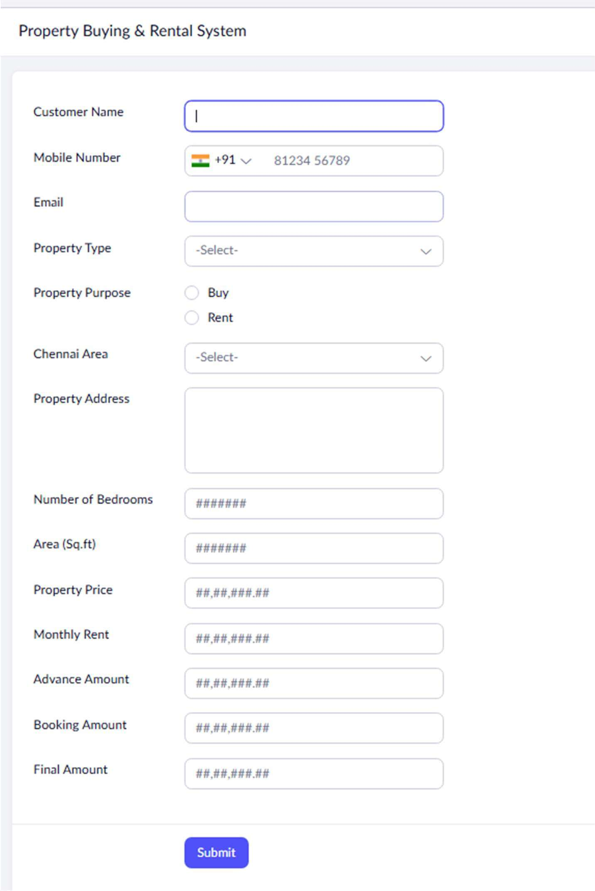

REPORT:

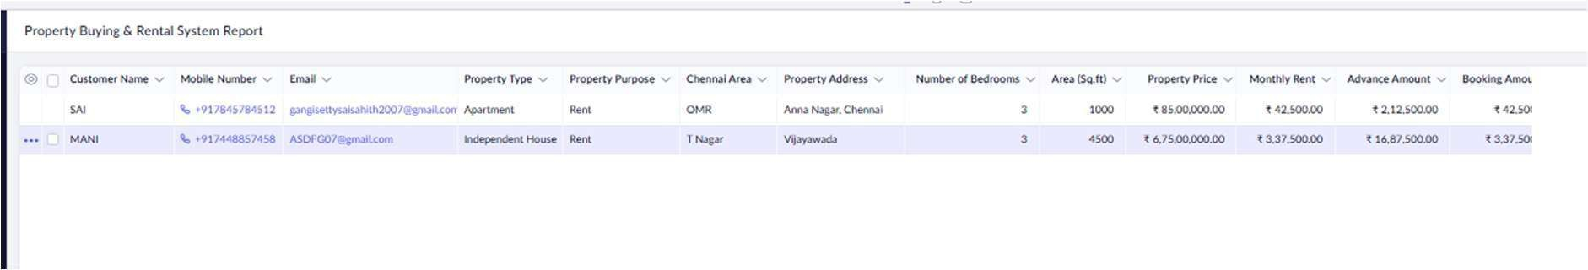
RESULT:
The Property Management System was successfully developed in Zoho Creator. It efficiently manages property information and enables easy storage, retrieval, and maintenance of records.
.

