PROGRAM 2: 8-PUZZLE PROBLEM
Aim
The aim of this experiment is to solve the 8-Puzzle Problem using the Breadth First Search (BFS) algorithm
Objective
To arrange the tiles in the correct order by moving the blank space.
Algorithm
Algorithm: EightPuzzleBFS()
Step 1: Start.
Step 2: Define the initial state and the goal state of the puzzle.
Step 3: Create an empty queue.
Step 4: Insert the initial state into the queue.
Step 5: Create an empty visited set.
Step 6: Repeat until the queue becomes empty.
Remove the front state from the queue.
If the current state is already visited,
Continue with the next state.
Mark the current state as visited.
If the current state is equal to the goal state,
Display the solution path.
Stop.
Locate the blank tile (0).
Generate all valid neighboring states by moving
the blank tile Up, Down, Left or Right.
Insert every unvisited neighboring state into the queue.
Step 7: If no solution exists,
Display "No Solution Found."
Step 8: Stop.
FLOW CHART:
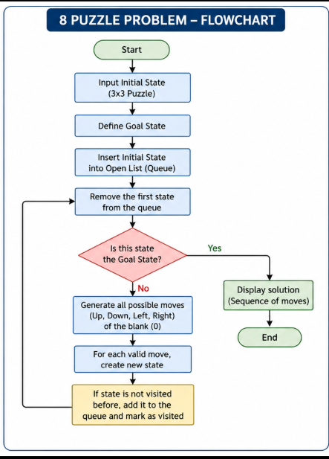

SOURCE CODE:
import heapq
print("192372103-pavanesh");
goal = [(1,2,3),(4,5,6),(7,8,0)]

def heuristic(state):
dist = 0
for i in range(3):
for j in range(3):
val = state[i][j]
if val == 0: continue
x, y = divmod(val-1, 3)
dist += abs(x - i) + abs(y - j)
return dist

def neighbors(state):
x, y = [(ix,iy) for ix,row in enumerate(state) for iy,v in enumerate(row) if v==0][0]
moves = []
for dx, dy in [(-1,0),(1,0),(0,-1),(0,1)]:
nx, ny = x+dx, y+dy
if 0<=nx<3 and 0<=ny<3:
new = [list(r) for r in state]
new[x][y], new[nx][ny] = new[nx][ny], new[x][y]
moves.append(tuple(tuple(r) for r in new))
return moves

def a_star(start):
heap = [(heuristic(start), 0, start, [])]
visited = set()
while heap:
est, cost, state, path = heapq.heappop(heap)
if state == tuple(tuple(r) for r in goal):
return path + [state]
if state in visited: continue
visited.add(state)
for nxt in neighbors(state):
if nxt not in visited:
heapq.heappush(heap, (cost+1+heuristic(nxt), cost+1, nxt, path + [state]))
return None

# Example
start = ((1,2,3),(4,0,6),(7,5,8))
solution = a_star(start)
for i, s in enumerate(solution):
print(f"Step {i}:\n" + "\n".join(str(row) for row in s), "\n")

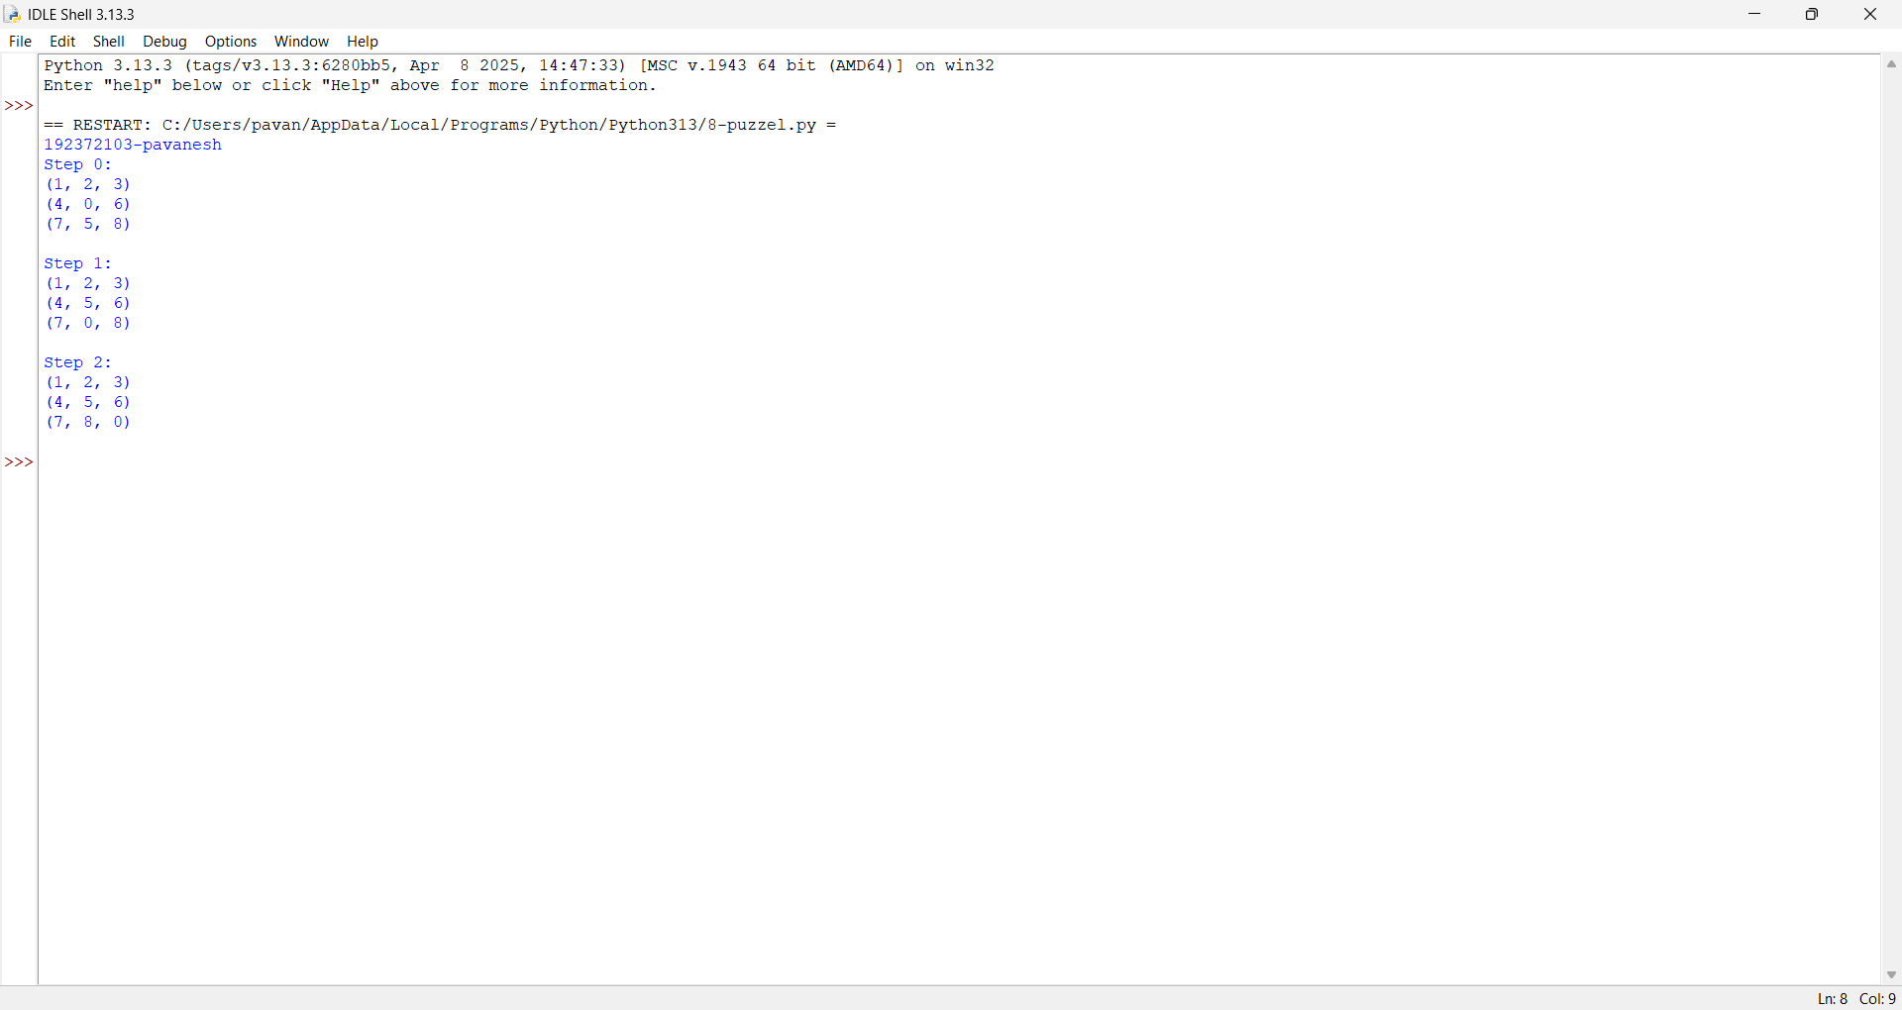

Result:
The 8-Queen problem was successfully solved using the Backtracking algorithm, and all eight queens were placed on the chessboard such that no two queens attack each other.

