EXPERIMENT 1: 8-Queen Problem

Aim: To solve the 8-Queen problem using the Backtracking algorithm.

Objectives:
- To understand the 8-Queen problem.
- To implement the Backtracking algorithm.
- To place eight queens on a chessboard so that no two queens attack each other.
- To find a valid solution efficiently.

Algorithm:
- Start with the first row.
- Place a queen in a safe column.
- Move to the next row.
- If a safe position is found, place the queen.
- If no safe position exists, backtrack to the previous row.
- Repeat until all eight queens are placed.
- Display the solution.

Flow Chart

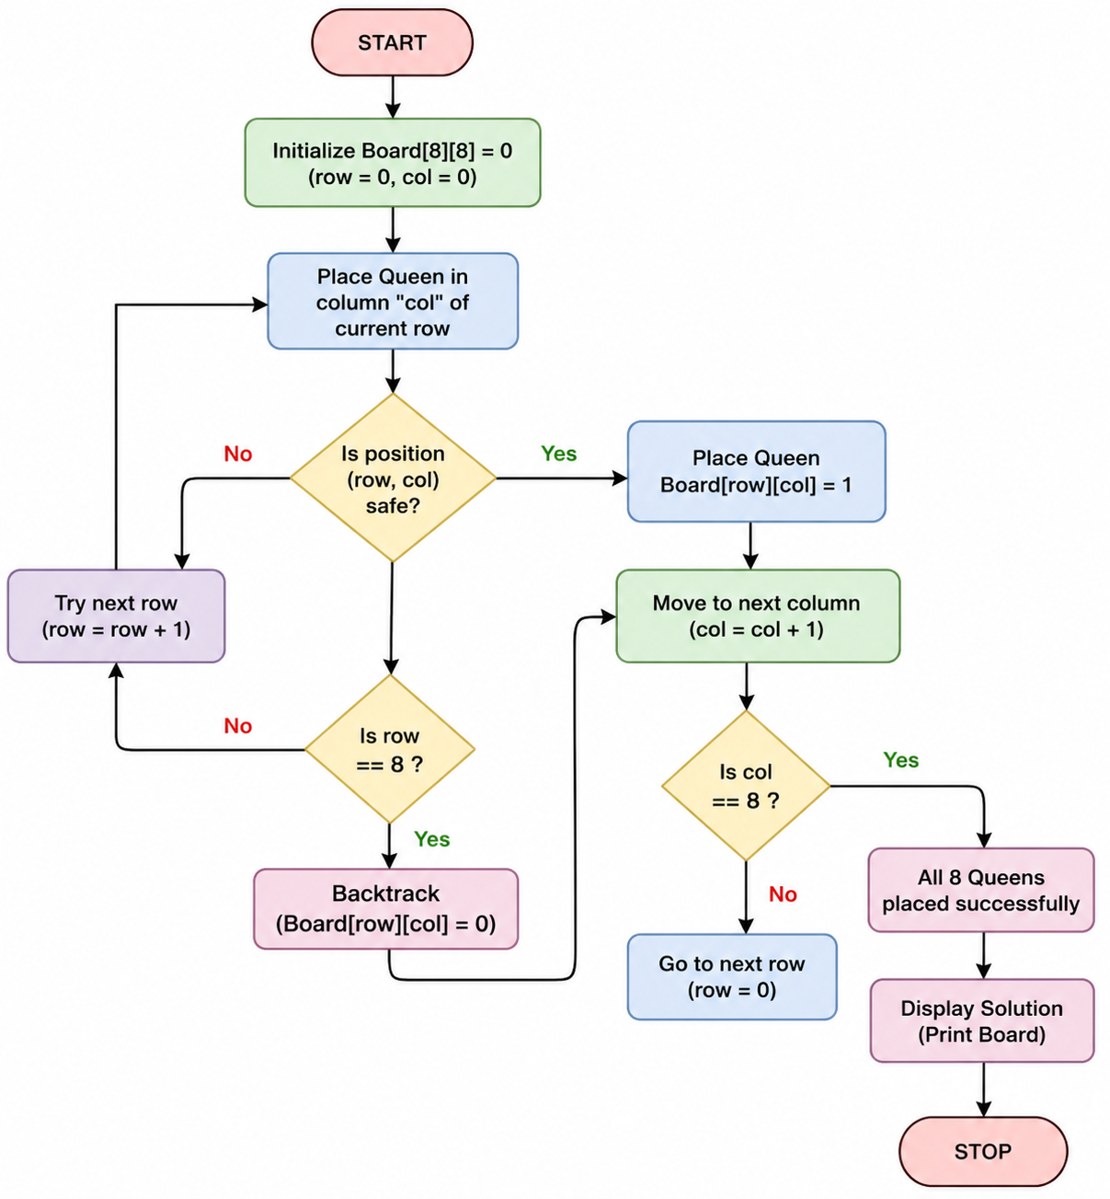

Source Code:
print("192372103-Pavanesh")
print ("Enter the number of queens")
N = int(input())
board = [[0]*N for _ in range(N)]

def attack(i, j):
#checking vertically and horizontally
for k in range(0,N):
if board[i][k]==1 or board[k][j]==1:
return True
for k in range(0,N):
for l in range(0,N):
if (k+l==i+j) or (k-l==i-j):
if board[k][l]==1:
return True
return False

def N_queens(n):
if n==0:
return True
for i in range(0,N):
for j in range(0,N):
if (not(attack(i,j))) and (board[i][j]!=1):
board[i][j] = 1
if N_queens(n-1)==True:
return True
board[i][j] = 0

return False

N_queens(N)
for i in board:
print (i)

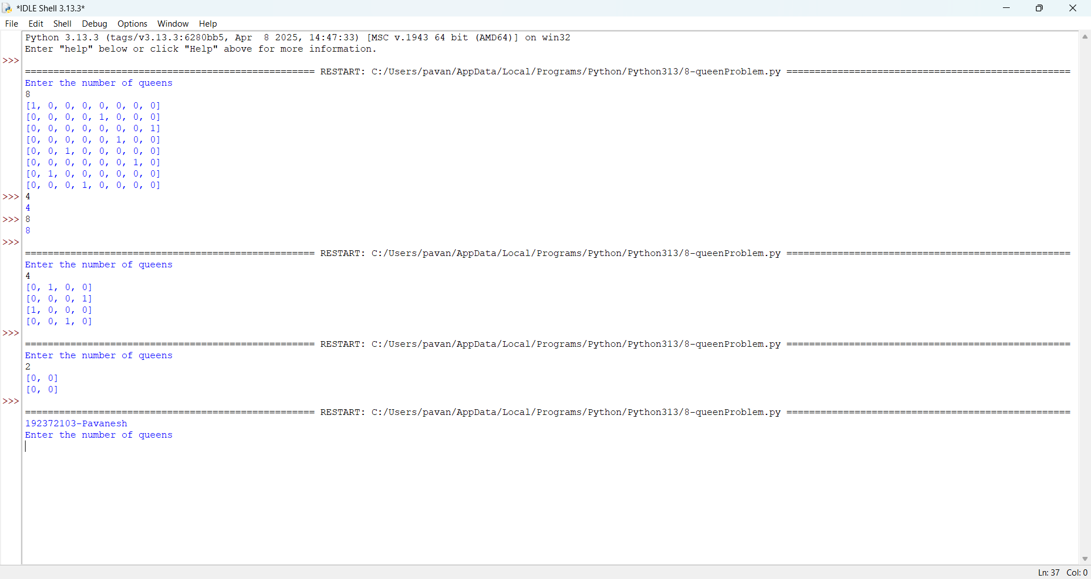

Result:
The 8-Queen problem was successfully solved using the Backtracking algorithm, and all eight queens were placed on the chessboard such that no two queens attack each other.

