PROGRAM 4: WATER JUG PROBLEM
Aim
The aim of this experiment is to solve the Water Jug Problem using the Breadth First Search (BFS) algorithm
Objective
To obtain exactly 2 litres of water using a 4-litre jug and a 3-litre jug.
Algorithm
Algorithm: WaterJugBFS()
Step 1: Start.
Step 2: Initialize the capacities of Jug1 and Jug2.
Step 3: Define the target state.
Step 4: Create an empty queue and insert the initial state (0,0).
Step 5: Create an empty visited set.
Step 6: Repeat until the queue becomes empty.
Remove the front state from the queue.
If the current state is already visited,
Continue to the next state.
Mark the current state as visited.
If the current state is equal to the target state,
Display the solution path.
Stop.
Generate all possible next states by:
Fill Jug1.
Fill Jug2.
Empty Jug1.
Empty Jug2.
Pour water from Jug1 to Jug2.
Pour water from Jug2 to Jug1.
Add all unvisited states to the queue.
Step 7: If no solution is found,
Display "No Solution Exists."
Step 8: End.

FLOW CHART
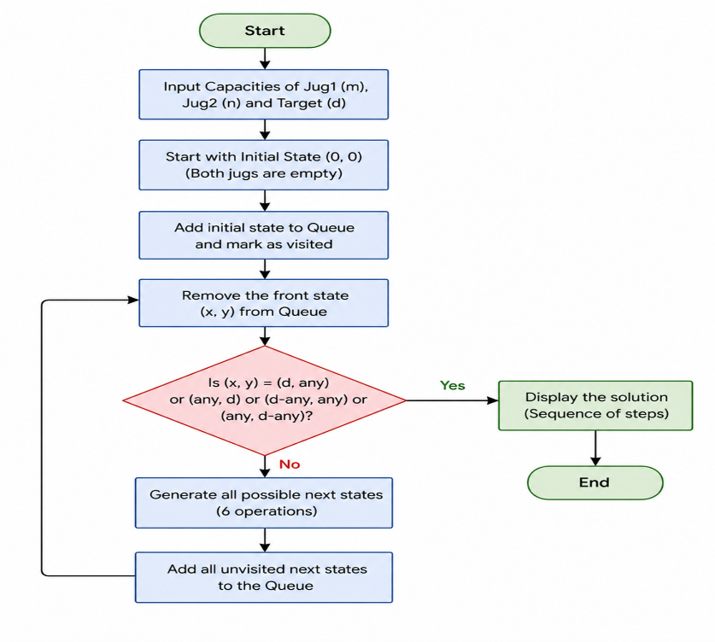

SOURECE CODE

from collections import deque
print("192372103-pavanesh")
def water_jug_bfs(jug1, jug2, target):
visited = set()
q = deque([(0, 0)]) # (jug1, jug2)

while q:
a, b = q.popleft()
if (a, b) in visited:
continue
visited.add((a, b))

if a == target or b == target:
print(f"Reached: ({a}, {b})")
return True

q.extend([
(jug1, b), (a, jug2), # fill jugs
(0, b), (a, 0), # empty jugs
(min(a + b, jug1), max(0, b - (jug1 - a))), # pour jug2 -> jug1
(max(0, a - (jug2 - b)), min(a + b, jug2)) # pour jug1 -> jug2
])
return False

# Example: Jug1=4L, Jug2=3L, target=2L
water_jug_bfs(4, 3, 2)

Result
Thus, the Python program to solve the Water Jug Problem was executed successfully.

