18-10-2026 NAME: Thanmai Priya B
EXPERIMENT-02 REG NO: 192524425
SLOT: A
SUBJECT CODE: CSA4701
SUBJECT: DEEP LEARNING
SEMESTER: MS2-SEPTEMBER-2026

Covariance, Eigenvalues and Eigenvectors Analysis
SCENARIO
A healthcare dataset contains patients' height, weight, and blood pressure. Calculate the covariance matrix to identify relationships among the features and visualize the correlations.
AIM
To calculate the covariance matrix of a healthcare dataset containing patients' height, weight, and blood pressure using Python, and visualize the correlations between these features using a heatmap to understand their relationships.
ALGORITHM
- Import the required libraries such as Pandas, NumPy, Matplotlib, and Seaborn.
- Create a healthcare dataset containing patients' height, weight, and blood pressure.
- Store the data in a Pandas Data Frame and display the dataset.
- Calculate the covariance matrix using the corr() function.
- Calculate the correlation matrix using the corr() function.
- Visualize the correlations using a heatmap with labels and numerical values.
- Analyze the covariance matrix and heatmap to understand the relationships among the features.
- Display the results and stop the program.
SOURCECODE
import pandas as pd
import numpy as np
import matplotlib.pyplot as plt
import seaborn as sns

# Create healthcare dataset
data = {
"Height": [150, 160, 165, 170, 175, 180, 155, 168, 172, 178],
"Weight": [50, 55, 60, 65, 70, 80, 52, 62, 68, 75],
"Blood Pressure": [110, 115, 120, 125, 130, 140, 112, 122, 128, 135]
}

df = pd.DataFrame(data)

# Display healthcare dataset
print("HEALTHCARE DATASET")
display(df)

# Display summary table
print("SUMMARY STATISTICS")
display(df.describe().round(2))

# Calculate covariance matrix
covariance_matrix = df.cov()

print("COVARIANCE MATRIX")
display(covariance_matrix.round(2))

# Calculate correlation matrix
correlation_matrix = df.corr()

print("CORRELATION MATRIX")
display(correlation_matrix.round(2))

# Plot 1: Height distribution
plt.figure(figsize=(6, 4))
plt.hist(df["Height"], bins=5, edgecolor="black")
plt.title("Distribution of Patient Height")
plt.xlabel("Height (cm)")
plt.ylabel("Number of Patients")
plt.grid(axis="y")
plt.show()

# Plot 2: Weight distribution
plt.figure(figsize=(6, 4))
plt.hist(df["Weight"], bins=5, edgecolor="black")
plt.title("Distribution of Patient Weight")
plt.xlabel("Weight (kg)")
plt.ylabel("Number of Patients")
plt.grid(axis="y")
plt.show()

# Plot 3: Blood pressure distribution
plt.figure(figsize=(6, 4))
plt.hist(df["Blood Pressure"], bins=5, edgecolor="black")
plt.title("Distribution of Blood Pressure")
plt.xlabel("Blood Pressure (mmHg)")
plt.ylabel("Number of Patients")
plt.grid(axis="y")
plt.show()

# Plot 4: Correlation heatmap
plt.figure(figsize=(7, 5))
sns.heatmap(
correlation_matrix,
annot=True,
cmap="coolwarm",
vmin=-1,
vmax=1,
fmt=".2f",
linewidths=0.5
)
plt.title("Correlation Heatmap of Healthcare Features")
plt.tight_layout()
plt.show()

# Plot 5: Relationship between height and weight
plt.figure(figsize=(6, 4))
plt.scatter(df["Height"], df["Weight"])
plt.title("Height vs Weight")
plt.xlabel("Height (cm)")
plt.ylabel("Weight (kg)")
plt.grid(True)
plt.show()

# Plot 6: Relationship between weight and blood pressure
plt.figure(figsize=(6, 4))
plt.scatter(df["Weight"], df["Blood Pressure"])
plt.title("Weight vs Blood Pressure")
plt.xlabel("Weight (kg)")
plt.ylabel("Blood Pressure (mmHg)")
plt.grid(True)
plt.show()

print("Analysis completed successfully.")

OUTPUT:
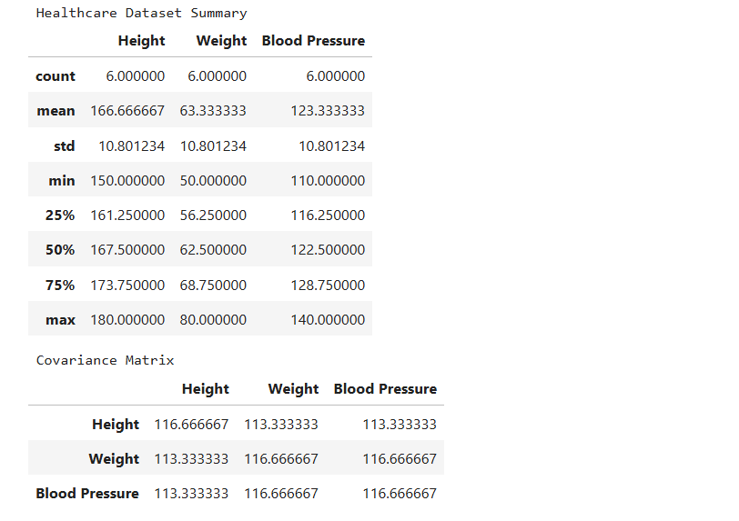

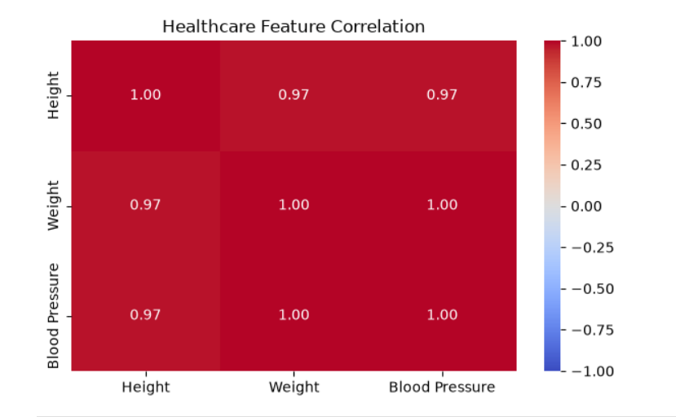

RESULT:
Thus, the covariance matrix for patients' height, weight, and blood pressure was calculated successfully using Python. The summary statistics and correlation matrix were displayed, and the relationships between the healthcare features were visualized using histograms, a heatmap, and scatter plots. The visualizations helped identify patterns and correlations among the selected features.

