18-10-2026 NAME: Thanmai Priya B
EXPERIMENT-03 REG NO: 192524425
SLOT: A
SUBJECT CODE: CSA4701
SUBJECT: DEEP LEARNING
SEMESTER: MS2-SEPTEMBER-2026

Probability Distributions and Bayes’ Theorem
SCENARIO
A hospital studies patients' waiting times, which approximately follow a normal distribution. Generate synthetic waiting-time samples, calculate probabilities for specified intervals, and visualize the distribution.
AIM
To generate synthetic hospital patient waiting-time data following a normal distribution, calculate the probabilities for specified waiting-time intervals, and visualize the distribution using a histogram and normal distribution curve in Python.
ALGORITHM
- Import the required libraries, such as NumPy, Matplotlib, and SciPy.
- Define the mean and standard deviation of patient waiting times.
- Generate synthetic waiting-time samples using a normal distribution.
- Calculate the probabilities for specified waiting-time intervals using the normal distribution.
- Display the generated waiting-time samples and calculated probabilities.
- Plot a histogram to represent the distribution of waiting times.
- Draw the normal distribution curve and add suitable labels, title, and legend.
- Display the results and stop the program.

SOURCECODE
import numpy as np
import pandas as pd
import matplotlib.pyplot as plt
from scipy.stats import norm

# Generate synthetic waiting-time data
np.random.seed(42)

mean = 30
std = 8

waiting = np.random.normal(mean, std, 1000)

# Create summary table
df = pd.DataFrame({"Waiting Time (minutes)": waiting})

print("SUMMARY TABLE")
display(df.describe().round(2))

# Calculate probabilities for intervals
p1 = norm.cdf(20, mean, std)
p2 = norm.cdf(40, mean, std)
p3 = norm.cdf(40, mean, std) - norm.cdf(20, mean, std)

probabilities = pd.DataFrame({
"Waiting Time Interval": [
"Less than 20 minutes",
"Less than 40 minutes",
"Between 20 and 40 minutes"
],
"Probability": [p1, p2, p3]
})

print("WAITING TIME PROBABILITIES")
display(probabilities.round(4))

# Plot histogram and normal distribution curve
x = np.linspace(0, 60, 300)

plt.figure(figsize=(8, 5))
plt.hist(waiting, bins=25, density=True,
alpha=0.6, edgecolor="black", label="Waiting Time Samples")

plt.plot(x, norm.pdf(x, mean, std),
linewidth=2, label="Normal Distribution Curve")

plt.title("Hospital Patient Waiting Time Distribution")
plt.xlabel("Waiting Time (minutes)")
plt.ylabel("Probability Density")
plt.legend()
plt.grid(True, alpha=0.3)
plt.show()

OUTPUT:
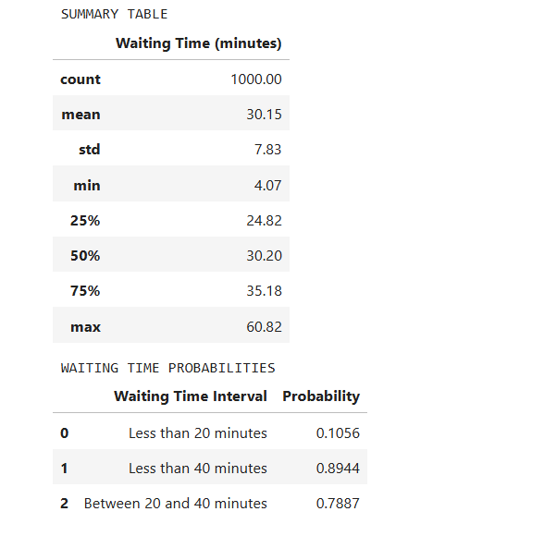

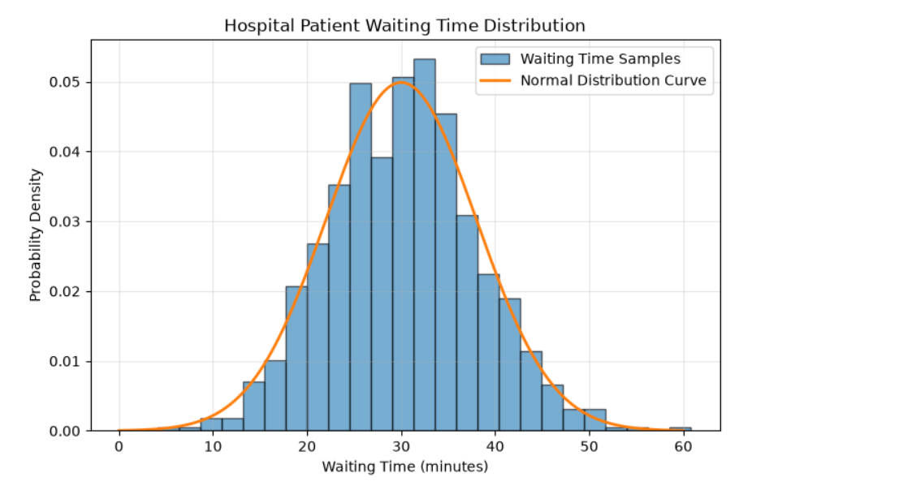

RESULT:
Thus, synthetic hospital patient waiting-time samples were generated using a normal distribution. The summary statistics and probabilities for specified waiting-time intervals were calculated successfully. The waiting-time distribution was visualized using a histogram and a normal distribution curve in Python.

