18-10-2026 NAME: Thanmai Priya B
EXPERIMENT-04 REG NO: 192524425
SLOT: A
SUBJECT CODE: CSA4701
SUBJECT: DEEP LEARNING
SEMESTER: MS2-SEPTEMBER-2026

Entropy, Cross-Entropy and KL Divergence
SCENARIO
A decision-support system classifies transactions into three risk categories. Calculate the entropy of the predicted class distribution to measure its uncertainty.
AIM
To calculate the entropy of the predicted class distribution in a decision-support system using Python to measure the uncertainty among three transaction risk categories: low risk, medium risk, and high risk.
ALGORITHM
- Import the required Python libraries, such as NumPy and Pandas.
- Define the predicted transaction counts for low-risk, medium-risk, and high-risk categories.
- Calculate the probability of each risk category by dividing its count by the total number of transactions.
- Calculate the entropy using the probabilities of the three categories.
- Display the risk category counts, probabilities, and calculated entropy.
- Interpret the entropy value to understand the uncertainty in the predicted class distribution.
- Display the result and stop the program.
SOURCECODE
import numpy as np
import pandas as pd
import matplotlib.pyplot as plt

category = ["Low Risk", "Medium Risk", "High Risk"]
count = [50, 30, 20]

total = sum(count)
probability = np.array(count) / total

entropy = 0

for p in probability:
if p > 0:
entropy = entropy - p * np.log2(p)

table = pd.DataFrame({
"Risk Category": category,
"Transaction Count": count,
"Probability": probability
})

print("TRANSACTION RISK ANALYSIS")
print("=========================")
print(table.to_string(index=False))

print("\nTOTAL TRANSACTIONS:", total)
print("\nENTROPY CALCULATION")
print("-------------------")

for i in range(len(category)):
print(category[i], "Probability =", round(probability[i], 2))

print("\nEntropy of Predicted Class Distribution:",
round(entropy, 4), "bits")

print("Maximum Possible Entropy:",
round(np.log2(len(category)), 4), "bits")

print("\nINTERPRETATION")
print("--------------")
print("The entropy value measures uncertainty in the")
print("predicted transaction risk categories.")
print("Higher entropy indicates a more balanced distribution.")
print("Lower entropy indicates that one category is dominant.")

plt.figure(figsize=(8, 5))
bars = plt.bar(category, probability)

plt.xlabel("Risk Category")
plt.ylabel("Probability")
plt.title("Predicted Transaction Risk Distribution")
plt.ylim(0, 0.6)

for bar, p in zip(bars, probability):
plt.text(bar.get_x() + bar.get_width() / 2,
bar.get_height() + 0.02,
str(round(p, 2)),
ha="center")

plt.grid(axis="y", linestyle="--", alpha=0.5)
plt.tight_layout()
plt.show()

OUTPUT:
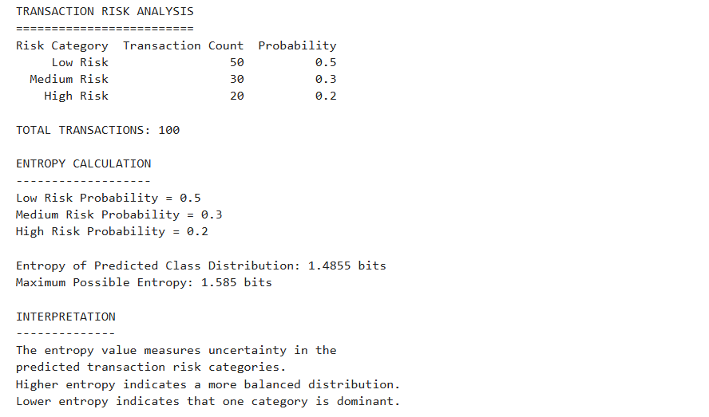

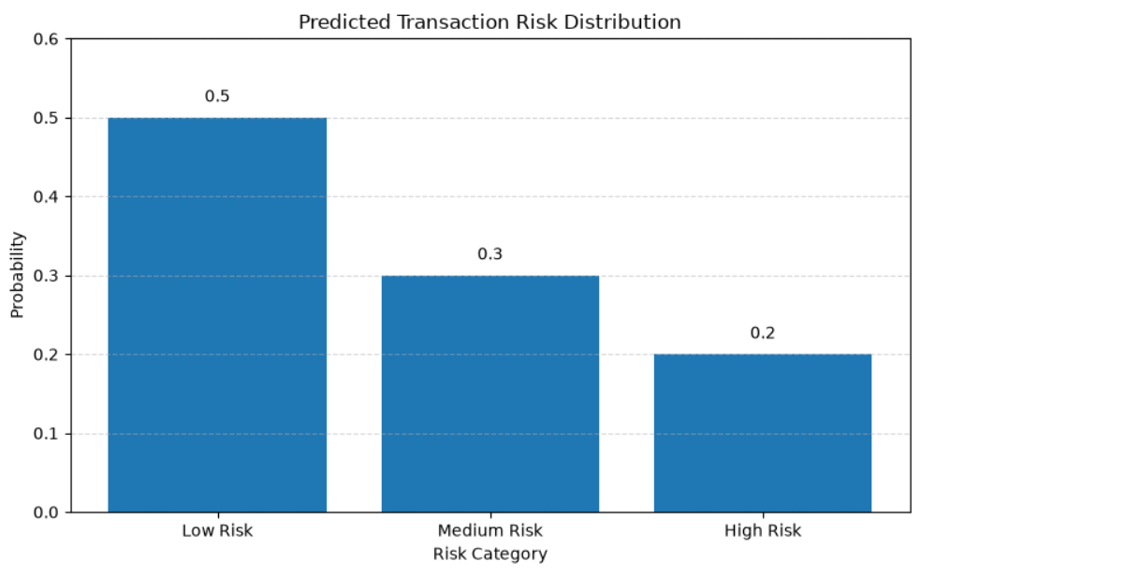

RESULT:
The entropy of the predicted transaction class distribution was successfully calculated using Python. The transactions were classified into three risk categories: Low Risk, Medium Risk, and High Risk.

