18-10-2026 NAME: Thanmai Priya B
EXPERIMENT-05 REG NO: 192524425
SLOT: A
SUBJECT CODE: CSA4701
SUBJECT: DEEP LEARNING
SEMESTER: MS2-SEPTEMBER-2026

Bias–Variance, Overfitting and Underfitting Analysis
SCENARIO
A student-performance prediction model uses a linear regression algorithm on nonlinear data. Compare training and testing errors to identify whether the model is underfitting.
AIM
To apply the Linear Regression algorithm to a nonlinear student-performance dataset, evaluate the model by calculating training and testing errors, and identify underfitting by comparing the prediction errors using Python.
ALGORITHM
- Import the required Python libraries.
- Create a nonlinear dataset of study hours and student scores.
- Split the dataset into training and testing data.
- Train the Linear Regression model using training data.
- Predict scores for both training and testing data.
- Calculate the Mean Squared Error (MSE) for both datasets.
- Display the errors in a summary table and plot the results to identify underfitting.

SOURCECODE
import numpy as np
import pandas as pd
import matplotlib.pyplot as plt
from sklearn.model_selection import train_test_split
from sklearn.linear_model import LinearRegression
from sklearn.metrics import mean_squared_error

hours = np.array([1, 2, 3, 4, 5, 6, 7, 8, 9, 10]).reshape(-1, 1)
scores = np.array([10, 15, 25, 40, 60, 75, 85, 90, 92, 93])

xtrain, xtest, ytrain, ytest = train_test_split(
hours, scores, test_size=0.3, random_state=42
)

model = LinearRegression()
model.fit(xtrain, ytrain)

trainpred = model.predict(xtrain)
testpred = model.predict(xtest)

trainerror = mean_squared_error(ytrain, trainpred)
testerror = mean_squared_error(ytest, testpred)

table = pd.DataFrame({
"Dataset": ["Training", "Testing"],
"Number of Samples": [len(ytrain), len(ytest)],
"Actual Average Score": [np.mean(ytrain), np.mean(ytest)],
"Predicted Average Score": [np.mean(trainpred), np.mean(testpred)],
"Mean Squared Error": [trainerror, testerror]
})

print("\nSTUDENT PERFORMANCE MODEL - SUMMARY TABLE")
print("=" * 85)
print(table.round(2).to_string(index=False))
print("=" * 85)

print("\nUNDERFITTING ANALYSIS")
print("Training Error:", round(trainerror, 2))
print("Testing Error:", round(testerror, 2))

if trainerror > 100 and testerror > 100:
print("Result: The model shows signs of underfitting.")

# Plot actual scores and regression line
plt.figure(figsize=(10, 6))
plt.scatter(hours, scores, color="blue", s=80,
label="Actual Student Scores")

plt.plot(hours, model.predict(hours), color="red",
linewidth=2.5, label="Linear Regression Prediction")

plt.xlabel("Study Hours", fontsize=12)
plt.ylabel("Performance Score", fontsize=12)
plt.title("Student Performance Prediction - Underfitting Analysis",
fontsize=14)

plt.legend()
plt.grid(True, linestyle="--", alpha=0.6)
plt.tight_layout()
plt.show()

OUTPUT:
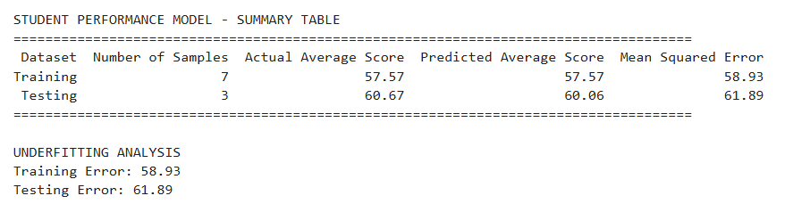

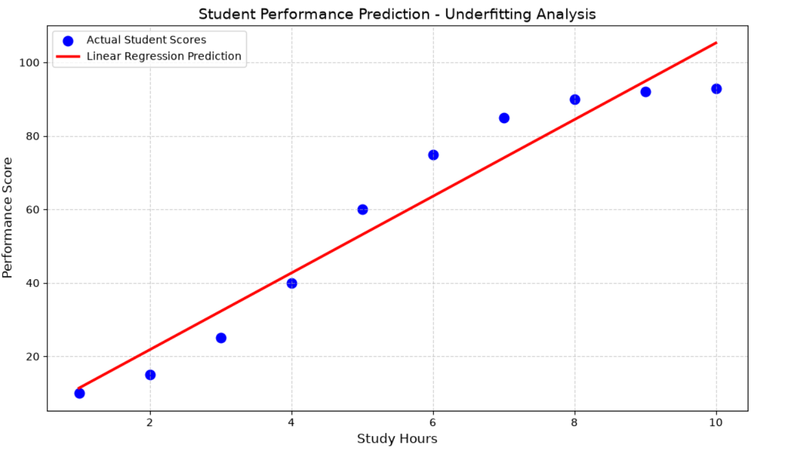

RESULT:
The Linear Regression model was implemented successfully. Training and testing errors were calculated and displayed in a summary table. The plot compared actual student scores with predicted scores to identify underfitting in the nonlinear dataset.

