18-10-2026 NAME: Thanmai Priya B
EXPERIMENT-06 REG NO: 192524425
SLOT: A
SUBJECT CODE: CSA4701
SUBJECT: DEEP LEARNING
SEMESTER: MS2-SEPTEMBER-2026

Gradient Descent, SGD, Momentum and Adam Comparison
SCENARIO
A linear regression model predicts house prices but initially produces high prediction error. Implement gradient descent and visualize how the loss changes over successive iterations.
AIM
To implement the Gradient Descent optimization algorithm in a Linear Regression model for predicting house prices, reduce the initial prediction error by updating model parameters over successive iterations, and visualize the using a graph to evaluate the model's learning process and improvement in prediction accuracy.
ALGORITHM
- Import the required Python libraries, NumPy, Pandas, and Matplotlib.
- Create a dataset containing house sizes and their prices.
- Initialize the model parameters, learning rate, and number of iterations.
- Calculate predicted house prices and the Mean Squared Error (MSE).
- Update the model parameters using gradient descent in each iteration.
- Store the loss values for every iteration.
- Plot the loss against the number of iterations to visualize the reduction in prediction error.
- Display the final model parameters and loss values.

SOURCECODE
import numpy as np
import pandas as pd
import matplotlib.pyplot as plt

# House size and price data
size = np.array([500, 700, 800, 1000, 1200, 1400, 1600, 1800, 2000])
price = np.array([15, 20, 25, 30, 35, 40, 45, 50, 55], dtype=float)

# Normalize house size
x = (size - np.mean(size)) / np.std(size)
y = price.copy()

# Initialize parameters
m = 0.0
b = 0.0
rate = 0.01
iterations = 1000
n = len(x)

lossvalues = []

# Gradient descent
for i in range(iterations):
predicted = m * x + b
error = predicted - y

loss = np.mean(error ** 2)
lossvalues.append(loss)

dm = (2 / n) * np.sum(error * x)
db = (2 / n) * np.sum(error)

m = m - rate * dm
b = b - rate * db

# Final prediction
finalpred = m * x + b
finalerror = np.mean((finalpred - y) ** 2)

# House price summary table
table = pd.DataFrame({
"House Size": size,
"Actual Price": price,
"Predicted Price": np.round(finalpred, 2),
"Prediction Error": np.round(y - finalpred, 2),
"Squared Error": np.round((y - finalpred) ** 2, 2)
})

print("HOUSE PRICE PREDICTION SUMMARY")
print(table.to_string(index=False))

# Loss summary table
selected = [1, 10, 50, 100, 200, 500, 750, 1000]

losstable = pd.DataFrame({
"Iteration": selected,
"Loss (MSE)": [
round(lossvalues[i - 1], 4) for i in selected
]
})

print("\nLOSS REDUCTION SUMMARY")
print(losstable.to_string(index=False))

print("\nMODEL DETAILS")
print("Initial Loss:", round(lossvalues[0], 4))
print("Final Loss:", round(finalerror, 4))
print("Final Slope:", round(m, 4))
print("Final Intercept:", round(b, 4))

# Plot 1: Loss reduction
plt.figure(figsize=(9, 5))
plt.plot(range(1, iterations + 1), lossvalues,
color="blue", label="Loss")

plt.xlabel("Iterations")
plt.ylabel("Mean Squared Error")
plt.title("Gradient Descent Loss Reduction")
plt.legend()
plt.grid(True)
plt.tight_layout()
plt.show()

# Plot 2: Actual and predicted prices
plt.figure(figsize=(9, 5))
plt.scatter(size, price, label="Actual Prices")

plt.plot(size, finalpred, color="red",
marker="o", label="Predicted Prices")

plt.xlabel("House Size (sq.ft)")
plt.ylabel("House Price (Lakhs)")
plt.title("House Price Prediction using Gradient Descent")
plt.legend()
plt.grid(True)
plt.tight_layout()
plt.show()
OUTPUT:
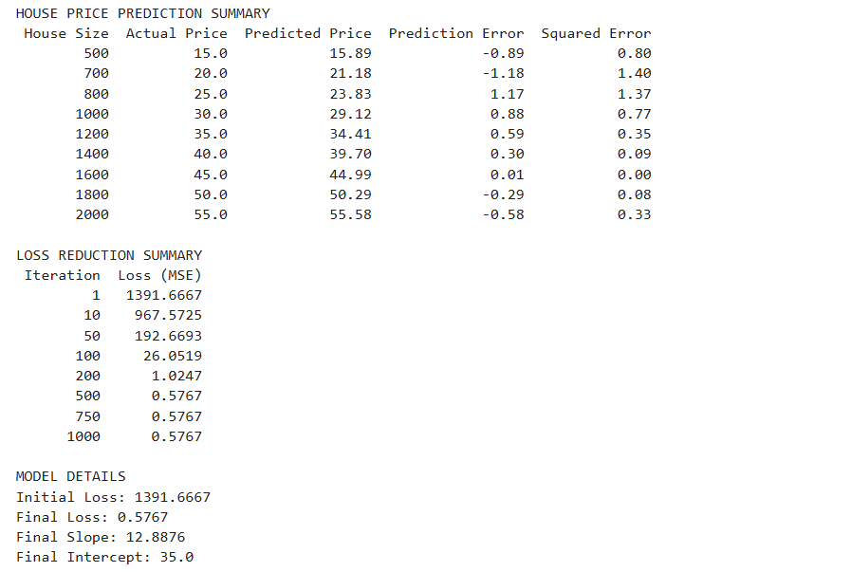

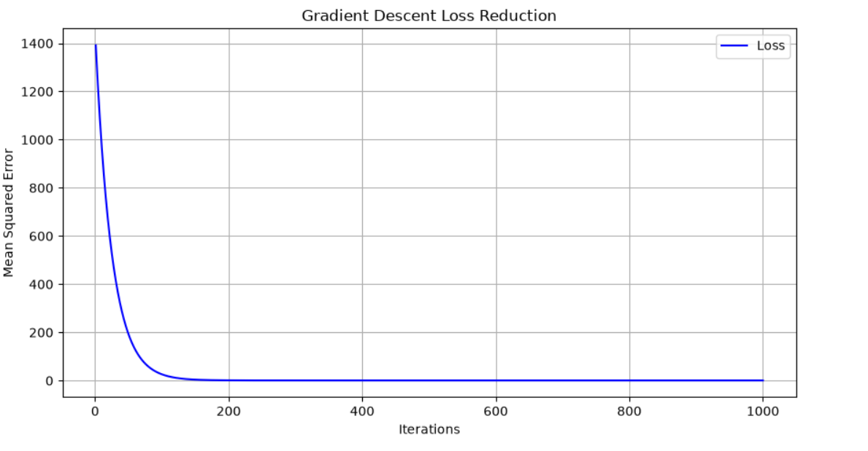
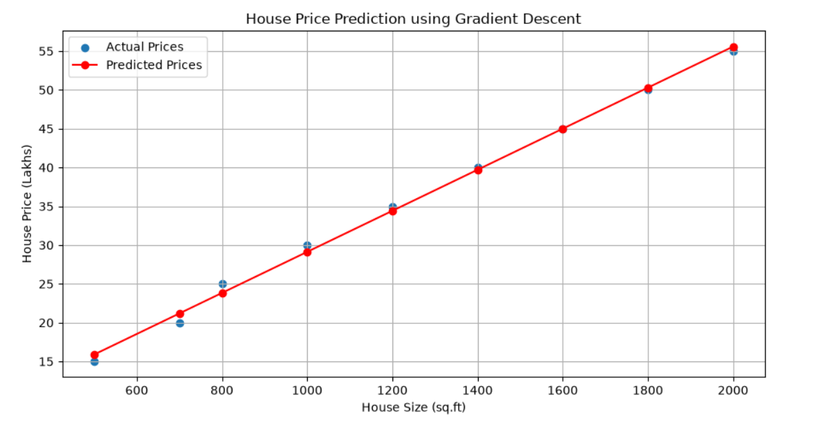

RESULT:
The Gradient Descent algorithm was successfully implemented to predict house prices using Linear Regression. The summary tables displayed actual and predicted prices and loss values. The plots visualized the decrease in loss over iterations and compared actual prices with predicted prices.

