Name : Tamil Elakiya S Course : Software Engineering
Reg No : 192524443
Experiment – 24

Question :
Create a CI/CD Pipeline Using GitHub Actions
Tasks:
• Set up a GitHub repository for a containerized Flask application.
• Define a GitHub Actions workflow file to automate testing and deployment.
• Add steps to build, test, and push Docker images to Docker Hub.
• Deploy the application to a cloud platform (Heroku/AWS).
• Submit the workflow file and deployment link.

Submission :

GitHub Repository: https://github.com/tamilelakiya07/flask-cicd.git
Docker Hub: https://hub.docker.com/repository/docker/tamilelakiya19/flask- cicd/general
Workflow File: github/workflows/ci-cd.yml
Deployment Link: https://flask-cicd-onxb.onrender.com

Aim
To create a CI/CD pipeline for a containerized Flask application using GitHub Actions, Docker Hub, and a cloud platform.
Procedure
- Created a Flask application using app.py and requirements.txt.
- Created a Dockerfile to containerize the Flask application.
- Tested the Flask application locally.
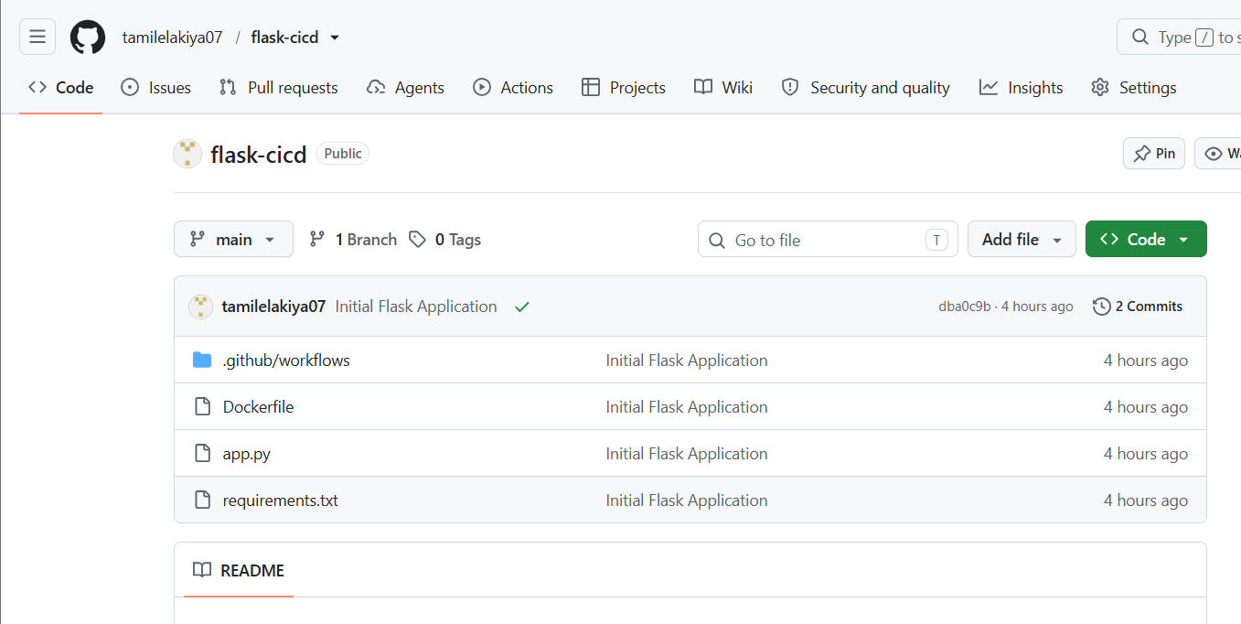
- Created a GitHub repository and pushed the project.

- Created the GitHub Actions workflow file: .github/workflows/ci-cd.yml
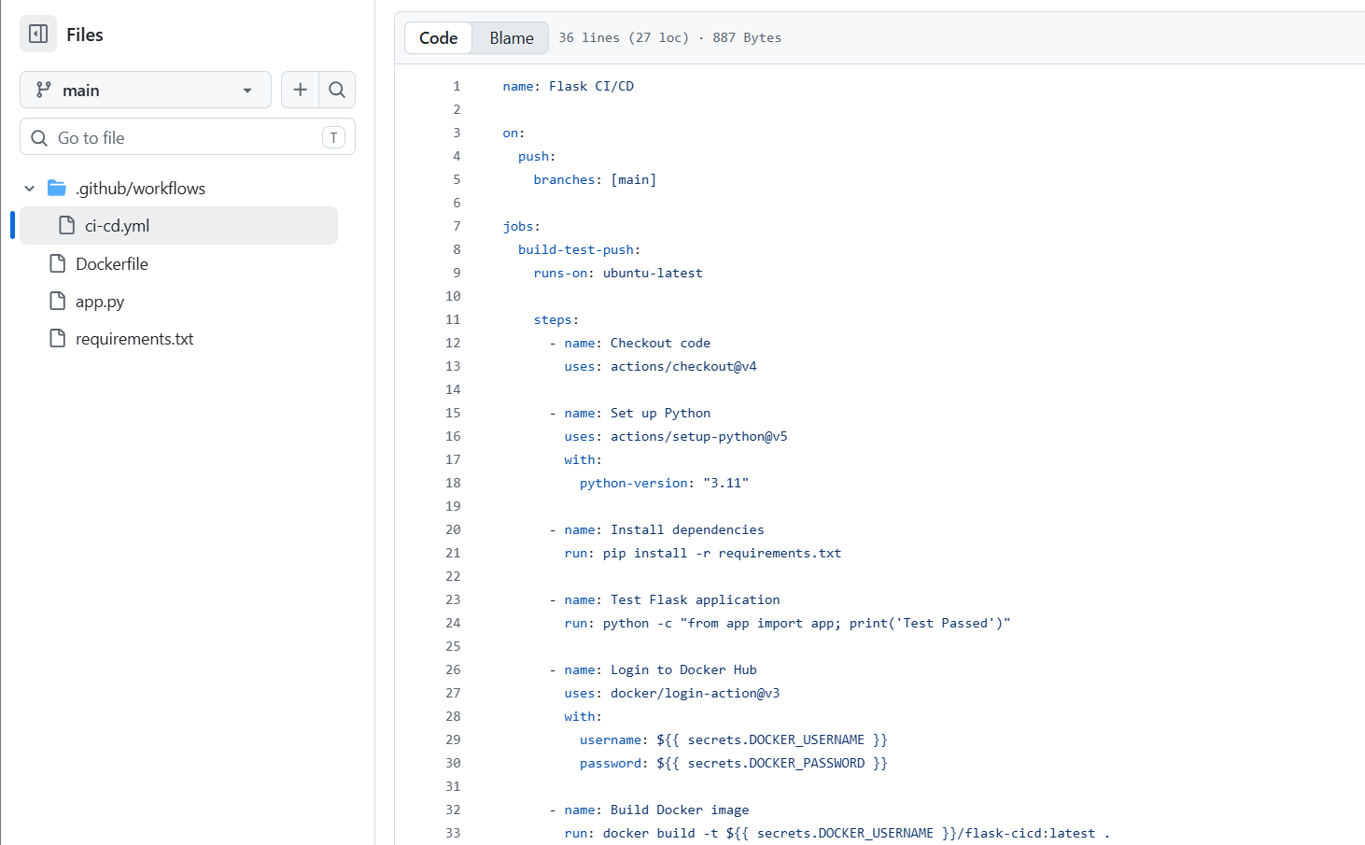

- Configured GitHub Actions to:
  - Checkout the source code
  - Install Python dependencies
  - Test the Flask application
  - Build the Docker image
  - Login to Docker Hub
  - Push the Docker image to Docker Hub
- Added DOCKER_USERNAME and DOCKER_PASSWORD as GitHub repository secrets.
- Verified the workflow execution under the Actions tab.
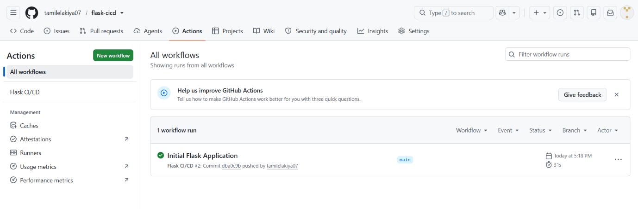

- Deployed the Dockerized Flask application to a cloud platform.

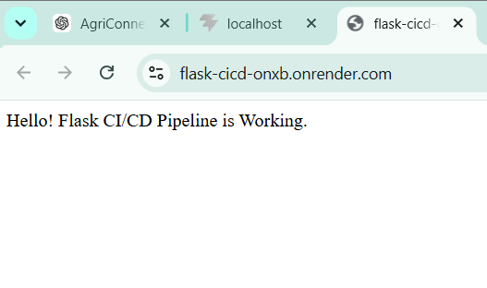

- Verified the application using the generated deployment URL.
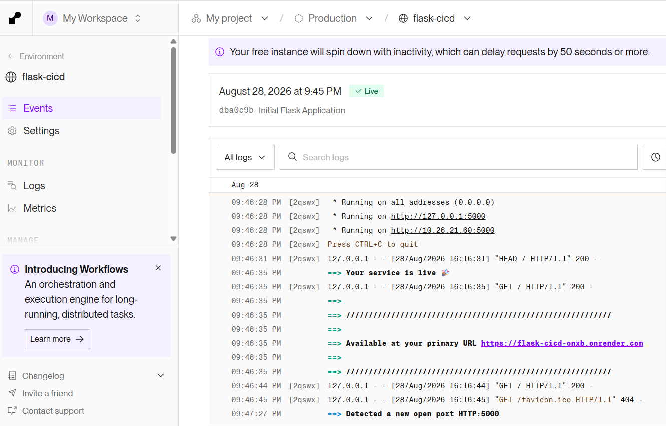

CI/CD Workflow
GitHub Push
↓
GitHub Actions
↓
Install Dependencies
↓
Run Tests
↓
Build Docker Image
↓
Push to Docker Hub
↓
Cloud Deployment
↓
Live Flask Application

Result
The CI/CD pipeline was successfully created. GitHub Actions automatically tested the Flask application, built and pushed the Docker image to Docker Hub, and the application was deployed to the cloud.

