Name : Tamil Elakiya S Course : Software Engineering
Reg No : 192524443
Experiment – 14

Question :
Demonstrate how to work collaboratively in Git/GitHub on a project using the fork-and-pull request workflow.
Tasks:
1. Fork an existing public GitHub repository (e.g., a sample JavaScript or Python project).
2. Clone the forked repository to your local machine using Git.
3. Create a new branch for the feature or change you want to work on.
4. Make modifications or add new features (e.g., add a function, fix a bug, or update the README).
5. Commit your changes and push the branch to GitHub.
6. Go to the GitHub repository and create a pull request to merge your feature branch into the main branch.
7. Review the pull request and provide feedback on the changes.
8. Respond to feedback by making additional commits to the feature branch if necessary.
9. Once the pull request is approved, merge it into the main branch.
10. Finally submit the link to the pull request along with a summary of the changes you made and how you collaborated.

Git Hub Repository Link : https://github.com/tamilelakiya07/Python

Aim
To demonstrate collaborative development using Git and GitHub through the fork-and-pull request workflow.

Procedure
- Fork: Forked an existing public GitHub repository into my GitHub account.
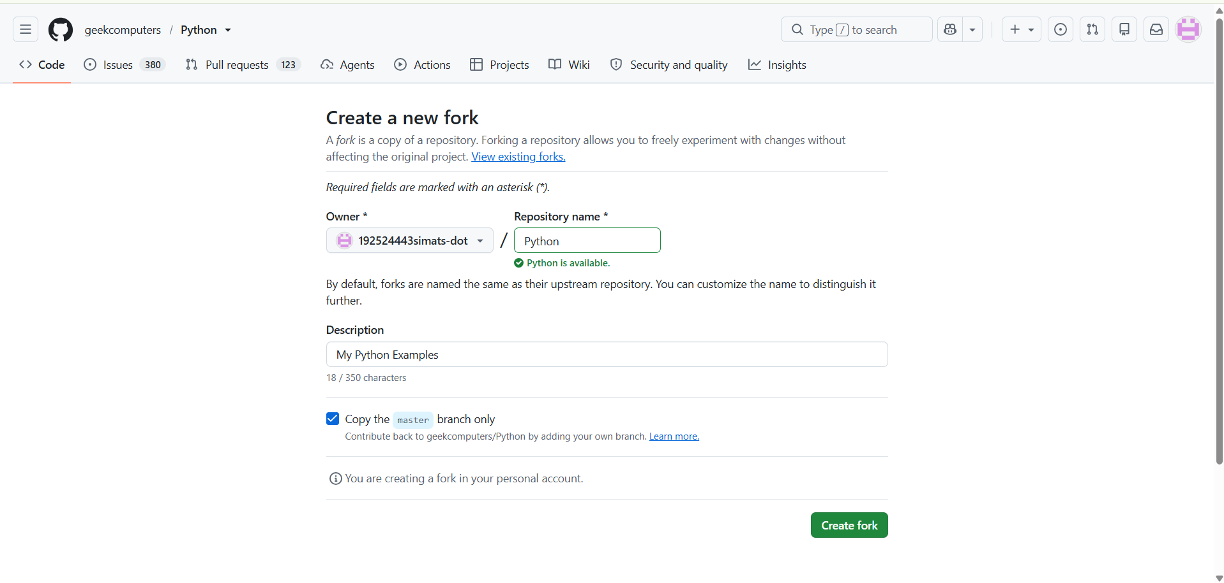

- Clone: Cloned the forked repository to the local machine using Git Bash.
git clone <repository-url>
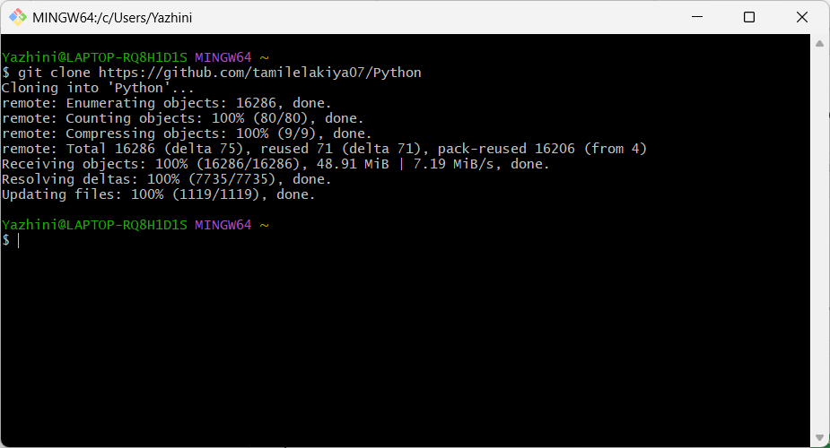

- Branch: Created a separate feature branch.
git checkout -b update-readme
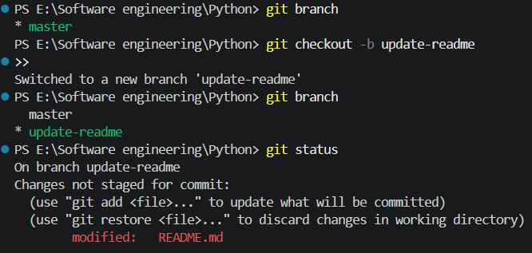

- Modify: Updated the README.md file with additional project documentation.
- Commit: Staged and committed the changes.
git add .
git commit -m "Update README documentation"
- Push: Pushed the feature branch to GitHub.
git push -u origin update-readme
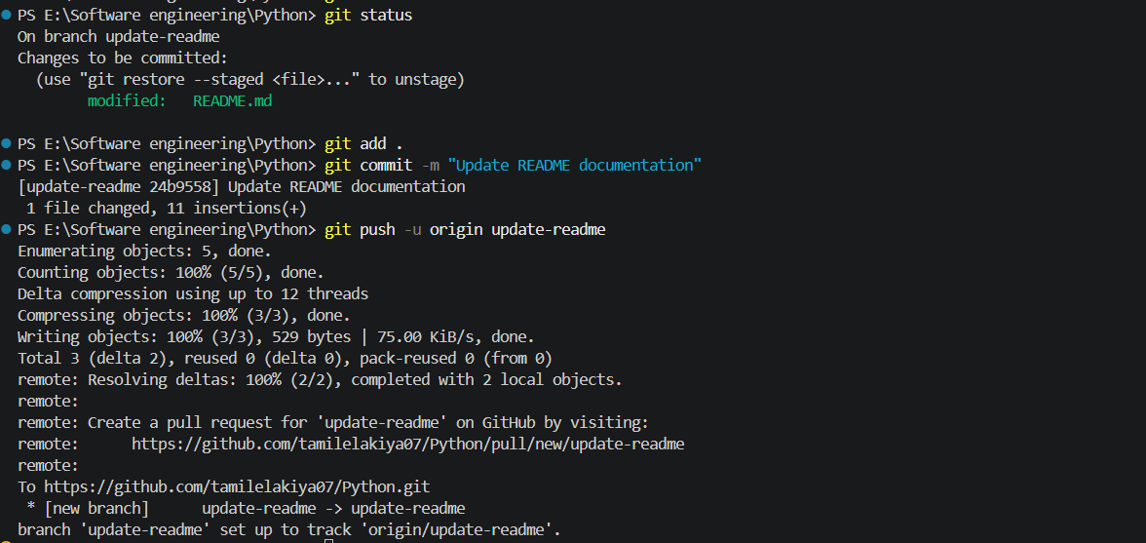

- Pull Request: Created a Pull Request from update-readme to the main branch.
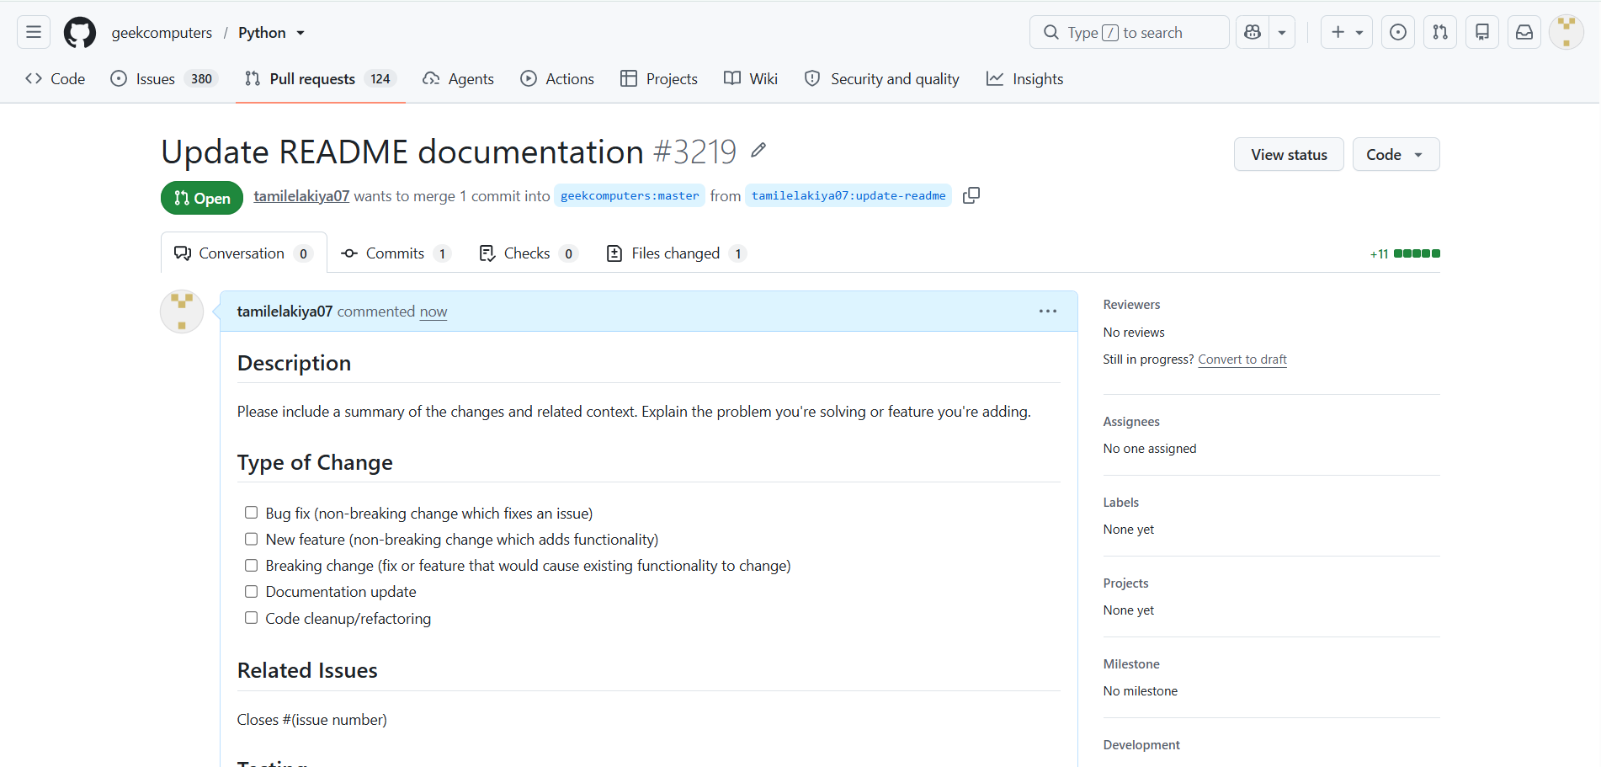

- Review: Reviewed the changes and provided feedback through GitHub.
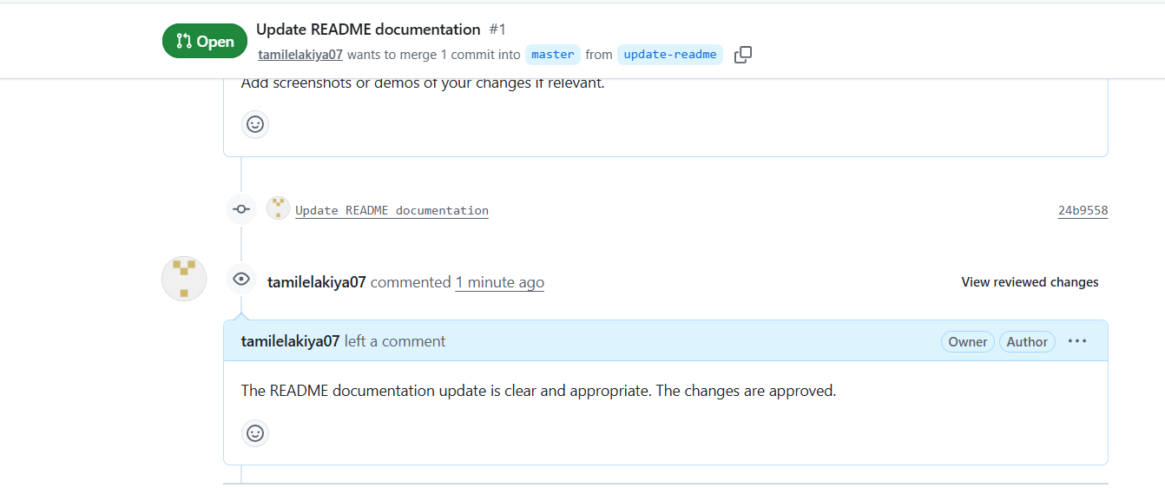

- Response: Addressed feedback using additional commits and pushed the changes.

- Merge: After approval, merged the Pull Request into the main branch.
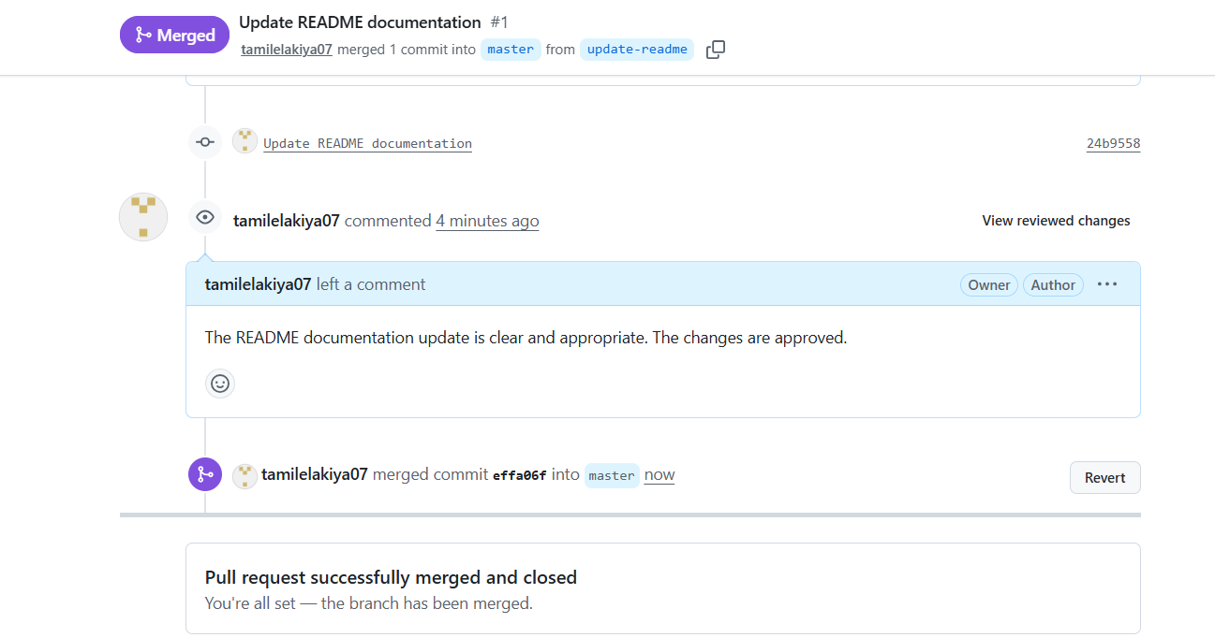

Result
The fork-and-pull request workflow was successfully demonstrated. Changes were developed in a separate branch, reviewed through a Pull Request, updated based on feedback, and finally merged into the main branch.

