Program 11: Banker's Algorithm (Deadlock Avoidance)
#include <stdio.h>
int main()
{
int n, m;
int allocation[10][10], maximum[10][10], need[10][10];
int available[10], work[10];
int finish[10] = {0};
int safeSequence[10];
int i, j, count = 0;
printf("Enter the number of processes: ");
scanf("%d", &n);
printf("Enter the number of resource types: ");
scanf("%d", &m);
printf("\nEnter the Allocation Matrix:\n");
for(i = 0; i < n; i++)
{
for(j = 0; j < m; j++)
{
scanf("%d", &allocation[i][j]);
}
}
printf("\nEnter the Maximum Matrix:\n");
for(i = 0; i < n; i++)
{
for(j = 0; j < m; j++)
{
scanf("%d", &maximum[i][j]);
}
}
printf("\nEnter the Available Resources:\n");
for(i = 0; i < m; i++)
{
scanf("%d", &available[i]);
work[i] = available[i];
}
/* Calculate Need Matrix */
for(i = 0; i < n; i++)
{
for(j = 0; j < m; j++)
{
need[i][j] = maximum[i][j] - allocation[i][j];
}
}
while(count < n)
{
int found = 0;
for(i = 0; i < n; i++)
{
if(finish[i] == 0)
{
int possible = 1;

for(j = 0; j < m; j++)
{
if(need[i][j] > work[j])
{
possible = 0;
break;
}
}
if(possible)
{
for(j = 0; j < m; j++)
{
work[j] += allocation[i][j];
}
safeSequence[count] = i;
finish[i] = 1;
count++;
found = 1;
}
}
}
if(found == 0)
{
printf("\nSystem is NOT in a Safe State.\n");
return 0;
}
}
printf("\nSystem is in a Safe State.\n");
printf("Safe Sequence: ");

for(i = 0; i < n; i++)
{
printf("P%d", safeSequence[i]);

if(i != n - 1)
{
printf(" -> ");
}
}

printf("\n");

return 0;
}
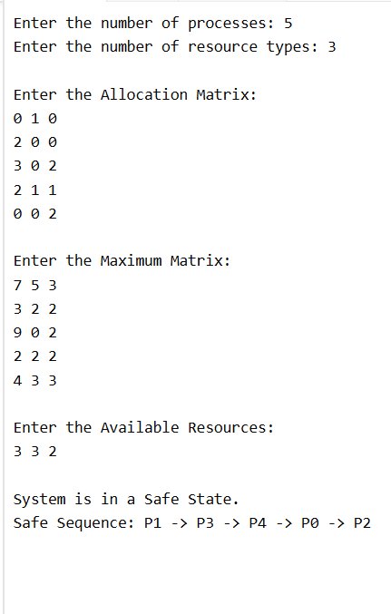
Program 12: Dining Philosophers Problem
#include <stdio.h>

#define N 5

int state[N];
int fork[N];

void takeFork(int p)
{
if (fork[p] == 1 && fork[(p + 1) % N] == 1)
{
fork[p] = 0;
fork[(p + 1) % N] = 0;
state[p] = 1;

printf("\nPhilosopher %d takes Fork %d and Fork %d",
p + 1, p + 1, ((p + 1) % N) + 1);
printf("\nPhilosopher %d is Eating\n", p + 1);
}
else
{
printf("\nPhilosopher %d is Waiting\n", p + 1);
}
}

void putFork(int p)
{
fork[p] = 1;
fork[(p + 1) % N] = 1;
state[p] = 0;

printf("\nPhilosopher %d puts down Fork %d and Fork %d",
p + 1, p + 1, ((p + 1) % N) + 1);

printf("\nPhilosopher %d is Thinking\n", p + 1);
}

int main()
{
int i, choice;

for(i = 0; i < N; i++)
{
fork[i] = 1;
state[i] = 0;
}

while(1)
{
printf("\n\n===== Dining Philosophers =====");
printf("\n1. Pick Forks");
printf("\n2. Put Forks");
printf("\n3. Exit");
printf("\nEnter your choice: ");
scanf("%d", &choice);

switch(choice)
{
case 1:
printf("Enter Philosopher Number (1-5): ");
scanf("%d", &i);

if(i >= 1 && i <= 5)
takeFork(i - 1);
else
printf("Invalid Philosopher Number!");

break;

case 2:
printf("Enter Philosopher Number (1-5): ");
scanf("%d", &i);

if(i >= 1 && i <= 5)
putFork(i - 1);
else
printf("Invalid Philosopher Number!");

break;

case 3:
return 0;

default:
printf("Invalid Choice!");
}
}

return 0;
}
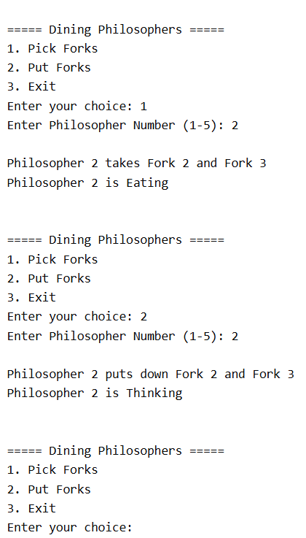

Program 17: Banker's Algorithm (Deadlock Avoidance)
#include <stdio.h>

int main()
{
int n, m;
int allocation[10][10], maximum[10][10], need[10][10];
int available[10], work[10];
int finish[10] = {0};
int safeSequence[10];

int i, j, count = 0;

printf("Enter the number of processes: ");
scanf("%d", &n);

printf("Enter the number of resource types: ");
scanf("%d", &m);

printf("\nEnter Allocation Matrix:\n");
for(i = 0; i < n; i++)
{
for(j = 0; j < m; j++)
{
scanf("%d", &allocation[i][j]);
}
}

printf("\nEnter Maximum Matrix:\n");
for(i = 0; i < n; i++)
{
for(j = 0; j < m; j++)
{
scanf("%d", &maximum[i][j]);
}
}

printf("\nEnter Available Resources:\n");
for(i = 0; i < m; i++)
{
scanf("%d", &available[i]);
work[i] = available[i];
}

/* Calculate Need Matrix */
for(i = 0; i < n; i++)
{
for(j = 0; j < m; j++)
{
need[i][j] = maximum[i][j] - allocation[i][j];
}
}

while(count < n)
{
int found = 0;

for(i = 0; i < n; i++)
{
if(finish[i] == 0)
{
int possible = 1;

for(j = 0; j < m; j++)
{
if(need[i][j] > work[j])
{
possible = 0;
break;
}
}

if(possible)
{
for(j = 0; j < m; j++)
{
work[j] += allocation[i][j];
}

safeSequence[count] = i;
finish[i] = 1;
count++;
found = 1;
}
}
}

if(found == 0)
{
printf("\nSystem is NOT in a Safe State.\n");
return 0;
}
}

printf("\nSystem is in a Safe State.\n");
printf("Safe Sequence: ");

for(i = 0; i < n; i++)
{
printf("P%d", safeSequence[i]);

if(i != n - 1)
{
printf(" -> ");
}
}

printf("\n");

return 0;
}
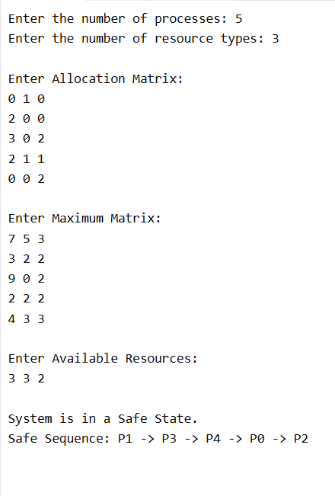
Program 18: Producer–Consumer Problem using Semaphores
#include <stdio.h>
#include <stdlib.h>

#define SIZE 5

int buffer[SIZE];
int in = 0, out = 0;
int full = 0;
int empty = SIZE;
int mutex = 1;

void wait(int *s)
{
(*s)--;
}

void signal(int *s)
{
(*s)++;
}

void produce()
{
int item;

if (empty == 0)
{
printf("\nBuffer is Full! Cannot Produce.\n");
return;
}

printf("Enter item to produce: ");
scanf("%d", &item);

wait(&empty);
wait(&mutex);

buffer[in] = item;
printf("Produced Item: %d\n", item);

in = (in + 1) % SIZE;

signal(&mutex);
signal(&full);
}

void consume()
{
if (full == 0)
{
printf("\nBuffer is Empty! Cannot Consume.\n");
return;
}

wait(&full);
wait(&mutex);

int item = buffer[out];
printf("Consumed Item: %d\n", item);

out = (out + 1) % SIZE;

signal(&mutex);
signal(&empty);
}

void display()
{
int i;

printf("\nBuffer Contents:\n");

if (full == 0)
{
printf("Buffer is Empty.\n");
return;
}

for (i = 0; i < full; i++)
{
printf("%d ", buffer[(out + i) % SIZE]);
}

printf("\n");
}

int main()
{
int choice;

while (1)
{
printf("\n===== Producer-Consumer =====");
printf("\n1. Produce");
printf("\n2. Consume");
printf("\n3. Display Buffer");
printf("\n4. Exit");

printf("\nEnter your choice: ");
scanf("%d", &choice);

switch (choice)
{
case 1:
produce();
break;

case 2:
consume();
break;

case 3:
display();
break;

case 4:
exit(0);

default:
printf("Invalid Choice!\n");
}
}

return 0;
}
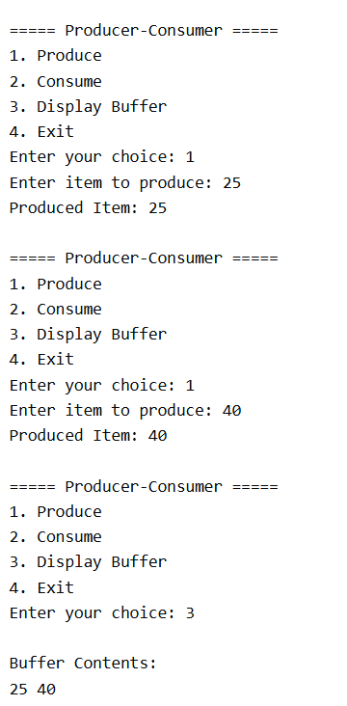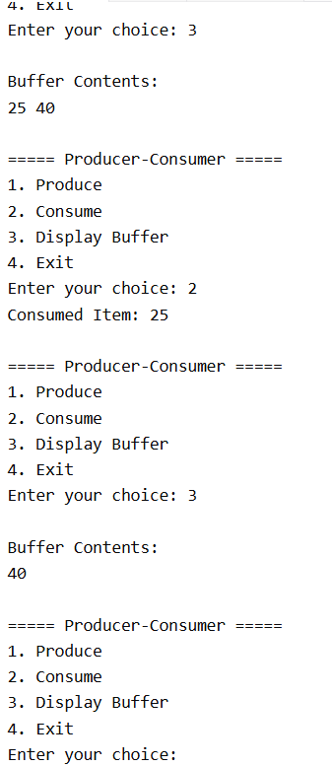
Program 19: Process Synchronization using Mutex Locks
#include <stdio.h>
#include <pthread.h>
#include <unistd.h>

pthread_mutex_t mutex;
int sharedVariable = 0;

void *increment(void *arg)
{
int i;

for(i = 1; i <= 5; i++)
{
pthread_mutex_lock(&mutex);

sharedVariable++;
printf("Thread %ld : Shared Variable = %d\n",
(long)arg, sharedVariable);

pthread_mutex_unlock(&mutex);

sleep(1);
}

pthread_exit(NULL);
}

int main()
{
pthread_t thread1, thread2;

pthread_mutex_init(&mutex, NULL);

pthread_create(&thread1, NULL, increment, (void *)1);
pthread_create(&thread2, NULL, increment, (void *)2);

pthread_join(thread1, NULL);
pthread_join(thread2, NULL);

pthread_mutex_destroy(&mutex);

printf("\nFinal Value of Shared Variable = %d\n", sharedVariable);

return 0;
}
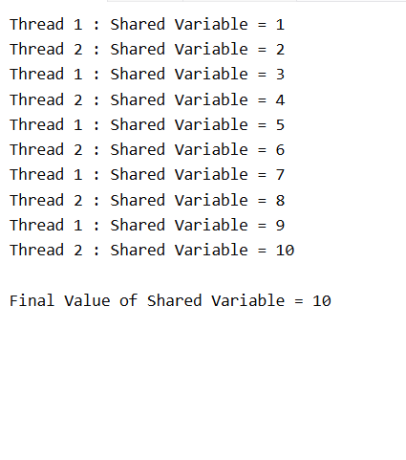
Program 20: Reader–Writer Problem using Semaphores
#include <stdio.h>
#include <pthread.h>
#include <semaphore.h>
#include <unistd.h>

sem_t mutex;
sem_t wrt;

int readCount = 0;
int sharedData = 100;

void *reader(void *arg)
{
int id = *(int *)arg;

sem_wait(&mutex);
readCount++;

if (readCount == 1)
{
sem_wait(&wrt);
}

sem_post(&mutex);

printf("Reader %d is reading data = %d\n", id, sharedData);

sleep(1);

sem_wait(&mutex);
readCount--;

if (readCount == 0)
{
sem_post(&wrt);
}

sem_post(&mutex);

pthread_exit(NULL);
}

void *writer(void *arg)
{
int id = *(int *)arg;

sem_wait(&wrt);

sharedData += 10;

printf("Writer %d is writing data = %d\n", id, sharedData);

sleep(1);

sem_post(&wrt);

pthread_exit(NULL);
}

int main()
{
pthread_t r1, r2, w1;
int reader1 = 1;
int reader2 = 2;
int writer1 = 1;

sem_init(&mutex, 0, 1);
sem_init(&wrt, 0, 1);

pthread_create(&r1, NULL, reader, &reader1);
pthread_create(&w1, NULL, writer, &writer1);
pthread_create(&r2, NULL, reader, &reader2);

pthread_join(r1, NULL);
pthread_join(w1, NULL);
pthread_join(r2, NULL);

sem_destroy(&mutex);
sem_destroy(&wrt);

return 0;
}
