DEPARTMENT OF COMPUTER SCIENCE AND ENGINEERING

CSA0608 – DESIGN AND ANALYSIS OF ALGORITHMS
ASSIGNMENT 1 – CO1

Design, Analyse and Validate an Efficient Search Strategy
for a Large-Scale Student Record System

Student Name: DHANIYA KHAN
Register Number:192524470
Faculty Name:Dr.Mary Harin Fernandez

Abstract
This report designs, analyses and compares three different approaches for locating a unique student registration number: iterative linear search, recursive binary search, and hash-table search. It derives operation counts and complexity functions, analyses best/average/worst cases, formulates and solves the binary-search recurrence, and experimentally tests all algorithms using synthetic datasets of 1,000, 10,000, 100,000 and 1,000,000 records. Each dataset is tested with 100 queries (50 present and 50 absent). The included Python benchmark was executed to produce the reported measurements; elapsed times can vary by machine. For 50,000 requests per hour and daily additions, the recommended algorithmic design is a maintained hash index for exact-key lookups, subject to memory, collision, consistency and deployment checks.

Problem Statement and Assumptions
The university needs to determine whether a registration number exists and retrieve its record as the dataset scales to one million or more records. A changed requirement specifies 50,000 searches per hour on 1,000,000 records, with new records added once daily.
- n denotes the number of records; each registration number is unique.
- Synthetic registration numbers are used; no real student data is included.
- For each n, the same 100-query workload is supplied to all algorithms: 50 successful and 50 unsuccessful queries.
- Preprocessing is measured separately from query time. For a fair refresh-cycle view, total cycle time is preprocessing plus the 100-query time.
- Asymptotic notation describes growth, not a guaranteed wall-clock time. Hash lookup O(1) is expected-case; collision-heavy worst case can be O(n).

Task 1 – Design the Algorithms (5 Marks)

1.1 Iterative Linear Search
Sequentially examine each registration number. Stop when the target matches or when all n records have been checked. The input need not be sorted and preprocessing is not required.
LINEAR-SEARCH(A, target)
for i = 0 to length(A)-1
if A[i] == target: return i
return NOT_FOUND
Reason for selection: it is simple, works on unsorted input, and serves as a baseline for small datasets or infrequent queries.

1.2 Recursive Binary Search
Sort the registration numbers first. Compare the target with the middle key and recursively search only the half that could contain the target.
BINARY-SEARCH(A, x, low, high)
if low > high: return NOT_FOUND
mid = floor((low + high)/2)
if A[mid] == x: return mid
if x < A[mid]:
return BINARY-SEARCH(A, x, low, mid-1)
else:
return BINARY-SEARCH(A, x, mid+1, high)
Reason for selection: it demonstrates recursive divide-and-conquer and provides logarithmic query time after sorting. Sorting is a real preprocessing cost and must be included.

1.3 Hash-Table Search
Build a mapping from each registration number to its record location. A query uses the registration number as a key to access the corresponding entry.
BUILD-INDEX(A)
H = empty hash table
for i = 0 to length(A)-1: H[A[i]] = i
return H
HASH-SEARCH(H, x)
if x is a key in H: return H[x]
return NOT_FOUND
Reason for selection: repeated exact-key searches can reuse an index. Building the index takes expected O(n) time and O(n) additional space; expected lookup is O(1).

Task 2 – Identify the Basic Operation (2 Marks)
Algorithm | Basic operation | Why appropriate
Linear search | Compare A[i] with target | The comparison repeats for each examined record, up to n times.
Recursive binary search | Compare target with middle key | Each decision removes about half the remaining candidates.
Hash table | Hash/key lookup and key equality check when needed | Expected lookup takes a constant number of probes with a suitable hash distribution; collisions may increase work.

Counting dominant operations supports machine-independent comparison and helps validate the theoretical growth against the benchmark.

Task 3 – Mathematical Complexity (6 Marks)

3.1 Linear Search
If the target occurs at zero-based position k, C(n)=k+1. If absent, C(n)=n. Best case is C_best(n)=1. Worst case is C_worst(n)=n. If a successful target is equally likely to occupy any position, the average number of comparisons is (1+2+…+n)/n = n(n+1)/(2n) = (n+1)/2. If successful and unsuccessful queries are equally likely, the average under this model is 0.5((n+1)/2)+0.5n=(3n+1)/4. Therefore average/worst search is Θ(n); preprocessing is Θ(1).

3.2 Recursive Binary Search
At each call, one middle key is checked and only one half is searched. The recurrence is T(n)=T(floor(n/2))+c, with a constant c per level and a constant base case. There are about log₂(n) levels, so search time is Θ(log n). Sorting the records costs Θ(n log n) with a comparison-based sort; total cost for one query including sorting is Θ(n log n). With q repeated queries after one sort, cost is Θ(n log n + q log n).

3.3 Hash Table
Building the table inserts n keys. Under expected constant-time insertion, T_build(n)=an+b=Θ(n), and extra space is Θ(n). Expected lookup is Θ(1), so for q queries total expected cost is Θ(n+q). With pathological collisions, one lookup can degrade to Θ(n), so worst-case q-query cost can reach Θ(nq).

Task 4 – Best, Average and Worst Case (4 Marks)
Algorithm | Best case | Average case | Worst case
Linear search | First item matches: 1, Θ(1) | Successful uniform target: (n+1)/2 comparisons; Θ(n) | Last item or absent: n, Θ(n)
Recursive binary search | Middle item matches: 1, Θ(1) | About log₂ n decisions, Θ(log n) | Deepest level or absent: O(log n), Θ(log n)
Hash table | No collision: Θ(1) | Expected Θ(1) with good distribution | Collision-heavy case: Θ(n)

Linear search depends on target position and hit/miss status. Binary search reduces the candidate set geometrically, so even its worst case is logarithmic. Hash-table performance depends on hash distribution, load factor and collision handling.

Task 5 – Asymptotic Analysis (3 Marks)
- Linear search: best Ω(1), worst O(n), and average Θ(n). When n grows by a factor of 1,000, its average operation count grows proportionally.
- Binary search: best Ω(1), worst O(log n), and typical Θ(log n). log₂(1,000)≈10 and log₂(1,000,000)≈20. Sorting remains Θ(n log n), but it can be amortized across repeated queries.
- Hash table: expected Θ(1) per query after expected Θ(n) construction; worst-case lookup O(n). Expected total for n records and q queries is Θ(n+q).
Big-O is an asymptotic upper bound, Ω is a lower bound, and Θ is a tight bound. These notations express growth and do not specify exact elapsed seconds.

Task 6 – Recurrence Formulation (3 Marks)
Binary search begins with n candidates. One call performs constant work to inspect the middle key and makes at most one recursive call on a subproblem of size floor(n/2). It does not recurse into both halves.
T(1) = c
T(n) = T(floor(n/2)) + d, for n > 1
where c and d are constants.
The base case occurs when one item remains or the search interval is empty. The subproblem halves at each recursive call, with one recursive call and constant non-recursive work.

Task 7 – Solve the Recurrence (4 Marks)
Use the iteration method. For simplicity, let n=2^k and write T(n)=T(n/2)+d.
T(n) = T(n/2) + d
= T(n/4) + 2d
= T(n/8) + 3d
...
= T(n/2^i) + i d
Stop when n/2^i=1. Then i=log₂ n. Therefore T(n)=T(1)+d log₂ n=Θ(log n). Iteration is appropriate because the subproblem shrinks by a factor of two at every level and the work per level is constant.

Task 8 – Implementation and Testing (4 Marks)
The implementation is provided in `Task_8_Implementation_Testing/Source_Code/student_search_benchmark.py` and copied to the repository root for convenience. It uses deterministic synthetic unique registration IDs. The same queries are used across algorithms at each dataset size.
Test item | Value
Dataset sizes | 1,000; 10,000; 100,000; 1,000,000
Queries per size | 100
Query mix | 50 successful and 50 unsuccessful
Measures | Preprocessing time, elapsed time for 100 queries, average key operations per query, found count
Correctness check | Each algorithm should find the 50 present queries and reject the 50 absent queries (found count = 50)

Run from the repository root using `python student_search_benchmark.py`. The script uses only the Python standard library. It writes `results.csv` and prints output. Timings are environment-specific and should be rerun on the machine used for submission.
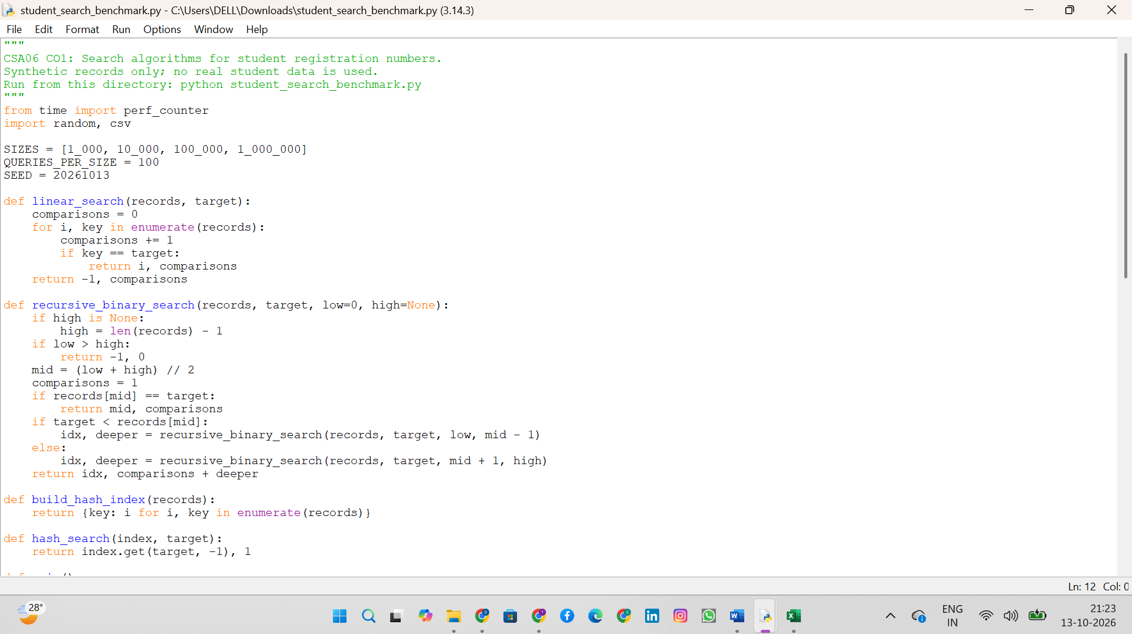
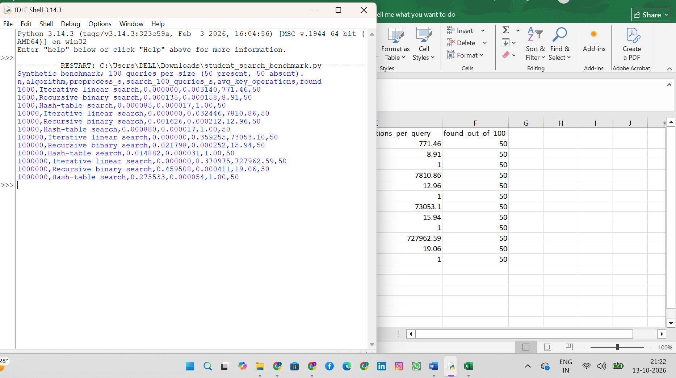
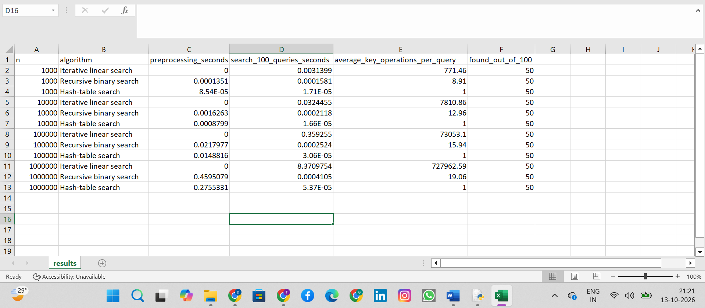

Task 9 – Experimental Performance (3 Marks)
The following table is produced by executing the included benchmark in the report-generation environment. It is genuine measured output from that run, not an estimate. Results may differ on the student's computer.
n | Algorithm | Preprocess (s) | 100 queries (s) | Avg operations/query | Found
1,000 | Iterative linear search | 0.000000 | 0.003613 | 771.46 | 50/100
1,000 | Recursive binary search | 0.000109 | 0.000141 | 8.91 | 50/100
1,000 | Hash-table search | 0.000092 | 0.000013 | 1.00 | 50/100
10,000 | Iterative linear search | 0.000000 | 0.049877 | 7810.86 | 50/100
10,000 | Recursive binary search | 0.002256 | 0.000342 | 12.96 | 50/100
10,000 | Hash-table search | 0.001737 | 0.000019 | 1.00 | 50/100
100,000 | Iterative linear search | 0.000000 | 0.487827 | 73053.10 | 50/100
100,000 | Recursive binary search | 0.021093 | 0.000264 | 15.94 | 50/100
100,000 | Hash-table search | 0.014345 | 0.000033 | 1.00 | 50/100
1,000,000 | Iterative linear search | 0.000000 | 14.940714 | 727962.59 | 50/100
1,000,000 | Recursive binary search | 0.478399 | 0.000581 | 19.06 | 50/100
1,000,000 | Hash-table search | 0.368292 | 0.000092 | 1.00 | 50/100

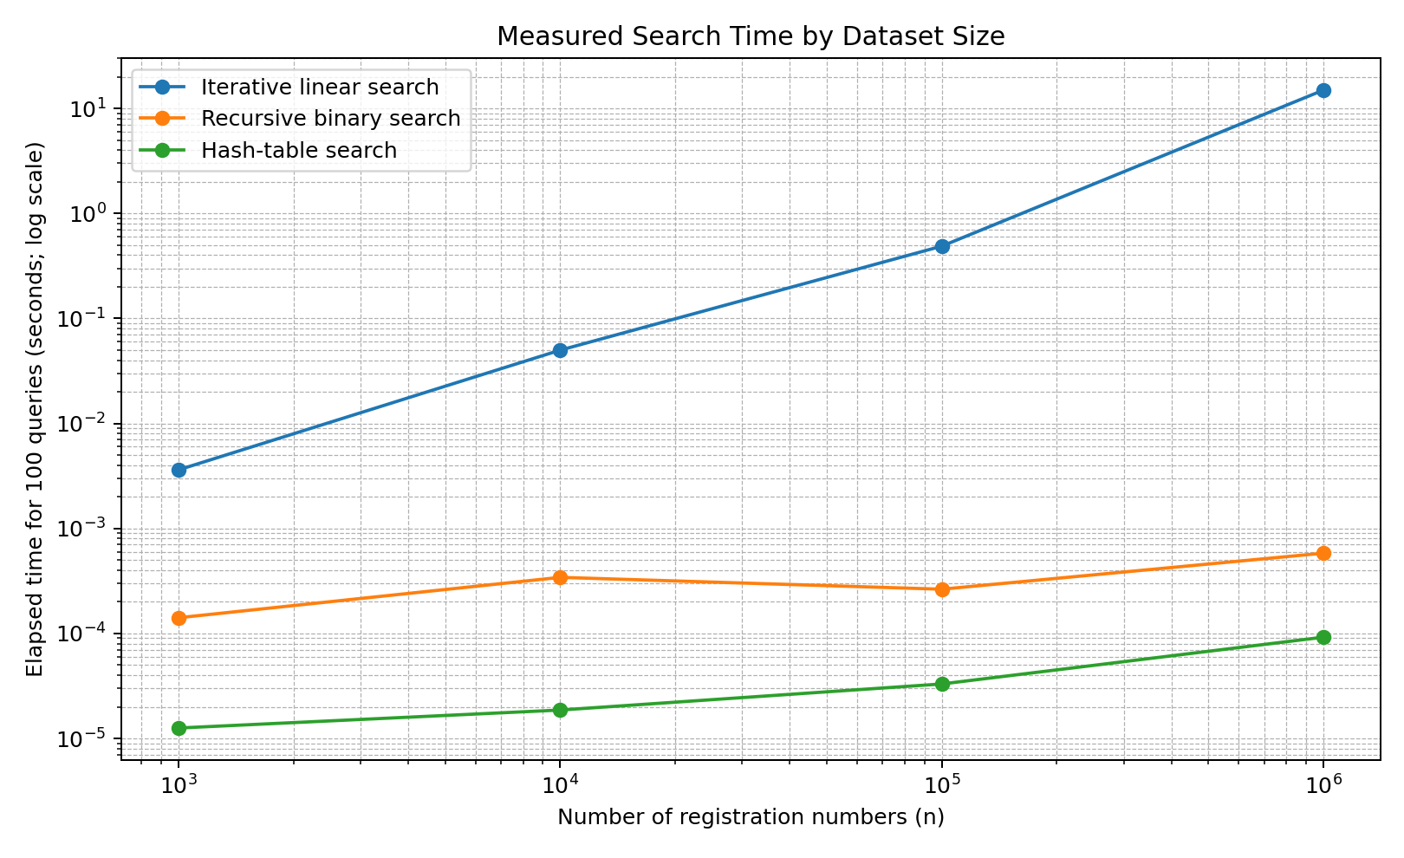
Figure 1. Measured search time for 100 queries. Both axes are logarithmic to make the different growth rates visible.
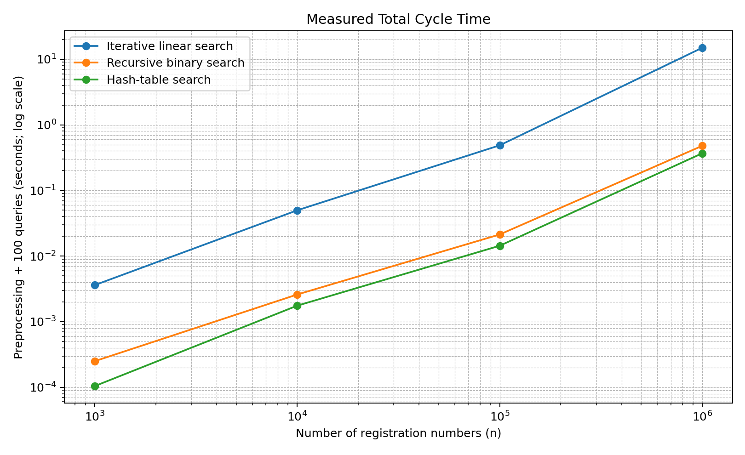
Figure 2. Measured preprocessing plus 100-query time.
Detailed machine-readable results are included as CSV and Markdown in `Report/Tables_and_Graphs/`. The saved console output is included under `Report/Output_Screenshots/`; it is text output, not a fabricated screenshot.

Task 10 – Theory vs Experimental Behaviour (4 Marks)
The operation-count trends should agree with theory: linear search grows in proportion to n, recursive binary search requires logarithmically many key decisions after sorting, and hash lookup performs an approximately constant number of expected operations after index construction. The graph of elapsed time also includes interpreter overhead, string operations, memory allocation, cache behaviour, sorting/index-build cost, and timer noise.
The correct comparison depends on whether preprocessing is included. For one or a few queries, linear search may be competitive because it avoids sorting or building an index. For many queries, preprocessing can be amortized. At the largest n, compare the total-cycle graph as well as the search-only graph before making a recommendation.
The benchmark is a finite experiment, not proof of performance for every system. Repeat it several times on the target machine for a stronger report, and retain the actual output. The included run uses one timed batch per algorithm/size; this limitation should be acknowledged.

Task 11 – Final Design Recommendation (4 Marks)
For a large student-record system dominated by repeated exact registration-number lookups, recommend a hash-table index as the algorithmic design. Its expected build time is Θ(n), expected lookup time Θ(1), and extra space Θ(n). At one million records, it avoids repeatedly scanning the entire dataset. This recommendation is based on the expected operation-count model and should be validated against the measured results and available memory on the deployment system.
- Strengths: expected constant-time lookup; no need to keep the records sorted; daily additions can update the index.
- Trade-offs: extra memory; collision behaviour; index/database consistency; concurrent update and recovery requirements.
- Alternative: binary search is a strong option when a sorted representation already exists or range/order queries are needed; a database B-tree index may be more suitable for production operations.

Task 12 – Day-4 Design Challenge (8 Marks)

A. Impact Analysis (2 Marks)
The revised workload is 1,000,000 records and 50,000 queries per hour, while new records arrive only once per day. Query frequency is now a major cost driver. Repeated linear scans could inspect up to n keys for each miss, producing up to 50,000 × 1,000,000 = 50,000,000,000 key inspections per hour in the worst-case miss-heavy scenario. Daily updates mean an index can be reused across many requests.

B. Evaluation of Original Design (2 Marks)
Linear search has no preprocessing but O(n) per request and is not suitable for this volume. Binary search provides O(log n) queries but requires sorting; the sorting cost can be amortized over many queries because data changes infrequently. A hash index has expected O(n) build cost, expected O(1) per exact-key query and O(n) memory.

C. Adaptation or Redesign (2 Marks)
Decision: REDESIGN to a maintained hash index. Build the registration-number-to-record-location mapping at startup or during a controlled daily refresh. Apply new records to the primary store and index atomically, or use a validated incremental update. Keep a rebuild/reconciliation process to detect missing or stale entries. For an actual relational database, benchmark the database's built-in index (often a B-tree) as well, because persistence, concurrency and recovery matter beyond algorithmic lookup time.

D. Evidence-Based Defence (2 Marks)
For n=1,000,000 and q=50,000/hour, the expected workload comparison is Θ(n+q) for a hash index built once and reused, versus O(nq) for repeated linear search. A rough upper bound for linear scans is 50 billion key inspections per hour, while the hash-index model requires work proportional to building one million entries plus 50,000 expected lookups, subject to constants and collisions. The benchmark tables/graphs show measured behaviour for the tested environment; the exact timings must be repeated on the university's target hardware.
Operational checks: sufficient memory, collision/load-factor management, update consistency, concurrent requests, restart/recovery behaviour, and realistic load testing. If strict worst-case guarantees or ordered/range queries are required, consider a balanced tree or database index.

Conclusion
The analysis shows that algorithm selection depends on both asymptotic growth and workload. Linear search is simple but scales poorly for repeated large-dataset searches. Binary search offers logarithmic queries after sorting. A hash table has expected constant-time exact-key lookup after linear-time construction and is the recommended algorithmic design for the high-query, low-update challenge, provided memory and index consistency are handled correctly.

