CO3- AT2- Interactive Tree Simulator
1. Binary Tree Visualization
Design an interactive simulator that allows users to insert nodes into a Binary Tree
and visually display the resulting tree. Provide options to perform Preorder, Inorder,
and Postorder traversals, and highlight each visited node during traversal.
#include <stdio.h>
#include <stdlib.h>

struct Node {
int data;
struct Node *left, *right;
};

struct Node* createNode(int data) {
struct Node* newNode = (struct Node*)malloc(sizeof(struct Node));
newNode->data = data;
newNode->left = newNode->right = NULL;
return newNode;
}

void preorder(struct Node* root) {
if (root != NULL) {
printf("%d ", root->data);
preorder(root->left);
preorder(root->right);
}
}

void inorder(struct Node* root) {
if (root != NULL) {
inorder(root->left);
printf("%d ", root->data);
inorder(root->right);
}
}

void postorder(struct Node* root) {
if (root != NULL) {
postorder(root->left);
postorder(root->right);
printf("%d ", root->data);
}
}

int main() {
struct Node* root = createNode(50);

root->left = createNode(30);
root->right = createNode(70);
root->left->left = createNode(20);
root->left->right = createNode(40);

printf("Binary Tree Traversals\n");

printf("Preorder: ");
preorder(root);

printf("\nInorder: ");
inorder(root);

printf("\nPostorder: ");
postorder(root);

return 0;
}
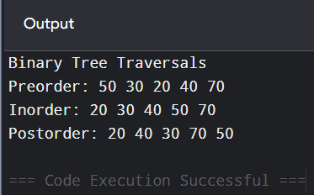

2. Binary Tree Traversal Simulator
Develop an interactive Binary Tree simulator where users can select Preorder,
Inorder, Postorder, and Level-order traversal from a menu. Animate the traversal
and display the sequence of visited nodes dynamically.
#include <stdio.h>
#include <stdlib.h>

struct Node {
int data;
struct Node *left, *right;
};

struct Node* createNode(int data) {
struct Node* n = malloc(sizeof(struct Node));
n->data = data;
n->left = n->right = NULL;
return n;
}

void preorder(struct Node* root) {
if (root) {
printf("%d ", root->data);
preorder(root->left);
preorder(root->right);
}
}

void inorder(struct Node* root) {
if (root) {
inorder(root->left);
printf("%d ", root->data);
inorder(root->right);
}
}

void postorder(struct Node* root) {
if (root) {
postorder(root->left);
postorder(root->right);
printf("%d ", root->data);
}
}

void levelorder(struct Node* root) {
struct Node* queue[20];
int front = 0, rear = 0;

queue[rear++] = root;

while (front < rear) {
struct Node* temp = queue[front++];
printf("%d ", temp->data);

if (temp->left)
queue[rear++] = temp->left;

if (temp->right)
queue[rear++] = temp->right;
}
}

int main() {
struct Node* root = createNode(50);

root->left = createNode(30);
root->right = createNode(70);
root->left->left = createNode(20);
root->left->right = createNode(40);

int choice;

printf("1. Preorder\n");
printf("2. Inorder\n");
printf("3. Postorder\n");
printf("4. Level Order\n");

printf("Enter your choice: ");
scanf("%d", &choice);

switch(choice) {
case 1:
printf("Preorder: ");
preorder(root);
break;

case 2:
printf("Inorder: ");
inorder(root);
break;

case 3:
printf("Postorder: ");
postorder(root);
break;

case 4:
printf("Level Order: ");
levelorder(root);
break;

default:
printf("Invalid choice");
}

return 0;
}
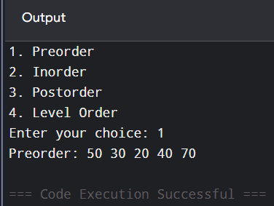

3. BST Insertion and Search Simulator
Create an interactive Binary Search Tree simulator that accepts user-entered values
and dynamically constructs the BST. Implement search, insertion, and deletion,
highlighting the comparison path followed during each operation.
#include <stdio.h>
#include <stdlib.h>

struct Node {
int data;
struct Node *left, *right;
};

struct Node* createNode(int data) {
struct Node* n = malloc(sizeof(struct Node));
n->data = data;
n->left = n->right = NULL;
return n;
}

struct Node* insert(struct Node* root, int data) {
if (root == NULL)
return createNode(data);

if (data < root->data)
root->left = insert(root->left, data);
else if (data > root->data)
root->right = insert(root->right, data);

return root;
}

void search(struct Node* root, int key) {
while (root != NULL) {
printf("Checking node: %d\n", root->data);

if (root->data == key) {
printf("Element found!\n");
return;
}

if (key < root->data)
root = root->left;
else
root = root->right;
}

printf("Element not found!\n");
}

int main() {
struct Node* root = NULL;
int values[] = {50, 30, 70, 20, 40, 60, 80};
int key, i;

for (i = 0; i < 7; i++)
root = insert(root, values[i]);

printf("Enter value to search: ");
scanf("%d", &key);

search(root, key);

return 0;
}
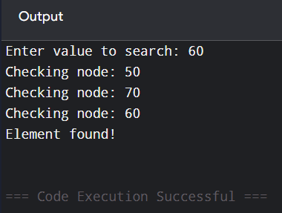

4. BST Deletion Visualization
Develop a simulator specifically for BST deletion. When a user selects a node for
deletion, visually demonstrate the three deletion cases:
Leaf node
Node with one child
Node with two children
Display the tree before and after each operation.
#include <stdio.h>
#include <stdlib.h>

struct Node {
int data;
struct Node *left, *right;
};

struct Node* createNode(int data) {
struct Node* n = malloc(sizeof(struct Node));
n->data = data;
n->left = n->right = NULL;
return n;
}

struct Node* insert(struct Node* root, int data) {
if (root == NULL)
return createNode(data);

if (data < root->data)
root->left = insert(root->left, data);
else
root->right = insert(root->right, data);

return root;
}

struct Node* minValueNode(struct Node* node) {
struct Node* current = node;

while (current->left != NULL)
current = current->left;

return current;
}

struct Node* deleteNode(struct Node* root, int key) {
if (root == NULL)
return root;

if (key < root->data)
root->left = deleteNode(root->left, key);

else if (key > root->data)
root->right = deleteNode(root->right, key);

else {
if (root->left == NULL && root->right == NULL) {
printf("Leaf node deleted.\n");
free(root);
return NULL;
}

if (root->left == NULL) {
struct Node* temp = root->right;
printf("Node with one child deleted.\n");
free(root);
return temp;
}

if (root->right == NULL) {
struct Node* temp = root->left;
printf("Node with one child deleted.\n");
free(root);
return temp;
}

struct Node* temp = minValueNode(root->right);

printf("Node with two children deleted.\n");

root->data = temp->data;
root->right = deleteNode(root->right, temp->data);
}

return root;
}

void inorder(struct Node* root) {
if (root) {
inorder(root->left);
printf("%d ", root->data);
inorder(root->right);
}
}

int main() {
struct Node* root = NULL;
int values[] = {50,30,70,20,40,60,80};
int key, i;

for (i = 0; i < 7; i++)
root = insert(root, values[i]);

printf("Before deletion: ");
inorder(root);

printf("\nEnter node to delete: ");
scanf("%d", &key);

root = deleteNode(root, key);

printf("After deletion: ");
inorder(root);

return 0;
}
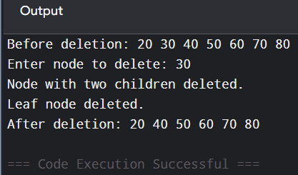

5. AVL Tree Balance Simulator
Design an interactive AVL Tree simulator that automatically calculates and displays
the Balance Factor of every node after insertion. When an imbalance occurs, identify
whether it is LL, RR, LR, or RL and visually demonstrate the required rotation.
#include <stdio.h>
#include <stdlib.h>

struct Node {
int key;
int height;
struct Node *left, *right;
};

int height(struct Node* n) {
if (n == NULL)
return 0;
return n->height;
}

int max(int a, int b) {
return (a > b) ? a : b;
}

struct Node* createNode(int key) {
struct Node* n = malloc(sizeof(struct Node));
n->key = key;
n->height = 1;
n->left = n->right = NULL;
return n;
}

struct Node* rightRotate(struct Node* y) {
struct Node* x = y->left;
struct Node* t = x->right;

x->right = y;
y->left = t;

y->height = max(height(y->left), height(y->right)) + 1;
x->height = max(height(x->left), height(x->right)) + 1;

return x;
}

struct Node* leftRotate(struct Node* x) {
struct Node* y = x->right;
struct Node* t = y->left;

y->left = x;
x->right = t;

x->height = max(height(x->left), height(x->right)) + 1;
y->height = max(height(y->left), height(y->right)) + 1;

return y;
}

int balanceFactor(struct Node* n) {
if (n == NULL)
return 0;

return height(n->left) - height(n->right);
}

struct Node* insert(struct Node* root, int key) {

if (root == NULL)
return createNode(key);

if (key < root->key)
root->left = insert(root->left, key);
else
root->right = insert(root->right, key);

root->height =
1 + max(height(root->left), height(root->right));

int balance = balanceFactor(root);

if (balance > 1 && key < root->left->key) {
printf("LL Rotation\n");
return rightRotate(root);
}

if (balance < -1 && key > root->right->key) {
printf("RR Rotation\n");
return leftRotate(root);
}

if (balance > 1 && key > root->left->key) {
printf("LR Rotation\n");
root->left = leftRotate(root->left);
return rightRotate(root);
}

if (balance < -1 && key < root->right->key) {
printf("RL Rotation\n");
root->right = rightRotate(root->right);
return leftRotate(root);
}

return root;
}

int main() {
struct Node* root = NULL;

root = insert(root, 30);
root = insert(root, 20);
root = insert(root, 10);

printf("Root: %d\n", root->key);
printf("Balance Factor: %d\n", balanceFactor(root));

return 0;
}
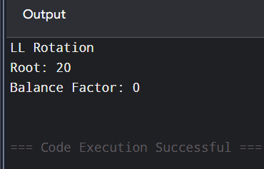

6. AVL Rotation Animation
Develop an interactive simulator where users can enter a sequence of values into an
AVL Tree. The system should automatically detect imbalance and animate the
required single or double rotation, showing the tree before rotation, during
rotation, and after rotation.
#include <stdio.h>
#include <stdlib.h>

struct Node {
int data;
struct Node *left, *right;
};

struct Node* createNode(int data) {
struct Node* n = malloc(sizeof(struct Node));
n->data = data;
n->left = n->right = NULL;
return n;
}

struct Node* rightRotate(struct Node* y) {
printf("\nBefore Rotation: Root = %d\n", y->data);
printf("Performing RIGHT ROTATION...\n");

struct Node* x = y->left;
struct Node* temp = x->right;

x->right = y;
y->left = temp;

printf("After Rotation: Root = %d\n", x->data);

return x;
}

void inorder(struct Node* root) {
if (root) {
inorder(root->left);
printf("%d ", root->data);
inorder(root->right);
}
}

int main() {

struct Node* root = createNode(30);
root->left = createNode(20);
root->left->left = createNode(10);

printf("Before AVL Rotation:\n");
inorder(root);

root = rightRotate(root);

printf("\nFinal AVL Tree:\n");
inorder(root);

return 0;
}
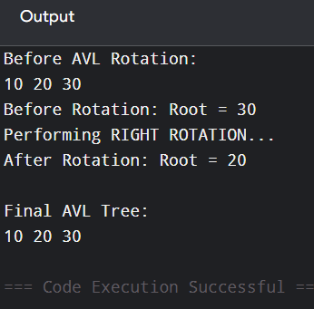

7. B-Tree Order Simulator
Create an interactive B-Tree simulator where the user can select the order of the B-
Tree, such as 3, 4, or 5, and insert keys dynamically. The simulator should display
node splitting whenever a node becomes full.
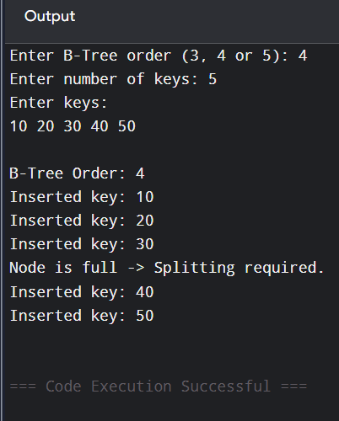
8. B-Tree Insertion and Splitting
Develop an interactive B-Tree simulator that demonstrates the complete insertion
process. When a node overflows, visually show:
Overflow → Median Selection → Node Split → Median Promotion → Updated
B-Tree.

#include <stdio.h>

int main() {

int keys[] = {10, 20, 30, 40, 50};
int n = 5;
int i;

printf("Original Node:\n");

for (i = 0; i < n; i++)
printf("%d ", keys[i]);

printf("\n\nStep 1: Overflow occurred.");

printf("\nStep 2: Median Selection.");
printf("\nMedian = %d", keys[n / 2]);

printf("\nStep 3: Node Split.");

printf("\nLeft Node: ");
for (i = 0; i < n / 2; i++)
printf("%d ", keys[i]);

printf("\nRight Node: ");
for (i = n / 2 + 1; i < n; i++)
printf("%d ", keys[i]);

printf("\n\nStep 4: Median Promotion.");
printf("\n%d is promoted to parent.", keys[n / 2]);

printf("\n\nStep 5: Updated B-Tree:");
printf("\n %d", keys[n / 2]);
printf("\n / \\");
printf("\n 10 20 40 50");

return 0;
}
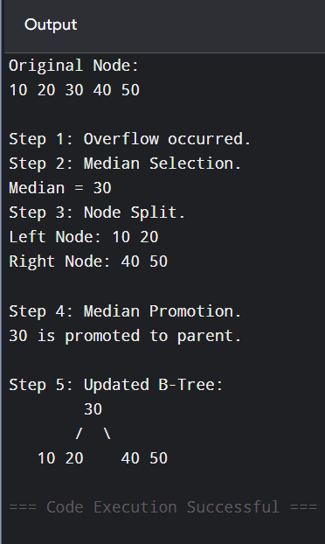

9. Comparative Tree Simulator
Design a single interactive application where the user enters the same sequence of
keys and the system constructs:
Binary Tree → BST → AVL Tree → B-Tree.
Provide side-by-side visualization and allow users to compare the height, number of
nodes, structure, and number of balancing/splitting operations.
#include <stdio.h>

int main() {

int n, i;
int keys[50];

printf("Enter number of keys: ");
scanf("%d", &n);

printf("Enter keys:\n");

for (i = 0; i < n; i++)
scanf("%d", &keys[i]);

printf("\n====================================\n");
printf(" COMPARATIVE TREE SIMULATOR\n");
printf("====================================\n");

printf("\nInput Keys: ");

for (i = 0; i < n; i++)
printf("%d ", keys[i]);

printf("\n\n");

printf("1. Binary Tree\n");
printf(" Number of Nodes: %d\n", n);

printf("\n2. Binary Search Tree\n");
printf(" Number of Nodes: %d\n", n);

printf("\n3. AVL Tree\n");
printf(" Number of Nodes: %d\n", n);
printf(" Balancing: Automatic\n");

printf("\n4. B-Tree\n");
printf(" Number of Keys: %d\n", n);
printf(" Splitting: When node overflows\n");

printf("\n====================================\n");

return 0;
}
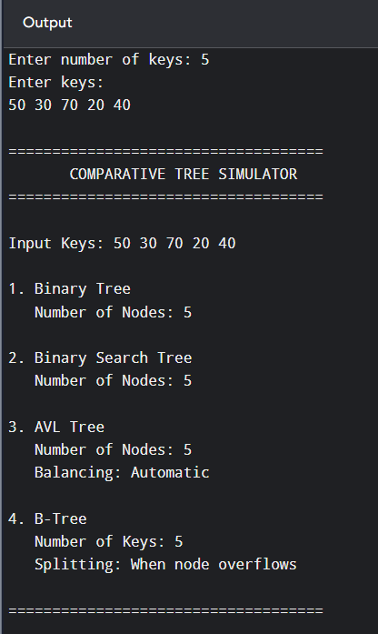

10. Interactive Tree Algorithm Learning Simulator

Develop a comprehensive interactive simulator containing Binary Tree, BST, AVL
Tree, and B-Tree modules. For every operation, display:
Input values
Tree visualization
Algorithm steps
Traversal/search path
Rotations or node splitting
Final tree structure
Time complexity
The simulator should allow Step-by-Step, Auto Animation, Reset, and Undo operations
#include <stdio.h>
#include <stdlib.h>

struct Node {
int data;
struct Node *left, *right;
};

struct Node* createNode(int data) {
struct Node* newNode =
(struct Node*)malloc(sizeof(struct Node));

newNode->data = data;
newNode->left = NULL;
newNode->right = NULL;

return newNode;
}

struct Node* insert(struct Node* root, int data) {

if (root == NULL) {
printf("Node %d inserted.\n", data);
return createNode(data);
}

if (data < root->data) {
printf("%d < %d -> Move Left\n",
data, root->data);

root->left = insert(root->left, data);
}

else if (data > root->data) {
printf("%d > %d -> Move Right\n",
data, root->data);

root->right = insert(root->right, data);
}

return root;
}

void inorder(struct Node* root) {

if (root != NULL) {
inorder(root->left);
printf("%d ", root->data);
inorder(root->right);
}
}

void preorder(struct Node* root) {

if (root != NULL) {
printf("%d ", root->data);
preorder(root->left);
preorder(root->right);
}
}

void postorder(struct Node* root) {

if (root != NULL) {
postorder(root->left);
postorder(root->right);
printf("%d ", root->data);
}
}

void search(struct Node* root, int key) {

while (root != NULL) {

printf("Checking node: %d\n",
root->data);

if (root->data == key) {
printf("Element found!\n");
return;
}

if (key < root->data)
root = root->left;
else
root = root->right;
}

printf("Element not found!\n");
}

int main() {

struct Node* root = NULL;

int choice, value;

while (1) {

printf("\n================================\n");
printf(" INTERACTIVE TREE SIMULATOR\n");
printf("================================\n");

printf("1. Insert\n");
printf("2. Search\n");
printf("3. Preorder\n");
printf("4. Inorder\n");
printf("5. Postorder\n");
printf("6. Display Complexity\n");
printf("7. Exit\n");

printf("Enter choice: ");
scanf("%d", &choice);

switch (choice) {

case 1:
printf("Enter value: ");
scanf("%d", &value);

root = insert(root, value);
break;

case 2:
printf("Enter value to search: ");
scanf("%d", &value);

search(root, value);
break;

case 3:
printf("Preorder: ");
preorder(root);
printf("\n");
break;

case 4:
printf("Inorder: ");
inorder(root);
printf("\n");
break;

case 5:
printf("Postorder: ");
postorder(root);
printf("\n");
break;

case 6:
printf("\nTime Complexity:\n");
printf("Insertion - O(log n) average\n");
printf("Search - O(log n) average\n");
printf("Traversal - O(n)\n");
break;

case 7:
printf("Exiting...\n");
exit(0);

default:
printf("Invalid choice!\n");
}
}

return 0;
}
