Experiment 15: Create a Snapshot of a VM and Test it by Loading the Previous Version/Cloned VM

Aim:
To create a snapshot of a virtual machine and restore it to a previous version using VMware Workstation.

Procedure:
Step 1: Open VMware Workstation and select the virtual machine.
Step 2: Click VM → Snapshot → Take Snapshot, enter a snapshot name, and click Take Snapshot.
Step 3: Make some changes to the virtual machine (e.g., create a folder or install software).
Step 4: Click VM → Snapshot → Snapshot Manager, select the saved snapshot, and click Go To (Restore).
Step 5: Verify that the virtual machine returns to the previous state saved in the snapshot.

STEP1:
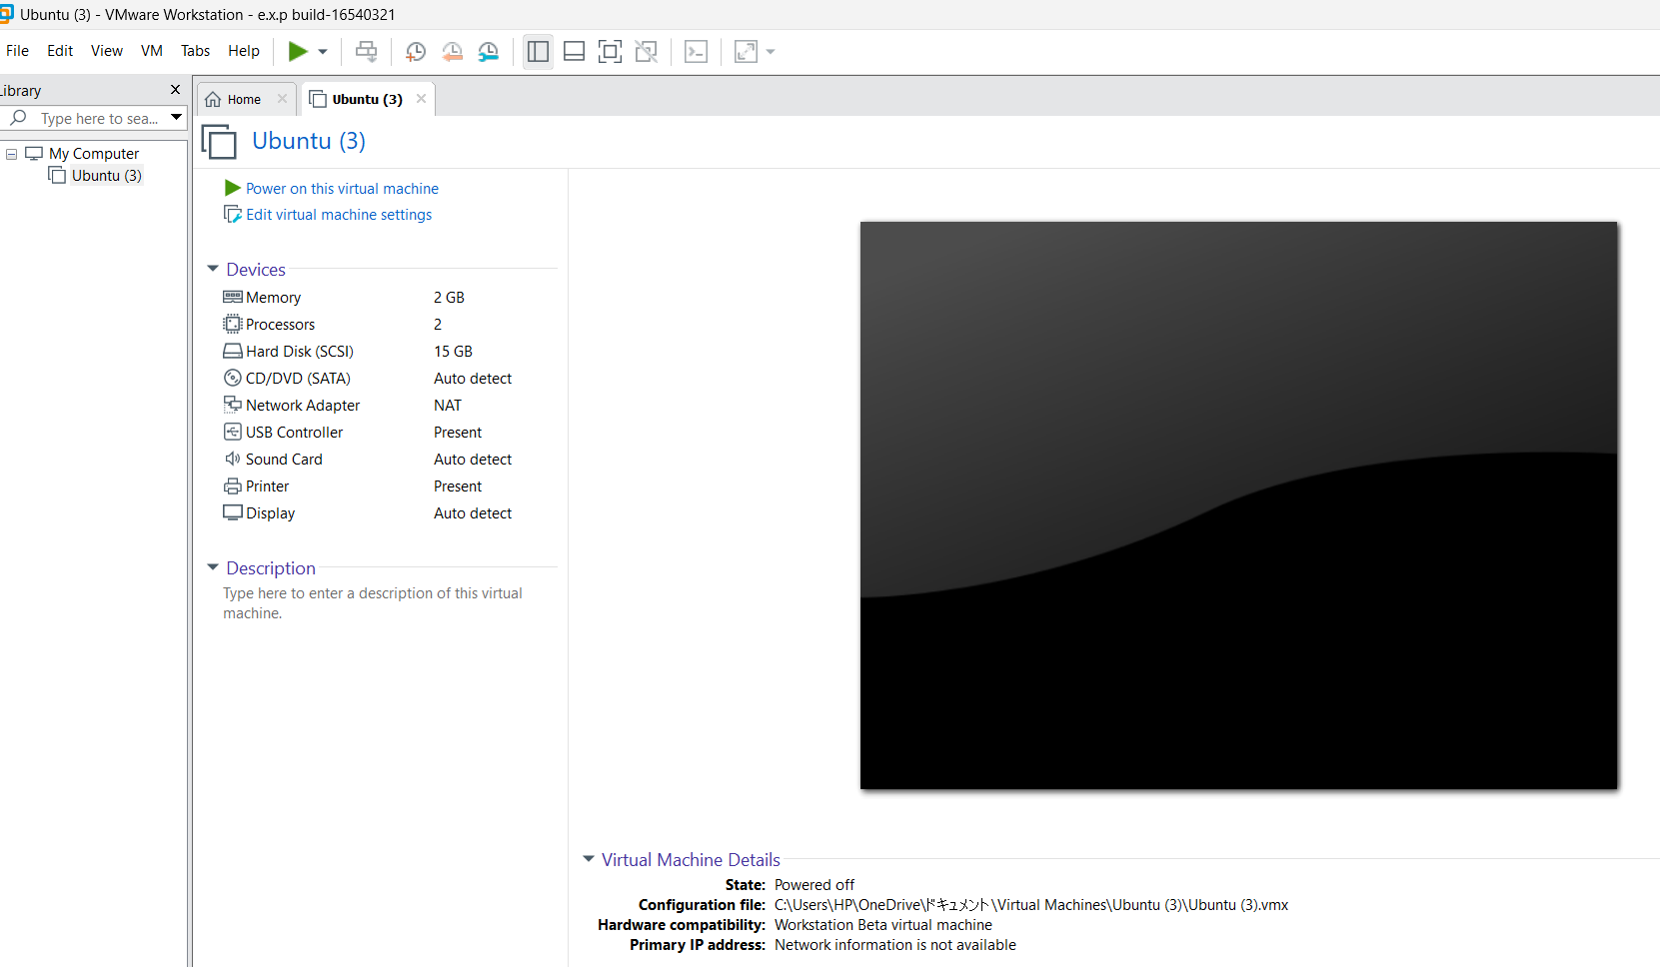

STEP2:
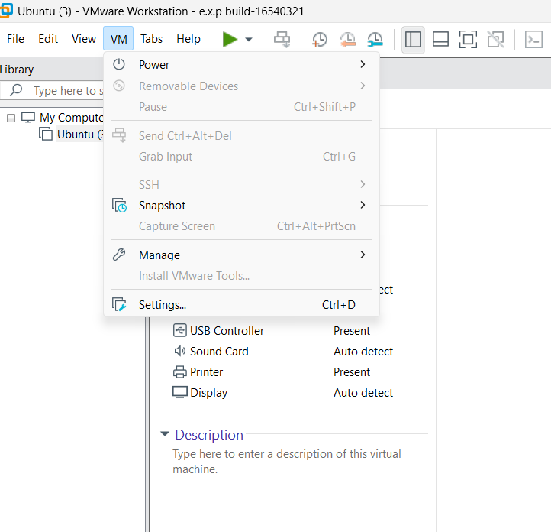

STEP3:
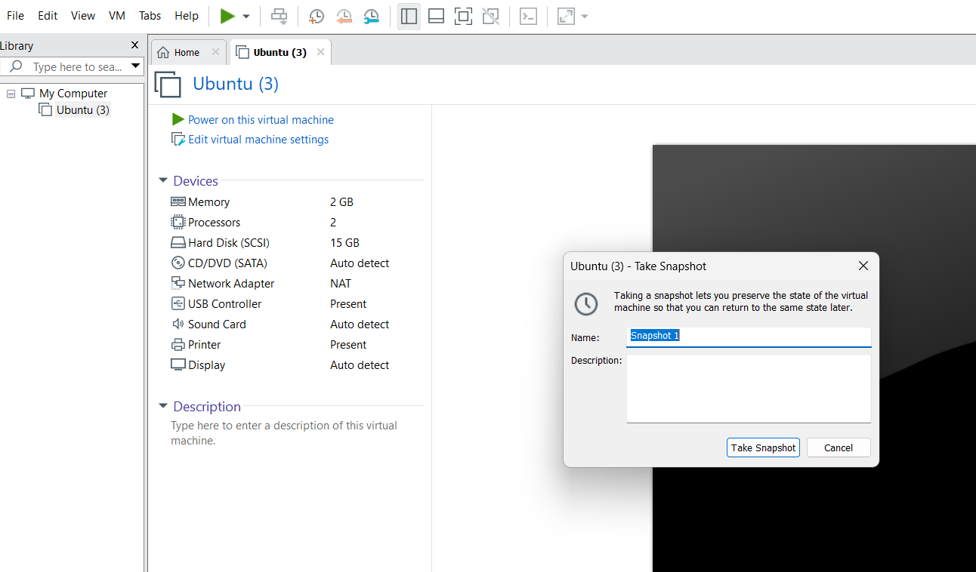

STEP4:
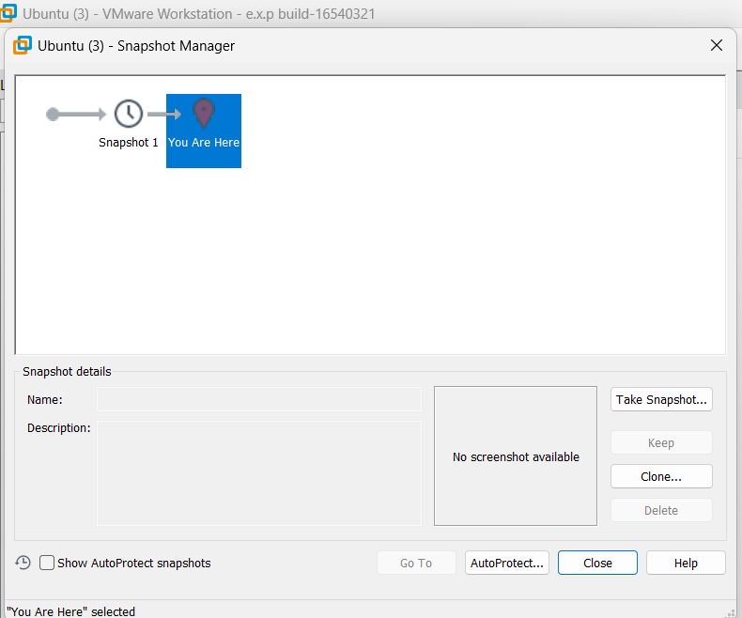

STEP5:
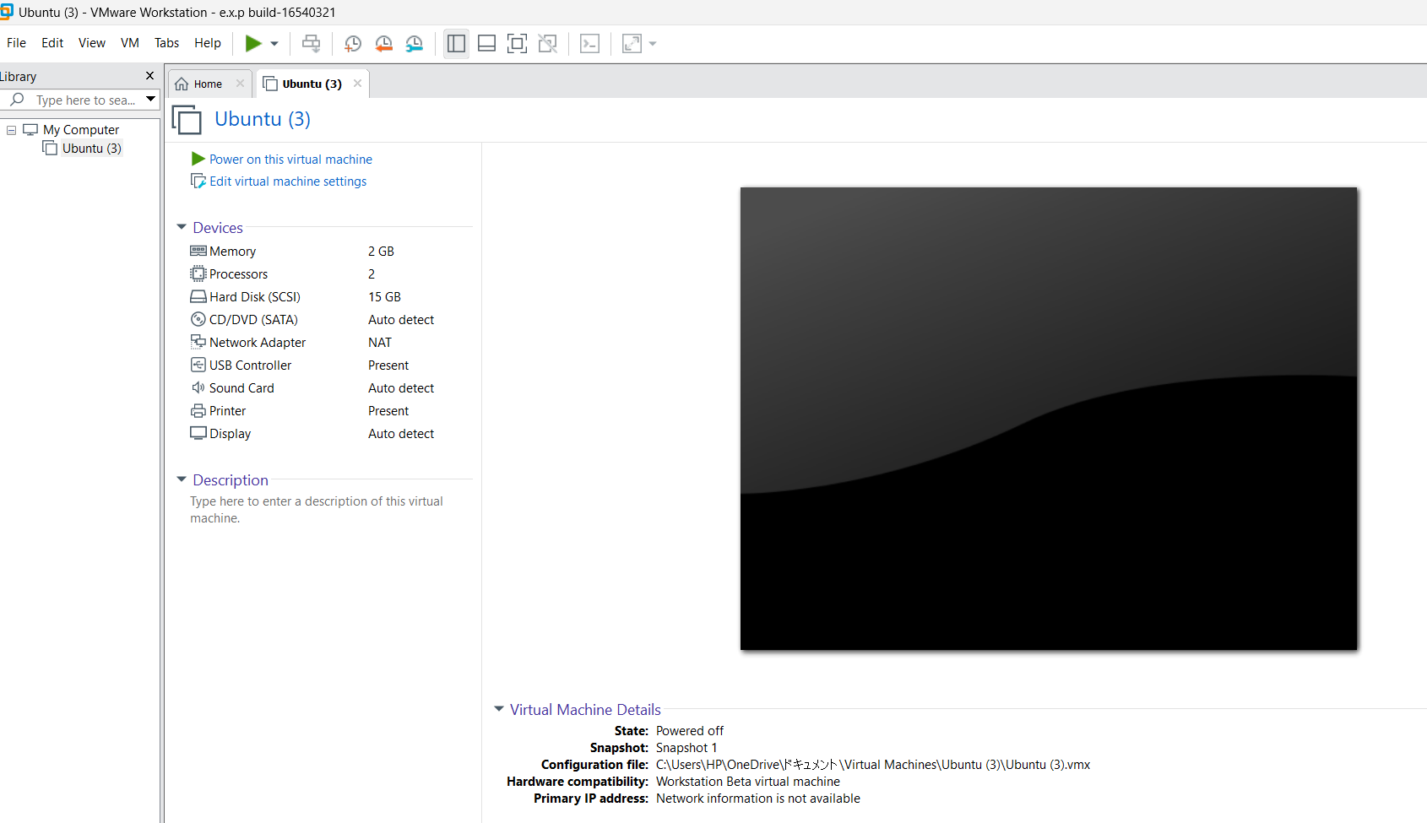

Result:
A snapshot was successfully created and restored. The virtual machine was reverted to its previous state using the saved snapshot.

