Experiment 16: Create a Cloning of a VM and Test it by Loading the Cloned VM

Aim:
To create a clone of a virtual machine and test it by loading the cloned virtual machine using VMware Workstation.

Procedure:
Step 1: Open VMware Workstation and select the virtual machine to be cloned.
Step 2: Click VM → Manage → Clone to start the Clone Virtual Machine Wizard.
Step 3: Select Full Clone and click Next.
Step 4: Enter the cloned VM name and location, then click Finish to create the clone.
Step 5: Open and power on the cloned virtual machine to verify that it works independently of the original VM.

STEP1:
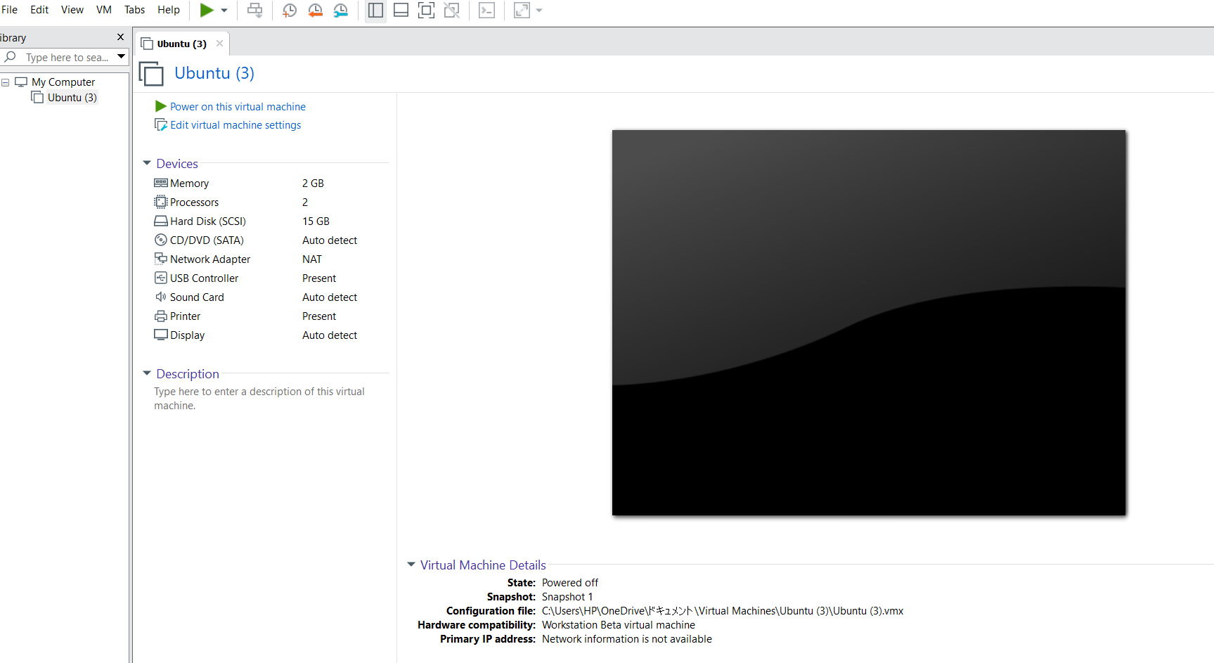
STEP2:
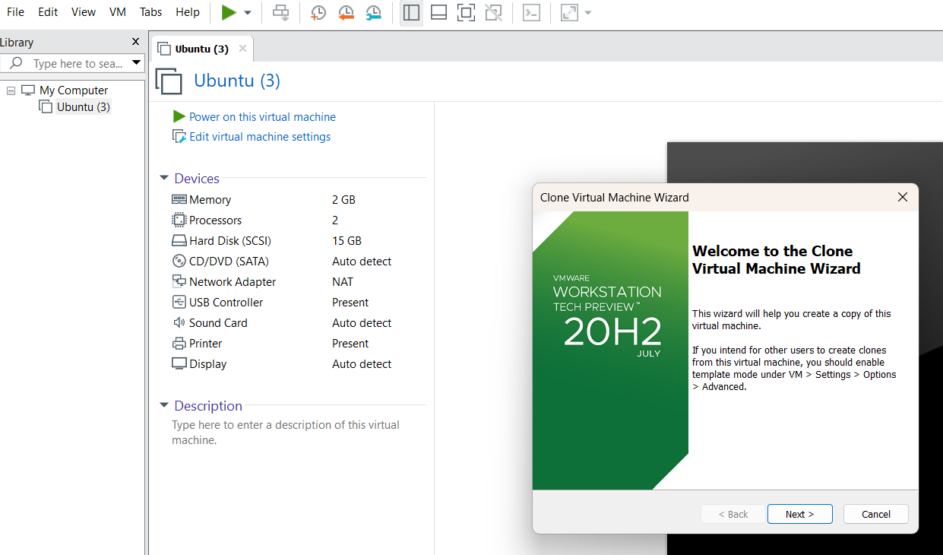
STEP3:
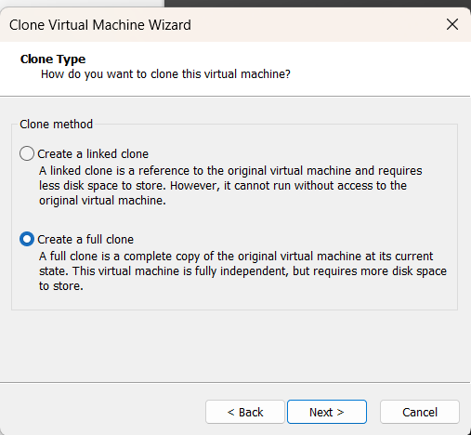

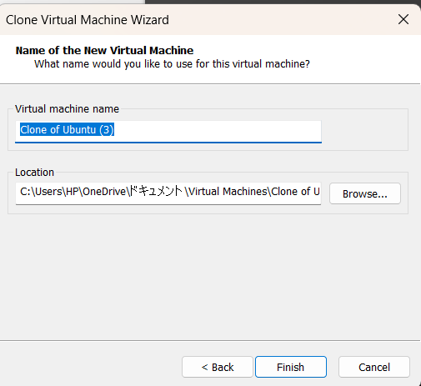

STEP4:
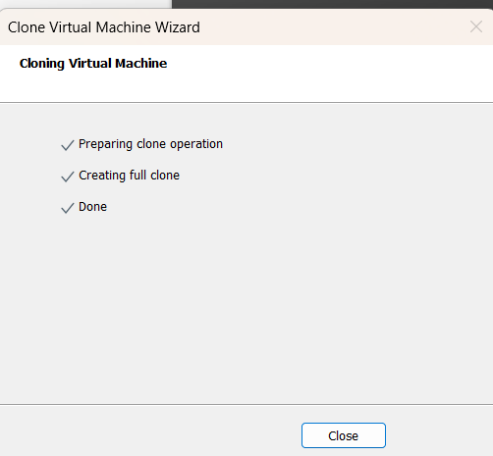
STEP5:
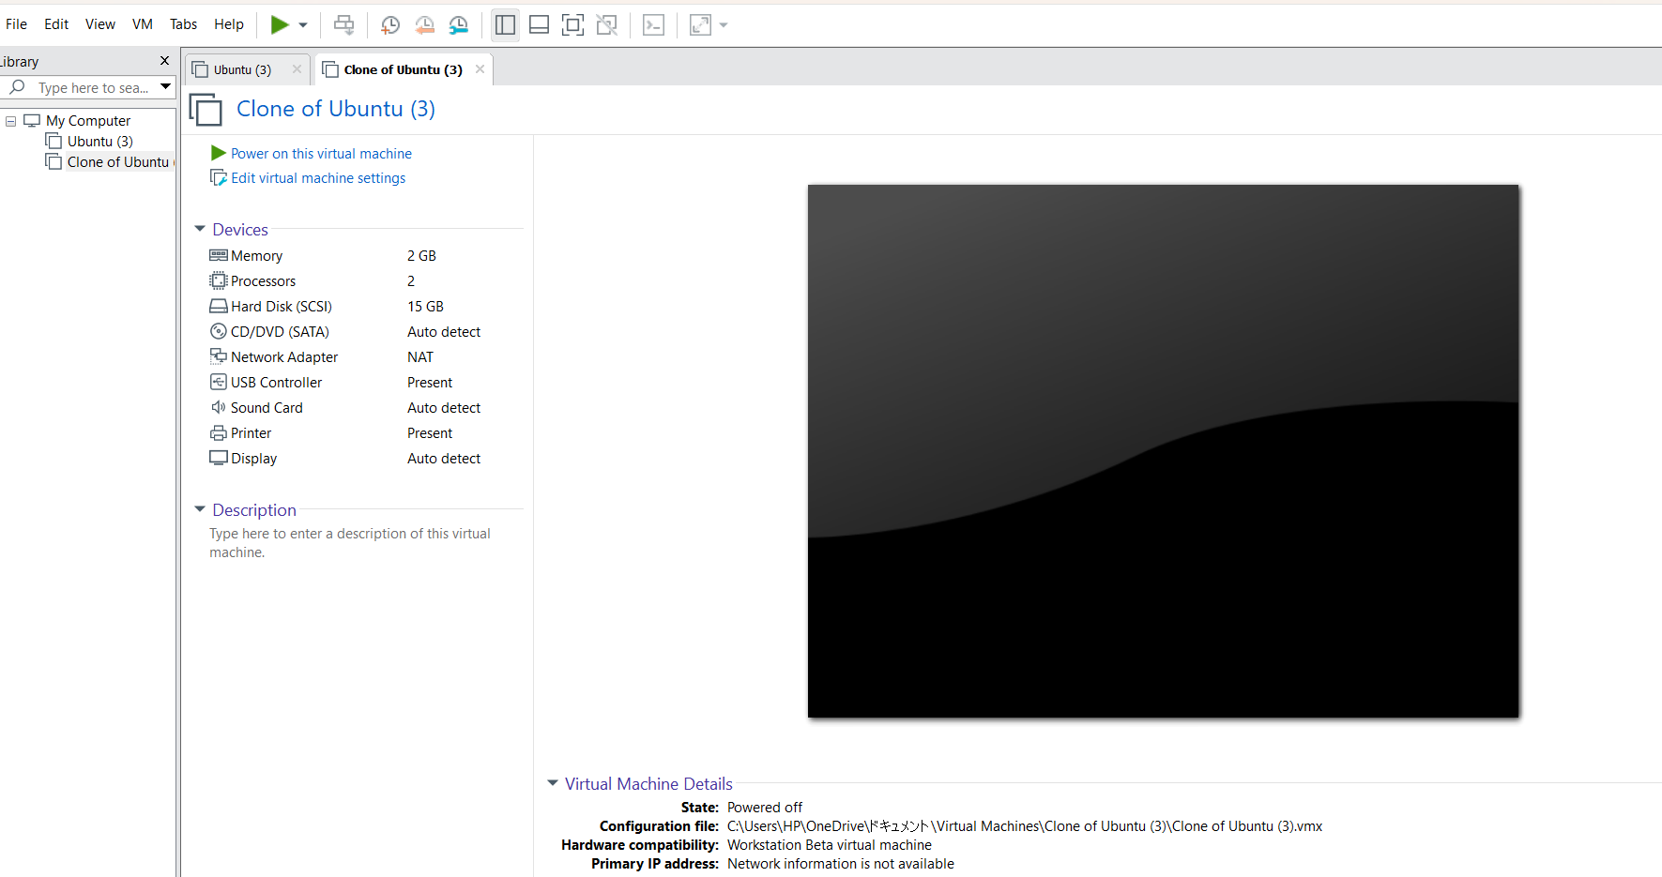
Result:
The virtual machine was successfully cloned using VMware Workstation. The cloned VM was loaded and verified to operate independently of the original virtual machine.

