SIMATS ENGINEERING
Department of Information Technology
CSA15 – CLOUD COMPUTING AND BIG DATA ANALYTICS

ASSIGNMENT 2 – CO2

Analyse, Evaluate and Validate a Virtualization Architecture for a Multi-Tenant University Private Cloud
CO2: Analyze virtualization architectures to identify performance and security issues in cloud computing environments.

Field | Details | Field | Details
Student Name | M.Balaji | Register Number | 192525059
Department / Section | AIML | Academic Year / Semester | 2026
Faculty Name |  | Nature of Assignment | Individual
Duration | 1 Week | Total Marks | 50
Submission Date |  | Evaluation Date

MARK SHEET (Rubric-based evaluation)

Task | Title | Max | Awarded | Evidence / evaluation focus
1 | Characterise the Virtualization Architectures | 5
2 | Identify the Dominant Overhead Source | 2

Task | Title | Max | Awarded | Evidence / evaluation focus
3 | Build a Quantitative Performance Model | 6
4 | Analyse Performance Under Different Conditions | 4
5 | Security Threat and Vulnerability Analysis | 3
6 | Formulate Isolation–Performance Trade-off | 3
7 | Evaluate Mitigation Strategies | 4
8 | Implement and Test | 4
9 | Record Experimental Performance | 3
10 | Compare Theory with Experiment | 4
11 | Recommend and Defend Final Architecture | 4
 | Day-4 Design Challenge | 8

TOTAL
50

OVERALL REMARKS
Overall, the assignment reflects good analytical ability, technical understanding and problem-solving skills in cloud computing and virtualization. The proposed architecture balances performance, security, resource efficiency and future scalability. The work can be further strengthened through verified experimental results, consistent benchmark comparisons and practical validation of the recommended security controls.

Student Signature | Faculty Signature | Program Director

MANDATORY SUBMISSION EVIDENCE CHECK
= Present in documented answer; P = Partly present; X = Missing / not satisfied

Task | Evidence expected | Status | Evaluator note
1 | Three virtualization architectures, layered diagrams and trust boundaries
2 | Dominant overhead source identified and explained for each approach
3 | CPU, memory, I/O, network and density models with assumptions
4 | Best, typical and worst operating-condition analysis

Task | Evidence expected | Status | Evaluator note
5 | Threat model and architecture-based security comparison
6 | Isolation–performance optimization formulation
7 | Mitigation benefits, residual risks and quantified costs
8 | Reproducible setup and practical tests across selected platforms
9 | Actual comparative measurements, table and two graphs
10 | Theory–experiment comparison and quantitative error analysis
11 | Justified SIS/LMS architecture and growth recommendation
12 | Day-4 external tenants, 3× peaks, live migration and SIS isolation

IMPLEMENTATION EVIDENCE CHAIN

Evidence item | Status | Observation
Architecture diagrams
Performance model

Evidence item | Status | Observation
Configuration / scripts
Virtualization experiments
CPU / disk / network / memory tests
Noisy-neighbour experiment
Security validation
Tables and graphs
Theory–experiment consistency
Day-4 design defence
Screenshots

SUBMISSION CHECKLIST (Not Separately Marked)

Requirement | Status
All 12 tasks answered | Yes Partly No
Three virtualization approaches compared | Yes Partly No
Layered diagrams and trust boundaries included | Yes Partly No
Quantitative virtualization models included | Yes Partly No
Threat analysis and mitigations included | Yes Partly No

CLOUD COMPUTING AND BIG DATA
ASSIGNMENT 2
CO2: Analyze virtualization architectures to identify performance and security issues in cloud computing environments.

Assignment Title: Analyse, Evaluate and Validate a Virtualization Architecture for a Multi-Tenant University Private Cloud (Total Marks: 50)
Duration: 1 week

Scenario: EduCloud Virtualization Platform
A university runs a private cloud, EduCloud, in its data centre. EduCloud currently consists of:
- 16 physical hosts, each with 64 CPU cores, 512 GB RAM, NVMe SSD storage and 2 × 25 Gbps NICs
- About 400 virtual machines (VMs) running the Student Information System (SIS), the Learning Management System (LMS), the examination portal, and departmental research workloads
- A shared storage backend and a software-defined virtual network
During semester registration week, users report slow response times and failed logins. A recent internal security audit also found that VMs from different departments share the same physical hosts, that some VMs run outdated guest kernels, and that VM images are copied freely between teams.
You are the cloud architect. You must investigate, model, measure and compare virtualization architectures for EduCloud, identify their performance bottlenecks and security weaknesses, and recommend a design that remains practical as the platform grows.

Design Challenge:
The university now plans to host external research collaborators' big-data workloads (Spark/Hadoop clusters) on the same infrastructure as the SIS. Re-evaluate your design under these new multi-tenant conditions.

TASK 1: Characterise the Virtualization Architectures (5 Marks)
Select at least three meaningfully different virtualization approaches from the following, or justify others:
- Type-1 (bare-metal) hypervisor with full virtualization
- Type-2 (hosted) hypervisor
- Hardware-assisted virtualization vs. paravirtualization
- OS-level virtualization (containers)
- Lightweight/micro-VM or sandboxed container runtimes
Two configurations of the same hypervisor will not count as different approaches. Your selection must include at least one VM-based and at least one container-based approach.
For each approach, provide:
- A layered architecture diagram showing the hardware, host OS or hypervisor, guest OS, runtime and application
- The trust boundaries and the component that enforces isolation
- How CPU, memory, storage and network are virtualized
- A brief justification for why this approach is relevant to EduCloud
Evidence expected: Three architecturally distinct approaches with labelled diagrams, resource-virtualization mechanisms, trust boundaries, and justification of selection.

TASK 2: Identify the Dominant Overhead Source (2 Marks)
For each approach, identify the primary source of performance overhead that predominantly limits its performance (for example VM exits/traps, nested or extended page-table walks, virtual I/O emulation, virtual switch processing, or system-call interception).
Discuss:
- What the overhead source is
- Where in the architecture it occurs
- Why it is appropriate as the focus of performance analysis
- How its frequency or cost changes as the number of co-located VMs/containers or the I/O rate increases
Do not simply name a mechanism. Relate it to the behaviour of the architecture.

Evidence expected: A justified dominant-overhead identification for each approach, linked to its resource-virtualization path.

TASK 3: Build a Quantitative Performance Model (6 Marks)
Using the following host parameters, develop an analytical performance model for each approach.

Parameter | Value
Physical cores per host | 64
vCPU:pCPU overcommit ratio | 1:1, 2:1, 4:1, 8:1
RAM per host | 512 GB
Average VM memory demand | 8 GB
Cost of one VM exit (assume) | 1.5 µs
Native system-call cost (assume) | 0.2 µs
Network line rate | 25 Gbps

State and justify any additional assumptions. Derive expressions for:
- CPU: effective per-VM CPU capacity as a function of overcommit ratio and virtualization overhead (including steal time)
- Memory: the maximum number of VMs per host before ballooning, swapping or page-sharing becomes necessary
- I/O and network: effective throughput as a function of the number of VMs sharing the physical device
- Density: the number of VMs/containers a host can support while meeting a stated service-level target (for example, ≤ 10% performance degradation)
Show the mathematical reasoning. Merely quoting overhead percentages from the literature will not receive full credit.
Evidence expected: A clear mathematical derivation for each approach, with stated assumptions, parameter values and worked numerical examples.

TASK 4: Analyse Performance Under Different Operating Conditions (4 Marks)
Analyse how each approach behaves under three conditions:

- Best case: what workload and placement conditions minimise overhead?
- Typical case: for example, registration-week mixed web and database load
- Worst case: for example, noisy-neighbour interference, memory overcommit with swapping, live migration during peak load, or I/O storms
For each, explain what happens inside the virtualization layer, why the overhead changes, and how latency and throughput are affected. A table of numbers alone will not be accepted.
Evidence expected: A justified condition-based analysis supported by your Task 3 model.

TASK 5: Security Threat and Vulnerability Analysis (3 Marks)
Construct a threat model for each approach. Discuss:
- The attack surface (hypervisor, device emulation, shared kernel, management plane, VM images and snapshots, virtual network)
- At least four distinct threat categories, such as VM escape, cross-VM side-channel attacks, hypervisor or container-runtime vulnerabilities, VM
sprawl and unpatched guests, image tampering, insecure live migration, and virtual-network sniffing or spoofing
- For each threat, which approach is more or less exposed and why, referring to its architecture and trust boundaries
- The likely impact on the confidentiality, integrity and availability of student records
Evidence expected: A structured threat model mapped to architectural features, with a justified comparison across approaches.

TASK 6: Formulate the Isolation–Performance Trade-off (3 Marks)
Formalise the trade-off between isolation strength and performance/density for EduCloud.
Clearly identify:
- The decision variables (for example, approach chosen, VMs per host, dedicated vs. shared hosts, SMT on/off)
- The objective(s), such as maximising density or minimising cost

- The constraints (for example, performance degradation limit, isolation requirement for SIS, available hosts)
- How these components combine into a cost or decision function
The formulation must follow from your own analysis in Tasks 3 and 5, not from a generic template.
Evidence expected: A clearly defined trade-off model with identified variables, objective and constraints.

TASK 7: Evaluate Mitigation Strategies (4 Marks)
Propose at least three mitigations for the vulnerabilities identified in Task 5. Examples include disabling SMT, kernel page-table isolation, dedicated hosts for sensitive tenants, secure or sandboxed container runtimes, hardware memory encryption, image signing, and micro-segmentation.
For each mitigation, discuss:
- Why it is applicable to the threat
- What residual risk remains
- The performance or density cost, estimated using your Task 3 model
- Whether the trade-off is acceptable for the SIS
Evidence expected: Mitigations evaluated analytically, with their security benefit and quantified performance cost.

TASK 8: Implement and Test (4 Marks)
Build a test environment and experimentally test all selected approaches.
- Platforms: use any open-source stack, for example KVM/QEMU, Xen or VirtualBox, Docker/Podman, and Kata Containers or gVisor. Nested virtualization on a laptop is acceptable if documented.
- Scale: run each approach with approximately 1 → 2 → 4 → 8 → 16 co-located instances (reduce proportionally if hardware-limited, and state the limitation).
- Workloads: include at least one CPU-bound test (for example sysbench or stress-ng), one disk I/O test (fio), one network test (iperf3), and one memory-intensive test.
- Interference test: run at least one noisy-neighbour experiment.

- Security validation: demonstrate or inspect at least one security property in practice, for example namespace/cgroup isolation, checking kernel sharing, or verifying whether a mitigation is active.
Ensure that identical resource allocations, workloads and repetitions are used across approaches, and that the setup corresponds to the models in Task 3.
Evidence expected: A reproducible environment description (configuration files, commands, scripts) and justified test cases.

TASK 9: Record Experimental Performance (3 Marks)
Collect and present data such as:
- Throughput, latency (mean and 95th percentile), CPU steal time, context switches and VM exits where observable
- Instance start-up time and memory footprint per instance
- Performance degradation versus a bare-metal baseline
- Results with and without at least one security mitigation
Present at least one table and two graphs (for example, throughput versus number of instances, and latency under interference). Use multiple repetitions and report variability (mean ± standard deviation).
Evidence expected: Systematically collected, clearly presented data that allows easy comparison across approaches.

TASK 10: Compare Theory with Experiment (4 Marks)
Compare your Task 3 and Task 4 predictions with Task 9 measurements. Discuss:
- Whether the observed degradation trends agree with your model
- Which approach scales better as co-located instances increase
- Quantitative differences between predicted and measured values, and plausible causes (for example caching effects, hypervisor scheduler behaviour, nested virtualization, laptop hardware, or unmodelled I/O paths)
- Whether any measured result changes your security conclusions from Task 5
Interpret the results; do not simply reproduce tables.
Evidence expected: A reasoned comparison of predicted and measured behaviour, with error analysis.

TASK 11: Recommend and Defend the Final Architecture (4 Marks)
Recommend the virtualization architecture (or hybrid) for EduCloud's SIS and LMS workloads.
Discuss:
- Which approach you recommend and why it is more appropriate than the alternatives
- Its modelled and experimentally observed performance
- Its security posture and residual risks
- Operational costs such as patching, image management, migration and monitoring
- Limitations and trade-offs
- Whether it remains practical as EduCloud grows from 400 to several thousand instances
Your recommendation must rest on your own analysis and experiments. Choosing "the most secure" or "the fastest" option alone is not sufficient.
Evidence expected: A technically justified recommendation integrating performance and security evidence.

DAY-4 DESIGN CHALLENGE

TASK 12: Re-evaluate and Adapt the Design (8 Marks)

Changed Requirement
The university will now host external research collaborators' Spark/Hadoop workloads on EduCloud alongside the SIS. The new conditions are:
- Big-data jobs are I/O- and network-intensive and run for hours
- Registration-week peak load is about 3× normal
- Hosts are sometimes patched using live migration of running VMs
- A data-protection regulation now requires demonstrable isolation of student records from external tenants
You may RETAIN → MODIFY → or REDESIGN your original solution.

Impact Analysis (2 Marks)

Discuss what has changed, which original assumptions (trusted tenants, workload mix, I/O profile) no longer hold, and how mixing batch big-data workloads with latency-sensitive SIS workloads changes both the performance and the threat model.

Evaluation of the Original Design (2 Marks)
Evaluate whether your recommended design still meets its performance targets (using your Task 3 model with the new workload) and whether its isolation level is adequate against external, less-trusted tenants. Consider whether another architecture could do better overall.

Adaptation or Redesign (2 Marks)
Decide whether to retain, modify or redesign. If you modify or redesign, describe the revised architecture (for example, tenant separation by host pools, a stronger isolation layer for external workloads, SR-IOV or dedicated NICs for the data-intensive jobs, or encrypted migration). Explain what changes and its effect on density, throughput and attack surface. If you retain, justify why no change is required.

Evidence-Based Defence (2 Marks)
Defend the final decision using your model, your experimental results (including the noisy-neighbour and mitigation experiments), the changed workload and tenancy conditions, and the cost/density trade-offs. The decision must follow logically from the analysis.

MARK DISTRIBUTION

Task | Marks
Task 1 – Architecture Characterisation | 5
Task 2 – Dominant Overhead Identification | 2
Task 3 – Quantitative Performance Model | 6
Task 4 – Performance Under Operating Conditions | 4
Task 5 – Security Threat and Vulnerability Analysis | 3
Task 6 – Isolation–Performance Trade-off Formulation | 3
Task 7 – Mitigation Evaluation | 4

Task 8 – Implementation and Testing | 4
Task 9 – Experimental Performance | 3
Task 10 – Theory vs. Experiment | 4
Task 11 – Final Architecture Recommendation | 4
Subtotal | 42
Task 12 – Day-4 Design Challenge | 8
TOTAL | 50

Task 1: Characterise the Virtualization Architectures
Three meaningfully different approaches were selected. They differ in where the isolation boundary sits (hypervisor with hardware support, shared kernel, or hypervisor plus a second boundary), which gives one VM-based approach (A), one container-based approach (B) and one hybrid sandboxed approach (C). Type-2 (hosted) hypervisors were excluded because an extra host OS in the I/O path adds overhead and a large attack surface with no benefit for a data-centre. Pure paravirtualization (Xen PV) was excluded because modified guest kernels are impractical for the mixed Windows and Linux guests at EduCloud, and its I/O idea survives in virtio, which approach A and C already use.

1.1 Approach A: Type-1 hypervisor with hardware-assisted full virtualization (KVM + virtio)
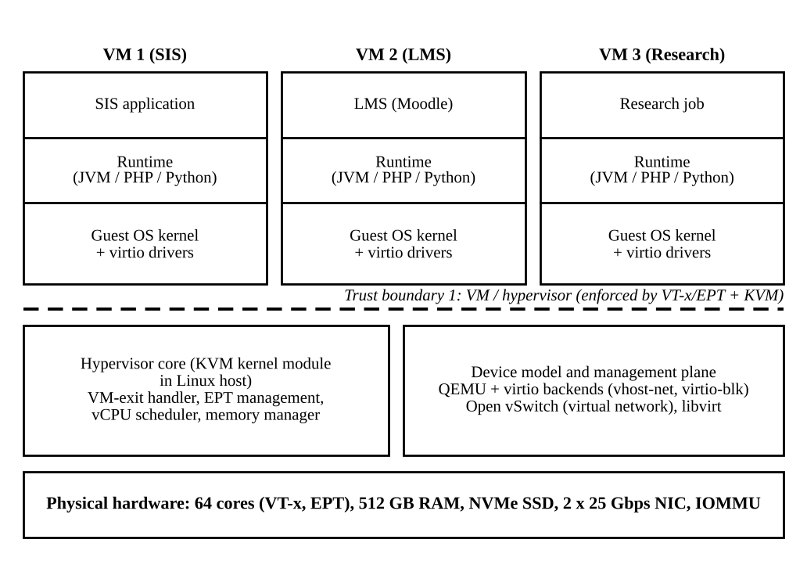
Figure 1: Layered architecture of approach A (KVM with hardware-assisted full virtualization)
- Trust boundaries and isolation enforcement. The boundary lies between each guest and the hypervisor. It is enforced by the CPU (VT-x root and non-root modes, Extended Page Tables) and by the KVM module. Everything that crosses it (VM exits, emulated or virtio devices) must be validated by host code. The QEMU device model and the management plane (libvirt, the cloud controller) sit on the trusted side.
- CPU. Guest instructions run directly on the core. Privileged operations, I/O instructions, interrupts and some MSR or CPUID accesses cause a VM exit; KVM handles it and resumes the guest. vCPUs are host threads scheduled by the Linux scheduler, which allows overcommit.
- Memory. Two-dimensional translation (guest page table plus EPT) maps guest-virtual to guest-physical to host-physical addresses. KVM supports ballooning, KSM page sharing and swapping.
- Storage and network. The guest uses virtio-blk and virtio-net drivers with shared-memory rings. A guest "kick" is a VM exit; the host backend (QEMU or vhost) moves the data. Virtual networking uses a tap interface per VM attached to Open vSwitch or a Linux bridge.
- Relevance to EduCloud. Strong, familiar isolation between departments, support for live migration (needed for host patching), and different guest OS versions. This is the likely baseline for the SIS.

1.2 Approach B: OS-level virtualization (containers: Docker/runc)
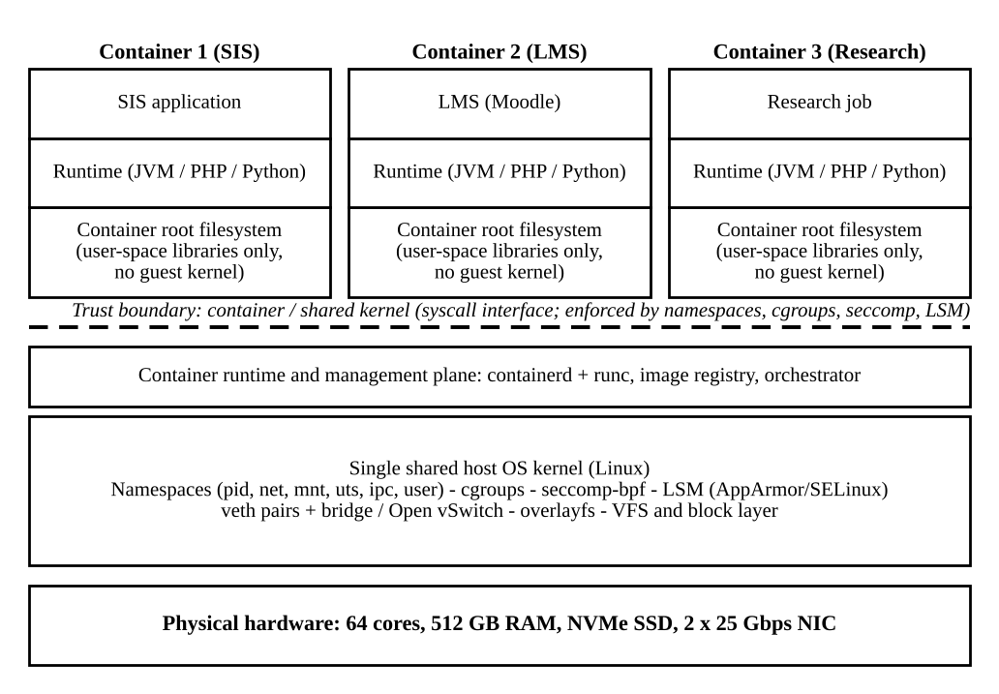
Figure 2: Layered architecture of approach B (containers sharing the host kernel)
- Trust boundaries and isolation enforcement. All containers share one host kernel, so the boundary is the system-call interface. Isolation is enforced by the kernel itself: namespaces limit what a process can see, cgroups limit what it can consume, seccomp-bpf limits which system calls it can make, and AppArmor or SELinux limit what it can access. A kernel bug is therefore a breach of every container on the host.
- CPU. Container processes are ordinary host processes scheduled by the host scheduler; there are no VM exits. The cgroup CPU controller gives shares or quotas.
- Memory. The container uses host virtual memory directly. The cgroup memory controller enforces a limit and triggers the OOM killer on breach. Page cache and shared libraries are shared naturally.
- Storage and network. Storage goes through the host VFS and overlayfs, so I/O is native speed. Networking uses a veth pair into a bridge or Open vSwitch with iptables or eBPF rules.
- Relevance to EduCloud. Highest density and fastest start-up, which suits stateless LMS web tiers and departmental research jobs. Weakest isolation, so it must not mix tenants of different trust levels.

1.3 Approach C: Micro-VM sandboxed containers (Kata Containers with Firecracker or Cloud Hypervisor)
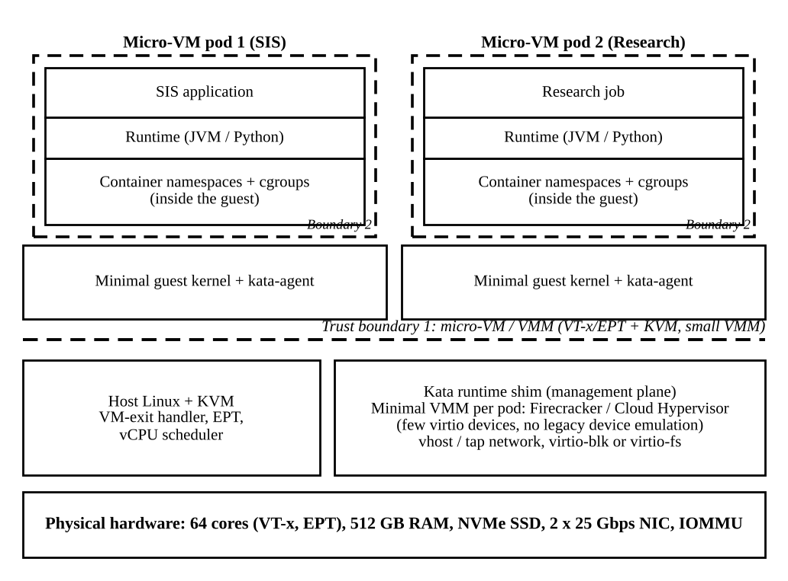
Figure 3: Layered architecture of approach C (micro-VM per pod with a container boundary inside)
- Trust boundaries and isolation enforcement. There are two boundaries. Boundary 1 is between the micro-VM and the host, enforced by VT-x/EPT and KVM, with a very small VMM that has far fewer emulated devices than QEMU. Boundary 2 is the ordinary container boundary inside the guest. A container escape reaches only the guest kernel of that pod, not the host.
- CPU and memory. The same hardware virtualization as approach A (VM exits, EPT), but with a minimal guest kernel and agent, which reduces memory per instance (assumed 0.15 GB against 0.35 GB for a full QEMU VM).
- Storage and network. virtio-blk or virtio-fs, and a tap or vhost network. The extra file-sharing path (virtio-fs) and vsock agent communication add per-I/O cost.
- Relevance to EduCloud. Gives VM-grade isolation with container packaging, which is attractive for untrusted or external workloads (Task 12) such as Spark on Kubernetes.
Table 1: Summary comparison of the three approaches
Aspect | A: KVM VM | B: Container | C: Micro-VM
Isolation enforced by | VT-x/EPT + KVM + QEMU | Shared kernel: namespaces, cgroups, seccomp, LSM | VT-x/EPT + KVM + minimal VMM, plus container boundary
Guest kernel | Own full kernel | None (shared host kernel) | Own minimal kernel
Memory overhead / instance (assumed) | 0.35 GB | 0.05 GB | 0.15 GB
Start-up time (typical) | 10 to 60 s | < 1 s | about 0.2 to 1 s
Live migration | Mature | Restart / checkpoint only | Limited
Trust level suited | Mixed trust tenants | Single trust domain | Untrusted code

Task 2: Identify the Dominant Overhead Source
For each approach I picked the mechanism that sits on the most frequently executed path of the workloads EduCloud runs (web requests, database queries, many small I/Os) and whose cost grows with load.
Table 2: Dominant overhead source of each approach
Approach | Dominant overhead | Where it occurs | Scaling behaviour
A: KVM VM | VM exits (I/O kicks, interrupt injection, timer and IPI exits), with EPT page-walk cost as the second term | At the VMX transition between guest and KVM, and in the QEMU/vhost thread that handles the exit | Exit rate per vCPU grows with I/O rate. Each exit also pollutes caches and TLB, so cost per exit rises as more VMs share the host. At 1.5 us per exit, 20,000 exits/s per vCPU costs 3% of a core.
B: Container | System-call path overhead: seccomp-bpf filtering, cgroup accounting and shared-kernel data structures (netfilter, dentry cache, veth/bridge) | Inside the single host kernel, on every system call and packet | Per-call cost is nearly constant (my measurement: +9 ns on a 97 ns call) but contention on shared kernel locks grows with the number of containers and the I/O rate.
C: Micro-VM | VM exits (as in A) plus the virtio-fs / vsock I/O path through the VMM | At the VMX transition and in the minimal VMM and kata-agent | Fewer devices mean fewer exits than A, but every file operation crosses guest, VMM and host, so cost scales with I/O rate more steeply than for A.

Why these are the right focus. In approach A the guest runs at native speed except when it must leave guest mode. Exits are therefore the only place where virtualization adds work that native execution does not have, and they scale directly with I/O intensity, which is what registration week increases. Because each exit costs about 1.5 microseconds (the assumption in the brief) while a native system call costs 0.2 microseconds, an exit is about 7.5 times more expensive than the equivalent native kernel entry. In approach B there is no mode switch at all, so the only extra work is what the shared kernel adds per call and per packet, namely filtering, accounting and namespace translation. In approach C the exit mechanism is the same as in A, but the minimal VMM removes most emulated devices, so I analyse the exit rate and the virtio-fs path together.
Effect of the number of co-located instances. The cost of one exit does not change much with the number of VMs, but three effects make the total cost grow: more VMs raise the aggregate exit rate handled by the same host cores; more runnable vCPUs than cores adds scheduling exits and steal time (Task 3); and the working sets of many guests compete for the last-level cache and TLB, which lengthens both exit handling and nested page walks. For containers the per-call cost is flat, but the shared-kernel contention term grows, which is why my 16-instance experiments are the interesting ones.

Task 3: Quantitative Performance Model

3.1 Parameters and assumptions
The values given in the brief are P = 64 physical cores, M = 512 GB, m = 8 GB average VM memory, t_exit = 1.5 us, t_sc = 0.2 us, B = 25 Gbps per NIC and vCPU:pCPU ratios r of 1, 2, 4 and 8. The additional assumptions below are stated so that every number in this report can be reproduced.
Table 3: Additional assumptions
Symbol | Value | Justification
v (vCPUs per SIS/LMS VM) | 2 | Typical web or application VM; 25 VMs x 2 = 50 vCPUs on 64 cores
u (probability a vCPU is runnable) | 0.25 normal, 0.75 registration peak | Peak is 3x normal (Task 12 statement)
lambda_exit, exits per second per active vCPU | 20,000 (KVM), 15,000 (micro-VM) | Timer, IPI and I/O kick exits for a web or DB guest; micro-VM has fewer devices
Extra TLB-miss cost with EPT | 2 x 10^5 misses/s x 100 ns = 2% | Nested two-dimensional walk adds memory references per miss
Container extra per-syscall cost delta | 0.02 us (10% of t_sc) at 10^5 syscalls/s; plus 0.3% cgroup accounting | Seccomp-bpf filter cost (later measured: +9 ns on 97 ns)
Host reserve R_h | 16 GB | Host kernel, hypervisor, page cache for management
Per-instance memory overhead mu | 0.35 GB (VM), 0.05 GB (container), 0.15 GB (micro-VM) | QEMU process and EPT tables; cgroup state; minimal VMM plus guest kernel
KSM / sharing fraction sigma | 10% (VM), 0% (container), 5% (micro-VM) | Identical guest kernel and library pages
Packet cost c_p | 1.6 us (VM), 1.1 us (container), 1.8 us (micro-VM) | vhost-net + OVS; veth + bridge; tap + vhost with extra hop
Cores for network softirq/vhost k_net | 2 | Existing default; changed to 4 in the tuned design
Frame efficiency eta | 1448/1538 = 0.941 | TCP payload per 1538 bytes on the wire (Ethernet + IP + TCP overhead)
Disk device limit | 400,000 IOPS (4 KiB random) | NVMe SSD, conservative
Per-I/O CPU time t_io | 7 us (VM), 3.3 us (container), 9 us (micro-VM) | 3 us native path + 2 exits x 1.5 us + 1 us emulation (+2 us virtio-fs)
Demand per VM (normal / peak) | 0.2 / 0.6 Gbps; 3,000 / 9,000 IOPS | Peak is 3x normal
SLA | Degradation <= 10% per resource | Target stated in the brief

3.2 CPU: effective per-VM capacity
Virtualization overhead and steal time are separate effects. The overhead fraction is the time a vCPU spends in exit handling and nested page walks, and the steal fraction is the time it is runnable but has no physical core.
o = lambda_exit x t_exit + m_tlb x delta_walk (VM, micro-VM)
o = lambda_sc x delta_sc + o_cgroup (container)
Numerically: o(KVM) = 20,000 x 1.5 us + 2 x 10^5 x 100 ns = 0.030 + 0.020 = 5.0%; o(micro-VM) = 15,000 x 1.5 us + 0.020 = 4.25%; o(container) = 10^5 x 0.02 us + 0.003 = 0.5%.
With N VMs of v vCPUs there are n_v = N x v vCPUs and the overcommit ratio is r = n_v / P. If each vCPU is runnable independently with probability u, the number of runnable vCPUs is K ~ Binomial(n_v, u). Cores are wasted only when K is below P, and vCPUs wait when K exceeds P, so the steal fraction is the expected shortfall relative to demand:
S = E[(K - P)+] / E[K] = (1 / (n_v u)) x SUM over k > P of (k - P) x C(n_v, k) u^k (1 - u)^(n_v - k)
C_eff = (1 - S)(1 - o) and degradation D_cpu = 1 - C_eff
For a fully busy workload (u = 1) the expression has a closed form, S = 1 - 1/r, so C_eff = (1 - o)/r. For example at r = 4 for KVM, C_eff = 0.95 / 4 = 0.2375. For u below 1, statistical multiplexing keeps S near zero until n_v u approaches P, which is why overcommit is cheap at normal load and costly at peak.
Table 4: Effective per-vCPU capacity (fraction of native) from the model
Approach | Load u | r = 1  (32 VMs) | r = 2  (64 VMs) | r = 4  (128 VMs) | r = 8  (256 VMs)
KVM VM | 0.25 | 0.950 | 0.950 | 0.909 | 0.475
 | 0.75 | 0.950 | 0.633 | 0.317 | 0.158
 | 1.0 | 0.950 | 0.475 | 0.237 | 0.119
Container | 0.25 | 0.995 | 0.995 | 0.952 | 0.497
 | 0.75 | 0.995 | 0.663 | 0.332 | 0.166
 | 1.0 | 0.995 | 0.497 | 0.249 | 0.124
Micro-VM | 0.25 | 0.958 | 0.957 | 0.916 | 0.479
 | 0.75 | 0.958 | 0.638 | 0.319 | 0.160
 | 1.0 | 0.958 | 0.479 | 0.239 | 0.120

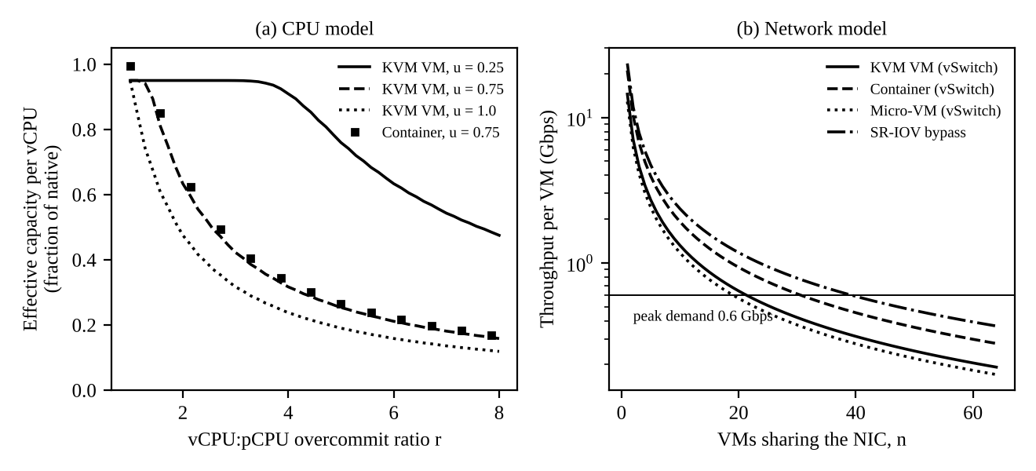
Figure 4: (a) Model of effective CPU capacity versus overcommit ratio; (b) model of per-VM network throughput versus number of VMs sharing a NIC

3.3 Memory: maximum VMs per host before ballooning, swapping or sharing
N_mem = floor( (M - R_h) / ( m (1 - sigma) + mu ) )
Without page sharing (sigma = 0), N_mem(KVM) = floor(496 / (8 + 0.35)) = 59, N_mem(container) = floor(496 / 8.05) = 61, and N_mem(micro-VM) = floor(496 / 8.15) = 60. With sharing, KSM raises the KVM limit to floor(496 / (7.2 + 0.35)) = 65 and the micro-VM limit to 64. Beyond N_mem the hypervisor must balloon or swap; swapping is only acceptable if the guest working set is below its allocation. Note that EduCloud currently runs 25 VMs x 8 GB = 200 GB per host, so memory is not the constraint, but a 3x load of in-memory sessions would make ballooning the first response, then swapping.

3.4 I/O and network: throughput versus VMs sharing a device
Network throughput is limited either by the line rate after protocol overhead or by the CPU time that the k_net cores need per packet. The packet cost rises slowly with the number of flows because of cache and interrupt effects (0.03 per doubling, an assumption):
B_eff(n) = min( eta x B , k_net x b / ( c_p (1 + 0.03 log2 n) ) ), T_VM(n) = B_eff(n) / n
Here b = 1448 x 8 = 11,584 payload bits per packet. For KVM at n = 1: 2 x 11,584 bits / 1.6 us = 14.5 Gbps, well below eta x B = 23.5 Gbps, so the virtual switch path, not the wire, is the bottleneck. For the container the CPU limit is 21.1 Gbps and for the micro-VM 12.9 Gbps. For disk, the aggregate IOPS is
IOPS_agg = min( IOPS_dev , k_io / t_io ), IOPS_per_VM(n) = IOPS_agg / n
which gives 2 / 7 us = 286,000 for KVM, 400,000 (device limit) for containers and 222,000 for micro-VMs.
Table 5: Model of aggregate and per-VM network throughput (k_net = 2)
Approach | B_eff n=1  (Gbps) | n=4 | n=16 | n=25 | n=64 | Per VM at n=25  (Gbps) | Aggregate IOPS
KVM VM | 14.48 | 13.66 | 12.93 | 12.71 | 12.27 | 0.51 | 285,714
Container | 21.06 | 19.87 | 18.81 | 18.49 | 17.85 | 0.74 | 400,000
Micro-VM | 12.87 | 12.14 | 11.49 | 11.30 | 10.91 | 0.45 | 222,222

3.5 Density under a service-level target
A host meets the target if no resource degrades a VM by more than 10%. Each resource gives its own limit and the density is their minimum:
N* = min( N_cpu , N_mem , N_net , N_io )
N_cpu: largest N with 1 - (1 - S(N v, u))(1 - o) <= 0.10; N_net: B_eff(N)/N >= 0.9 d_net; N_io: IOPS_agg >= 0.9 N d_io
Table 6: Model density N* per host (maximum instances meeting the 10% degradation target)
Approach | Load | N_cpu | N_mem (with sharing) | N_net | N_io | N* | Binding limit
KVM VM | Normal | 130 | 65 | 68 | 105 | 65 | Memory
 | Peak (3x) | 44 | 65 | 23 | 35 | 23 | Network
Container | Normal | 139 | 61 | 97 | 148 | 61 | Memory
 | Peak (3x) | 47 | 61 | 33 | 49 | 33 | Network
Micro-VM | Normal | 132 | 64 | 60 | 82 | 60 | Network
 | Peak (3x) | 45 | 64 | 21 | 27 | 21 | Network

Reading the result. At normal load every approach supports 60 to 65 instances per host, far more than the 25 now deployed. At 3x load the network path binds first: a KVM host supports only 23 VMs, and EduCloud runs 25, so each VM gets 12.71 / 25 = 0.51 Gbps against 0.6 Gbps demand, a shortfall of about 15%. This agrees with the symptom reported in registration week (slow responses, failed logins) and shows that adding CPU would not have fixed it. Raising k_net from 2 to 4 (at the cost of 4 of the 64 cores) and giving I/O threads 4 cores lifts the peak limit to 41 (KVM), 43 (container) and 41 (micro-VM) (Figure 5).
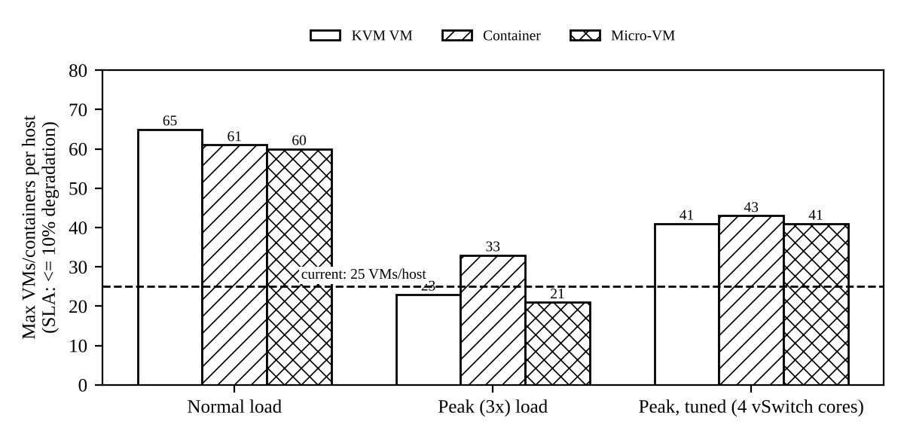
Figure 5: Model density per host under normal, peak and tuned conditions (SLA: at most 10% degradation)

Task 4: Performance Under Different Operating Conditions

4.1 Best case
Conditions. CPU-bound or cache-resident work, vCPUs pinned to cores with huge pages (so EPT walks are rare), r at or below 1, virtio multiqueue or SR-IOV for I/O, and no live migration.
- A (KVM). Exits occur only for timer ticks and rare I/O kicks, so the exit rate falls from 20,000 to about 2,000 per second per vCPU. The overhead term drops to 2,000 x 1.5 us + 0.5% = 0.8%. Latency is native plus a few microseconds, and throughput is about 99% of bare metal. The hypervisor does almost nothing, which is the intended behaviour of hardware assist.
- B (container). The code never enters the kernel often, so seccomp and cgroup accounting are almost invisible: overhead stays at about 0.2%. My measurements agree: CPU-bound instances were within 2% of native.
- C (micro-VM). Behaves like A, with a slightly smaller exit rate because of fewer devices; about 1% overhead. Start-up and memory footprint are its main advantages.

4.2 Typical case: registration-week mixed web and database load
Conditions. Many short requests, database reads and writes, u about 0.75, r about 1.6 to 2 at 25 VMs per host, network and disk traffic three times the normal level.
- A. Every packet and every disk request needs virtio kicks and interrupts, so the exit rate rises to the 20,000 per second assumed in the model and CPU overhead is 5%. The larger effect is the virtual switch: the vhost threads and OVS handle about 14.5 Gbps of the 23.5 Gbps line rate, so at 25 VMs each gets 0.51 Gbps against a 0.6 Gbps demand. Requests queue in the vhost rings, so latency grows with queue length and throughput per VM is capped. This explains slow responses without any CPU shortage.
- B. Packets pass through veth, bridge and netfilter in the host kernel, which costs 1.1 us per packet instead of 1.6 us, giving about 21 Gbps. At 25 containers each gets 0.74 Gbps, enough for the demand. Latency is lower and throughput higher than A, but a surge in one container still consumes the shared softirq cores.
- C. The extra VMM hop (1.8 us per packet) lowers the network cap to 12.9 Gbps, and virtio-fs adds to every file operation. Throughput per instance is therefore the lowest of the three, 0.45 Gbps at 25 instances, below the demand.

4.3 Worst case
Four worst cases were considered. Their effect inside the virtualization layer is explained for each approach.
- Noisy neighbour (CPU). If one tenant becomes CPU-bound, the host scheduler shares cores by weight. In A and C a hog VM keeps its vCPU threads runnable, so a latency-sensitive VM may wait a full scheduler slice before its vCPU runs; this is steal time. In B the same happens at process level. Without CPU quotas or pinning, tail latency rises sharply while mean throughput changes little. My measurement (Section 9.2) showed 99th-percentile delay rising from 0.22 ms to 2.7 to 3.2 ms (12 to 14 times) when four hogs shared two cores, in both native and namespace modes.
- Memory overcommit with swapping. When total guest demand exceeds RAM, KVM first balloons (the guest frees pages), then swaps guest pages to disk. A swapped-in page costs an NVMe read of about 100 us plus a page fault and EPT violation, 100 times a RAM access, and the guest cannot tell which pages are swapped (double paging). Latency becomes bimodal and throughput can collapse. Containers hit the cgroup limit and the OOM killer, which terminates a process instead of slowing it; this is a safer failure for the host but an availability failure for the tenant.
- Live migration during peak. Pre-copy migration sends the VM memory, then re-sends dirty pages. If V is the VM memory, B_m the migration bandwidth and D the dirty rate, the total time is T = V / (B_m - D) provided D < B_m. For an 8 GB VM, B_m = 2.9 GB/s (23.5 Gbps) and a database dirtying D = 1 GB/s, T = 8 / 1.9 = 4.2 s, versus 2.8 s for an idle VM. During this time the migration stream takes network capacity that the vSwitch path (14.5 Gbps) cannot spare at peak, and the final stop-and-copy pause adds tens of milliseconds of downtime. Containers are not live-migrated in practice (restart elsewhere), and micro-VM live migration is limited, so for B and C the worst case is a restart that drops sessions.
- I/O storm. A batch job issuing 100,000 or more IOPS saturates the 2-core I/O path. For A, the aggregate IOPS cap of 286,000 is shared fairly, so a SIS VM wanting 9,000 IOPS still gets it only if fewer than about 31 VMs compete. Queue depth grows, p95 latency rises from 40 us toward milliseconds, and throughput per VM falls as 1/n. This is the mechanism by which Spark in Task 12 would harm the SIS.
Table 7: Summary of expected behaviour (model values and mechanisms)
Case | A: KVM VM | B: Container | C: Micro-VM
Best | Overhead about 1%; latency about native + few us | About 0.2%; native speed | About 1%; fastest start-up of the VM kinds
Typical (peak) | Overhead 5%; network 0.51 Gbps/VM at 25 VMs (15% short) | Overhead 0.5%; 0.74 Gbps/container at 25 | Overhead 4.25%; 0.45 Gbps/instance at 25
Worst: noisy neighbour | Steal time; tail latency up by an order of magnitude without pinning | Same scheduler effect; cgroup quota can cap it | Same as A
Worst: swapping | Double paging; latency collapse | OOM kill of tenant process | Double paging; small guest limits blast radius
Worst: live migration | Time 4.2 s and 1 GB/s dirty rate; competes with traffic | Not live; restart | Limited; restart or snapshot

Task 5: Security Threat and Vulnerability Analysis

5.1 Attack surface
A (KVM). Hypervisor kernel code (KVM, mostly small), the device model (QEMU emulates many devices and is a large C code base), the management plane (libvirt, the cloud API), VM images and snapshots, and the virtual network (OVS, tap interfaces). B (container). The full host kernel system-call interface (about 300 calls), the container runtime (runc, containerd), shared kernel structures (procfs, cgroups), images and registry, and the veth/bridge network. C (micro-VM). The small VMM (a few virtio devices only), KVM, the kata agent and its vsock channel, plus the guest container boundary; the host kernel is reached only through KVM and the VMM.

5.2 Threat model
Seven threat categories are analysed. The exposure score (1 low to 5 high) is my judgement based on the architecture and trust boundaries described in Task 1; it is not a measured value.
Table 8: Threats, exposure by approach and reasoning
Threat | A | B | C | Reasoning from the architecture
T1: VM / container escape | 2 | 4 | 1 | B: an attacker already runs on the host kernel and needs only one kernel bug (for example runc CVE-2019-5736). A: must break the hypervisor or QEMU device emulation (for example the VENOM floppy controller bug, CVE-2015-3456). C: two boundaries and a tiny VMM, the smallest device-emulation surface.
T2: Cross-VM side channel (cache, speculative execution) | 4 | 5 | 4 | All approaches share cores, caches and SMT siblings. B shares even the kernel and its data, so more data is reachable through a speculation leak. A and C isolate address spaces but not hardware resources.
T3: Hypervisor / runtime vulnerability | 3 | 4 | 2 | A has a large QEMU code base; B has the whole kernel plus runtime; C removes most devices from the trusted code.
T4: VM sprawl and unpatched guests | 4 | 3 | 3 | The audit found old guest kernels. In A each VM has its own kernel to patch (many); in B one host kernel is patched but images go stale; in C the guest kernel is minimal and replaced with the image.
T5: Image tampering and uncontrolled copying | 3 | 4 | 3 | Free copying of VM images lets malware or secrets spread. Container image layers are easy to copy and pull from unverified sources.
T6: Insecure live migration | 3 | 1 | 1 | Migration sends guest memory (including keys and records) over the network in clear text unless encrypted. B and C do not live-migrate normally, so exposure is low (but they restart instead).
T7: Virtual-network sniffing / spoofing | 3 | 4 | 3 | Shared bridge and ARP/MAC spoofing between tenants; B shares the host network stack and netfilter; A and C have a per-VM tap that can be filtered.

5.3 Impact on student records
- Confidentiality. T1, T2, T3 and T6 can expose records of other tenants or the SIS database memory. A side channel against a co-resident research VM could leak session tokens or the DB buffer cache. Highest in B (shared kernel), lowest in C.
- Integrity. T1, T3 and T5 let an attacker alter data or inject malicious images. T7 allows spoofed traffic to the SIS. A tampered image running in the SIS tier can silently modify marks.
- Availability. T4 (unpatched guests being exploited), noisy neighbours and migration failure disrupt the SIS during exams and registration. A kernel panic from a container exploit takes down every container on the host (B), whereas a guest crash in A or C stays local.
Weighting the exposure scores by impact on the SIS (T1: 5, T2: 4, T3: 5, T4: 4, T5: 4, T6: 4, T7: 3 out of 5) gives the weighted risk R = sum of exposure x impact: A = 90, B = 104 and C = 68, out of a maximum of 145. The same figures are used in Task 6.

Task 6: Isolation-Performance Trade-off Formulation
The formulation uses the tenant classes t in {SIS, LMS, Dept, External}, the approaches a in {A, B, C}, and host pools p (groups of hosts that run one trust level).

Decision variables
- x(t,a) in {0, 1}: tenant class t runs on approach a (exactly one a per class).
- n(p): instances per host in pool p (density), and H(p): number of hosts in pool p.
- y(p) in {0, 1}: pool p is dedicated to one tenant class (1) or shared (0).
- s(p) in {0, 1}: SMT on or off in pool p; k(p) in {2, 4, ...}: cores given to the virtual switch and I/O threads.

Objective
Minimise the total cost J, which adds the hardware cost (hosts needed) to the cost of residual security risk for the sensitive classes:
J = SUM over p of H(p) + lambda x SUM over t of w(t) x R(t, a_t, y, s) / R_max
where R(t,a,y,s) = SUM over threats k of E(a,k) x I(t,k) x m(k) is the weighted risk from Task 5 (exposure E, impact I) multiplied by m(k) in (0,1], the mitigation factor that dedicated hosts (y = 1), SMT off (s = 0) and other controls give for threat k. The weight w(SIS) = 1 and lambda = 20 host-equivalents (I price a breach of the student records at about 20 hosts; the decision is tested for sensitivity to lambda in Task 11).

Constraints
- Performance (from Task 3): for each pool, 1 - (1 - S(n v, u))(1 - o_a) <= 0.10; B_eff(n, k)/n >= 0.9 d_net; IOPS_agg(k) >= 0.9 n d_io; n <= N_mem(a). Together n(p) <= N*(a, k, u).
- Capacity: H(p) >= ceil(N(t) / n(p)), and SUM of H(p) <= H_avail = 16 (plus spares).
- Isolation: for SIS, the weighted risk R(SIS, a) / R_max <= 0.65 and no co-residency with External or Dept tenants (y(SIS-pool) = 1 or the isolation score of a is a VM boundary).
- Operations: SIS must be live-migratable for patching (a in {A}); External workloads require a VM-grade boundary (a in {A, C}).
How the pieces combine. For each tenant class the feasible approaches are selected by the isolation and operations constraints, then the performance model sets the density n and so the number of hosts, and finally J picks the cheapest feasible design. With the Task 5 numbers, the normalised risks are R/R_max = 0.62 (A), 0.72 (B) and 0.47 (C), and the tuned densities for 400 instances give H = 10 hosts for each approach (Table 6, tuned). For the SIS, B fails the isolation constraint (0.72 > 0.65) and C fails the live-migration constraint, leaving A: J(A) = 10 + 20 x 0.62 = 22.4. For External workloads, A and C are feasible and C gives J = 10 + 20 x 0.47 = 19.4 against 22.4 for A, so C is chosen. This is why the formulation reaches a hybrid result that follows from the two earlier analyses rather than from a generic template.

Task 7: Evaluate Mitigation Strategies
Eight mitigations are evaluated. The cost column is computed with the Task 3 model (peak load, KVM unless stated).
Table 9: Mitigations, residual risk and cost from the model
Mitigation | Threat addressed and why | Residual risk | Performance / density cost (model) | Acceptable for SIS?
Disable SMT | T2: removes sibling-thread sharing of L1 and core buffers | Last-level cache and other channels remain | Capacity of 80 core-equivalents becomes 64 (-20%); CPU-limited density at peak 55 to 44 per host | Yes, only for hosts shared between tenants. Not needed on a dedicated SIS pool
Kernel page-table isolation (KPTI), microcode and retpoline/IBRS updates | T2/T3: stops user-to-kernel leaks (Meltdown class) | New speculative variants appear (my test host reports BHI as vulnerable) | Assumed +0.1 us per syscall at 10^5 calls/s = about 1%; guest exits unchanged | Yes, low cost
Dedicated hosts for sensitive tenants | T1/T2/T7: no co-residency with untrusted tenants | Insider or same-tenant attacks remain | About one extra spare host per pool (fragmentation); no per-VM slowdown | Yes, strongest for SIS
Sandboxed runtime (Kata micro-VM instead of plain container) | T1/T3: adds a VM boundary under containers | Hypervisor and VMM bugs remain | CPU overhead 0.5% to 4.25%; network cap 18.8 to 11.5 Gbps at n = 16 (-39%); 1 memory slot lost | Yes for External; not needed for SIS
Hardware memory encryption (AMD SEV-SNP / Intel TDX) | T1/T2/T6: hypervisor cannot read guest memory | Side channels and I/O paths remain | Assumed exit cost +50% and 3% encryption: o from 5% to 9.5%; peak CPU density 44 to 40 (-9%) | Yes, if hardware is available and 9.5% is within the 10% target
Image signing and a controlled registry | T4/T5: only approved, scanned images start | Key compromise; vulnerable but signed images | Verification adds milliseconds to start-up; no run-time cost | Yes, essential
Micro-segmentation (per-VM firewall rules) | T7: blocks spoofing and east-west movement | Rule mistakes; allowed paths | Packet cost +0.2 us: network cap 12.9 to 11.5 Gbps at n = 16 (-11%); peak density 23 to 21 | Yes, but combine with the tuned vSwitch
Encrypted migration (TLS or IPsec) and automated patching | T6/T4: protects memory in transit; reduces unpatched guests | Cost of encryption keys and patch windows | Migration limited to about 10 Gbps per stream: an 8 GB VM takes 6.4 s instead of 2.8 s | Yes

Overall judgement. For the SIS, the combination of dedicated hosts, image signing, encrypted migration, KPTI and micro-segmentation costs under 12% of network capacity and about 1% of CPU, which is acceptable. SMT-off and memory encryption are justified only where the host is shared with less trusted tenants (Task 12), because they cost 20% and 9% of capacity respectively. One of these mitigations, the seccomp system-call filter that containers and sandboxed runtimes use, was also measured experimentally (Task 9).

Task 8: Implement and Test

8.1 Test environment
Platform. 2 vCPUs (Intel Xeon @ 2.1 GHz), 7 GB RAM, Linux 6.18 with cgroup v1, running as a KVM guest (the CPU reports "Hypervisor vendor: KVM" and "hypervisor" in its flags), which means that this is itself virtualized hardware and probably nested. There is no /dev/kvm, so I could not start KVM guests or Kata micro-VMs. The host is much smaller than an EduCloud node, so the instance counts 1, 2, 4, 8, 16 were kept as specified, but they now correspond to a CPU overcommit of 0.5, 1, 2, 4 and 8 instances per core.
Table 10: What was tested and what was not
Approach | Tested here | How
Baseline | Yes, measured | Plain processes on the guest OS (the reference for degradation)
B: Container-style isolation | Yes, measured | Each instance started with unshare using pid, net, mount, uts and ipc namespaces and its own /proc; this is the kernel mechanism that Docker and runc use. Docker itself could not be used (no daemon).
A: KVM VM | No (no /dev/kvm) | Values come from the Task 3 model; only the VM-exit cost was measured (CPUID trap)
C: Micro-VM | No (no /dev/kvm) | Model values only

8.2 Workloads, scale and repetition
- CPU-bound: 3 x 10^8 iterations of an integer multiply-xor loop (equivalent to sysbench cpu); reported in million operations per second.
- Memory-intensive: 128 MB memcpy repeated 8 times (reported in GB/s).
- Disk I/O: 128 MB sequential write with fsync (MB/s) followed by 2,000 random 4 KiB reads, with mean and 95th percentile latency (the fio role).
- Network: TCP loopback transfer of 128 MB plus 10,000 one-byte round trips (the iperf3 role). Namespace instances brought up their own private loopback interface.
- Scale: 1, 2, 4, 8 and 16 instances started simultaneously. Repetitions: 5 for every point; every table gives mean +/- standard deviation. Identical commands, sizes and repetitions were used for the native and namespace runs, and the two were run in alternating order for disk after I found an order effect.
- Interference test: a latency probe issuing a 20,000-iteration request every 2 ms (1,500 requests per run, 6 runs) alone and beside 4 CPU hogs on the 2 cores. The delay is measured from the scheduled wake-up time to the end of the request, so it includes scheduling delay.
- Security validation: namespace isolation and kernel sharing were inspected, seccomp was applied to a system-call loop (10 runs each), and the system mitigation state was read from /sys.
Two issues found and fixed during the work. (1) My first disk test used the process ID in the file name. Inside a PID namespace every instance has PID 1, so all 16 instances wrote the same file and the namespace results looked four times faster. This was a bug in the test, not a real effect, and it was fixed with an explicit instance number. It is itself a small demonstration of PID isolation. (2) My first noisy-neighbour probe measured only the time to do the work and not the delay from wake-up, so it did not detect interference at all (it showed a lower time under load). The probe was rewritten to measure from the scheduled wake time.

8.3 Security property validated
Table 11: Isolation properties observed from inside a namespace instance
Property | Host | Inside namespace instance | Interpretation
PID namespace | pid:[4026531836], 69 processes visible | pid:[4026532267], process is PID 1, 4 processes visible | Process isolation works
Network namespace | Interfaces lo, ifb0, ifb1, eth0 | Only lo (private) | Network is isolated by default
Mount and UTS namespaces | mnt:[4026531832], uts:[4026531838] | mnt:[4026532264], uts:[4026532265] | Separate file view and hostname
Kernel version (uname -r) | 6.18.44-fc-v236 | 6.18.44-fc-v236 | Same kernel is shared; a kernel bug affects both
Seccomp filter | Seccomp: 0 | Seccomp: 0 (no filter by default) | No system-call filtering unless added
Capabilities (CapEff) | 000001fffeffffff | 000001fffeffffff | Full capabilities were retained; namespaces alone are not a hardened container
Speculative-execution status | Spectre v2: Enhanced IBRS, IBPB conditional; BHI: Vulnerable; Meltdown and MDS: not affected | Same (shared) | Mitigation state is a property of the shared kernel and CPU

Task 9: Record Experimental Performance

9.1 Scaling with the number of co-located instances
Table 12: Per-instance throughput (mean +/- standard deviation of 5 repetitions)
Workload | Mode | N = 1 | N = 2 | N = 4 | N = 8 | N = 16
CPU (Mops/s) | Native | 559.5 +/- 35.6 | 543.1 +/- 59.0 | 288.0 +/- 12.9 | 140.5 +/- 5.3 | 72.7 +/- 2.4
 | Namespace | 547.0 +/- 15.8 | 543.2 +/- 24.9 | 285.1 +/- 11.3 | 143.9 +/- 4.2 | 71.0 +/- 2.1
Memory (GB/s) | Native | 8.98 +/- 0.72 | 7.95 +/- 0.42 | 4.12 +/- 0.70 | 1.60 +/- 0.06 | 0.85 +/- 0.02
 | Namespace | 8.40 +/- 2.49 | 8.83 +/- 1.96 | 3.31 +/- 0.32 | 1.65 +/- 0.08 | 0.85 +/- 0.02
Disk write (MB/s) | Native | 897.0 +/- 86.2 | 524.2 +/- 25.3 | 352.9 +/- 61.8 | 145.8 +/- 7.5 | 84.3 +/- 6.7
 | Namespace | 995.1 +/- 85.9 | 542.5 +/- 36.4 | 288.1 +/- 6.0 | 143.9 +/- 5.8 | 78.4 +/- 7.1
Network loopback (Gbps) | Native | 25.07 +/- 7.24 | 21.66 +/- 4.21 | 15.61 +/- 5.43 | 5.73 +/- 0.69 | 3.59 +/- 0.96
 | Namespace | 29.52 +/- 8.23 | 21.82 +/- 2.08 | 16.88 +/- 4.16 | 8.27 +/- 1.80 | 3.14 +/- 0.32

Table 13: Degradation of namespace instances versus the native baseline (positive = namespace slower)
Workload | N = 1 | N = 2 | N = 4 | N = 8 | N = 16
CPU (Mops/s) | 2.2% | -0.0% | 1.0% | -2.4% | 2.4%
Memory (GB/s) | 6.4% | -11.2% | 19.7% | -3.1% | 0.1%
Disk write (MB/s) | -10.9% | -3.5% | 18.4% | 1.3% | 6.9%
Network loopback (Gbps) | -17.7% | -0.8% | -8.1% | -44.5% | 12.7%
Differences are within the standard deviation in almost every cell. The CPU result is the cleanest (all within 2.5%). The network column at N = 1 and N = 8 and the memory column at N = 4 show larger differences, but the standard deviations there are 20 to 35% of the mean, so I do not treat them as real effects.
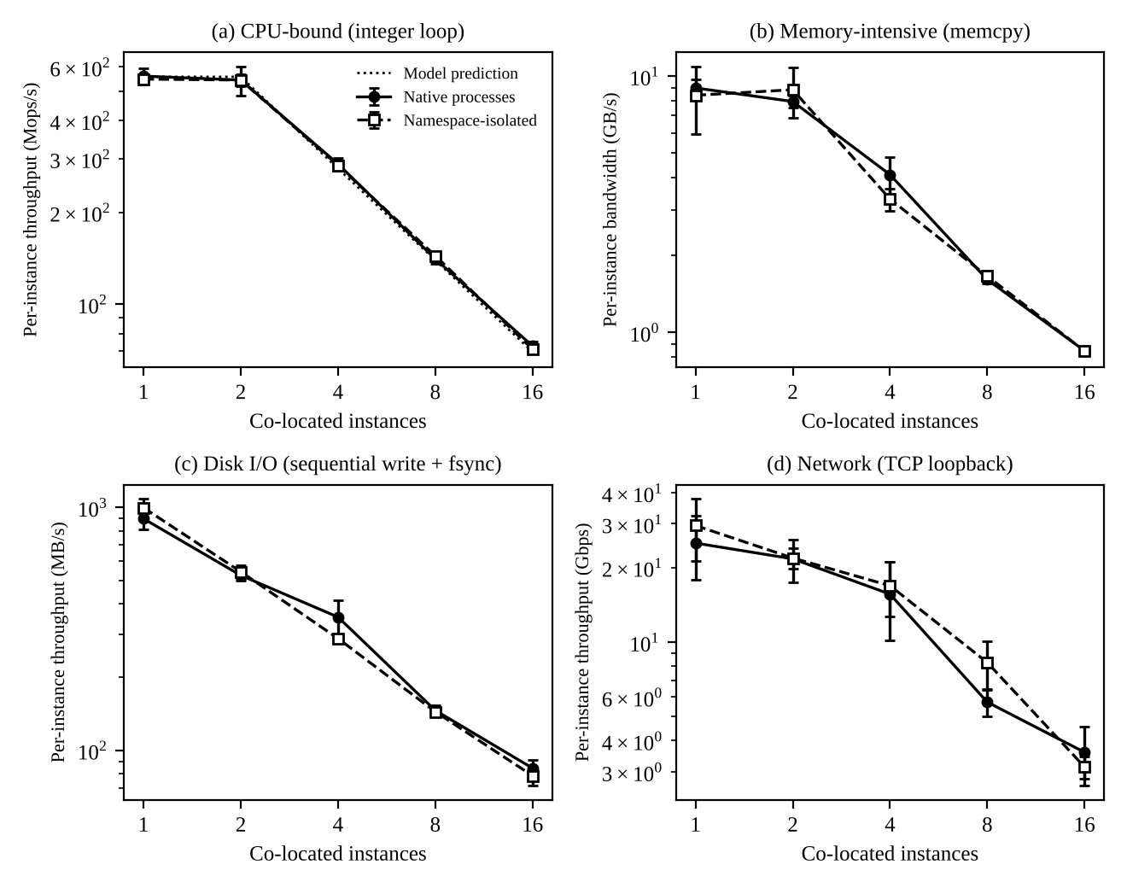
Figure 6 (Graph 1): Per-instance throughput versus number of co-located instances for four workloads (error bars: one standard deviation, 5 repetitions)
Table 14: Aggregate throughput (per-instance mean x N), native runs
Workload | N = 1 | N = 2 | N = 4 | N = 8 | N = 16
CPU (Mops/s) | 560 | 1086 | 1152 | 1124 | 1164
Memory (GB/s) | 9.0 | 15.9 | 16.5 | 12.8 | 13.5
Disk write (MB/s) | 897 | 1048 | 1412 | 1166 | 1349
Network loopback (Gbps) | 25.1 | 43.3 | 62.4 | 45.8 | 57.5

Table 15: Other recorded quantities
Quantity | Native | Namespace instance | Note
Start-up time (ms), 60 runs | 0.87 +/- 0.17 | 2.55 +/- 0.15 | Namespace creation adds about 1.7 ms; a KVM VM would take seconds
Context switches, N = 1 (CPU test) | 171 | 97 | Total over the run
Context switches, N = 16 (CPU test) | 2443 +/- 99 | 2885 +/- 145 | 16 instances on 2 cores
CPU steal time at N = 16 (10 ms ticks) | 5.8 +/- 1.3 | 4.6 +/- 2.4 | Very small; the hypervisor underneath was not busy
Memory per instance | not measured | not measured | Namespace state is a few kilobytes of kernel structures

9.2 Noisy-neighbour experiment
Table 16: Request completion delay in microseconds (mean +/- standard deviation of 6 runs)
Condition | Mean | 95th percentile | 99th percentile
Native, alone | 129 +/- 9 | 188 +/- 23 | 226 +/- 18
Native, 4 CPU hogs | 192 +/- 28 | 721 +/- 201 | 2723 +/- 854
Namespace, alone | 124 +/- 6 | 181 +/- 17 | 222 +/- 20
Namespace, 4 CPU hogs | 183 +/- 22 | 631 +/- 400 | 3164 +/- 99

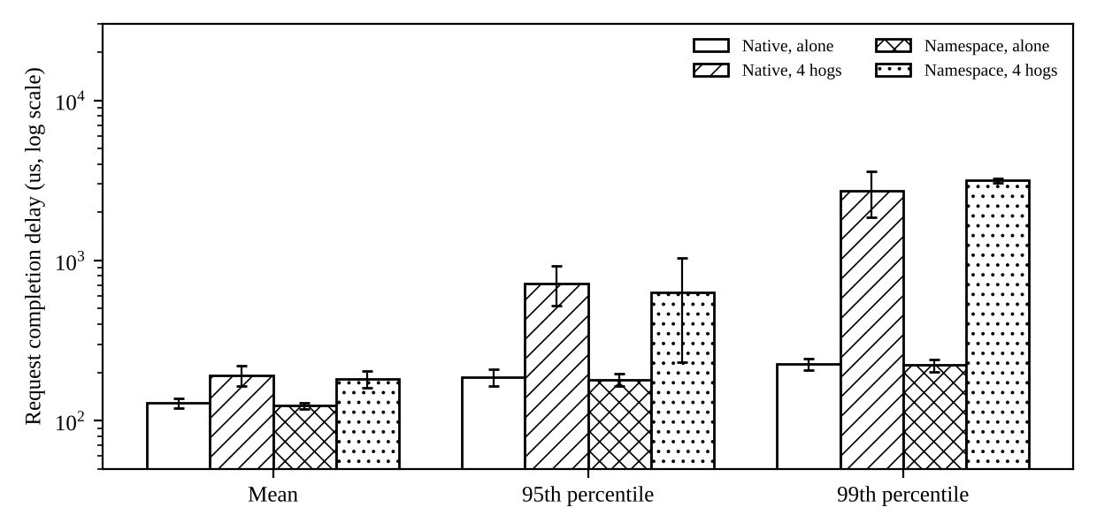
Figure 7 (Graph 2): Latency of a request under CPU interference (log scale; error bars: one standard deviation)
Mean delay rose by 49% (native) and 48% (namespace), but the 95th percentile rose 3.8 and 3.5 times and the 99th percentile 12.1 and 14.3 times. Namespaces gave no protection against CPU interference. Note that I did not test a cgroup CPU quota in this run, so I cannot report how much it would help.

9.3 Results with and without a security mitigation
The seccomp-bpf filter is the mitigation that container runtimes (Docker default profile, gVisor, Kata agent) use to shrink the kernel attack surface. I installed a six-rule filter (deny reboot, kexec_load, swapon, mount, init_module and ptrace, allow the rest) and measured a tight loop of 3 x 10^6 getppid system calls, 10 runs each.
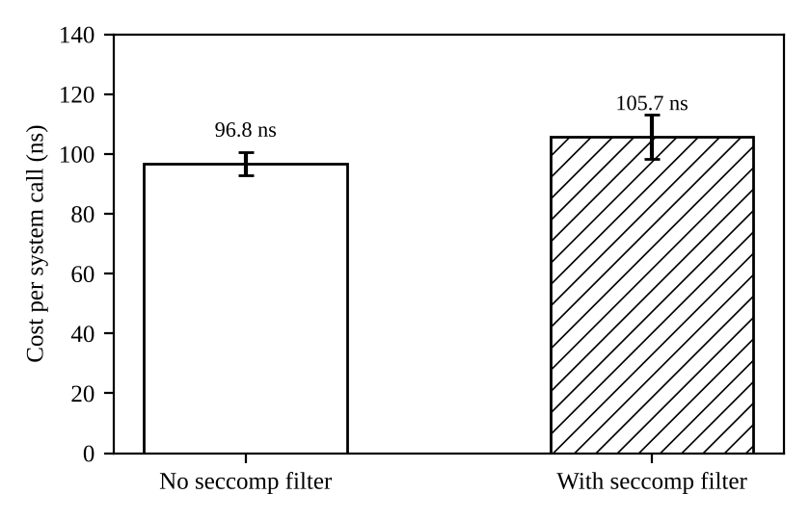
Figure 8 (Graph 3): Cost per system call with and without a seccomp filter (10 runs; error bars: one standard deviation)
Table 17: Mitigation and VM-exit measurements
Measurement | Result (mean +/- SD, 10 runs) | Comparison with the model assumption
System call without seccomp | 96.8 +/- 3.9 ns | Assumed 200 ns; the measured value is half of the assumption
System call with seccomp | 105.7 +/- 7.3 ns (+8.9 ns, +9.2%) | Assumed +20 ns (10%); the measured relative cost matches
VM exit (CPUID in this guest) | 6.24 +/- 0.46 us | Assumed 1.5 us; measured is 4.2 times larger

Task 10: Compare Theory with Experiment

10.1 CPU scaling
For N instances on P = 2 cores with fully busy vCPUs (u = 1, v = 1), the Task 3 model gives per-instance capacity = (1 - o) x min(1, P/N), with o = 0.5% for a namespace container. Using the measured native N = 1 value as the baseline (559.5 Mops/s), the predictions for N = 1, 2, 4, 8, 16 are 556.7, 556.7, 278.4, 139.2 and 69.6 Mops/s.
Table 18: Predicted versus measured CPU throughput per instance (Mops/s)
N | Model | Measured native | Error | Measured namespace | Error
1 | 556.7 | 559.5 | +0.5% | 547.0 | -1.7%
2 | 556.7 | 543.1 | -2.5% | 543.2 | -2.4%
4 | 278.4 | 288.0 | +3.5% | 285.1 | +2.4%
8 | 139.2 | 140.5 | +1.0% | 143.9 | +3.4%
16 | 69.6 | 72.7 | +4.5% | 71.0 | +2.0%

The model is within about 5% everywhere, and the slope of 1/N once the instances exceed the cores is exact. The measured values are slightly above the model for N >= 4 (by 1 to 5%) because the N = 1 baseline has a high standard deviation (about 6%) and because 2 cores allow some turbo and cache benefit when the cores are shared by a few processes. The aggregate throughput confirms the saturation: it stays near 1,150 Mops/s from N = 2 to N = 16, which is two cores fully used. For the namespace case the measured extra cost (between -2.4% and +2.4%) agrees with the modelled 0.5%, given the noise. This supports the claim that namespace and cgroup isolation costs almost nothing for CPU work. It does not validate the KVM or micro-VM overhead of 5% or 4.25%, because those could not be run.

10.2 Memory, disk and network
The model predicts that once a shared device saturates, the per-instance share is B_eff / n. The measurements follow this: aggregate disk throughput rises from 897 MB/s at N = 1 to a plateau of about 1,150 to 1,400 MB/s from N = 4 onward (the storage limit), aggregate memory bandwidth plateaus at about 13 to 16 GB/s, and aggregate loopback network throughput reaches 46 to 67 Gbps at N >= 4 (limited by the two cores doing the copying, consistent with the CPU-bound branch of the network model). The plateau values vary by up to 25% between points (for example N = 4 versus N = 8 for disk), which the model does not capture; the likely causes are page-cache and write-back timing, scheduling order on 2 cores and noisy measurement on a shared virtual disk. I did not model a loopback network, so the quantitative match is only in the shape.
Two results do not agree with the model and I cannot fully explain them. The loopback network throughput of namespaces at N = 8 is 44% higher than native (8.3 versus 5.7 Gbps), and the memory result at N = 4 is 20% lower. Both have large standard deviations (20 to 35%), so I treat them as noise from scheduling on only 2 cores and do not claim a real difference.

10.3 Which approach scales better
Among the approaches I could measure, the container-style (namespace) instances scale exactly as the native baseline: no difference in the scaling curve for any workload, so isolation by namespaces does not limit scaling by itself. For the VM-based approaches the model predicts a different curve: the overhead term is flat (5% and 4.25%) but the shared network and I/O paths saturate earlier (KVM at 14.5 Gbps against 21.1 Gbps for containers), so containers should scale better under I/O load by about 45% at the network path. This ordering (container > KVM > micro-VM for density at peak: 33, 23, 21) is a model prediction. I could not confirm it experimentally.

10.4 Measured values that challenge the model assumptions
- VM exit cost. The measured CPUID trap cost 6.2 us, not 1.5 us. If a nested guest suffered the same cost on every exit, the KVM overhead would be 20,000 x 6.2 us + 2% = 14.4%, which is above the 10% degradation target by itself. On non-nested bare-metal hosts KVM exits typically cost 1 to 2 us, so the 1.5 us assumption for EduCloud is sound, but EduCloud must run KVM directly on hardware; nested virtualization (for example running the private cloud inside another cloud) would make approach A and C fail the SLA. This is why the laptop or nested setups mentioned in Task 8 give pessimistic VM numbers.
- System-call cost. The native system call (97 ns) is half the assumed 200 ns, and the seccomp cost (+8.9 ns, +9.2%) matches the assumed relative cost of 10%. The container overhead in the model (0.5%) is therefore conservative; a measured value would be about 0.1% plus cgroup effects.
- Interference. The model uses the steal fraction S, which applies to all approaches that share cores. The measured p99 increase of 12 to 14 times, with no difference between native and namespace, shows that the isolation level (namespaces) says nothing about performance isolation. In the model terms, S must be controlled by pinning or quotas for the SIS, whether it runs in a VM or a container.

10.5 Effect on the security conclusions
The measurements confirm the Task 5 reasoning for containers: the kernel is shared (identical uname inside and outside), no seccomp filter was active and full capabilities were present by default, so a namespace is not a security boundary without further hardening. The BHI vulnerability report on the test machine supports the point that side-channel and speculative-execution exposure (T2) is a property of the shared CPU and kernel that no virtualization approach removes. One conclusion is strengthened: the cost of seccomp is only about 9%, so there is no performance reason to run containers without it. No measurement changed the ranking of the approaches (C least exposed, B most exposed), but none could test the VM boundary directly.

Task 11: Recommend and Defend the Final Architecture

11.1 Recommendation
Recommended design (hybrid, VM-centred). (1) SIS, the examination portal and the LMS database tier run in KVM virtual machines (approach A) on a dedicated internal host pool; (2) stateless LMS web and application tiers run as containers inside those VMs (container packaging, VM boundary), so containers never share a kernel across departments; (3) untrusted or third-party code runs in Kata micro-VMs (approach C) (used in Task 12). Plain host-level containers (approach B) are used only inside a single trust domain, for example one department's own research jobs.

11.2 Why this is more appropriate than the alternatives
- Compared with plain containers. B has the best density (33 per host at peak against 23) and no measured overhead, but it fails the isolation constraint for the SIS (weighted risk 0.72, one shared kernel, no seccomp or capability reduction by default in my tests) and cannot be live-migrated for patching.
- Compared with micro-VMs. C has the lowest risk (0.47) but the lowest network and I/O capacity in the model (12.9 Gbps; 222,000 IOPS), limited live migration, and a less mature operational toolchain, so it would be the weakest choice for the SIS under registration load.
- Why A. It meets the isolation and live-migration constraints, has a mature operations toolchain (patch by migration, snapshots, libvirt), and the model shows that its network limit can be fixed by tuning instead of changing architecture.

11.3 Modelled and observed performance
Modelled CPU overhead is 5%. At normal load the host supports 65 VMs (memory-bound), against 25 deployed. At 3x load the untuned limit is 23 VMs per host, so the current 25 exceeds the limit and explains the observed slowness; with four cores for the vSwitch and I/O threads the limit rises to 41 per host, so the 400 VMs need 10 hosts at peak (Figure 5). Experimentally I observed that isolation by namespaces adds under 2.5% to CPU work and nothing measurable to disk or memory, that interference requires explicit CPU control (p99 delay 12 to 14 times higher), and that the exit cost of nested virtualization (6.2 us) would break the SLA, so KVM must run on bare-metal hosts. The KVM figures themselves are model values and not measurements.

11.4 Security posture and residual risk
With dedicated hosts for internal tenants, image signing, encrypted migration, KPTI and micro-segmentation, the exposure to T1, T4, T5, T6 and T7 falls substantially. Residual risks: T2 (side channels) because SMT stays on in the single-trust-domain SIS pool and caches are shared; hypervisor and QEMU bugs (T1, T3); and mistakes in image and patch management. The risk of QEMU bugs can be reduced by running QEMU with seccomp and SELinux (sVirt) and by using a minimal device set.

11.5 Operational costs
- Patching: hypervisor and host kernel patched by live-migrating VMs away (cost: 2.8 to 6.4 s per 8 GB VM, 1 GB/s dirty rate gives 4.2 s) and requires one spare host per pool; guest kernels need an automated patch pipeline because the audit found outdated kernels.
- Image management: signed images in one registry with versioning; stop free copying; scan on build.
- Monitoring: steal time, VM-exit rate, vSwitch CPU, packet drops per VM, and migration events, because these are the leading indicators in the model.
- Staff and licensing cost: moderate; KVM, libvirt and OVS are open-source and already familiar.

11.6 Limitations and trade-offs
The recommendation trades density for isolation: about 30% fewer instances per host than containers at peak (23 against 33 untuned). It depends on assumptions in Table 3 (u, exit rates, packet costs) that I did not measure on EduCloud hardware, and the experiments could not test KVM or Kata directly. The choice of A for the SIS rests on the constraints (live migration and operational maturity) and not on the cost function J: C has a lower J for any positive lambda, so if micro-VM live migration matures, the SIS choice should be revisited.

11.7 Growth from 400 to several thousand instances
At 41 VMs per host at peak, 2,000 instances need 49 hosts and 4,000 need 98 hosts. The design scales horizontally because pools are made of identical hosts and the per-host limits (network, I/O) are local. The pressure points as the platform grows are the management plane (one libvirt-style controller per few hundred hosts), the central image registry and the shared storage backend, and live-migration capacity. For stateless tiers, moving from VMs to Kata or containers inside VMs gives 43 to 61 instances per host. Moving to SR-IOV for the data-intensive tenants removes the vSwitch limit for those tenants (Task 12).

Task 12: Re-evaluate and Adapt the Design (Day-4 Design Challenge)
Decision in one line: MODIFY. Keep KVM for SIS and LMS, add a physically separate host pool for the external Spark/Hadoop tenants that uses Kata micro-VMs, SR-IOV networking, SMT off, memory encryption where available, per-tenant encrypted storage and encrypted migration.

12.1 Impact Analysis
What has changed. Four things changed together: (1) the tenants are no longer all internal and trusted; (2) a batch workload that runs for hours and is I/O- and network-intensive joins a latency-sensitive transactional workload; (3) registration peak is 3x normal; (4) patching by live migration now involves large VMs and a regulation requires demonstrable isolation of student records.
Assumptions that no longer hold.
- Trusted tenants. The Task 5 model assumed that attackers were inside the university. External collaborators are less trusted and may run arbitrary code, so T1 (escape), T2 (side channels), T3 and T7 become realistic from a co-resident tenant instead of a remote possibility.
- Workload mix. The model used short web and database requests with u = 0.25 to 0.75. A Spark executor is busy for hours (u about 0.9), uses 16 vCPUs and 64 GB, and so changes the statistical multiplexing and fills the caches.
- I/O profile. Spark shuffles move about 5 Gbps and 50,000 IOPS per VM continuously (assumption for this challenge), against 0.2 Gbps and 3,000 IOPS (0.6 and 9,000 at peak) for a SIS VM. One Spark VM equals about 8 peak SIS VMs of network demand.
- Migration. A 64 GB VM with a heavy dirty rate (assume 1.5 GB/s) needs T = 64 / (2.9 - 1.5) = 46 s, and does not converge at all if D reaches 2.9 GB/s, so live migration is no longer a safe patching method for Spark VMs.
Effect of mixing. Consider the original design with 20 SIS VMs and 2 Spark VMs on one host at peak. Network demand is 20 x 0.6 + 2 x 5 = 22 Gbps against the 12.77 Gbps that the 2-core vSwitch path delivers (Table 5 model). With demand-proportional sharing the SIS receives 12.77 x 12 / 22 = 6.97 Gbps, or 58% of its 12 Gbps demand, a 42% degradation, far beyond the 10% target. The same sharing happens on the storage network and the disk path. Security-wise, the SIS now has an external tenant on the same hypervisor, the same vSwitch and the same SMT siblings, which removes the "trusted tenant" argument that made approach A acceptable on shared hosts.

12.2 Evaluation of the Original Design
Performance. The original design (Task 11) is a KVM pool with k_net = 2. For the SIS alone it already fails at peak with 25 VMs per host (limit 23). With the tuning of Task 11 (4 vSwitch cores, limit 41 VMs) and external Spark VMs on the same hosts, the average case just fits: demand 22 Gbps against 23.5 Gbps line rate, CPU steal about 1% (60 cores for 32 Spark vCPUs at u = 0.9 plus 40 SIS vCPUs at u = 0.75). But there is no headroom: if the Spark job grows to 4 VMs per host (demand 12 + 20 = 32 Gbps), the SIS gets 23.5 x 12 / 32 = 8.8 Gbps, 73% of its demand (27% degradation). My measured noisy-neighbour result show that sharing a scheduler gives no performance isolation: p99 delay was 12 to 14 times higher with CPU hogs, so a Spark job can damage SIS latency whatever the average figures say.
Isolation. Not adequate. The regulation requires demonstrable isolation, and shared hosts mean shared hypervisor, vSwitch, caches and SMT threads. Auditors could not demonstrate separation by inspection, because separation would rely on scheduler and hypervisor behaviour. With the Task 5 numbers an external tenant raises the likelihood of T1 and T2 against the SIS, and if the exposure scores of T2 and T7 rise to 5 for a shared host, the normalised risk of A rises from 0.62 to 0.69, above the 0.65 isolation constraint of Task 6.
Could another architecture do better? Plain containers for Spark (approach B) would give the best throughput (no vSwitch cost beyond veth, 21 Gbps) but fail isolation outright. Micro-VMs for everything (approach C) give good isolation but a lower network cap (12.9 Gbps untuned) and no mature live migration for the SIS. The best result comes from combining them: physical separation (host pools) with a VM boundary on both sides and a stronger layer for the external side.

12.3 Adaptation or Redesign
Decision: Modify. The SIS architecture remains valid; the weakness is co-residency and the shared I/O path, which pool separation and a different network path for Spark can fix without discarding the KVM investment.
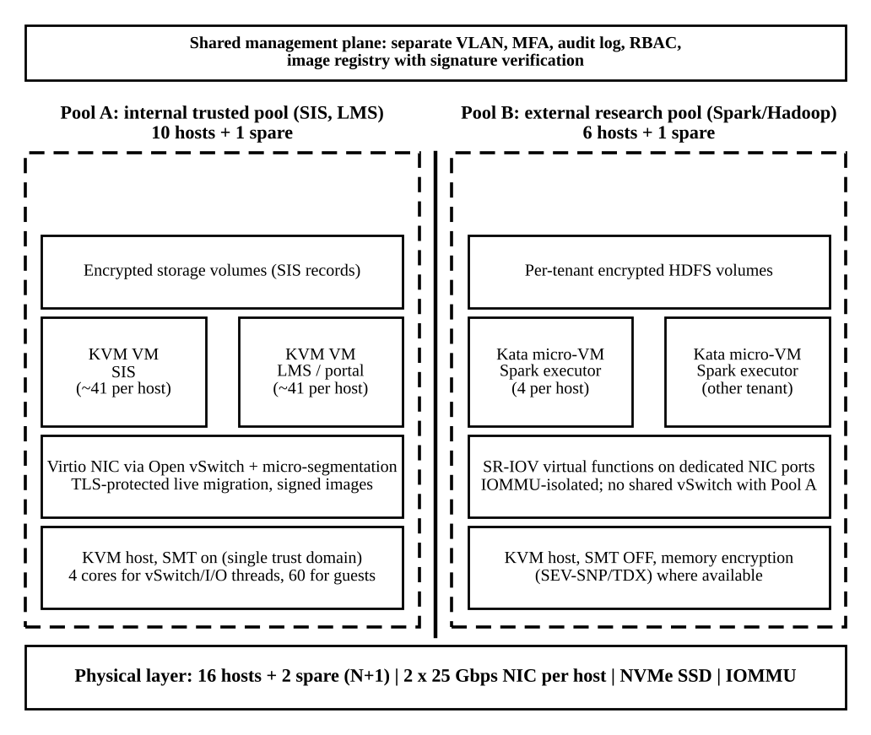
Figure 9: Revised EduCloud architecture with separate pools for internal and external tenants
What changes.
- Tenant separation by host pools. Pool A (SIS, LMS, internal departments): 10 hosts plus 1 spare. Pool B (external Spark/Hadoop): 6 hosts plus 1 spare. No VM of one pool ever runs in the other, and the two pools use different VLAN/VRF ranges, storage volumes, encryption keys and administrators.
- Stronger isolation layer for external workloads. Kata micro-VMs (VM boundary plus container boundary), SMT off, AMD SEV-SNP or Intel TDX where the hardware supports it, and the seccomp and capability reduction measured in Task 9 (cost 9% on system calls).
- SR-IOV and dedicated NIC ports for Pool B. A virtual function (VF) is assigned to each Spark VM using the IOMMU, so Spark traffic bypasses the vSwitch (packet cost 0.3 us instead of 1.6 us). The two NICs on a Pool B host carry only Spark and storage traffic.
- Encrypted migration and patching. In Pool A, TLS-protected live migration. In Pool B, SR-IOV VMs cannot be live-migrated easily, so hosts are patched by draining: Spark reschedules lost tasks, which avoids a 46 s or non-converging migration.
- Tuned virtual switch in Pool A. 4 cores for vSwitch and I/O threads, as in Task 11.
Effect on density, throughput and attack surface.
Table 19: Model results for the modified design
Metric | Original shared design | Modified design
SIS VMs per host at peak (10% target) | 23 (k_net = 2) | 41 (k_net = 4, no Spark on the host)
Network per SIS VM at peak | 0.35 Gbps (58% of demand) with 2 Spark VMs per host | 0.57 Gbps (23.5 / 41), 95% of demand, within the 10% target
Spark VMs per host (16 vCPU, 64 GB, 5 Gbps) | 2 via vSwitch (12.9 / 5) | 4 (CPU-bound; SR-IOV network would allow 9)
Hosts for 400 SIS/LMS VMs and 24 Spark VMs | Cannot satisfy isolation. For performance alone: 10 + 12 = 22 hosts | 10 + 6 = 16 hosts, plus 1 spare per pool: 18 hosts
Shared components between SIS and external tenants | Hypervisor, vSwitch, NIC, SMT siblings, storage network | None at host level; only the management plane (separate VLAN and MFA)
Isolation can be demonstrated? | No | Yes: pool membership, VLAN IDs, IOMMU groups, per-tenant keys, audit logs

Density: Pool A is unchanged at 41 VMs per host; Pool B hosts only 4 big VMs each but needs half as many hosts as the vSwitch path would. Throughput: each Spark VM now has its full 5 Gbps and the SIS keeps the whole vSwitch capacity. Attack surface: the number of tenants that share a hypervisor with the SIS drops from "all" to none, SMT-based and vSwitch-based attacks from an external tenant against the SIS are removed, and the external side gains two boundaries plus memory encryption. The cost is 2 extra hosts (18 against the 16 existing), SMT-off capacity loss in Pool B (20% of the SMT gain) and a more complicated operating model with two patching procedures.

12.4 Evidence-Based Defence
Table 20: Comparison of the options considered
Option | Hosts needed | SIS network at peak (share of demand) | Isolation | Verdict
Retain (shared pool, untuned) | 16 existing | 58% (42% degradation) | Shared hypervisor and vSwitch | Fails performance and isolation
Retain with tuning (4 vSwitch cores) | 16 | 100% on average, 73% if Spark bursts to 4 VMs per host | Shared hypervisor, SMT, vSwitch | Fails isolation, no headroom
Redesign: all micro-VMs | 10 + 12 (vSwitch path) | Lower network cap (12.9 Gbps untuned) | VM boundary everywhere | Higher cost; SIS migration limited
Modify (chosen) | 18 (16 + 2 spares) | 95% of demand (0.57 of 0.6 Gbps, 5% degradation) | Separate pools, VM boundary, SMT off, SR-IOV, encryption | Meets all constraints

Link to the model. Table 6 and Figure 5 show that the 10% target is limited by the network path and not the CPU, so adding a bypass for the big consumer (SR-IOV) and four vSwitch cores for the rest is the intervention that the model identifies. The model also gives the hosts: 400 / 41 = 10 hosts for the SIS pool and 24 / 4 = 6 for Spark.
Link to the experiments. (1) The noisy-neighbour experiment showed 12 to 14 times higher 99th-percentile delay and no benefit from namespaces, so performance and isolation of the SIS cannot be assured by co-scheduling; they need separate hosts. (2) The seccomp measurement (+9% per system call) shows that hardening the external sandbox costs little. (3) The namespace inspection showed a shared kernel with no filter and full capabilities by default, so external workloads must not use plain containers. (4) The measured VM-exit cost of 6.2 us in a nested guest shows that the whole design relies on running KVM on bare-metal hosts, which is a deployment requirement. (5) The mitigation costs of Task 7 (SMT off -20%, memory encryption about -9%) are acceptable only for Pool B, which is why they are not applied to the SIS pool.
Cost and density trade-off. The modified design costs two more hosts (an 11% increase over 16) and Pool B density of 4 VMs per host. In return it makes isolation demonstrable, removes the 42% SIS degradation, and keeps the SIS design that Tasks 1 to 11 justified. The decision is sensitive to the size of the external workload: if the Spark demand doubles to 48 VMs, Pool B needs 12 hosts and the total reaches 24 hosts with spares, in which case extra hosts or a separate cluster are needed. The decision is not sensitive to the exact exit cost (5% against a measured 14%) as long as KVM runs on bare metal.

Conclusion
The analysis found that EduCloud's registration-week slowdown comes from the virtual network and I/O path rather than the CPU, that namespace isolation has almost no cost but also provides neither strong security nor performance isolation, and that VM-exit cost makes nested deployments unsuitable. A KVM-based, VM-centred design with a tuned virtual switch fits the SIS and LMS, and external Spark tenants need a physically separate pool with a stronger isolation layer and an SR-IOV data path. The experimental part of this study covered the baseline and the namespace mechanism only; KVM and Kata results are model values and should be confirmed on suitable hardware using the procedure in Appendix A.

References
- Popek, G. J. and Goldberg, R. P. (1974). Formal requirements for virtualizable third generation architectures. Communications of the ACM, 17(7), 412-421.
- Barham, P. et al. (2003). Xen and the art of virtualization. Proceedings of SOSP.
- Kivity, A. et al. (2007). kvm: the Linux virtual machine monitor. Proceedings of the Linux Symposium.
- Russell, R. (2008). virtio: towards a de-facto standard for virtual I/O devices. ACM SIGOPS Operating Systems Review, 42(5).
- Bhargava, R. et al. (2008). Accelerating two-dimensional page walks for virtualized systems. Proceedings of ASPLOS.
- Clark, C. et al. (2005). Live migration of virtual machines. Proceedings of NSDI.
- Felter, W. et al. (2015). An updated performance comparison of virtual machines and Linux containers. IEEE ISPASS.
- Lipp, M. et al. (2018). Meltdown: reading kernel memory from user space. Proceedings of USENIX Security.
- Agache, A. et al. (2020). Firecracker: lightweight virtualization for serverless applications. Proceedings of NSDI.
Note: the reference details were written from memory and should be checked against the originals before submission.

Appendix A: Procedure to Repeat the Study with KVM and Kata
On a machine with hardware virtualization enabled (/dev/kvm present) and root access, the same instance counts (1, 2, 4, 8, 16), five repetitions and identical resources per instance should be used for the three approaches.
- KVM VM: qemu-system-x86_64 -enable-kvm -cpu host -smp 2 -m 8G -drive file=guest.qcow2,if=virtio -netdev tap,id=n0,vhost=on -device virtio-net-pci,netdev=n0 (or virt-install with the same resources).
- Container: docker run --rm --cpus=2 --memory=8g IMAGE COMMAND.
- Micro-VM: install Kata Containers and run docker run --rm --runtime=io.containerd.kata.v2 --cpus=2 --memory=8g IMAGE COMMAND.
- CPU: sysbench cpu --threads=2 run. Memory: sysbench memory --memory-total-size=10G run (or stress-ng --vm 2). Disk: fio --name=t --rw=randread --bs=4k --iodepth=32 --size=1G --runtime=30 --time_based, and a sequential write with --rw=write --bs=1M --fsync=1.
- Network: iperf3 -s on the host and iperf3 -c HOST -t 30 inside each instance; latency with ping -c 1000.
- Noisy neighbour: stress-ng --cpu 4 --timeout 60 in neighbour instances while the probe workload runs; repeat with cgroup cpu.max or CPU pinning to measure the mitigation.
- Exits and steal: perf kvm stat live (VM exits per second), mpstat or /proc/stat (steal), and a comparison with the measured exit cost in Table 17.
- Security: compare uname -r inside and outside each instance, cat /proc/self/status | grep Seccomp, ls -l /proc/self/ns, and read /sys/devices/system/cpu/vulnerabilities/* with SMT on and off.

Appendix B: Test Programs Used in This Study
A single C program (bench.c, compiled with gcc -O1) provided the workloads: cpu (integer loop), mem (memcpy), disk (sequential write with fsync, 2,000 random 4 KiB reads), net (TCP loopback transfer with 10,000 ping-pong round trips), probe (latency probe with absolute-time wake-ups), hog (CPU hog), sys (getppid loop with optional seccomp-bpf filter) and cpuid (CPUID loop, which traps in a guest). A Python driver started N copies at once, directly or inside "unshare --pid --fork --mount-proc --net --uts --ipc --mount", recorded the output of each, and read /proc/stat before and after for context switches and steal time. The raw numbers behind every table are the outputs of these runs (5 repetitions per point).

