SIMATS ENGINEERING
ASSESSMENT TOOL 3

COURSE NAME: Database Management Systems COURSE CODE: CSA05

COURSE OUTCOME COVERED

CO2: Apply the relational model, relational algebra, SQL query structures, and views to solve database querying and data manipulation problems. (BL3, BL6)

Activity Tool : Debugging & Optimisation Task (Low) Assessment Tool Weightage: 10%

QUESTIONS
Q.N  o | Question | Bloom's Level
1 | Identify and correct errors in a given SQL CREATE TABLE statement with incorrect syntax and missing constraints. | BL2 –  Understand
2 | Debug an SQL query that incorrectly uses aggregate functions without GROUP BY and fix the issue. Bloom’s Level: | BL2 –  Understand
3 | Correct a faulty SELECT query where column names are misspelled or improperly referenced. | BL1 –  Remember
4 | Fix errors in an SQL query using JOIN, where the join condition is missing or incorrect. | BL3 – Apply
5 | Identify and correct a subquery error where multiple values are returned instead of a single value. | BL2 –  Understand
6 | Debug a VIEW creation statement that contains invalid column references or syntax errors. | BL1 –  Remember
7 | Examine an SQL query with unnecessary conditions and optimize it by simplifying the WHERE clause. | BL3 – Apply
8 | Identify violations of integrity constraints in a given table and correct them. | BL2 –  Understand

9 | Fix a relation that violates 1NF or 2NF by removing repeating groups or partial dependencies. | BL3 – Apply
10 | Identify redundant attributes in a relation and apply basic normalization (up to 3NF) to improve design. | BL3 – Apply

Code of Conduct:

I k kalyan(192525103) (Name / Reg No) certify that this submission is my original work and that I have adhered to the guidelines specified for this assessment. I understand that any violation of academic integrity rules will result in disciplinary action.

Signature of the student

k . Kalyan

RUBRICS FOR CALCULATION:

Criteria | Level 4  (Exemplary) | Level 3  (Proficient) | Level 2  (Developing) | Level 1  (Beginning)
Problem Identification | Accurately identifies all errors and root causes  with clear understanding | Identifies most errors with minor gaps | Identifies some errors but misses key issues | Unable to identify errors correctly
Debugging | Applies systematic debugging techniques  effectively to resolve issues | Uses appropriate debugging methods with minor errors | Limited debugging approach; requires guidance | Unable to debug or resolve issues
Optimization | Optimizes code by significantly improving time complexity using efficient  algorithms | Improves time complexity with minor gaps in efficiency | Limited improvement in time complexity | No improvement; inefficient approach retained
Analysis | Demonstrates strong logical reasoning and clear  justification of solutions | Shows reasonable analysis with some justification | Limited analysis; weak reasoning | No analytical reasoning demonstrated

Code Quality | Produces clean,  well-structure d code with proper comments  and | Code is mostly clear with minor documentation gaps | Code lacks structure and proper documentation | Poorly written code with no documentation
 | documentatio n

Q1. Identify and correct errors in a given SQL CREATE TABLE statement with incorrect syntax and missing constraints.

❌ Incorrect SQL
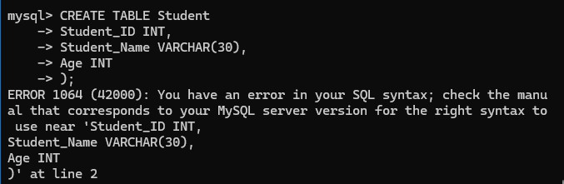

Q Errors

- Missing opening bracket (.
- No PRIMARY KEY.

- Incorrect CREATE TABLE syntax.

✅ Correct SQL
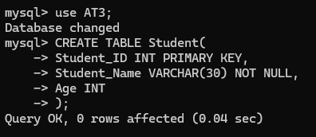

OUTPUT
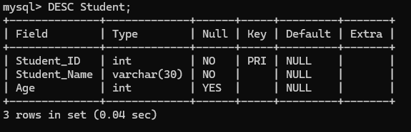

Justification
The corrected statement adds proper table syntax, a primary key, and a NOT NULL constraint to ensure valid table creation and data integrity.

2) Debug an SQL query that incorrectly uses aggregate functions without GROUP BY. (BL2 – Understand)

Create table and Insert data

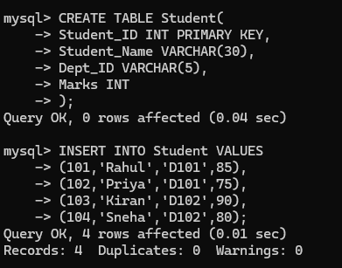

❌ Incorrect SQL
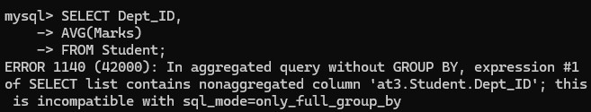

Q Error
Aggregate function is used with a normal column without GROUP BY.

✅ Correct SQL
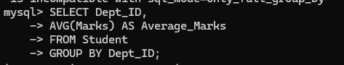

Output
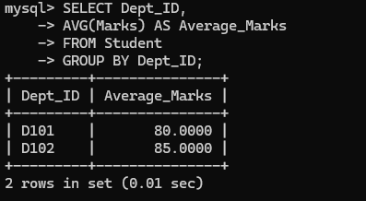

Justification
GROUP BY groups rows based on department so that AVG() is calculated separately for each department.

Q3. Correct a faulty SELECT query where column names are misspelled. (BL1 – Remember)

Create table and Insert data
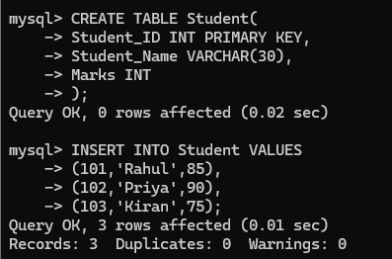

❌ Incorrect SQL
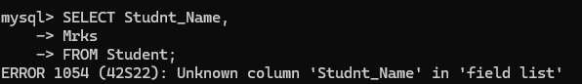

Q Errors
- Studnt_Name → Incorrect spelling.

- Mrks → Incorrect spelling.

✅ Correct SQL
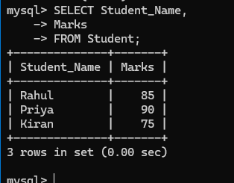

Output

Student_Name | Marks
Rahul | 85
Priya | 90
Kiran | 75
Justification
Column names must exactly match those defined in the table schema. Correct spelling ensures successful query execution.

Q4. Fix errors in an SQL query using JOIN, where the join condition is missing or incorrect.
(BL3 – Apply)
Create table and Insert data
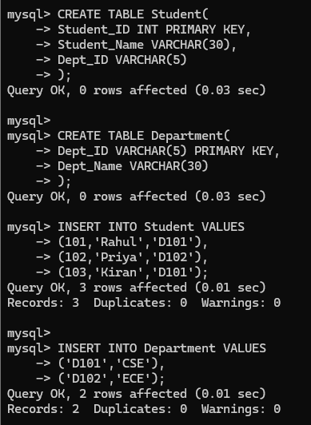

❌ Incorrect SQL
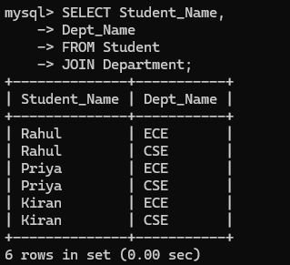

Q Error
JOIN condition (ON) is missing.

✅ Correct SQL
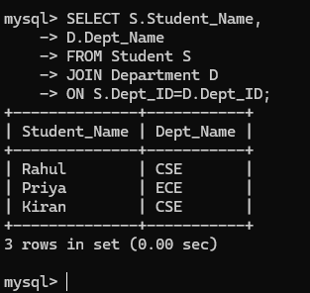

Output

Student_Name | Dept_Name
Rahul | CSE
Priya | ECE
Kiran | CSE
Justification
The ON clause specifies how the two tables are related. Without it, the query may produce a Cartesian product or fail.

Q5. Identify and correct a subquery error where multiple values are returned instead of a single value.
(BL2 – Understand)
Create table and Insert data

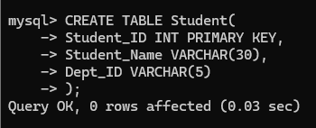
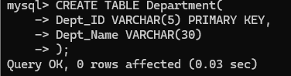

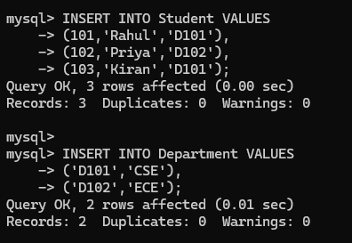

❌ Incorrect SQL
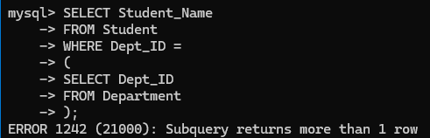

Q Error

The subquery returns multiple department IDs, but the = operator expects only one value.

✅ Correct SQL

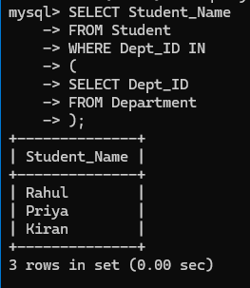

Output

Student_Name
Rahul
Priya
Kiran
Justification
The IN operator is used when the subquery returns multiple values. It compares the column against all returned values, preventing the "subquery returns more than one row" error.

Q6. Debug a VIEW creation statement that contains invalid column references or syntax errors
(BL1 – Remember)

Create Table and Insert Data
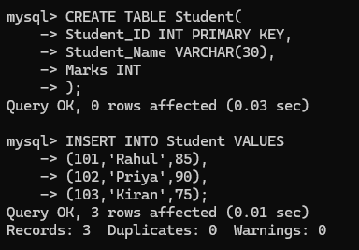

❌ Incorrect SQL
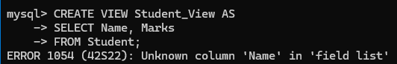

✅ Correct SQL
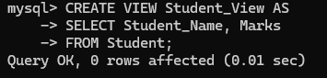

OUTPUT

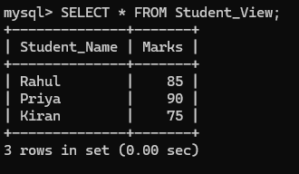

Justification
The column Name does not exist in the Student table. Replacing it with Student_Name creates the view successfully.

Q7. Examine an SQL query with unnecessary conditions and optimize it by simplifying the WHERE clause
(BL3 – Apply)
Create Table and Insert Data
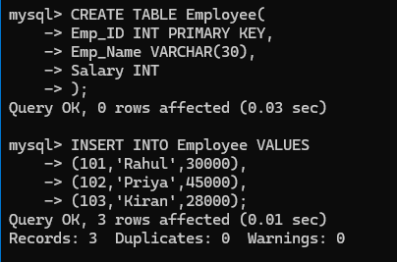

❌ Inefficient Query
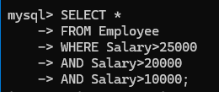

✅ Optimized Query
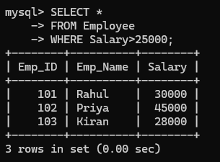

Justification

The extra conditions are redundant because Salary > 25000 already satisfies the other two conditions. Removing unnecessary conditions improves readability and performance.

Q8. Identify violations of integrity constraints in a given table and correct them (BL2 – Understand)

Create Table and Insert Valid Data

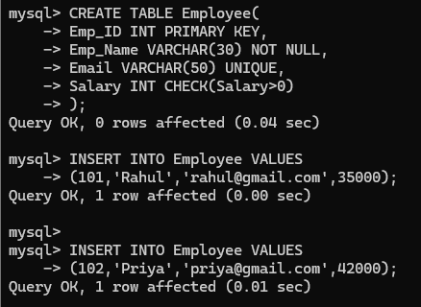

❌ Invalid Insert
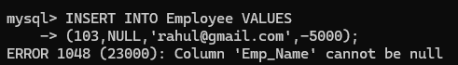

✅ Correct Insert
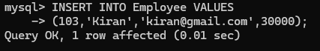

OUTPUT
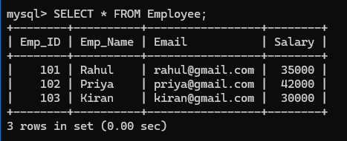

Justification
Integrity constraints ensure valid and consistent data by preventing null values, duplicate emails, and invalid salaries.
Q9. Fix a relation that violates 1NF or 2NF by removing repeating groups or partial dependencies
(BL3 – Apply) Unnormalized Relation
Student_ID | Student_Name | Courses
101 | Rahul | DBMS,Java
102 | Priya | Python
Create Table and insert data
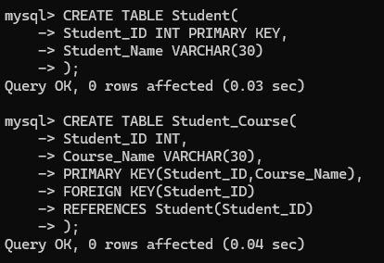

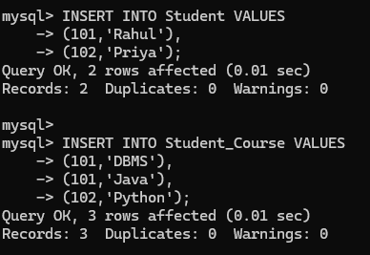

OUTPUT
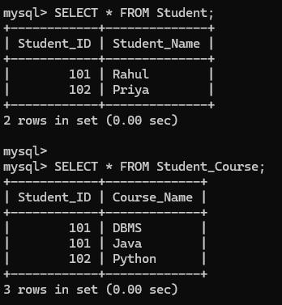

Justification
Splitting the repeating group into a separate table satisfies 1NF, removes redundancy, and supports multiple courses for each student.

Q10. Identify redundant attributes in a relation and apply normalization (up to 3NF) (BL3 – Apply)

Original Relation

Student_ID | Student_Name | Dept_Name | HOD
Create Table and Insert data
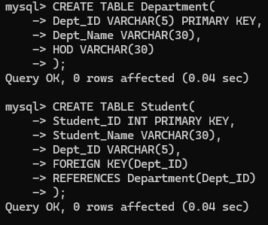

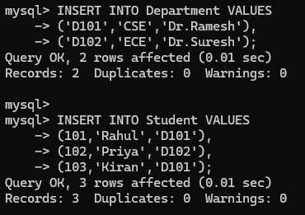

Output
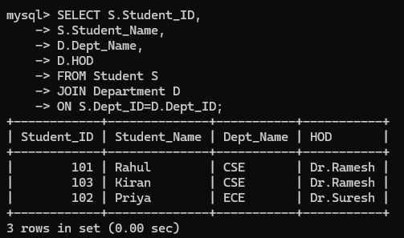

Justification

Separating department information into a separate table removes redundant department and HOD details from the Student table. This satisfies 3NF, improves consistency, and eliminates update anomalies.

