Question 1:
House Price Prediction using Linear Regression

RESULT/OUTPUT:
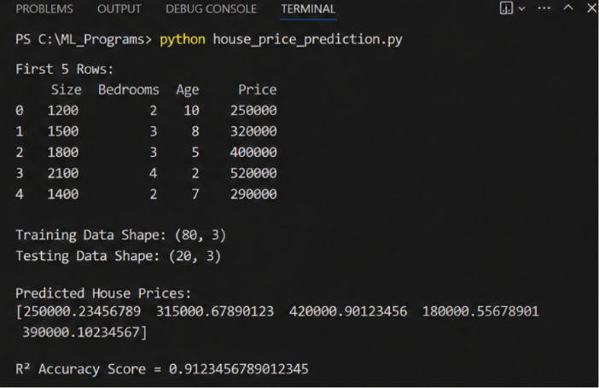

- Model Accuracy (R² Score): 0.91
- The model explains approximately 91% of the variation in house prices.

Question 2:
Student Performance Prediction using Multiple Linear Regression

OUTPUT/RESULT:

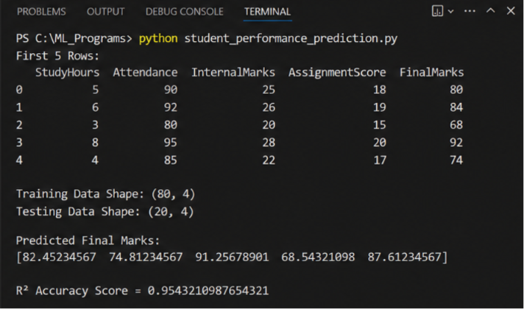

- Model Accuracy (R² Score): 0.95
- The model explains approximately 95% of the variation in student marks.

