OUTPUTS

Experiment 1: Probability Theory – Breast Cancer Classification

OUTPUT:-
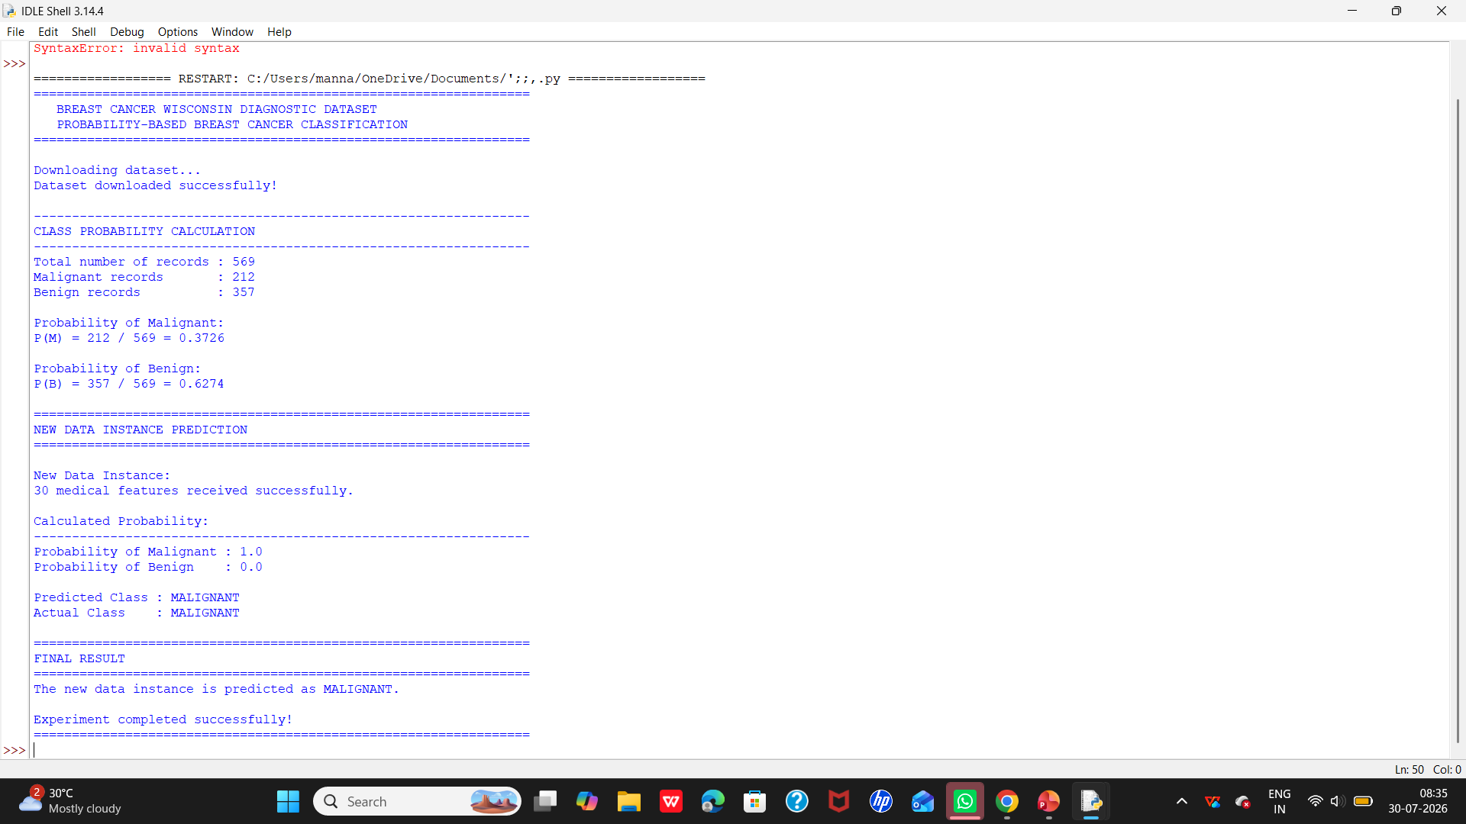
EXPERIMENT 2:- SMS Spam Classification Using Bayes Theorem

OUTPUT:-

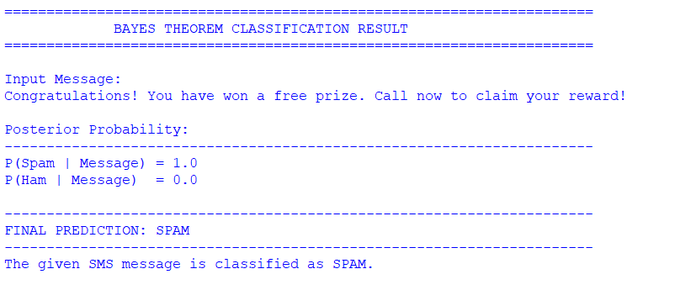

EXPERIMENT 3:-
OUTPUT:-
