SIMATS ENGINEERING

ASSESSMENT TOOL 2

COURSE NAME:COMPUTER ARCHITECTURE COURSE CODE:CSA12
NAME:P.AKSHAYA REGISTER NO:192525190

COURSE OUTCOME COVERED

CO1: Components of a computer system, including CPU, memory, and I/O. Basic Operational Concepts: Instruction execution cycle, instruction fetch and decode.Bus Structures: Single-bus, multi-bus, and hierarchical buses.Factors of Performance: CPU execution time, CPI, clock cycles, and benchmarking.8085 and 8086 Architectures: Overview, instruction sets, and addressing modes. Modern Architectures: ARM Cortex, Intel Core, and AMD Ryzen.Instruction Sets, Formats, and Addressing Modes. Number Systems: Binary, hexadecimal, and their applications in computer systems. (BL4)
Assessment Tool Weightage: 40%

QUESTIONS:5 Total Marks:25

ANNEXURE A CONCEPT MAPPING

Code of Conduct:

I P.AKSHAYA(192525190) (Name / Reg No) certify that this submission is my original work and that I have adhered to the guidelines specified for this assessment. I understand that any violation of academic integrity rules will result in disciplinary action.

Signature of the student:


ANNEXURE A

- Construct a concept map that connects the components of a computer system (CPU, memory, and I/O) with the instruction execution cycle. Clearly show how instruction fetch, decode, and execution stages interact with memory and input/output operations during program execution.
- Develop a concept map linking different bus structures (single-bus, multi-bus, hierarchical bus) with system performance factors such as CPU execution time, clock cycles, and CPI. Illustrate how bus design influences data transfer speed and overall system efficiency.
- Create a concept map that compares 8085 and 8086 architectures with modern architectures like ARM Cortex, Intel Core, and AMD Ryzen. Show relationships in terms of instruction sets, addressing modes, processing capability, and architectural advancements.
- Design a concept map that integrates instruction sets, instruction formats, and addressing modes with number systems (binary and hexadecimal). Explain how instructions are represented, decoded, and executed using these number systems in a computer.
- Prepare a concept map that connects benchmarking techniques with performance metrics such as CPU execution time, CPI, and clock cycles, and relate these to different architectures (8085, 8086, and modern processors). Demonstrate how performance evaluation varies across different system designs.

MARKS ALLOCATION

Criteria | Understandin g of Problem  Context (20%) | Application of Concepts (20%) | Problem-Solving Approach (20%) | Accuracy of Solution (20%) | Clarity (20%)
Q1
Q2
Q3
Q4
Q5

RUBRICS FOR CALCULATION:
Criteria | Weightage | Level 4 – Exemplary | Level 3 – Proficient | Level 2 – Developing | Level 1 – Beginnin g
Understan ding of Problem Context | 20 | Clearly understands the problem and accurately identifies all requirements | Good  understanding with minor gaps | Basic understanding; some  requirements unclear | Poor understanding or misinterpretatio n of the problem
Application of Concepts | 30 | Accurately applies appropriate concepts to solve complex problems | Applies relevant concepts correctly with minor errors | Applies basic concepts with limited accuracy | Fails to apply appropriate concepts
Problem-Solving Approac h | 20 | Logical,  well-structured, and efficient approach | Mostly logical approach with minor gaps | Basic approach with some inconsistencies | Illogical or  unclear approach
Accuracy of Solution | 20 | Completely correct solution with proper justification | Mostly correct with minor errors | Partially correct solution | Incorrect or incomplete solution
Clarity | 10 | Clear, well-organized, and properly explained solution | Understandable with minor clarity issues | Limited clarity and explanation | Poorly presented and difficult to understand

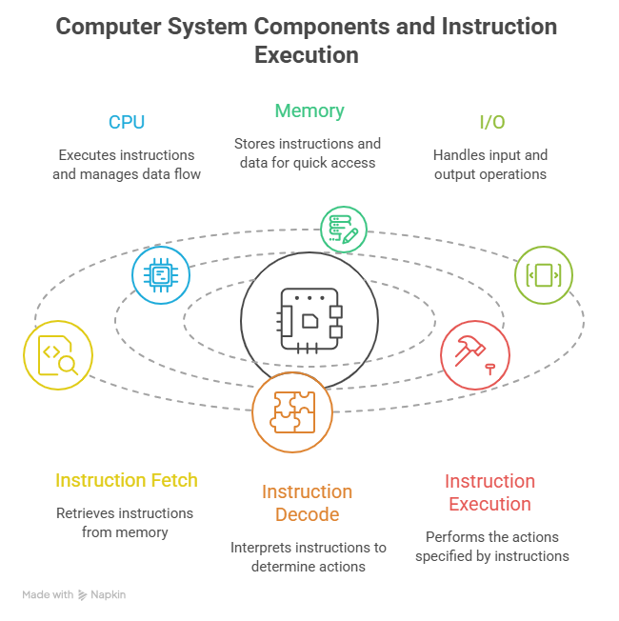

CPU (Central Processing Unit)
- Controls all processing operations.
- Fetches, decodes, and executes instructions.
- Contains Control Unit (CU) and Arithmetic Logic Unit (ALU).
Memory
- Stores program instructions and data.
- Supplies instructions to CPU during execution.
- Stores results after processing.
Input Devices
- Provide data and instructions to the computer.
- Examples: Keyboard, Mouse, Scanner.
Output Devices
- Display processed information.
- Examples: Monitor, Printer, Speakers.

Instruction Execution Cycle
1. Fetch
- CPU retrieves the next instruction from memory.
- Instruction is loaded into the Instruction Register (IR).
2. Decode
- Control Unit interprets the instruction.
- Determines the operation to be performed.
3. Execute
- ALU performs arithmetic or logical operations.
- Data may be read from or written to memory.
- Input/Output devices may be accessed.

Conclusion
The CPU, Memory, and I/O devices work together through the Fetch–Decode–Execute cycle. Memory stores instructions and data, the CPU processes them, and I/O devices provide input and output, enabling successful program execution.

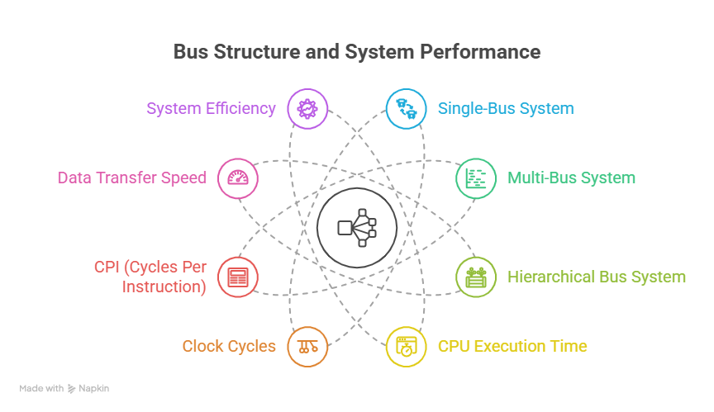

Single Bus
- All components share one bus.
- Low cost but creates traffic congestion.
- Increases CPU waiting time and clock cycles.
Multi-Bus
- Uses multiple buses simultaneously.
- Allows parallel data transfers.
- Improves speed and reduces CPI.
Hierarchical Bus
- Organizes buses into levels.
- Reduces unnecessary traffic.
- Provides better overall efficiency for large systems.
Relationship with Performance
- Faster bus structures improve data transfer speed.
- Reduced waiting time lowers clock cycles.
- Lower clock cycles reduce CPU execution time.
- Efficient bus design improves overall system performance.

Conclusion

Bus structures play a crucial role in determining the performance of a computer system. A Single Bus structure is simple and cost-effective but can create data transfer bottlenecks, leading to higher CPU execution time, more clock cycles, and increased CPI. A Multi-Bus structure improves performance by allowing multiple data transfers simultaneously, reducing delays and increasing efficiency

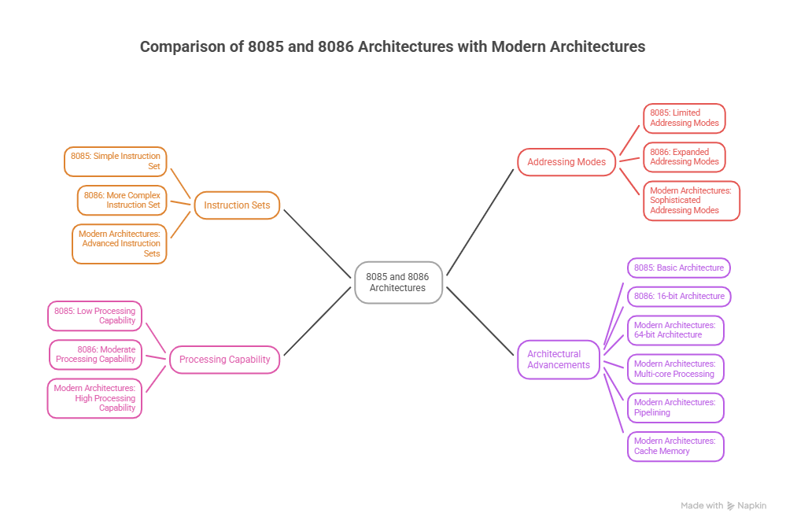

8085
- 8-bit microprocessor.
- Limited instruction set and addressing modes.
- Suitable for simple embedded applications.
8086
- 16-bit microprocessor.
- Supports segmented memory architecture.
- Better performance than 8085.
ARM Cortex
- Based on RISC architecture.
- Power-efficient and widely used in mobile devices.
- Supports 32-bit and 64-bit processing.
Intel Core
- Advanced CISC architecture.
- Multi-core processing and large cache memory.
- Designed for high-performance computing.
AMD Ryzen
- x86-64 architecture.
- Supports simultaneous multithreading (SMT).
- Excellent performance for multitasking and gaming.

Conclusion
The evolution from 8085 and 8086 microprocessors to modern architectures such as ARM Cortex, Intel Core, and AMD Ryzen demonstrates significant advancements in computing technology. Modern processors offer larger instruction sets, advanced addressing modes, higher processing speeds, multi-core execution, improved cache systems, and better power efficiency. These developments have greatly enhanced overall system performance, enabling faster and more efficient execution of complex applications.

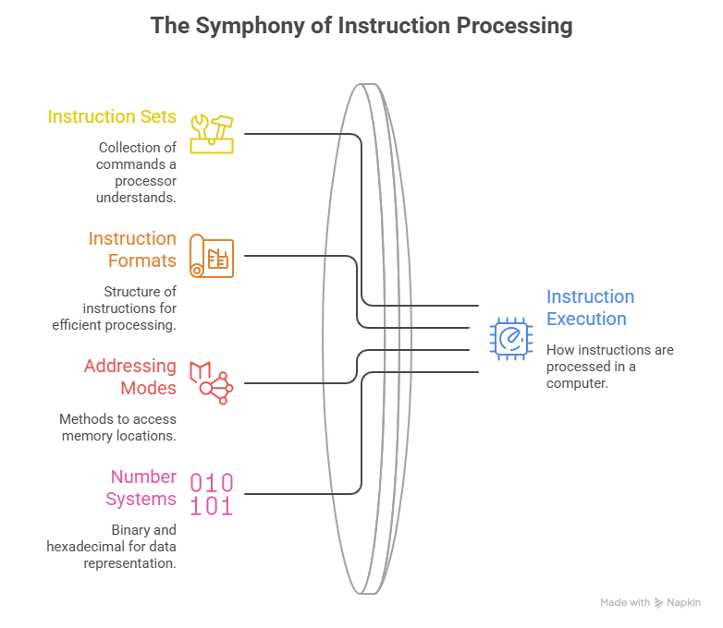

1. Instruction Sets
An instruction set is a collection of commands that a processor can execute.
Examples:
- ADD
- SUB
- MOV
- JMP
These instructions tell the CPU what operation to perform.

2. Instruction Formats
Instruction format defines how an instruction is arranged in memory.
Components:
- Opcode (operation code)
- Operand (data or address)
Example:
ADD R1, R2
- ADD = Opcode
- R1, R2 = Operands

3. Addressing Modes
Addressing modes specify how operands are accessed.
Types:
- Immediate Addressing
- Direct Addressing
- Indirect Addressing
- Register Addressing
These modes determine where the CPU finds the required data.

4. Binary Number System
Computers internally use binary numbers consisting of:
0 and 1
Example:
10110000
All instructions and data are stored in binary form.

5. Hexadecimal Number System
Hexadecimal is a compact representation of binary data.
Example:
Binary : 10110000
Hexadecimal : B0
Hexadecimal makes machine code easier for programmers to read and debug.

6. Instruction Representation and Execution
Fetch
- CPU fetches binary instructions from memory.
Decode
- Control Unit decodes the opcode and operands.
Execute
- ALU performs the required operation using the specified addressing mode.
Example:
Hex Code : B0 61
Binary : 10110000 01100001
Operation: Move data into a register

Conclusion
Instruction sets, instruction formats, and addressing modes work together to define how a computer processes data and executes programs. Instructions are stored internally in binary form and are often represented in hexadecimal form for easier interpretation. During program execution, the CPU fetches instructions from memory, decodes the opcode and operands, and executes the operation using the appropriate addressing mode. Thus, binary and hexadecimal number systems form the foundation for representing and processing computer instructions efficiently.

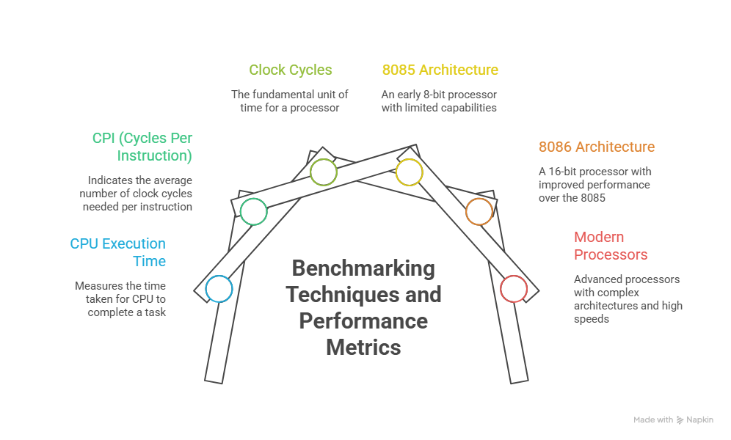

1. Benchmarking Techniques
Benchmarking is the process of measuring and comparing computer system performance.
Types:
- Synthetic Benchmarks – Artificial tests designed to evaluate performance.
- Application Benchmarks – Measure performance using specific software.
- Real-World Tests – Evaluate performance in practical situations.

2. Performance Metrics
CPU Execution Time
- Total time required to execute a program.
- Lower execution time indicates better performance.
Clock Cycles
- Number of processor cycles needed to complete instructions.
- Fewer cycles generally improve performance.
CPI (Cycles Per Instruction)
- Average number of clock cycles required for each instruction.
- Lower CPI means greater efficiency.

3. Performance Across Architectures
8085
- 8-bit microprocessor.
- Limited processing power.
- Higher execution time and CPI.
8086
- 16-bit architecture.
- Improved instruction handling.
- Better performance than 8085.
ARM Cortex
- RISC architecture.
- High efficiency with low power consumption.
- Lower CPI and faster execution.
Intel Core
- Advanced multi-core processor.
- Large cache memory and parallel execution.
- Very low execution time.
AMD Ryzen
- Multi-core and multithreaded architecture.
- Excellent parallel processing capability.
- High overall performance.

Conclusion
Benchmarking techniques provide a systematic way to evaluate computer performance using metrics such as CPU execution time, clock cycles, and CPI. These metrics reveal significant differences among processor architectures. The 8085 and 8086 processors exhibit higher execution times and lower processing capabilities compared to modern architectures.

