SIMATS ENGINEERING

ASSESSMENT TOOL 1

COURSE NAME:COMPUTER ARCHITECTURE COURSE CODE: CSA1203

NAME:P.AKSHAYA REGISTER NO:192525190

SLOT:C

COURSE OUTCOME COVERED

CO1: Components of a computer system, including CPU, memory, and I/O. Basic Operational Concepts: Instruction execution cycle, instruction fetch and decode.Bus Structures: Single-bus, multi-bus, and hierarchical buses.Factors of Performance: CPU execution time, CPI, clock cycles, and benchmarking.8085 and 8086 Architectures: Overview, instruction sets, and addressing modes. Modern Architectures: ARM Cortex, Intel Core, and AMD Ryzen.Instruction Sets, Formats, and Addressing Modes. Number Systems: Binary, hexadecimal, and their applications in computer systems. (BL4)
Assessment Tool Weightage: 40%

QUESTIONS:5 Total Marks:25

ANNEXURE A APPLICATION BASED QUESTIONS

Code of Conduct:

I P.AKSHAYA(192525190) certify that this submission is my original work and that I have adhered to the guidelines specified for this assessment.
I understand that any violation of academic integrity rules will result in disciplinary action.

Signature of the student:

ANNEXURE A

- A smart city surveillance system processes continuous video feeds from multiple cameras, where large volumes of data are transferred between I/O devices, memory, and CPU. During peak hours, the system experiences lag and delayed response in threat detection. Analyze how the interaction between CPU, memory, and I/O contributes to this issue, and explain how different bus structures (single-bus vs multi-bus) and improvements in instruction execution cycle can enhance system performance.
- A real-time stock trading application running on a processor executes millions of instructions per second, but users report delays in transaction processing during high load. The system has a high CPI due to frequent memory access and branch instructions. Examine how the fetch–decode–execute cycle impacts execution time in this scenario, and propose methods to reduce CPI and improve overall CPU performance using suitable architectural enhancements.
- An embedded system based on an 8085 microprocessor is used in an industrial temperature control unit, where sensors provide input and actuators respond accordingly. However, incorrect temperature readings are occasionally processed due to improper use of addressing modes in the program. Discuss how different addressing modes influence data access, identify possible causes of such errors, and suggest how the instruction set of 8085 can be effectively used to ensure accurate and reliable operation.
- A computing system uses an 8086 microprocessor with segmented memory for executing multiple programs simultaneously, but it encounters issues like incorrect data access and stack overflow errors. Evaluate how segmentation (code, data, and stack segments) works in 8086, analyze how improper segment handling can lead to such problems, and explain how instruction execution and addressing modes must be managed to ensure correct program execution.
- A data communication system represents packet information in hexadecimal format for ease of debugging and transmission, but a software engineer mistakenly interprets values, leading to incorrect data processing. Analyze the importance of number system conversions between hexadecimal and binary in such systems, explain how errors in conversion can affect instruction execution, and discuss how efficient CPU design and benchmarking can help detect and minimize such issues in real-time systems.

MARKS ALLOCATION

Criteria | Understanding of Problem Context (20%) | Application of Concepts (20%) | Problem-Solving Approach (20%) | Accuracy of Solution (20%) | Clarity (20%)
Q1
Q2
Q3
Q4
Q5

RUBRICS FOR CALCULATION:
Criteria | Weightage | Level 4 – Exemplary | Level 3 – Proficient | Level 2 – Developing | Level 1 – Beginning
Understan ding of Problem Context | 20 | Clearly understands the problem and accurately identifies all requirements | Good understanding with minor gaps | Basic understanding; some  requirements unclear | Poor understanding or misinterpretation of the problem
Application of Concepts | 30 | Accurately applies appropriate concepts to solve complex problems | Applies relevant concepts correctly with minor errors | Applies basic concepts with limited accuracy | Fails to apply appropriate concepts
Problem-Solving Approach | 20 | Logical, well-structured, and efficient approach | Mostly logical approach with minor gaps | Basic approach with some inconsistencies | Illogical or unclear approach
Accuracy of Solution | 20 | Completely correct solution with proper justification | Mostly correct with minor errors | Partially correct solution | Incorrect or incomplete solution
Clarity | 10 | Clear, well-organized, and properly explained solution | Understandable with minor clarity issues | Limited clarity and explanation | Poorly presented and difficult to understand

1. Smart City Surveillance System – CPU, Memory, I/O Interaction and Bus Structures
Introduction
A smart city surveillance system continuously receives video streams from multiple cameras. The data must be transferred from I/O devices (cameras) to memory and then processed by the CPU for threat detection. During peak hours, the large amount of data can create bottlenecks, causing lag and delayed responses.
Interaction Between CPU, Memory, and I/O
CPU
- Processes video frames and executes threat detection algorithms.
- Requires continuous access to data stored in memory.
Memory
- Stores video frames temporarily before processing.
- Acts as an intermediate storage between cameras and CPU.
I/O Devices
- Cameras continuously generate large amounts of video data.
- Transfer data to memory through I/O interfaces.
Cause of Lag
When many cameras send data simultaneously:
- CPU waits for data from memory.
- Memory becomes overloaded with video frames.
- I/O devices compete for bus access.
- Data transfer delays increase processing time.
Diagram 1: CPU–Memory–I/O Interaction
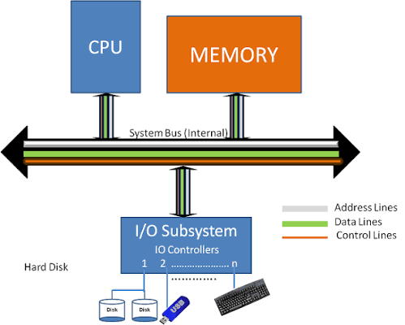
Characteristics
- One bus shared by CPU, memory, and I/O.
- Only one transfer can occur at a time.
- Creates traffic congestion during heavy loads.
Advantages
- Simple design.
- Low cost.
Disadvantages
- Reduced performance.
- Higher waiting time.
- Bus becomes a bottleneck.

Multi-Bus Structure
+------+
| CPU |
+------+
|
System Bus
|
+---------+---------+
| |
Memory Bus I/O Bus
| |
Memory Cameras
Characteristics
- Separate buses for memory and I/O.
- Multiple transfers occur simultaneously.
- Reduces contention.
Advantages
- Higher throughput.
- Faster communication.
- Better performance under heavy load.
Disadvantages
- Higher cost.
- More complex design.
Improving Instruction Execution Cycle
The instruction cycle consists of:
- Fetch
- Decode
- Execute
- Store Result
Performance Enhancements
1. Instruction Pipelining
- Overlaps instruction stages.
- Increases throughput.
2. Cache Memory
- Reduces memory access time.
- Frequently used data is stored near CPU.
3. DMA (Direct Memory Access)
- Allows I/O devices to transfer data directly to memory.
- CPU remains free for processing.
4. Parallel Processing
- Multiple cores process different video streams simultaneously.
5. High-Speed Buses
- Increase data transfer rate.
Conclusion
The lag in surveillance systems occurs due to heavy interaction between CPU, memory, and I/O devices. Using multi-bus architectures, DMA, cache memory, and pipelining can significantly improve performance and reduce response delays in threat detection systems.

2. Real-Time Stock Trading Application – Fetch–Decode–Execute Cycle and CPI Reduction
Introduction
A real-time stock trading application processes millions of transactions every second. During periods of heavy trading, delays may occur because the processor spends more clock cycles executing instructions. A high CPI (Cycles Per Instruction) caused by memory accesses and branch instructions reduces system performance.
Fetch–Decode–Execute Cycle
Every instruction passes through three main stages:
1. Fetch
- Instruction is fetched from memory.
2. Decode
- CPU interprets the instruction.
3. Execute
- Arithmetic, logic, or memory operation is performed.
4. Write Back
- Result is stored in register or memory.
Diagram 2: Instruction Execution Cycle
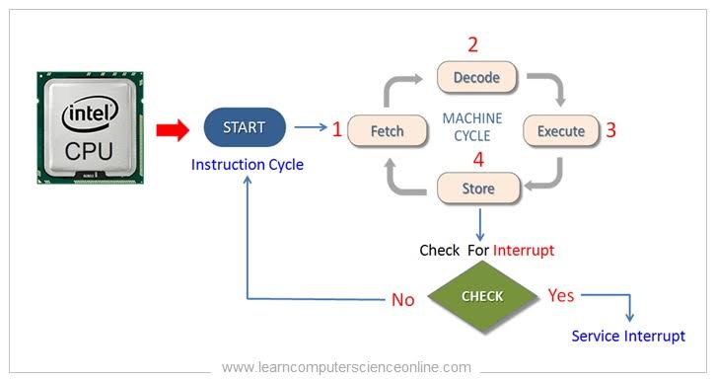
Impact on Execution Time
CPU execution time is:
CPU Time=Instruction Count×CPI×Clock Cycle Time\text{CPU Time} = Instruction\ Count \times CPI \times Clock\ Cycle\ TimeCPU Time=Instruction Count×CPI×Clock Cycle Time
Where:
- Instruction Count = Number of instructions executed.
- CPI = Cycles Per Instruction.
- Clock Cycle Time = Time per clock cycle.
High CPI Causes
Frequent Memory Access
- CPU waits for data from RAM.
- Memory latency increases execution time.
Branch Instructions
- Conditional jumps interrupt instruction flow.
- Wrong branch prediction causes pipeline stalls.
Cache Misses
- Data not found in cache.
- Additional memory accesses required.
Effects on Stock Trading System
- Delayed transaction execution.
- Slow order matching.
- Reduced responsiveness.
- Possible financial losses.
Methods to Reduce CPI
1. Cache Memory Improvement
- Increase cache size.
- Use multi-level caches (L1, L2, L3).
- Reduce memory access delays.
2. Pipelining
Cycle 1 : Fetch I1
Cycle 2 : Decode I1 + Fetch I2
Cycle 3 : Execute I1 + Decode I2 + Fetch I3
Benefits:
- Multiple instructions processed simultaneously.
- Higher throughput.
3. Branch Prediction
- Predicts likely execution path.
- Reduces pipeline stalls.
4. Superscalar Architecture
- Executes multiple instructions in one clock cycle.
5. Out-of-Order Execution
- Executes independent instructions earlier.
- Keeps CPU units busy.
6. Prefetching
- Loads instructions and data before needed.
- Reduces waiting time.
7. Faster Memory Systems
- High-speed RAM.
- Larger caches.
- Reduced memory latency.
Architectural Enhancements
Enhancement | Benefit
Cache Memory | Reduces memory access time
Pipelining | Increases throughput
Branch Prediction | Reduces branch penalties
Superscalar CPU | Executes multiple instructions simultaneously
Multicore Processor | Handles multiple tasks concurrently
Out-of-Order Execution | Improves CPU utilization
Conclusion
In a real-time stock trading system, high CPI caused by memory accesses and branch instructions increases execution time. Techniques such as pipelining, branch prediction, cache optimization, superscalar processing, and faster memory architectures significantly reduce CPI and improve CPU performance, ensuring faster transaction processing during high-load conditions.

3. 8085 Microprocessor in an Industrial Temperature Control Unit

Introduction
An industrial temperature control unit uses an 8085 microprocessor to read temperature values from sensors and control actuators such as heaters, coolers, or fans. The accuracy of the system depends on the correct use of addressing modes and instructions. Improper addressing can cause the microprocessor to access incorrect memory locations, leading to wrong temperature readings and faulty control actions.

Addressing Modes in 8085 and Their Influence

1. Immediate Addressing Mode
The data is included directly in the instruction.
Example:
MVI A,25H
Here, 25H is loaded directly into the accumulator.

2. Register Addressing Mode
Data is stored in registers.
Example:
MOV A,B
Transfers the contents of register B to A.

3. Direct Addressing Mode
The memory address containing data is specified in the instruction.
Example:
LDA 2500H
Loads data from memory location 2500H.

4. Register Indirect Addressing Mode
The memory address is stored in a register pair.
Example:
MOV A,M
Loads data from the memory location pointed to by HL pair.

5. Implied Addressing Mode
The operand is implied in the instruction.
Example:
CMA
Complements the accumulator contents.
Causes of Incorrect Temperature Readings
- Wrong memory address used to store sensor data.
- Incorrect HL register pair contents.
- Corruption of sensor data due to program errors.
- Improper use of direct and indirect addressing modes.
- Noise or faulty sensor interfacing causing invalid data.

Effective Use of 8085 Instruction Set
- LDA/STA for accurate memory access.
- MOV/MVI for reliable data transfer.
- CMP for comparing temperature values with reference values.
- JZ, JC, JMP for decision-making.
- IN and OUT instructions for sensor and actuator interfacing.
- Validation routines can be added before processing sensor values.

Diagram 1: 8085-Based Temperature Control System

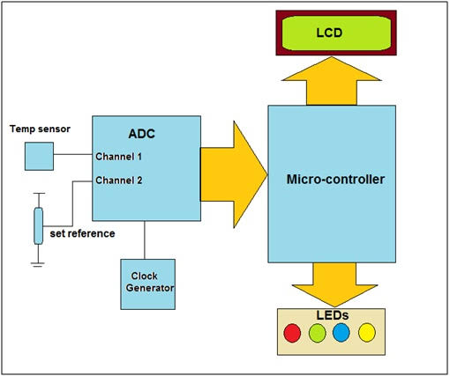
Working
- Sensor measures temperature.
- Data is sent to the 8085.
- Microprocessor reads data using suitable addressing modes.
- Temperature is compared with preset values.
- Appropriate actuator action is taken.
Conclusion
Proper use of addressing modes and instructions in the 8085 ensures correct data access, prevents processing errors, and improves the reliability of industrial temperature control systems.

4. 8086 Segmentation and Memory Management
Introduction
The 8086 microprocessor has a 20-bit address bus and can access up to 1 MB of memory. To manage this large memory space efficiently, it uses a segmentation technique. Memory is divided into code, data, stack, and extra segments.
Segmentation in 8086
1. Code Segment (CS)
- Stores program instructions.
- Works with the Instruction Pointer (IP).
2. Data Segment (DS)
- Stores variables and data used by programs.
3. Stack Segment (SS)
- Stores temporary data, return addresses, and register contents.
4. Extra Segment (ES)
- Additional data storage area.
Physical Address Calculation
The physical address is calculated as:
Physical Address=(Segment Address×10H)+Offset\text{Physical Address} = (\text{Segment Address} \times 10H) + \text{Offset}Physical Address=(Segment Address×10H)+Offset
Example
DS = 3000H
Offset = 2500H

Physical Address
= 3000H × 10H + 2500H
= 32500H
Diagram 2: 8086 Memory Segmentation
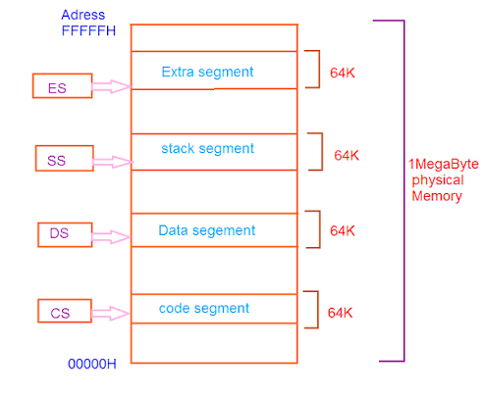

problems Due to Improper Segment Handling
Incorrect Data Access
- Wrong DS value causes access to incorrect memory locations.
- Results in corrupted data processing.
Wrong Instruction Execution
- Incorrect CS value causes execution of unintended instructions.
Stack Overflow
Occurs when excessive PUSH operations exceed stack capacity.
Stack Underflow
Occurs when POP instructions are executed more times than PUSH instructions.
Multitasking Problems
Different programs may overwrite each other's memory if segment registers are not managed correctly.
Managing Addressing Modes Properly
- Use base, indexed, and based-indexed addressing carefully.
- Initialize all segment registers before execution.
- Balance PUSH and POP operations.
- Monitor stack usage during execution.
Instruction Execution Process
- BIU fetches instruction from CS:IP.
- EU decodes and executes instruction.
- Data is accessed through DS.
- Stack operations use SS.
Conclusion
Correct handling of segment registers and addressing modes is essential for proper program execution. It prevents stack overflow, data corruption, and memory access errors in multitasking environments.

5. Number System Conversion, CPU Design, and Benchmarking

Introduction
In data communication systems, packet data is often represented in hexadecimal form because it is compact and easy to read. Internally, processors operate using binary data. Therefore, accurate conversion between hexadecimal and binary is essential for reliable communication and instruction execution.
Importance of Hexadecimal and Binary Conversion
Hexadecimal Representation
Hexadecimal uses sixteen symbols:
0 1 2 3 4 5 6 7 8 9 A B C D E F
Example Conversion
Convert hexadecimal 5A to binary:
5 = 0101
A = 1010

5A = 01011010
Advantages:
- Easier debugging.
- Compact representation.
- Simplifies memory address display.
- Widely used in communication protocols.
Role in Data Communication Systems
- Packet headers are often displayed in hexadecimal.
- Memory addresses are represented in hexadecimal.
- Network analyzers and debuggers use hexadecimal notation.
Effects of Conversion Errors
Example
Correct Conversion:
3A = 00111010
Incorrect Conversion:
3E = 00111110
Consequences:
- Incorrect packet decoding.
- Wrong instruction execution.
- Data corruption.
- Communication failure.
- Real-time system malfunction.
Impact on Instruction Execution
The CPU executes instructions based on binary patterns.
Example:
Hex Code → Binary → CPU Instruction
If conversion is incorrect:
- Different instruction may execute.
- Program may crash.
- Unexpected results may occur.
Efficient CPU Design
Features
- High processing speed.
- Error-checking mechanisms.
- Efficient instruction pipeline.
- Improved memory management.
- Faster arithmetic and logic operations.
Benefits
- Faster packet processing.
- Reduced communication delay.
- Better real-time performance.
CPU Benchmarking
Benchmarking evaluates:
- Execution speed.
- Throughput.
- Latency.
- Response time.
- Error handling capability.
Importance
- Detects performance bottlenecks.
- Identifies conversion-related errors.
- Measures system reliability.
- Helps optimize communication systems.
Diagram 3: Hexadecimal to Binary Conversion
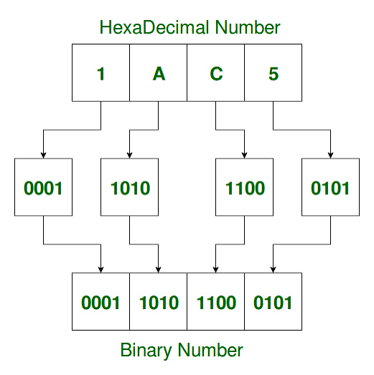

Conclusion

Accurate hexadecimal-to-binary conversion is crucial in communication systems because even a single-bit error can alter data or instructions. Efficient CPU design and benchmarking help identify and minimize such errors, ensuring reliable and high-performance real-time system operation.

