COMPILER DESIGN LAB EXPERIMENT
Email Validation Using FLEX

1. Aim
To design and implement a lexical analyzer using FLEX to identify email-address patterns from a text input file.

2. Algorithm
- Start the program.
- Check whether the input filename is supplied as a command-line argument.
- Open the specified input file in read mode.
- If the file cannot be opened, display an error message and terminate.
- Assign the file pointer to yyin.
- Call yylex() to scan the input file.
- Match text that follows the email regular expression.
- Print each matched string as a valid email pattern and ignore other characters.
- Close the input file.
- Stop.

3. Pseudocode
BEGIN
IF command-line argument count is not 2 THEN
DISPLAY usage message
EXIT with error
END IF

OPEN input file in read mode
IF file pointer is NULL THEN
DISPLAY file-opening error
EXIT with error
END IF

SET yyin to the input file
CALL yylex()
CLOSE input file
END

4. FLEX Program
%{
#include <stdio.h>
%}

%%
[A-Za-z0-9._%+-]+@[A-Za-z0-9.-]+\.[A-Za-z]{2,} {
printf("Valid Email: %s\n", yytext);
}
.|\n ;
%%

int yywrap(void)
{
return 1;
}

int main(int argc, char *argv[])
{
if (argc != 2)
{
printf("Usage: %s input.txt\n", argv[0]);
return 1;
}

FILE *fp = fopen(argv[1], "r");

if (fp == NULL)
{
printf("Error opening file!\n");
return 1;
}

yyin = fp;
yylex();

fclose(fp);
return 0;
}

5. Sample Input File (input.txt)
karthik@gmail.com
student123@yahoo.in
hello@college.edu
invalid-email
abc@domain

6. Sample Output

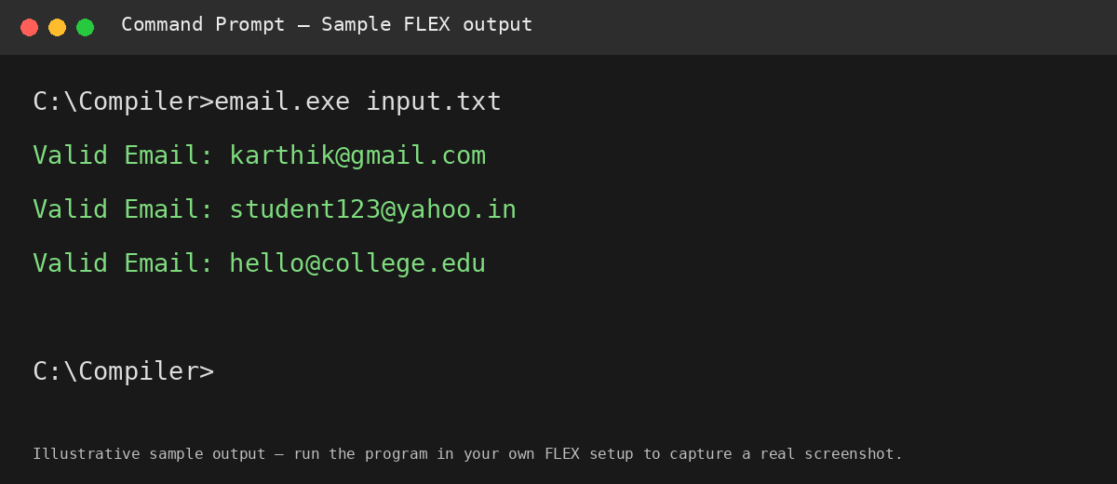

7. Result
Thus, the FLEX lexical analyzer was designed to scan a text file and print strings matching the specified email-address pattern.

