EXPERIMENT: LEX PROGRAM TO REPLACE “HELLO” WITH “HI”

1. AIM
To write a LEX program to identify the word hello in the input and replace it with hi, while displaying all other characters unchanged.

2. ALGORITHM
- Start the program.
- Include the required header file stdio.h.
- Define the LEX rules section.
- Specify the pattern hello to identify the word.
- Print hi whenever the word hello is encountered.
- Use the ECHO statement to display other characters unchanged.
- Use yywrap() to indicate the end of input.
- Call the yylex() function from the main() function.
- Execute the program and observe the output.
- Stop the program.

3. PSEUDOCODE
BEGIN
INITIALIZE LEX PROGRAM

IF input matches "hello" THEN
PRINT "hi"
ELSE
DISPLAY the input character
END IF

CONTINUE SCANNING INPUT

STOP AT END OF INPUT
END

4. PROGRAM
File name: hello.l
%{
#include <stdio.h>
%}

%%
hello { printf("hi"); }
. { ECHO; }
\n { ECHO; }
%%

int yywrap()
{
return 1;
}

int main()
{
yylex();
return 0;
}

5. SAMPLE INPUT
hello
hello world
hello everyone

6. SAMPLE OUTPUT

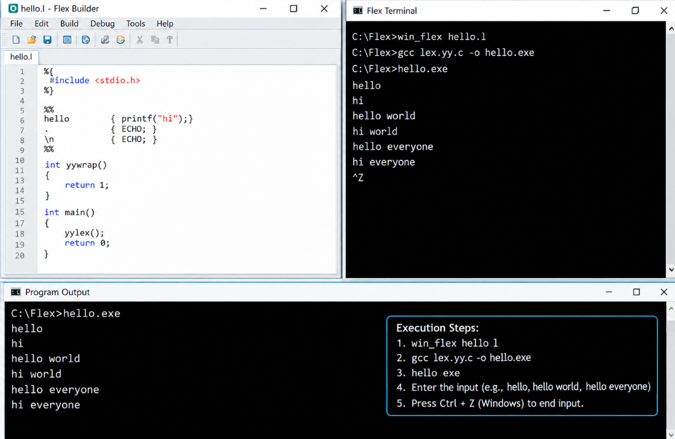

7. EXECUTION COMMANDS
For Windows using WinFlexBison and GCC:
win_flex hello.l
gcc lex.yy.c -o hello.exe
hello.exe

For Linux:
flex hello.l
gcc lex.yy.c -o hello
./hello

8. RESULT
Thus, the LEX program to identify the word hello and replace it with hi, while displaying other characters unchanged, was written and executed successfully.

