EX-13: Create a virtual machine (VM) with 2 GB RAM,15 GB hard disk on a storage disk and No. of processors = 4.

AIM:
To create a Virtual Machine (VM) with the following specifications using virtualization software
- RAM: 2 GB
- Hard Disk: 15 GB
- Processors: 4

PROCEDURE:
Step 1: Open the VirtualBox (VMware Workstation) software.
Step 2: Click New to create a new virtual machine.
Step 3: Enter the VM name and select the operating system and version.
Step 4: Set the RAM to 2 GB and click Next.
Step 5: Select Create a Virtual Hard Disk Now and click Create.
Step 6: Choose the disk file type (VDI) and select Dynamically Allocated.
Step 7: Set the virtual hard disk size to 15 GB and click ok.
Step 8: open the processors under the hard disk and set the no. of processors = 4 and click ok.
Step 9: launch/finish the VM (virtual machine).
Step 10: Now you can verify that the VM (virtual machine) has 2 GB RAM, 15 GB hard disk, and 4 processors.

1.SETTING OF HARD DISK DATA(GB):

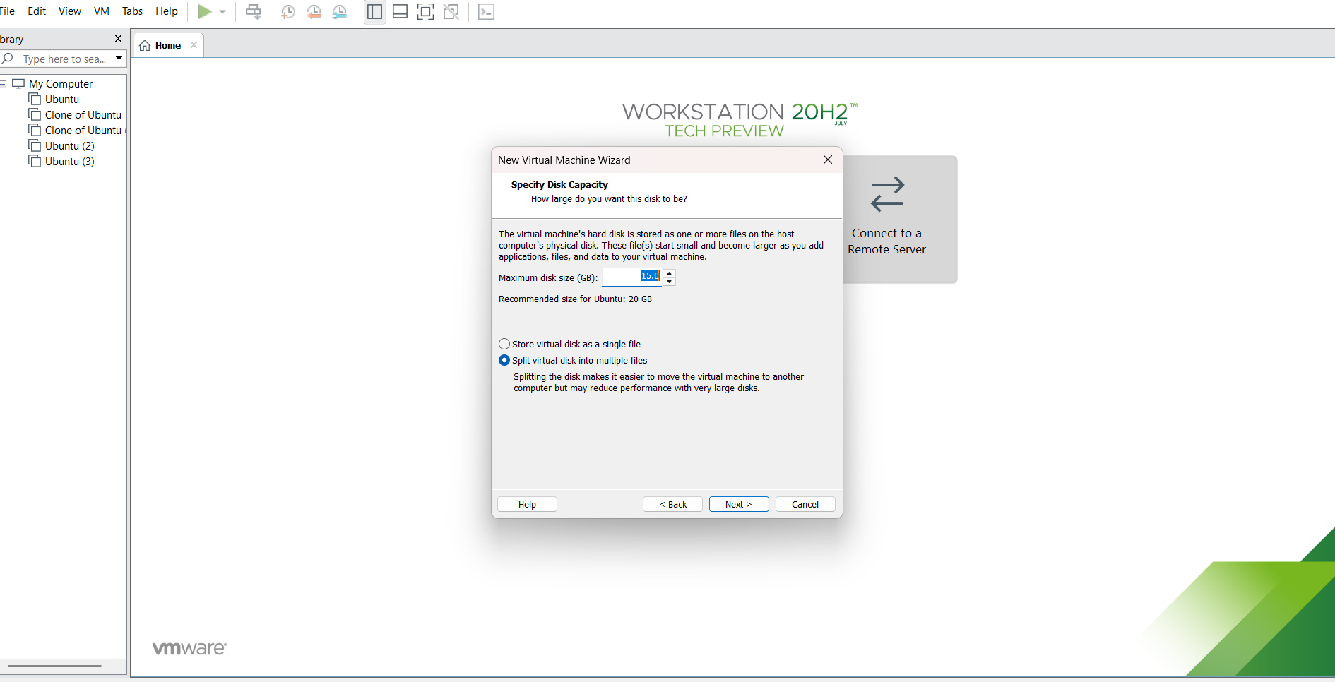

2.SELECTING MEMORY DATA(GB):

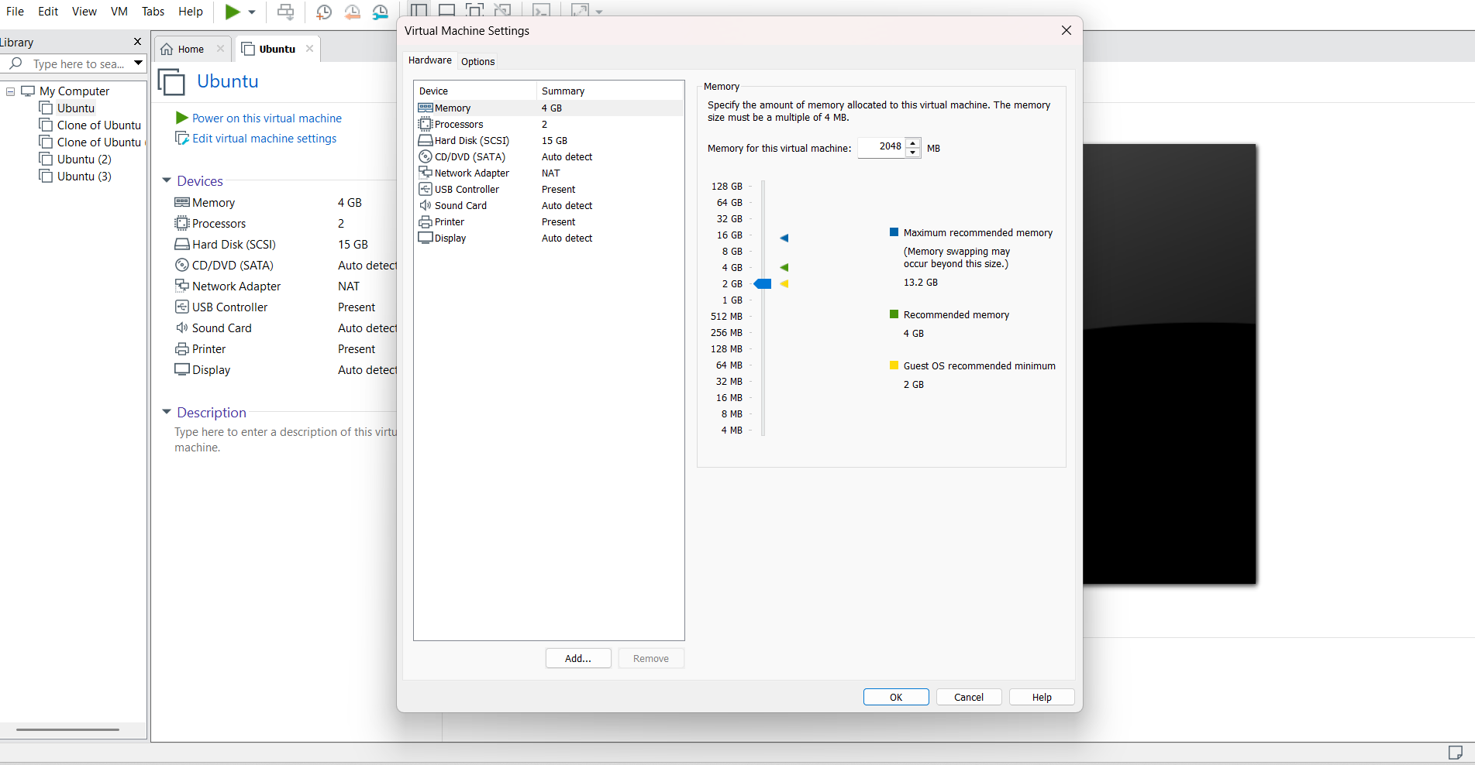
3. SELECTING NO. OF PROCESSORS:

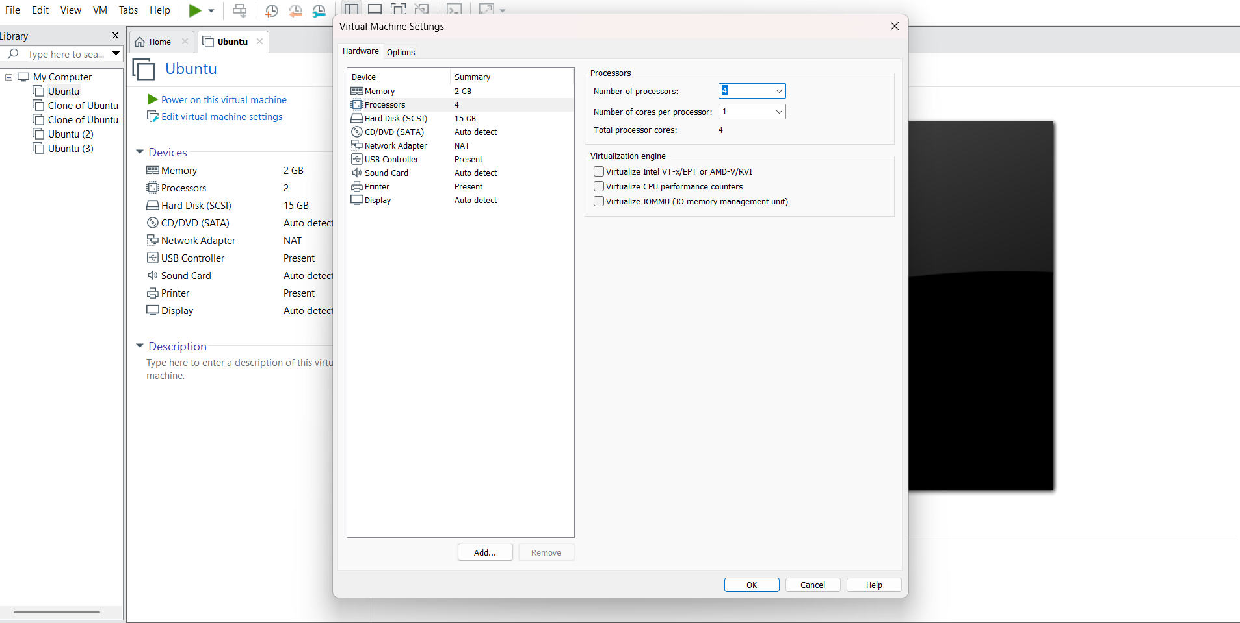

OUTPUT:

