EX-14: Create a virtual machine (VM) using snapshot.

AIM:
To create a snapshot of a Virtual Machine (VM) and use it to save and restore the VM's state whenever required.

PROCEDURE:

Step 1: Open the VirtualBox (VMware Workstation) software.
Step 2: create a virtual machine and fix the hard disk storage is either 20 or 15 and click ok.
Step 3: Ensure the VM is in the required state (powered off or running).
Step 4: Click the VM option In the file and select Snapshots option.
Step 5: Click Take Snapshot (or Create Snapshot).
Step 6: Enter a snapshot name and description.
Step 7: Click OK to create and save the snapshot.
Step 8: Make any required changes to the virtual machine.
Step 9: To restore the previous state, open the Snapshots tab.
Step 10: Select the required snapshot in the snapshot manager and click Restore.
Step 11: By using snapshot manager can also observe no. of snapshots
Step 12: Confirm the restore operation when prompted.
Step 13: Start the virtual machine and verify that it has returned to the saved snapshot state.

1.SELECTING SNAPSHOT OPTION:

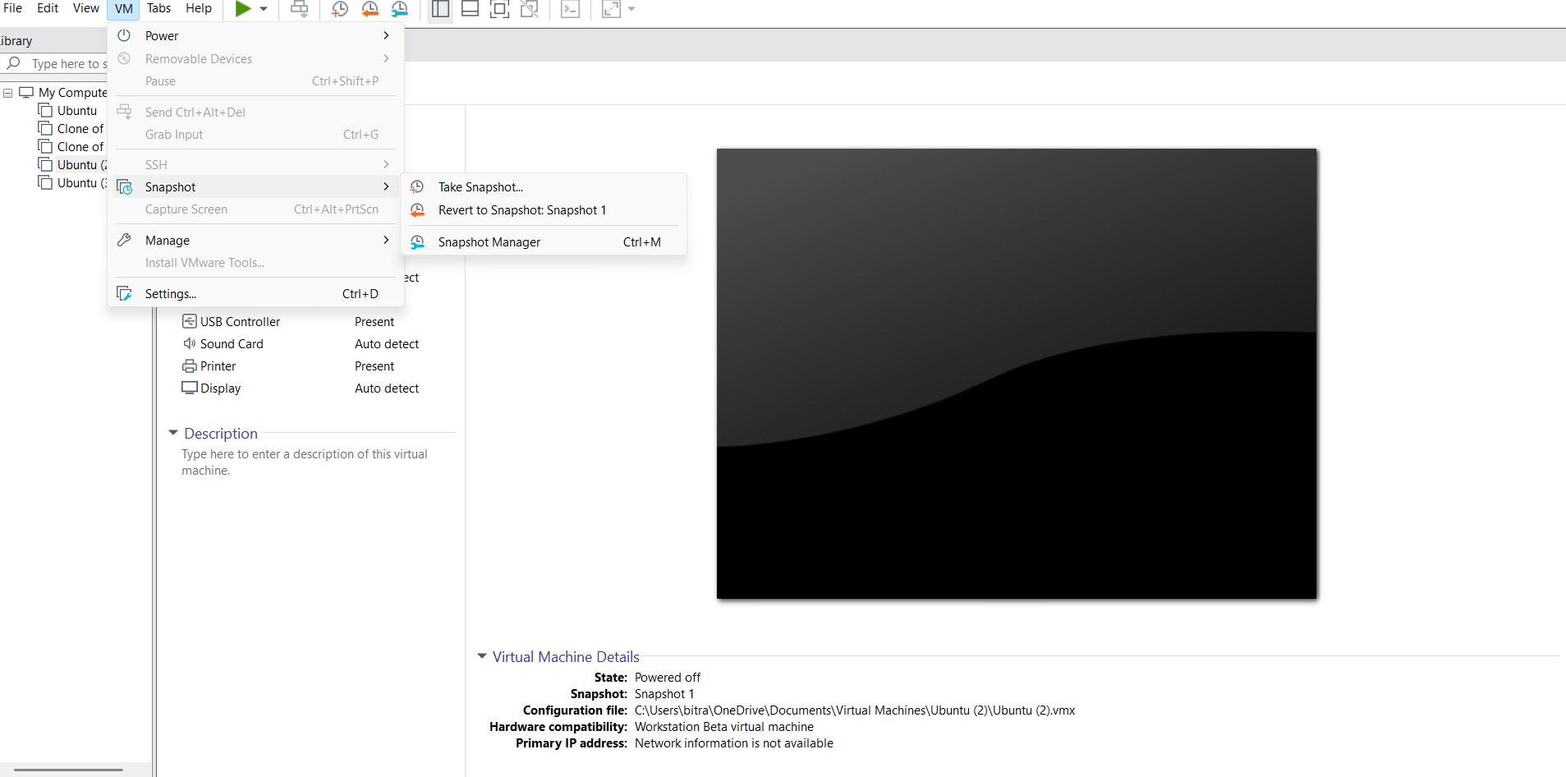

2. RETRIEVE OR RESTORING THE SNAPSHOT:

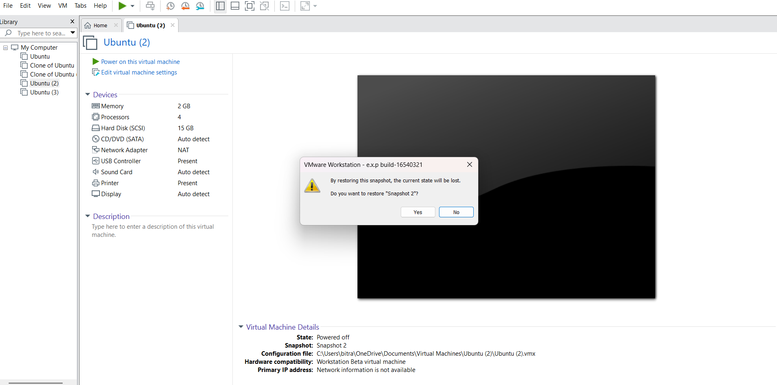
3. OBSERVING NO. OF SNAPSHOTS:

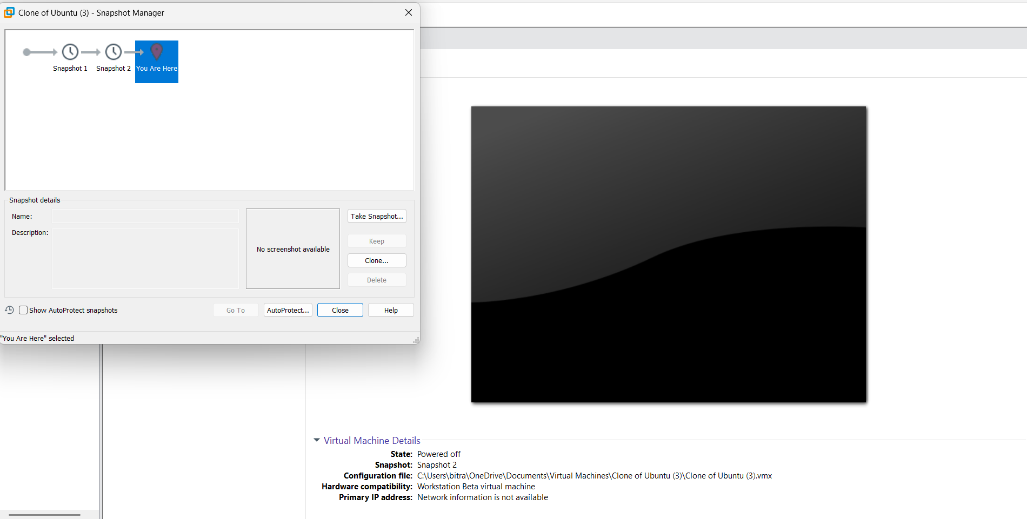

OUTPUT:

