EX-16: Create a virtual machine (VM) in windows OS of above compared & simple UNIX command in UNIX OS.

AIM:

To create a Virtual Machine (VM) in Windows OS and execute simple UNIX commands in a UNIX/Linux operating system for comparison with Windows commands.

PROCEDURE:

Step 1: Open VMware Workstation or Oracle VirtualBox.
Step 2: Click Create New Virtual Machine.
Step 3: Select Typical (Recommended) and click Next.
Step 4: Choose the Linux ISO file (e.g., Ubuntu) and click Next.
Step 5: Enter the VM name and select the installation location.
Step 6: Allocate 2 GB RAM, 15 GB Hard Disk, and 2 Processors (or as instructed).
Step 7: Click Finish to create the Virtual Machine.
Step 8: Power on the VM and complete the Linux installation.
Step 9: Log in to the Linux operating system.
Step 10: Open the Terminal.
Step 11: Execute the simple UNIX commands given below.
Step 12: Compare the UNIX commands with the equivalent Windows Command Prompt commands and record the output.

CODE:

S.No | Purpose | Windows Command | UNIX/Linux Command
1 | Show current directory | cd | pwd
2 | List files and folders | dir | ls
3 | Change directory | cd folder name | cd folder name
4 | Create a folder | mkdir folder name | mkdir folder name
5 | Delete a folder | rmdir foldername | rmdir folder name
6 | Create a file | type nul > file.txt | touch file.txt
7 | Delete a file | del file.txt | rm file.txt
8 | Display file contents | type file.txt | cat file.txt
9 | Clear the screen | cls | clear
10 | Show current user | whoami | whoami

1.VM Machine

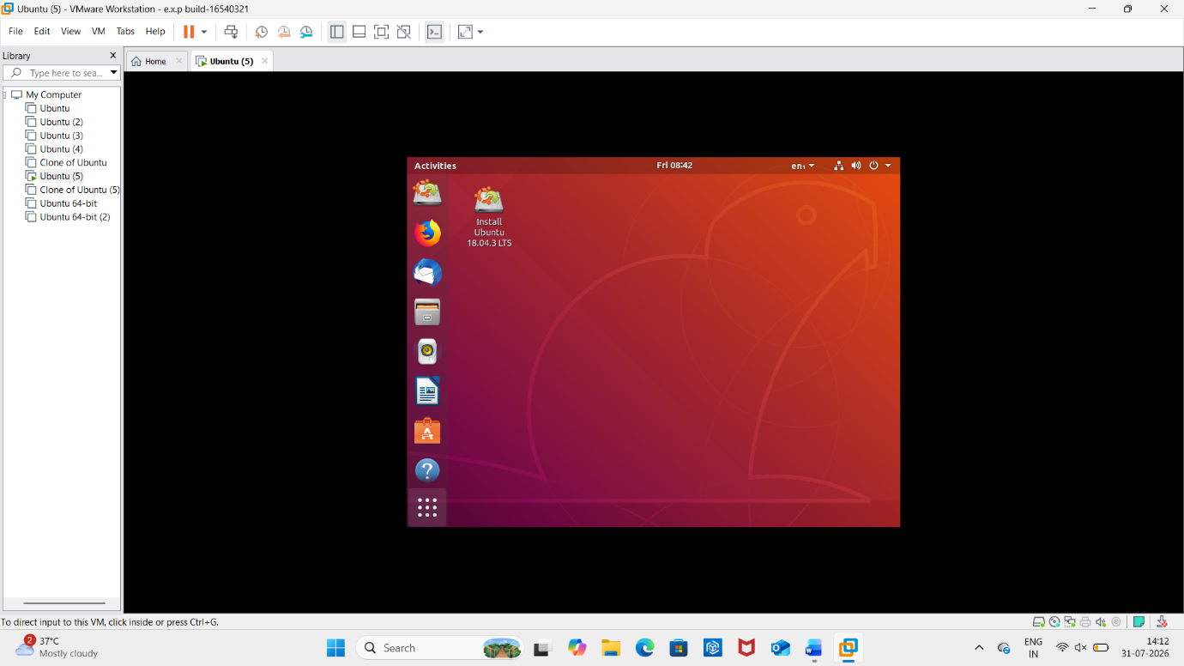

2.Terminal option:

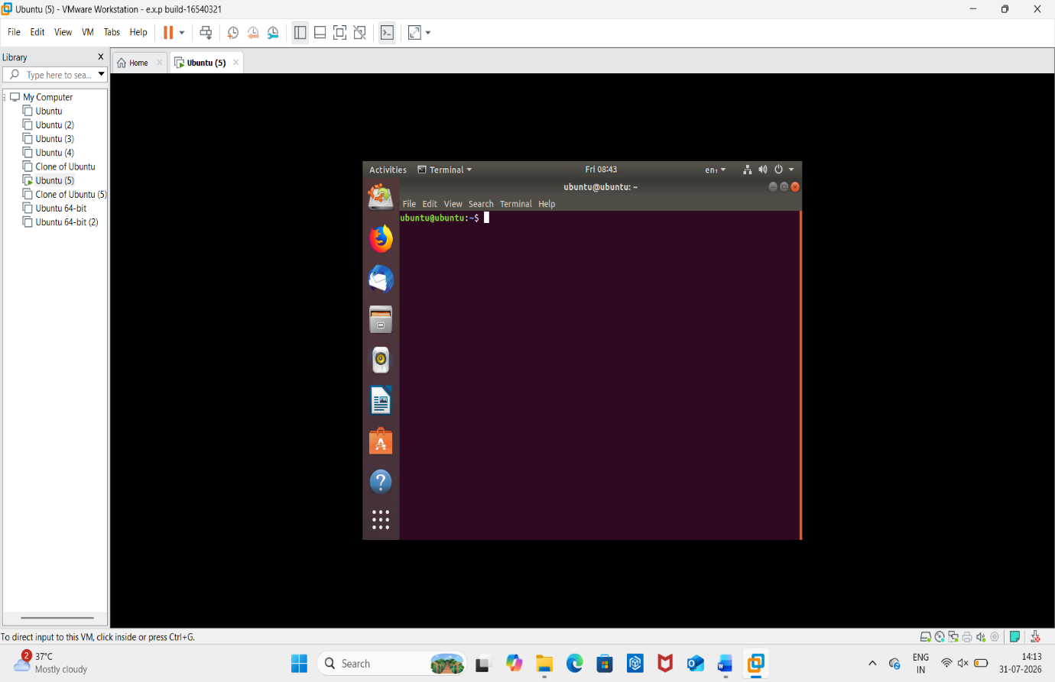
3. SIMPLE COMMANDS & OUTPUT:

