EXP NO -12: Create a virtual machine with 2 GB RAM,20 GB hard disk & No. of processors = 2 and additional hard disk of size 3GB.

AIM:
To create a Virtual Machine (VM) with the following specifications using virtualization software
- RAM: 2 GB
- Hard Disk: 20 GB
- Processors: 2
- Additional Hard Disk: 3 GB

PROCEDURE:
Step 1: Open VM ware work station and click New to create a virtual machine.
Step 2: Enter the VM name, select the operating system, and click Next.
Step 3: Set the memory (RAM) to 2 GB and click Next.
Step 4: Create a 20 GB virtual hard disk and click Create.
Step 5: Open Processor and set the number of processors to 2 and click ok.
Step 6: Open hard disk and add a new virtual hard disk, and set its size to 3 GB and click ok
Step 7: launch/finish the VM (virtual machine)

1.SELECTING MEMORY DATA(GB):

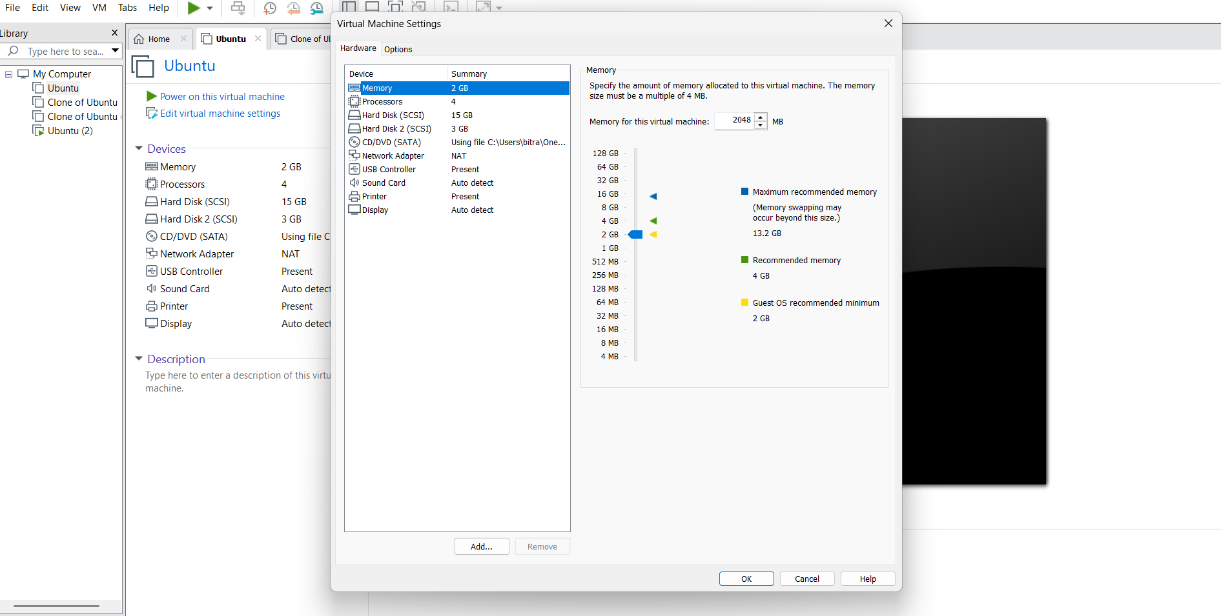

2.SELECTING NO. OF PROCESSORS:

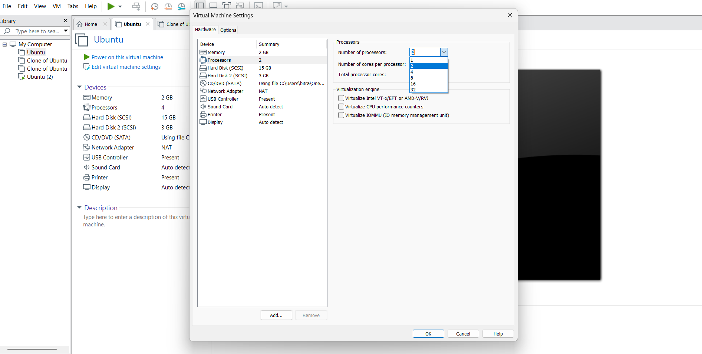
3.SETTING OF HARD DISK DATA(GB):

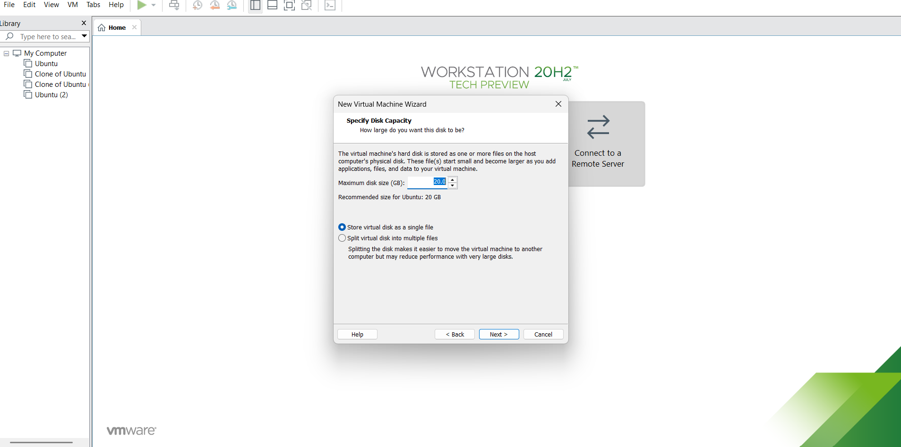

3. ADDING EXTRA HARD DISK:

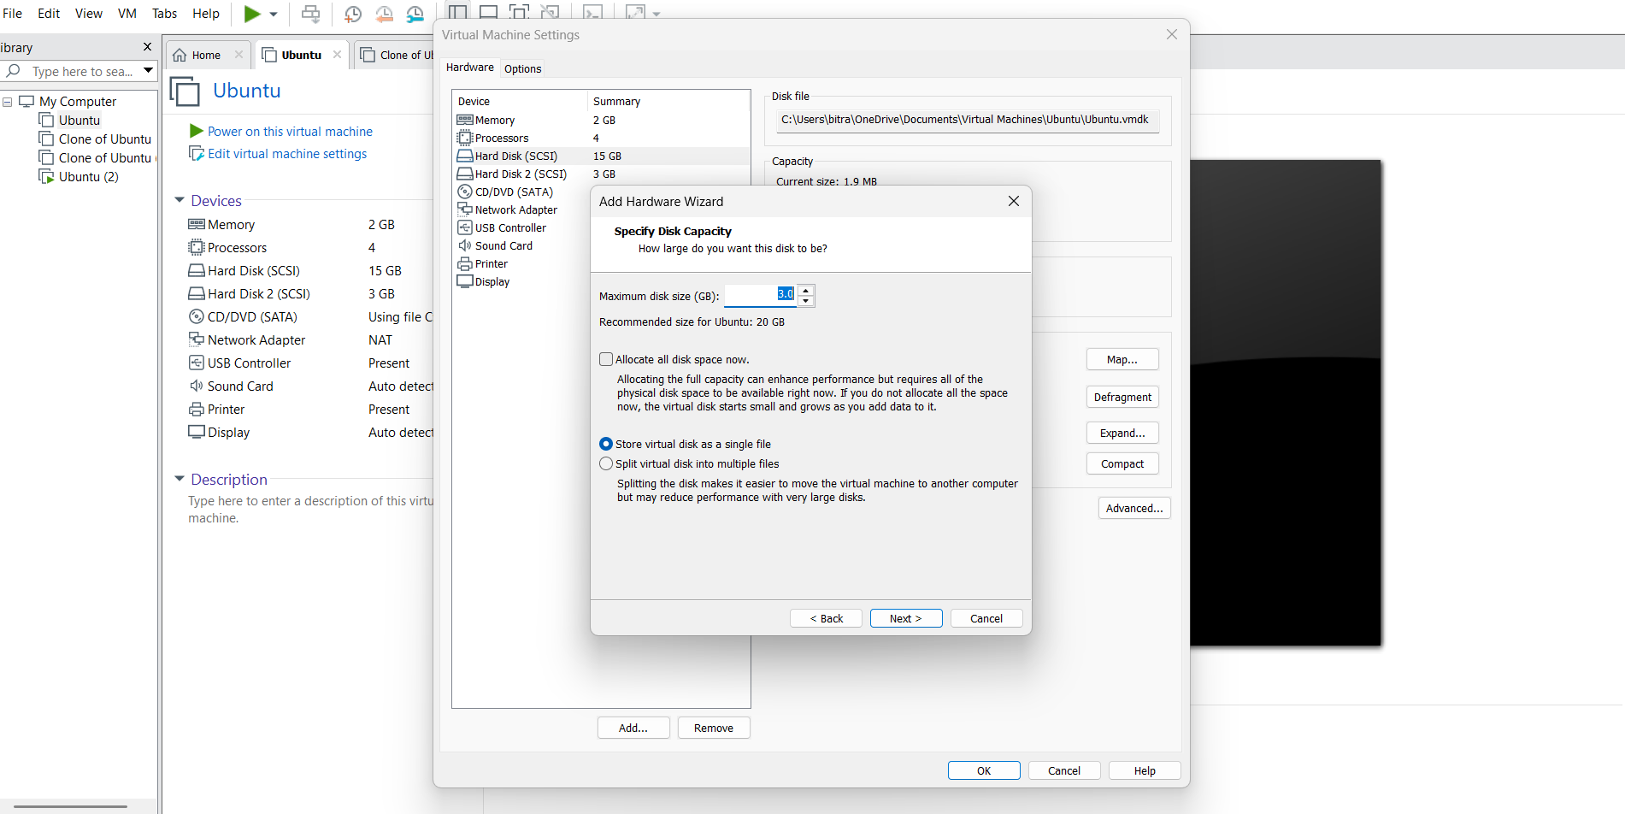

OUTPUT:

