EX-15: Create virtual machine (VM) using clone.

AIM:

To create a clone of an existing Virtual Machine (VM) using virtualization software such as VMware Workstation.

PROCEDURE:

Step 1: Open the virtualization software (VMware/VirtualBox).
Step 2: Select the existing virtual machine that you want to clone.
Step 3: Make sure the virtual machine is powered off.
Step 4: Right-click the VM and select Manage → Clone (or Clone).
Step 5: Click Next to start the Clone Wizard.
Step 6: Choose the clone type (Full Clone or Linked Clone).
Step 7: Enter a name and choose the location to save the cloned VM.
Step 8: Click Finish and wait until the cloning process is complete.
Step 9: Select the newly created cloned virtual machine.
Step 10: Power on the cloned VM and verify that it starts successfully.

Result:

The existing virtual machine was successfully cloned, and the cloned VM was created and booted successfully.

1.INCLUDING OF CLONE FROM VM

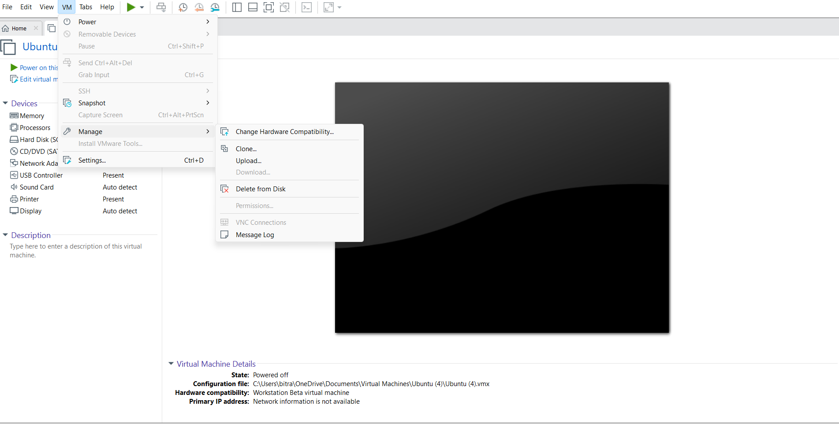

2. TYPE OF THE CLONE

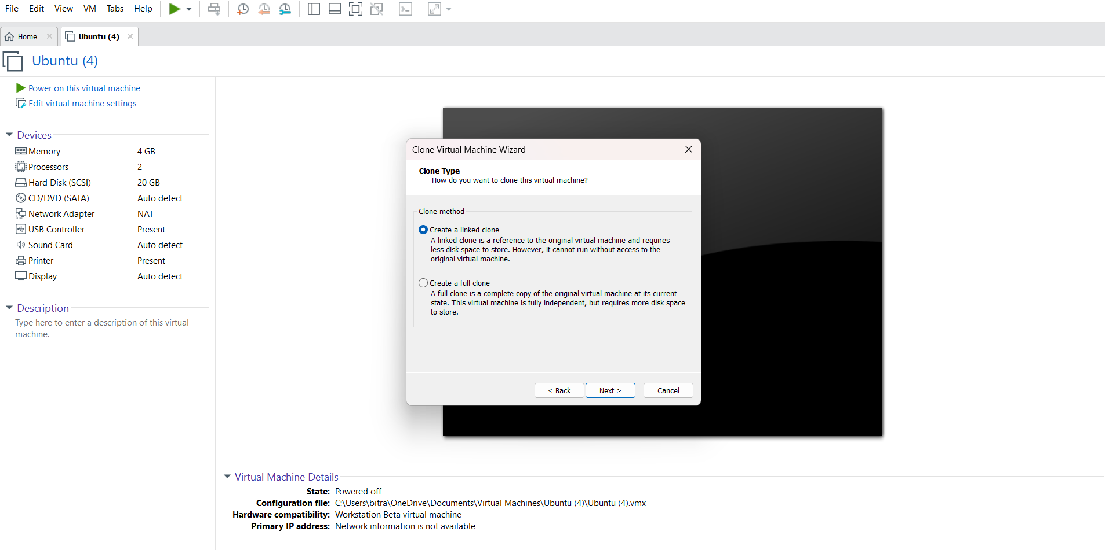
0UTPUT

