DSA0602 – Data Handling and Visualization
Activity: Identify Skewness using Violin Plots – Slot D

Answer Sheet
Rule used: a longer tail towards higher values indicates right (positive) skew; a longer tail towards lower values indicates left (negative) skew; similar tails indicate symmetry. For right-skewed data, mean is usually greater than median; for left-skewed data, mean is usually less than median; for symmetric data, mean is approximately equal to median.

Part A – Identify skewness and compare mean with median
Chart / Violin | Skewness (circle one) | Mean vs Median | Reason
Chart 1 – Group 1 | Right skew | Mean > Median | Longer tail extends to higher step counts.
Chart 1 – Group 5 | Left skew | Mean < Median | Longer tail extends to lower step counts.
Chart 1 – Group 4 | Symmetric (approx.) | Mean ≈ Median | The shape is fairly balanced around its centre.
Chart 2 – City | Right skew | Mean > Median | The upper-income tail extends to higher values.
Chart 2 – Village | Left skew | Mean < Median | The lower-value tail is longer.
Chart 2 – Metro | Symmetric (approx.) | Mean ≈ Median | The distribution is roughly balanced.
Chart 3 – Class A | Symmetric (approx.) | Mean ≈ Median | The violin is broadly balanced around the centre.
Chart 3 – Class B | Left skew | Mean < Median | The tail stretches farther towards lower marks.
Chart 3 – Class D | Right skew | Mean > Median | The tail stretches farther towards higher marks.
Chart 4 – Ward B | Right skew | Mean > Median | The longer tail reaches towards longer waiting times.
Chart 4 – Ward D | Symmetric (approx.) | Mean ≈ Median | The shape is approximately balanced.
Chart 4 – Ward E | Left skew | Mean < Median | The tail extends farther towards shorter waiting times.

Part B – Written answers
B1. In Chart 3, violin "Class B" has a longer tail towards the lower marks, so it is left-skewed. The median is the better measure of a typical exam mark because the mean can be pulled down by the tail and is more affected by extreme values.
B2. One ggplot2 line to draw a violin for each group and show the median is:
ggplot(df, aes(x = group, y = value)) + geom_violin() + stat_summary(fun = median, geom = "point", shape = 23, size = 2)

Visual reference – original worksheet
The worksheet images are included below for reference.
Charts 1 and 2: Daily steps and monthly income
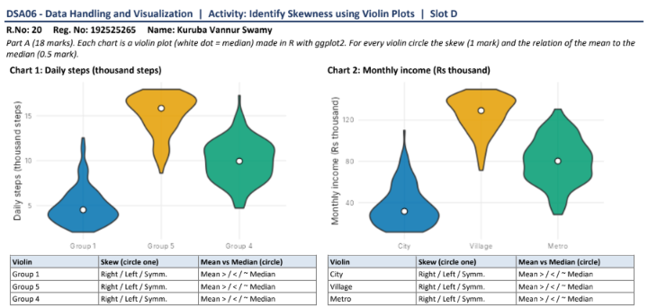
Charts 3 and 4: Exam marks and waiting time
