LAB EXPERIMENT RECORD
SET 27: PATIENT HEALTH RISK ANALYSIS
Particulars | Details
Department | AIML
Course Code / Course Name | DSA0601 / Data Handling and Visualization
Experiment | Data Visualization using R
Name | KURUBA VANNUR SWAMY
Register Number | 192525265
Date | 15 OCTOBER 2026
Day | Thursday

Aim
To explore patient health indicators using a bar chart of average indicators, a scatterplot matrix, and an empirical cumulative distribution function (ECDF) of cholesterol values.

Dataset: Patient Health Indicators
Patient ID | Age | BMI | Blood Pressure (BP) | Cholesterol
P1 | 25 | 22 | 120 | 180
P2 | 40 | 28 | 135 | 210
P3 | 55 | 30 | 145 | 240
P4 | 35 | 26 | 130 | 200
P5 | 60 | 32 | 150 | 260

PROGRAM 1: Bar Chart of Average Patient Health Indicators
To calculate average age, BMI, blood pressure, and cholesterol, then display the values in a labeled bar chart.
# SET 27 - PROGRAM 1
health_data <- data.frame(
Age = c(25, 40, 55, 35, 60),
BMI = c(22, 28, 30, 26, 32),
BP = c(120, 135, 145, 130, 150),
Cholesterol = c(180, 210, 240, 200, 260)
)
averages <- colMeans(health_data)
bar_positions <- barplot(
averages,
names.arg = c("Age", "BMI", "Blood Pressure", "Cholesterol"),
main = "Average Patient Health Indicators",
xlab = "Health Indicators",
ylab = "Average Value",
col = c("skyblue", "lightgreen", "orange", "pink"),
ylim = c(0, max(averages) * 1.15),
las = 2
)
text(bar_positions, averages,
labels = round(averages, 2), pos = 3, cex = 0.9)
print(averages)

Procedure: Create the numeric data frame, use colMeans() to compute the averages, draw a bar chart using barplot(), and add the numerical labels with text().
Observation / Result: The averages are Age = 43, BMI = 27.6, Blood Pressure = 136, and Cholesterol = 218. The indicators use different units and scales, so the bar heights should not be compared as if they measured the same quantity.
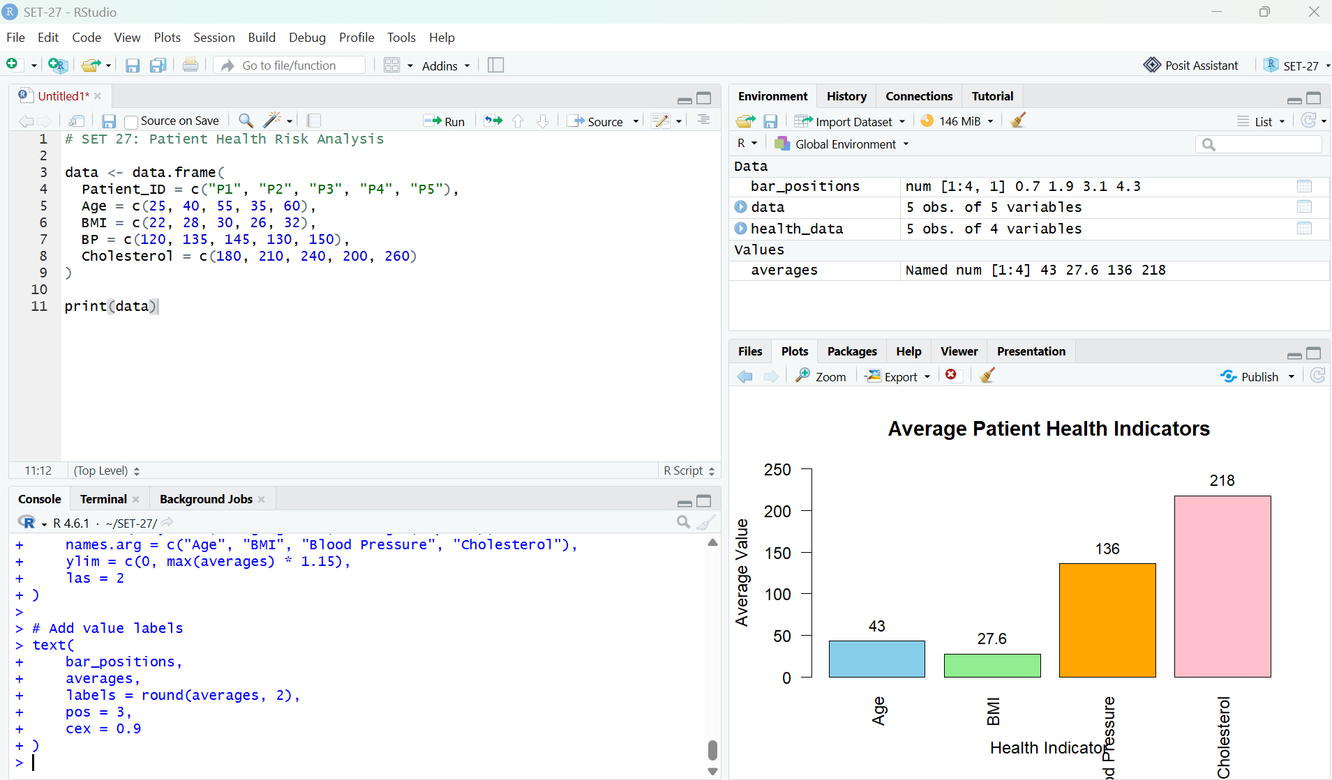
Figure 1. RStudio output: average values of the four patient health indicators.

PROGRAM 2: Scatterplot Matrix of Patient Health Indicators
To examine pairwise relationships among age, BMI, blood pressure, and cholesterol using a scatterplot matrix and correlation matrix.
# SET 27 - PROGRAM 2
health_data <- data.frame(
Age = c(25, 40, 55, 35, 60),
BMI = c(22, 28, 30, 26, 32),
BP = c(120, 135, 145, 130, 150),
Cholesterol = c(180, 210, 240, 200, 260)
)
pairs(
health_data,
main = "Scatterplot Matrix of Patient Health Indicators",
pch = 19,
col = "blue",
labels = c("Age", "BMI", "Blood Pressure", "Cholesterol")
)
cor_matrix <- cor(health_data)
print(round(cor_matrix, 2))

Procedure: Use pairs() to draw scatter plots for every pair of variables, then cor() to calculate Pearson correlations. The diagonal panels display variable names, while off-diagonal panels show pairwise relationships.
Observation / Result: The displayed data show strong positive associations among age, BMI, blood pressure, and cholesterol. Several correlations are close to 1 in this small, constructed dataset. These results describe only the supplied five records and do not establish clinical risk or causation.
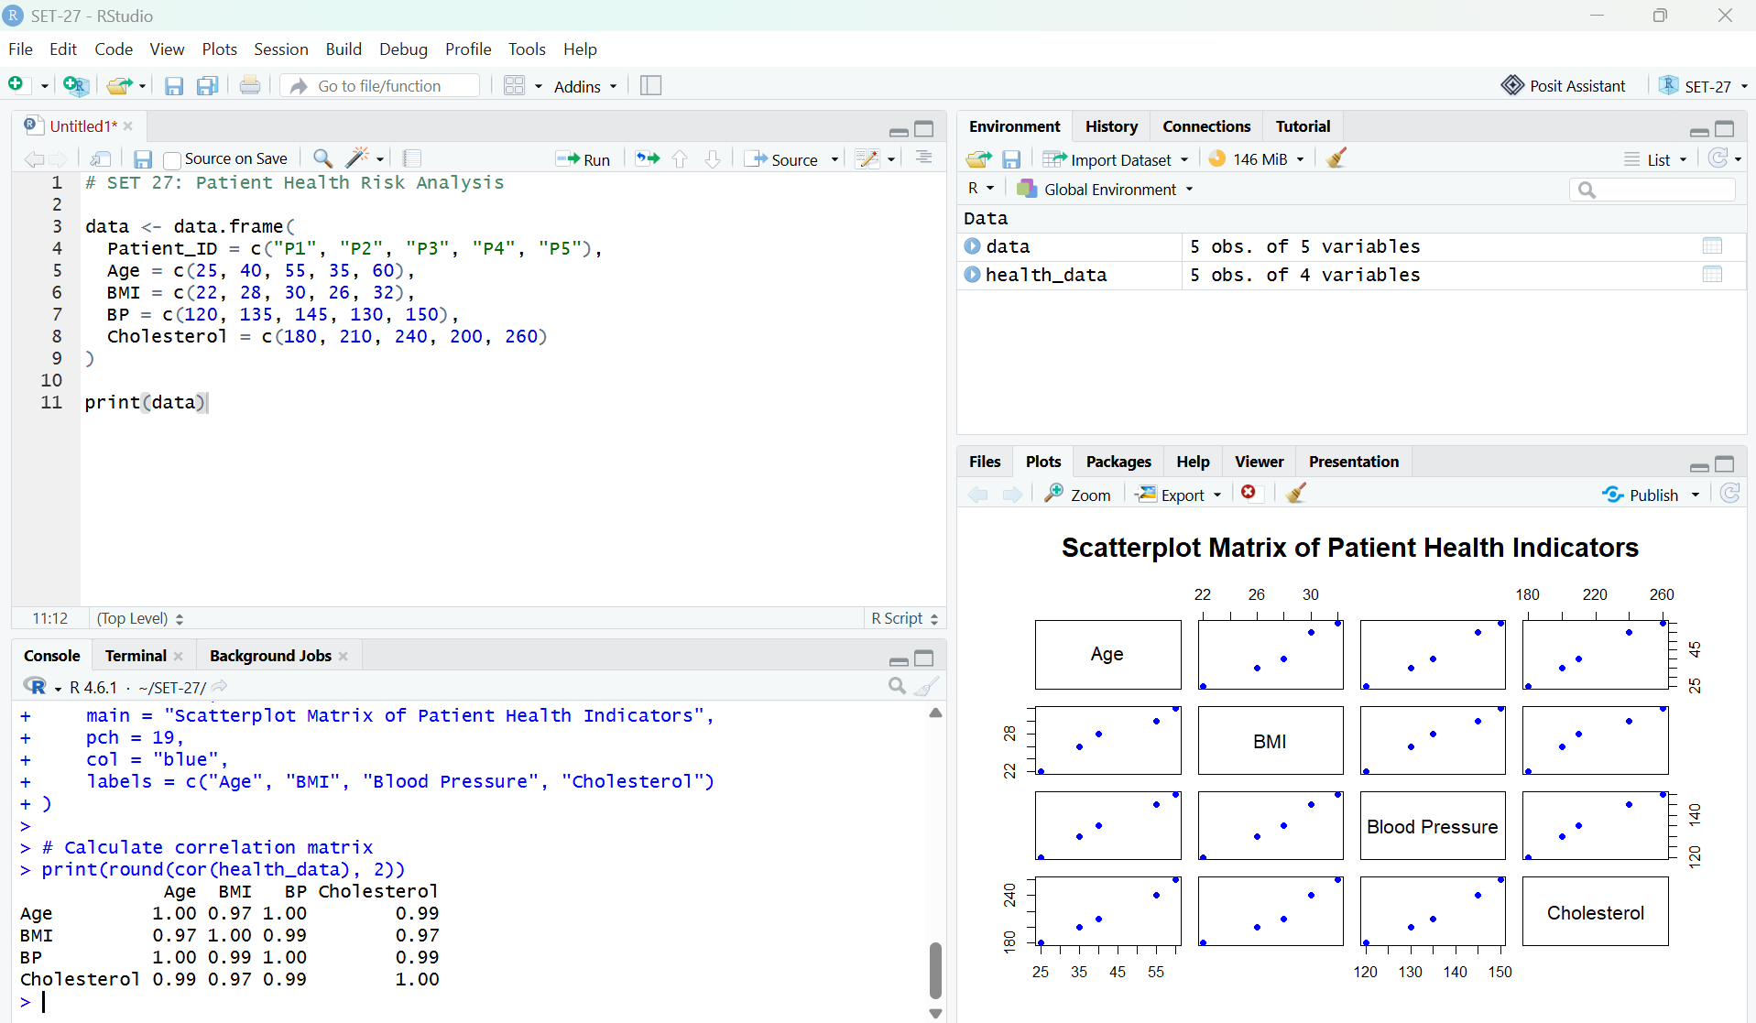
Figure 2. RStudio output: scatterplot matrix for age, BMI, blood pressure, and cholesterol.

PROGRAM 3: Empirical Cumulative Distribution of Cholesterol
To display the cumulative proportion of patients with cholesterol values at or below each observed level.
# SET 27 - PROGRAM 3
cholesterol <- c(180, 210, 240, 200, 260)
plot(
ecdf(cholesterol),
main = "Empirical Cumulative Distribution of Cholesterol",
xlab = "Cholesterol Level",
ylab = "Cumulative Probability",
col = "darkgreen",
lwd = 2,
verticals = TRUE,
do.points = TRUE
)
print(summary(cholesterol))

Procedure: Create the cholesterol vector, pass it to ecdf(), and plot the resulting step function. Use summary() to display minimum, quartiles, median, mean, and maximum.
Observation / Result: The cholesterol values range from 180 to 260, with median 210 and mean 218. The ECDF reaches 0.2 at 180, 0.4 at 200, 0.6 at 210, 0.8 at 240, and 1.0 at 260.
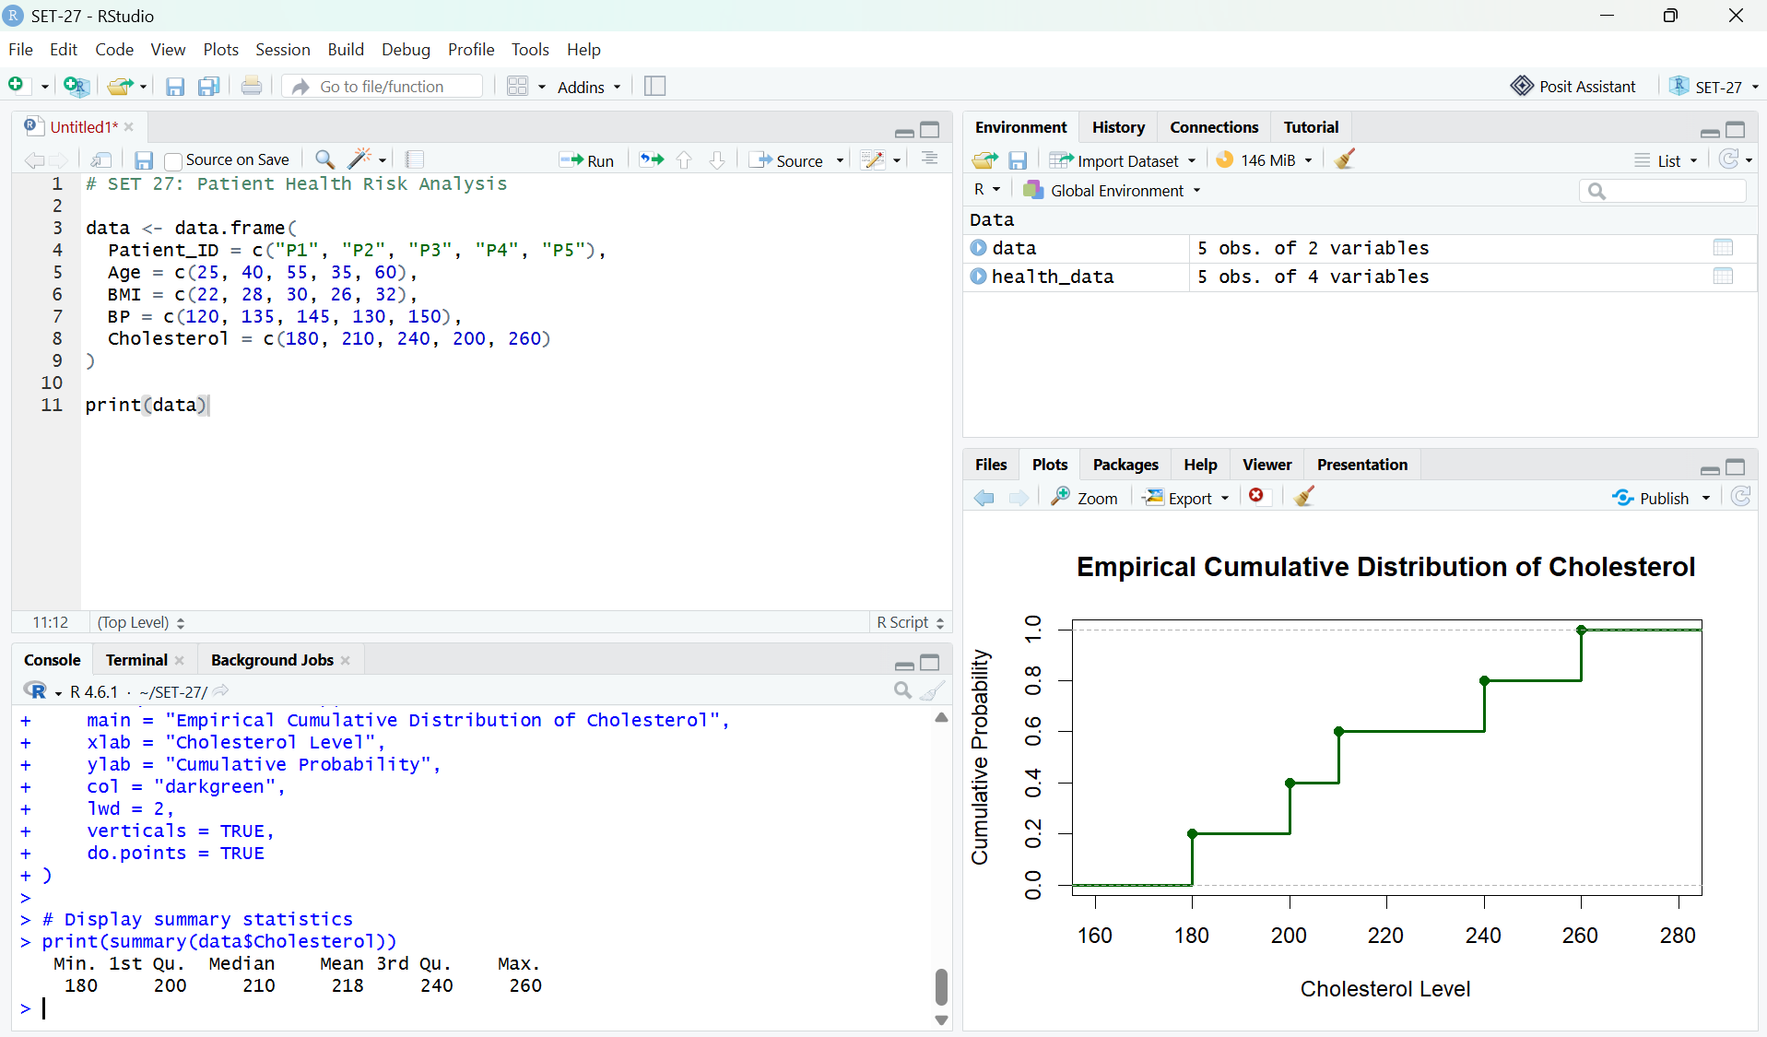
Figure 3. RStudio output: ECDF of the five cholesterol observations.

Overall Procedure
- Create the patient health dataset in RStudio.
- Calculate the average values and generate the labeled bar chart.
- Generate the scatterplot matrix and print the correlation matrix.
- Plot the empirical cumulative distribution of cholesterol and inspect summary statistics.

Overall Result
The patient health dataset was summarized using a bar chart, scatterplot matrix, correlation matrix, and ECDF. The average values were age 43, BMI 27.6, blood pressure 136, and cholesterol 218. The small dataset shows positive relationships among the indicators, while the ECDF summarizes the distribution of cholesterol values. These descriptive results are not a medical diagnosis or a validated patient-risk assessment.

