LAB EXPERIMENT RECORD
SET 3: EMPLOYEE PERFORMANCE EVALUATION
Department | AI & ML
Course Code / Course Name | DSA0602 / Data Handling and Visualization
Experiment | Data Visualization using R
Name | KURUBA VANNUR SWAMY
Register Number | 192525265
Date | 29 September 2026
Day | Tuesday

Aim
To visualize monthly sales and employee performance data using line, bar, and scatter charts, analyze the relationship between years of service and performance scores, and outline the creation of an interactive Tableau dashboard.

Dataset 1: Monthly Sales
Month | Sales ($)
January | 15000
February | 18000
March | 22000
April | 20000
May | 23000

Dataset 2: Employee Performance
Employee ID | Department | Years of Service | Performance Score
1 | Sales | 5 | 85
2 | HR | 3 | 92
3 | Marketing | 7 | 78
4 | Sales | 4 | 90
5 | HR | 2 | 76

PROGRAM 1: Line Chart of Employee Performance
The employee dataset contains one score per employee but no date or month field. Therefore, the employee performance line chart uses Employee ID on the x-axis. The separate monthly sales chart shows the available time-based trend.
# Employee Performance Data
Employee_id <- c(1, 2, 3, 4, 5)
Performance <- c(85, 92, 78, 90, 76)

# Employee Performance Line Chart
Plot(employee_id, performance,
Type = “o”,
Pch = 19,
Col = “blue”,
Xlab = “Employee ID”,
Ylab = “Performance Score”,
Main = “Employee Performance Scores”)

Legend(“topright”,
Legend = “Performance Score”,
Col = “blue”,
Lty = 1,
Pch = 19)

# Monthly Sales Data
Month <- c(“January”, “February”, “March”, “April”, “May”)
Sales <- c(15000, 18000, 22000, 20000, 23000)

# Monthly Sales Line Chart
Plot(sales,
Type = “o”,
Pch = 19,
Col = “darkgreen”,
Xaxt = “n”,
Xlab = “Month”,
Ylab = “Sales ($)”,
Main = “Monthly Sales Trend”)

Axis(1,
At = 1:5,
Labels = month)

Legend(“topleft”,
Legend = “Monthly Sales”,
Col = “darkgreen”,
Lty = 1,
Pch = 19)
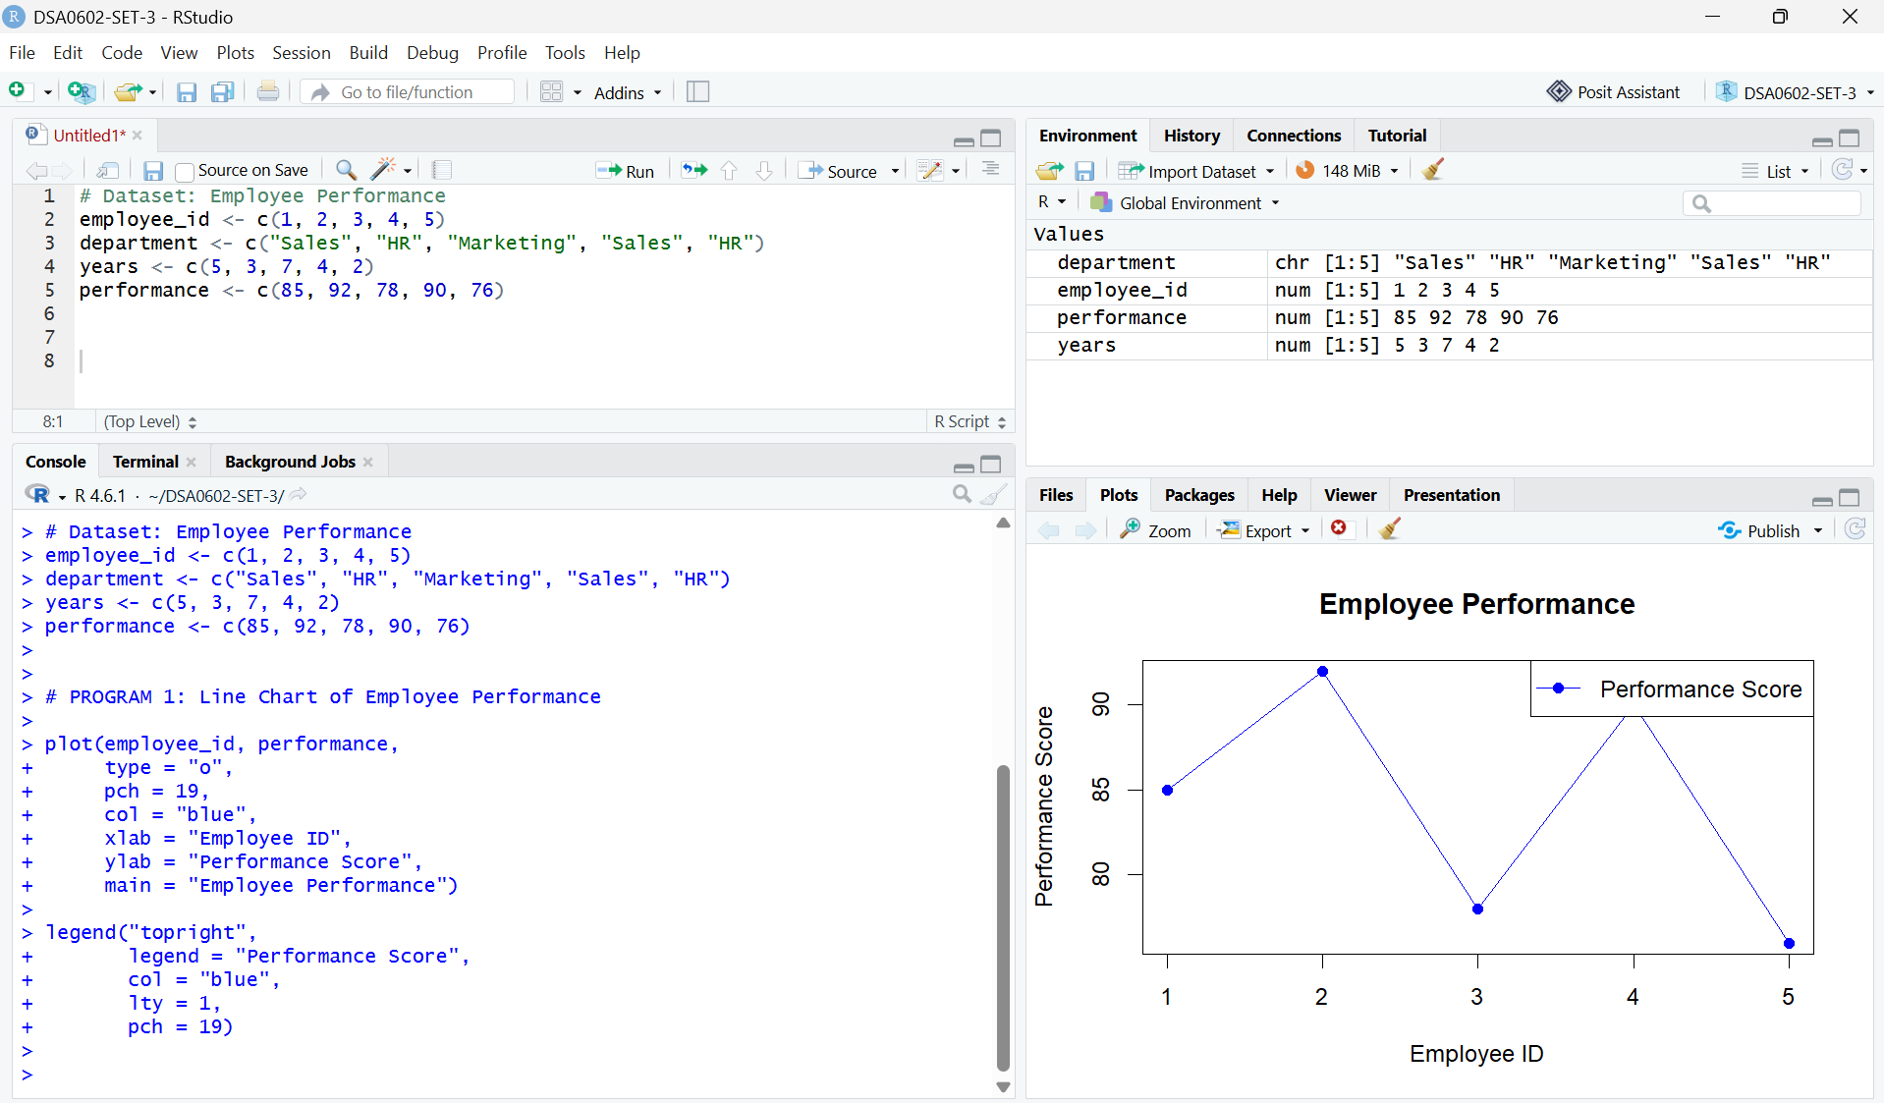
Output 1A: Employee Performance Scores by Employee ID
Observation: Employee 2 has the highest score (92), while Employee 5 has the lowest (76). This is a comparison across employees, not a time trend.

PROGRAM 2: Bar Chart of Employees by Department
Generate a bar chart showing the number of employees in each department and label the chart elements.
# Employee Department Data
department <- c(
"Sales", "HR", "Marketing", "Sales", "HR"
)

# Count Employees by Department
dept_count <- table(department)

# Bar Chart
barplot(
dept_count,
names.arg = names(dept_count),
xlab = "Department",
ylab = "Number of Employees",
main = "Employees by Department",
col = "skyblue",
ylim = c(0, 3)
)
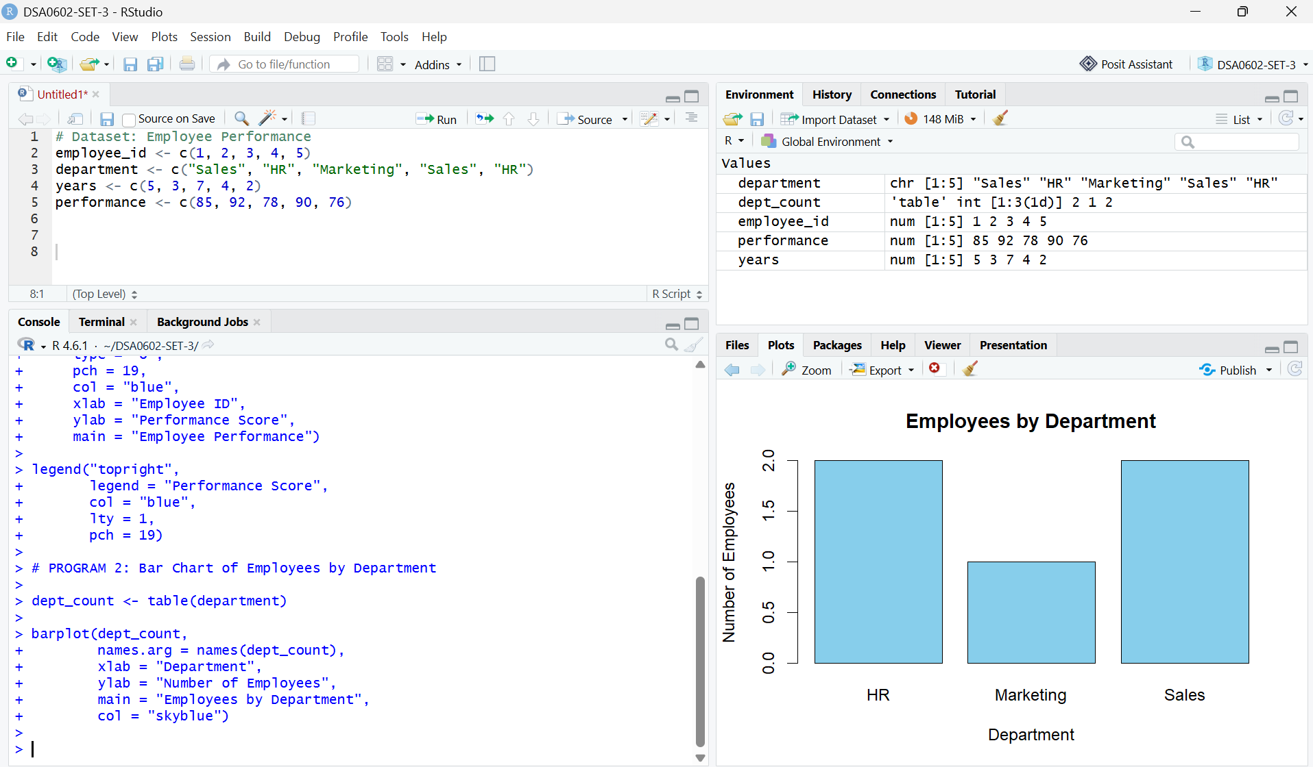
Output 2: Employees by Department
Observation: Sales and HR each contain 2 employees, while Marketing contains 1 employee.

PROGRAM 3: Scatter Plot of Years of Service vs Performance
Create a scatter plot to examine the relationship between years of service and performance score.
# Years of Service and Performance Data
Years <- c(5, 3, 7, 4, 2)
Performance <- c(85, 92, 78, 90, 76)

# Scatter Plot
Plot(
Years,
Performance,
Main = “Years of Service vs Performance Score”,
Xlab = “Years of Service”,
Ylab = “Performance Score”,
Pch = 19,
Col = “red”
)

# Add Employee Labels
Text(
Years,
Performance,
Labels = 1:5,
Pos = 3,
Cex = 0.8
)

# Pearson Correlation
Cor(
Years,
Performance,
Method = “pearson”
)
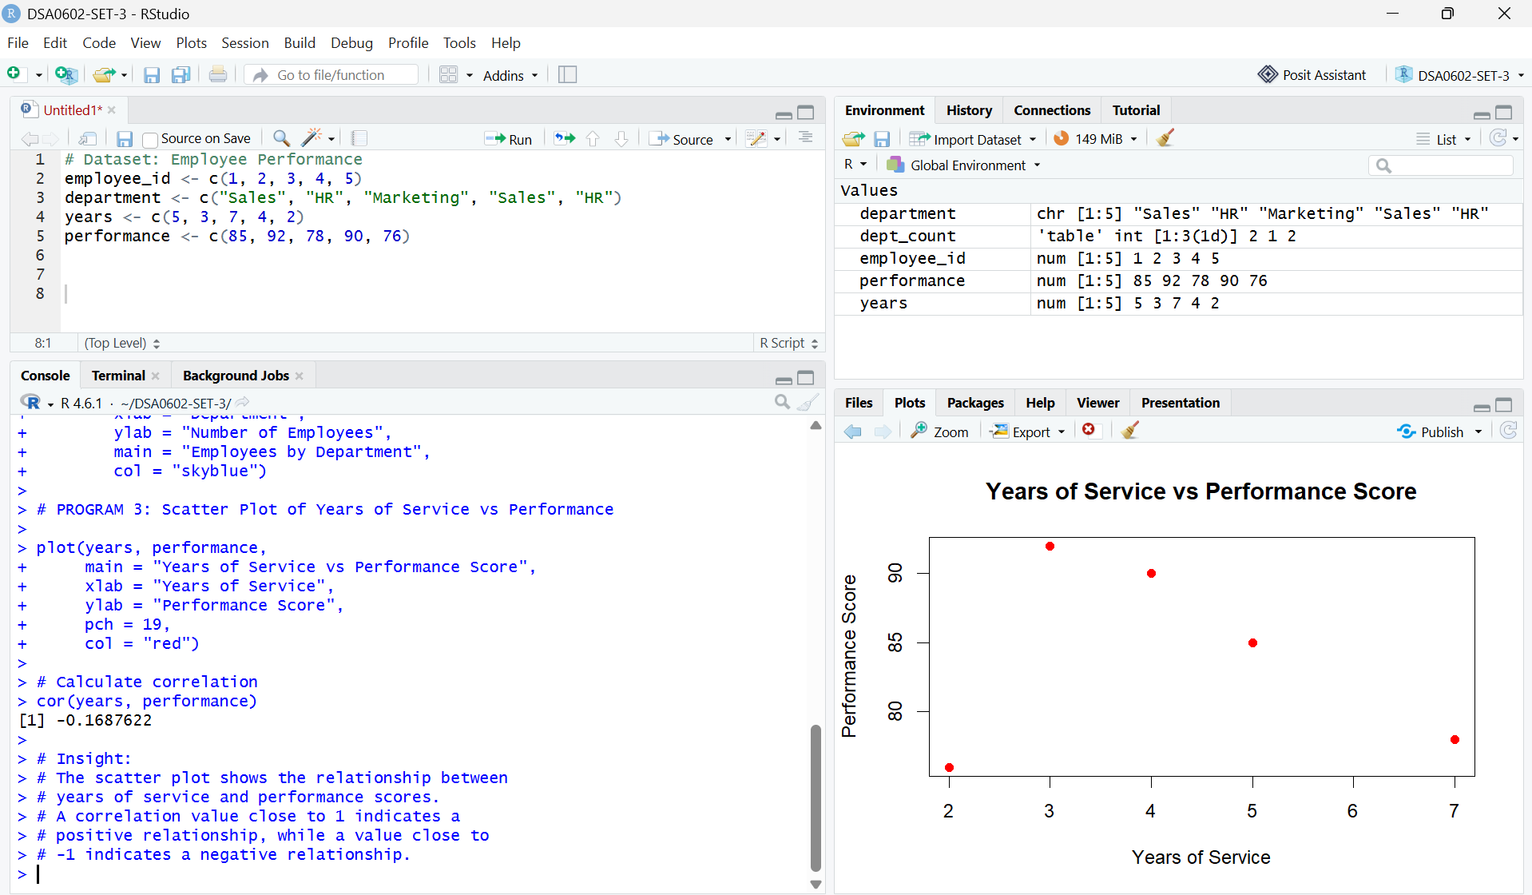
Output 3: Years of Service vs Performance Score
Insight: The Pearson correlation for these five records is approximately -0.169, showing a negative linear association in this small sample. Employees with more years of service do not necessarily have higher scores in these data. Correlation does not establish causation.

PROGRAM 4: Tableau Dashboard
Create an interactive Tableau dashboard containing the monthly sales line chart and department-wise employee bar chart.

Procedure in Tableau
- Open Tableau Desktop or Tableau Public and connect to the data source. Import or enter the Monthly Sales and Employee Performance tables.
- Create a worksheet named Monthly Sales Trend. Place Month on Columns and Sales on Rows, then select Line in the Marks card. Add a descriptive title.
- Create a worksheet named Employees by Department. Place Department on Columns and Employee ID on Rows; change the aggregation to COUNT, and select Bar.
- Create a new Dashboard and drag both worksheets onto the dashboard canvas.
- Add Month and Department filters where appropriate. Configure filters to apply to the relevant worksheets.
- Enable tooltips and optionally add dashboard filter actions to explore related views.
- Save the workbook as a Tableau packaged workbook (.twbx) or publish it using the available Tableau option.
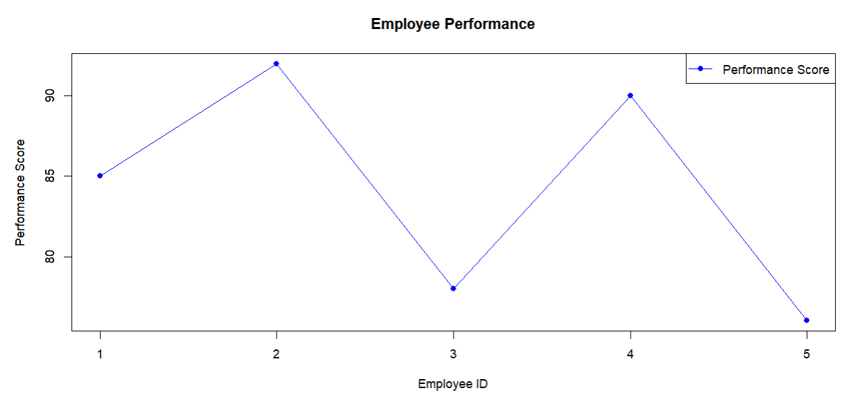

Output 4: Suggested Tableau Dashboard Layout (illustrative)
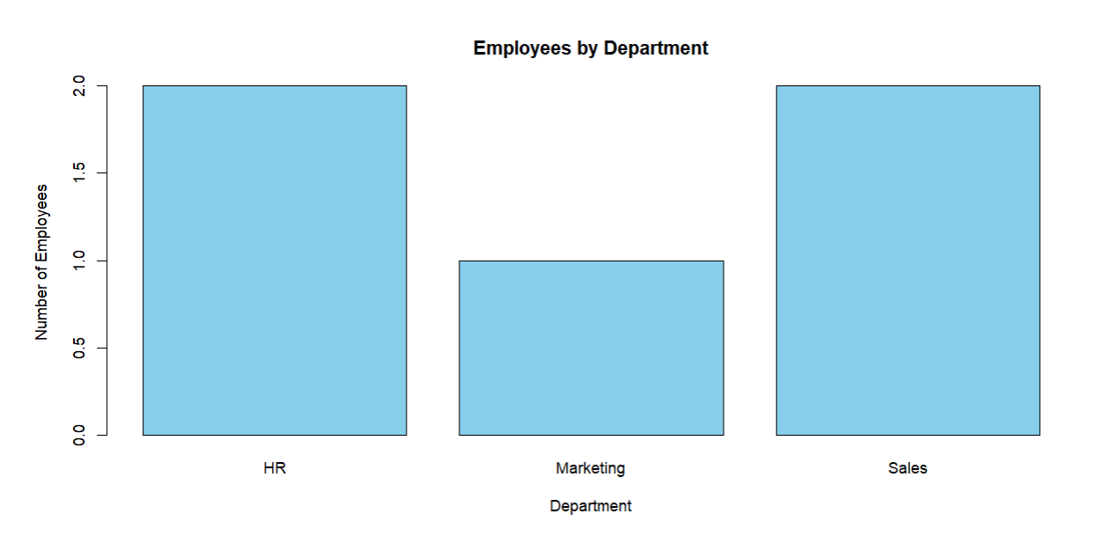
Expected behavior: The dashboard displays the monthly sales trend and department distribution together. Filters and tooltips support interactive exploration after the workbook is built in Tableau.

Set 3 Procedure
- Enter the monthly sales and employee performance values in R as vectors.
- Use plot() to draw employee scores against Employee ID and include axis labels, a title, and a legend.
- Use plot() with month labels to draw the monthly sales line chart.
- Use table() to count employees by department and barplot() to visualize the counts.
- Use plot() for the years-of-service versus performance scatter plot and cor() to calculate Pearson correlation.
- In Tableau, create the two worksheets, assemble them on a dashboard, and add filters and tooltips.

Result
The monthly sales and employee performance data were visualized using line charts, a department-wise bar chart, and a scatter plot. The department distribution and association between years of service and performance scores were examined. The steps to create an interactive Tableau dashboard with a monthly sales line chart and department bar chart were documented. A true employee performance trend over time requires dated performance observations for each employee.

Key R Functions Used
Function | Purpose
plot() | Creates line and scatter plots.
axis() | Adds custom axis tick labels.
legend() | Adds a chart legend.
barplot() | Creates a bar chart.
table() | Calculates frequency counts.
cor() | Calculates the correlation coefficient.

