LAB EXPERIMENT RECORD
SET 13 – GEOGRAPHIC DATA VISUALIZATION
Department | AIML
Course Code / Course Name | DSA0601 / Data Handling and Visualization
Experiment | Data Visualization using R
Name | KURUBA VANNUR SWAMY
Register Number | 192525265
Date | 8 October 2026
Day | Thursday
Aim
To analyze geographic data using a map chart, scatter plot, table, and an interactive dashboard in RStudio.
Dataset
City | Population | Avg. Temperature | Elevation
City A | 500000 | 75 | 1000
City B | 700000 | 68 | 800
City C | 600000 | 80 | 1200
Note
The dataset contains City A, City B, and City C without real geographic names or coordinates. For the map visualization, illustrative coordinates are used only to demonstrate the mapping technique.

PROGRAM 1: Map Chart – Geographic Distribution
To create a map chart to visualize the distribution of cities on a geographic map and label the map elements.
Required Packages
install.packages("ggplot2")
install.packages("maps")
R Program
library(ggplot2)
library(maps)
city <- c("City A", "City B", "City C")
population <- c(500000, 700000, 600000)
avg_temperature <- c(75, 68, 80)
elevation <- c(1000, 800, 1200)
# Illustrative coordinates because the dataset gives placeholder city names
longitude <- c(80.27, 77.21, 72.88)
latitude <- c(13.08, 28.61, 19.07)
geographic_data <- data.frame(
City = city,
Population = population,
Avg_Temperature = avg_temperature,
Elevation = elevation,
Longitude = longitude,
Latitude = latitude
)
world_map <- map_data("world")
ggplot() +
geom_polygon(
data = world_map,
aes(x = long, y = lat, group = group),
fill = "lightgray",
color = "white"
) +
geom_point(
data = geographic_data,
aes(x = Longitude, y = Latitude, size = Population),
color = "blue",
alpha = 0.7
) +
geom_text(
data = geographic_data,
aes(x = Longitude, y = Latitude, label = City),
vjust = -1,
fontface = "bold"
) +
labs(
title = "Geographic Distribution of Cities",
x = "Longitude",
y = "Latitude",
size = "Population"
) +
theme_minimal()
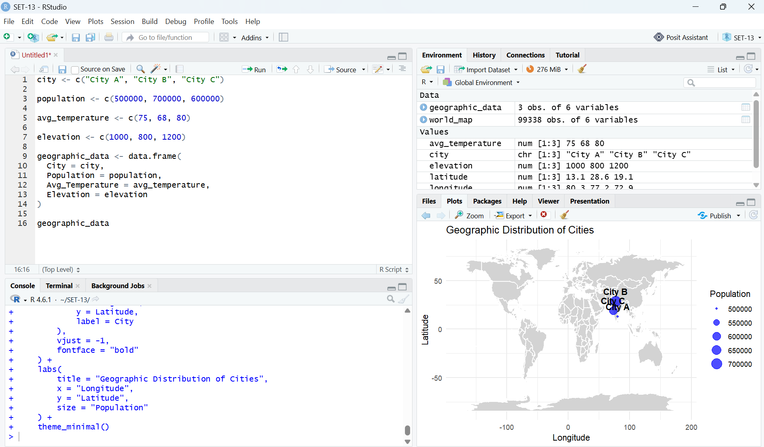
Output 1: Geographic Distribution of Cities – RStudio Execution Screenshot
Observation: The map displays City A, City B, and City C as labelled points. Point size represents population. City B has the largest population (700,000), followed by City C (600,000) and City A (500,000).

PROGRAM 2: Scatter Plot – Average Temperature vs Population
To generate a scatter plot to explore the relationship between average temperature and population size.
R Program
library(ggplot2)
city <- c("City A", "City B", "City C")
population <- c(500000, 700000, 600000)
avg_temperature <- c(75, 68, 80)
elevation <- c(1000, 800, 1200)
geographic_data <- data.frame(
City = city,
Population = population,
Avg_Temperature = avg_temperature,
Elevation = elevation
)
ggplot(
geographic_data,
aes(x = Avg_Temperature, y = Population)
) +
geom_point(size = 5, color = "blue") +
geom_text(
aes(label = City),
vjust = -1,
fontface = "bold"
) +
labs(
title = "Average Temperature vs Population",
x = "Average Temperature (°F)",
y = "Population"
) +
theme_minimal()
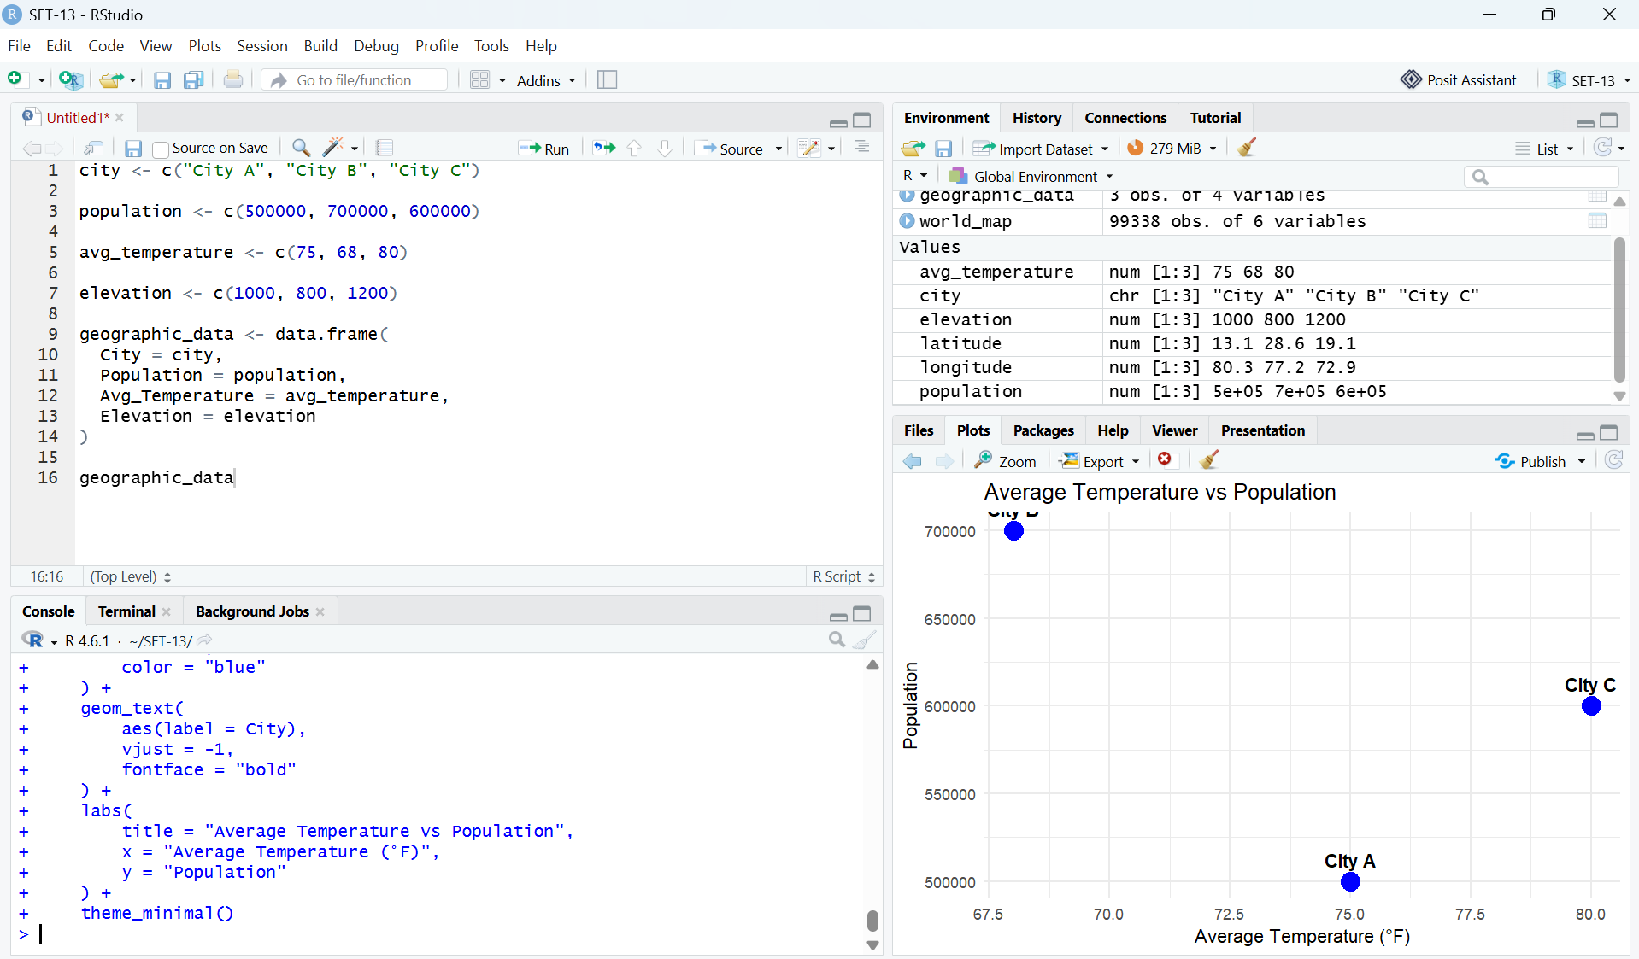
Output 2: Average Temperature vs Population – RStudio Execution Screenshot
Observation: City B has the highest population (700,000) but the lowest average temperature (68°F). City C has the highest temperature (80°F) with a population of 600,000, while City A has 75°F and 500,000. With only three observations, the data does not provide strong evidence of a consistent relationship between temperature and population.

PROGRAM 3: Geographic Data Table
To build a table to display the geographic data for each city and label the table elements.
R Program
city <- c("City A", "City B", "City C")
population <- c(500000, 700000, 600000)
avg_temperature <- c(75, 68, 80)
elevation <- c(1000, 800, 1200)
geographic_data <- data.frame(
City = city,
Population = population,
Avg_Temperature = avg_temperature,
Elevation = elevation
)
print(geographic_data)
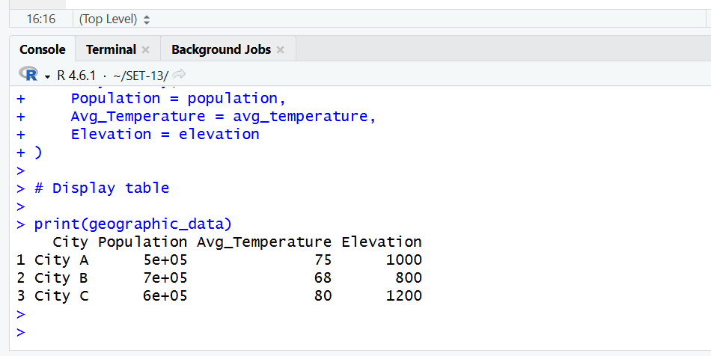
Output 3: Geographic Data Table – RStudio Console Screenshot
Observation: The table displays City, Population, Average Temperature, and Elevation for all three records. It provides exact numerical values for detailed comparison.

PROGRAM 4: Interactive Dashboard in RStudio
To develop an interactive dashboard combining the map chart, scatter plot, and geographic data table. The dashboard is implemented using Shiny in RStudio.
R Program
library(shiny)
library(ggplot2)
library(maps)
city <- c("City A", "City B", "City C")
population <- c(500000, 700000, 600000)
avg_temperature <- c(75, 68, 80)
elevation <- c(1000, 800, 1200)
longitude <- c(80.27, 77.21, 72.88)
latitude <- c(13.08, 28.61, 19.07)
geographic_data <- data.frame(
City = city,
Population = population,
Avg_Temperature = avg_temperature,
Elevation = elevation,
Longitude = longitude,
Latitude = latitude
)
world_map <- map_data("world")
ui <- fluidPage(
titlePanel("Geographic Data Dashboard"),
sidebarLayout(
sidebarPanel(
selectInput(
"selected_city",
"Select City:",
choices = c("All Cities", city),
selected = "All Cities"
)
),
mainPanel(
fluidRow(
column(
6,
h3("City Distribution Map"),
plotOutput("map")
),
column(
6,
h3("Temperature vs Population"),
plotOutput("scatter")
)
),
hr(),
h3("Geographic Data Table"),
tableOutput("table")
)
)
)
server <- function(input, output) {
filtered_data <- reactive({
if (input$selected_city == "All Cities") {
geographic_data
} else {
geographic_data[
geographic_data$City == input$selected_city,
]
}
})
output$map <- renderPlot({
data <- filtered_data()
ggplot() +
geom_polygon(
data = world_map,
aes(x = long, y = lat, group = group),
fill = "lightgray",
color = "white"
) +
geom_point(
data = data,
aes(x = Longitude, y = Latitude, size = Population),
color = "blue",
alpha = 0.7
) +
geom_text(
data = data,
aes(x = Longitude, y = Latitude, label = City),
vjust = -1,
fontface = "bold"
) +
labs(
title = "Geographic Distribution of Cities",
x = "Longitude",
y = "Latitude",
size = "Population"
) +
theme_minimal()
})
output$scatter <- renderPlot({
data <- filtered_data()
ggplot(
data,
aes(x = Avg_Temperature, y = Population)
) +
geom_point(size = 5, color = "blue") +
geom_text(
aes(label = City),
vjust = -1,
fontface = "bold"
) +
labs(
title = "Average Temperature vs Population",
x = "Average Temperature (°F)",
y = "Population"
) +
theme_minimal()
})
output$table <- renderTable({
data <- filtered_data()
data.frame(
City = data$City,
Population = data$Population,
Avg_Temperature = data$Avg_Temperature,
Elevation = data$Elevation
)
})
}
shinyApp(ui = ui, server = server)

PROGRAM 4: Dashboard Output and Explanation
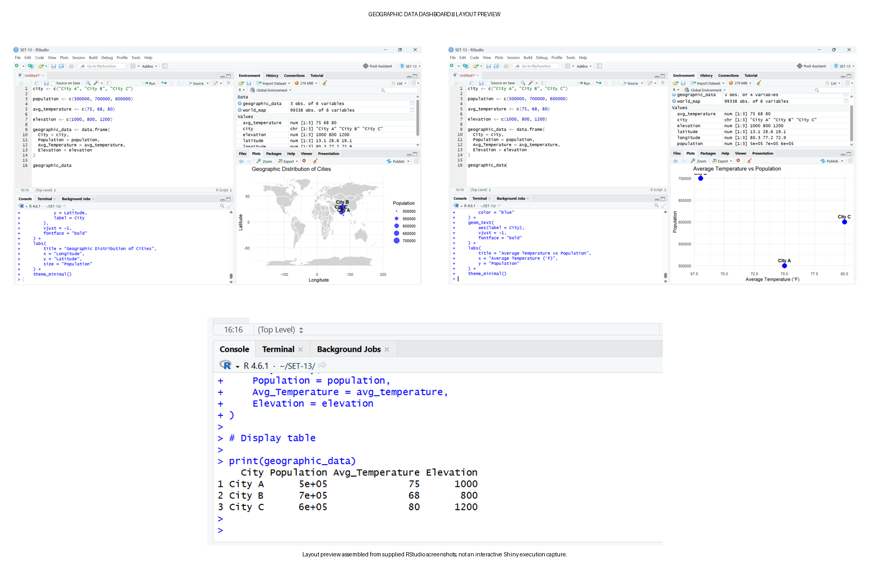
Output 4: Geographic Data Dashboard – Layout Preview
Observation: The dashboard combines the geographic map, temperature-versus-population scatter plot, and data table. The city selector filters the displayed information so that the user can explore All Cities or an individual city.
The preview above is assembled from the supplied RStudio screenshots. It is not a screenshot of an executed Shiny application. After running the dashboard with Run App, capture the actual Shiny application and replace this preview if execution evidence is required.

Procedure
• Create vectors for City, Population, Average Temperature, and Elevation.
• Combine the vectors using data.frame() to create the geographic dataset.
• Install and load ggplot2 and maps for geographic visualization.
• Assign illustrative latitude and longitude values because the supplied city names do not have actual coordinates.
• Create the geographic map using geom_polygon(), geom_point(), and geom_text().
• Create the scatter plot using Avg_Temperature on the x-axis and Population on the y-axis.
• Create the geographic data table using data.frame() and print().
• Install and load Shiny for the interactive dashboard.
• Create the dashboard interface using fluidPage(), sidebarLayout(), selectInput(), plotOutput(), and tableOutput().
• Use reactive() to filter the map, scatter plot, and table when a city is selected.
• Run the Shiny application and verify all three views.
Overall Insights
• City B has the largest population at 700,000.
• City C has the highest average temperature at 80°F.
• City C also has the highest elevation at 1,200 m.
• City B has the lowest average temperature at 68°F and the lowest elevation at 800 m.
• The scatter plot does not establish a reliable temperature-population relationship because the dataset contains only three observations.
• The map provides spatial-style visual comparison, while the scatter plot shows the relationship between two numerical variables.
• The table provides exact values and supports precise comparison.
• The Shiny dashboard combines all three views and allows the user to select a city interactively.
Result
The geographic data was successfully analyzed in RStudio using a map chart, scatter plot, and data table. An interactive Shiny dashboard was developed to combine the three views for geographic data exploration.
Important Submission Note
The supplied RStudio screenshots were inserted into the corresponding sections. The map screenshot uses illustrative coordinates because the original dataset does not provide real city locations. For final dashboard evidence, use a screenshot of the Shiny application after clicking Run App if your faculty requires proof of interactive execution.

