LAB EXPERIMENT RECORD
SET 8: EMPLOYEE PERFORMANCE ANALYSIS
Field | Details
Department | AI & ML
Course Code / Course Name | DSA0602 / Data Handling and Visualization
Experiment | Data Visualization using R
Name | KURUBA VANNUR SWAMY
Register Number | 192525265
Date | 03 October 2026
Day | Saturday
SET 8: EMPLOYEE PERFORMANCE ANALYSIS
Dataset: Employee Performance
Employee ID | Department | Years of Service | Performance Score
1 | Sales | 5 | 85
2 | HR | 3 | 92
3 | Marketing | 7 | 78
PROGRAM 1: Employee Performance Line Chart
Create a line chart to visualize the performance trend of employees over time. The supplied dataset does not contain a date or month field, so Employee ID is used on the x-axis to compare the available employee performance scores.
# Dataset
employee_id <- c(1, 2, 3)
performance <- c(85, 92, 78)
# Line Chart
plot(employee_id,
performance,
type = "o",
pch = 19,
col = "blue",
main = "Employee Performance Scores",
xlab = "Employee ID",
ylab = "Performance Score",
xaxt = "n")
axis(1,
at = employee_id,
labels = employee_id)
legend("topright",
legend = "Performance Score",
col = "blue",
lty = 1,
pch = 19)
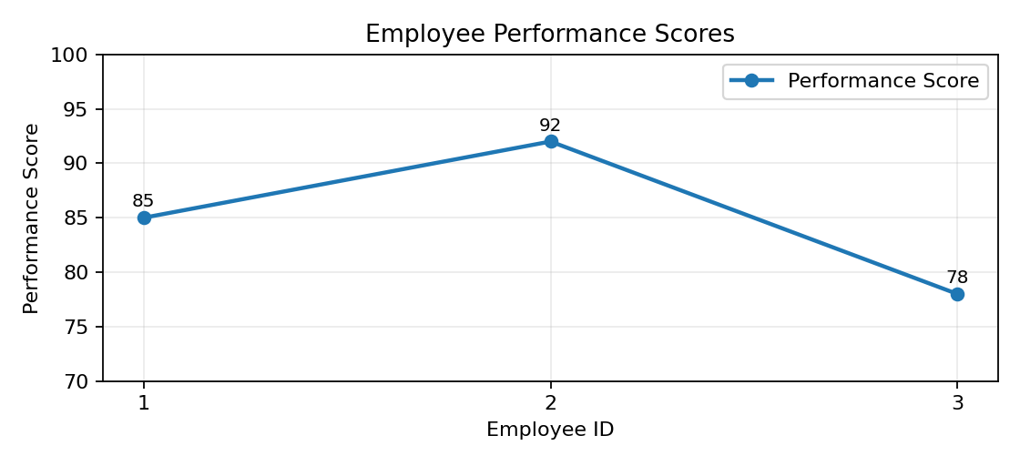
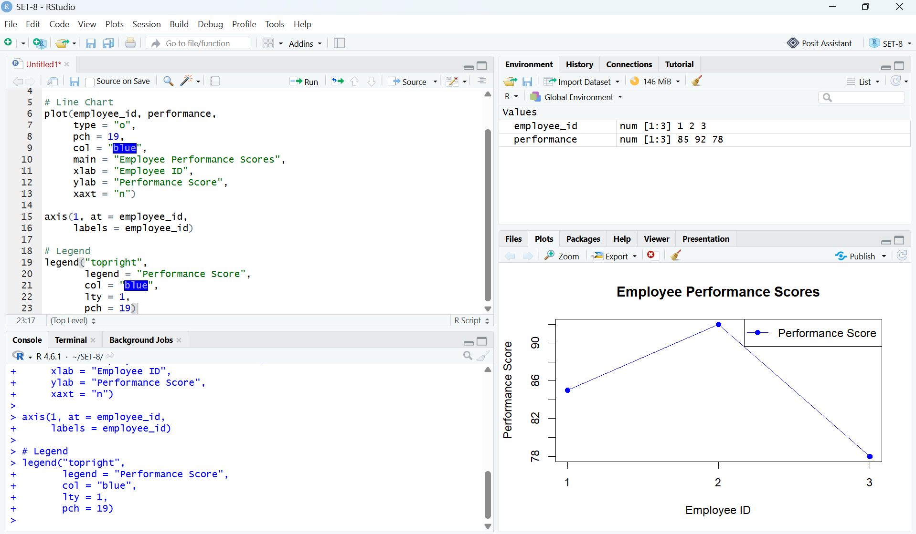Output 1: Employee Performance Line Chart
Observation: Employee 2 has the highest performance score of 92, Employee 1 has 85, and Employee 3 has the lowest score of 78. Because no time variable is supplied, this chart compares employees rather than showing a true time-based trend.

PROGRAM 2: Employee Distribution by Department
Generate a bar chart showing the distribution of employees across different departments. Label the chart elements.
# Department data
department <- c("Sales", "HR", "Marketing")
# Calculate department frequency
dept_count <- table(department)
# Bar Chart
barplot(dept_count,
names.arg = names(dept_count),
main = "Employee Distribution by Department",
xlab = "Department",
ylab = "Number of Employees",
col = "lightgreen",
ylim = c(0, 2))
legend("topright",
legend = "Employees",
fill = "lightgreen")
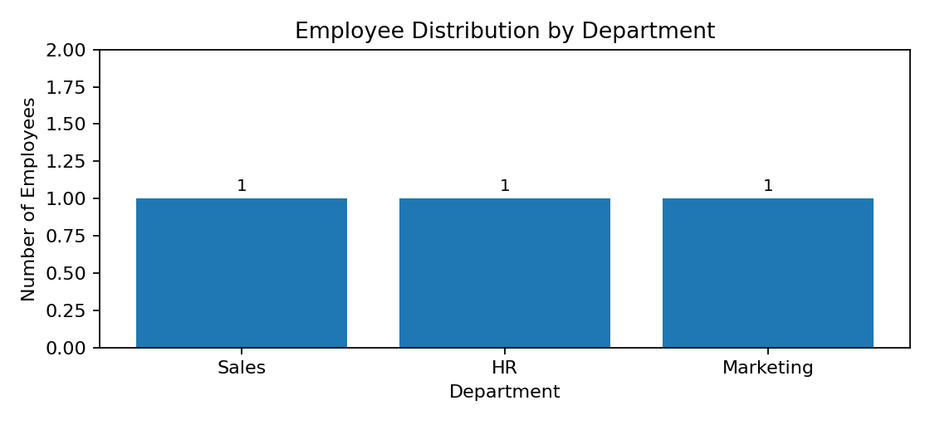
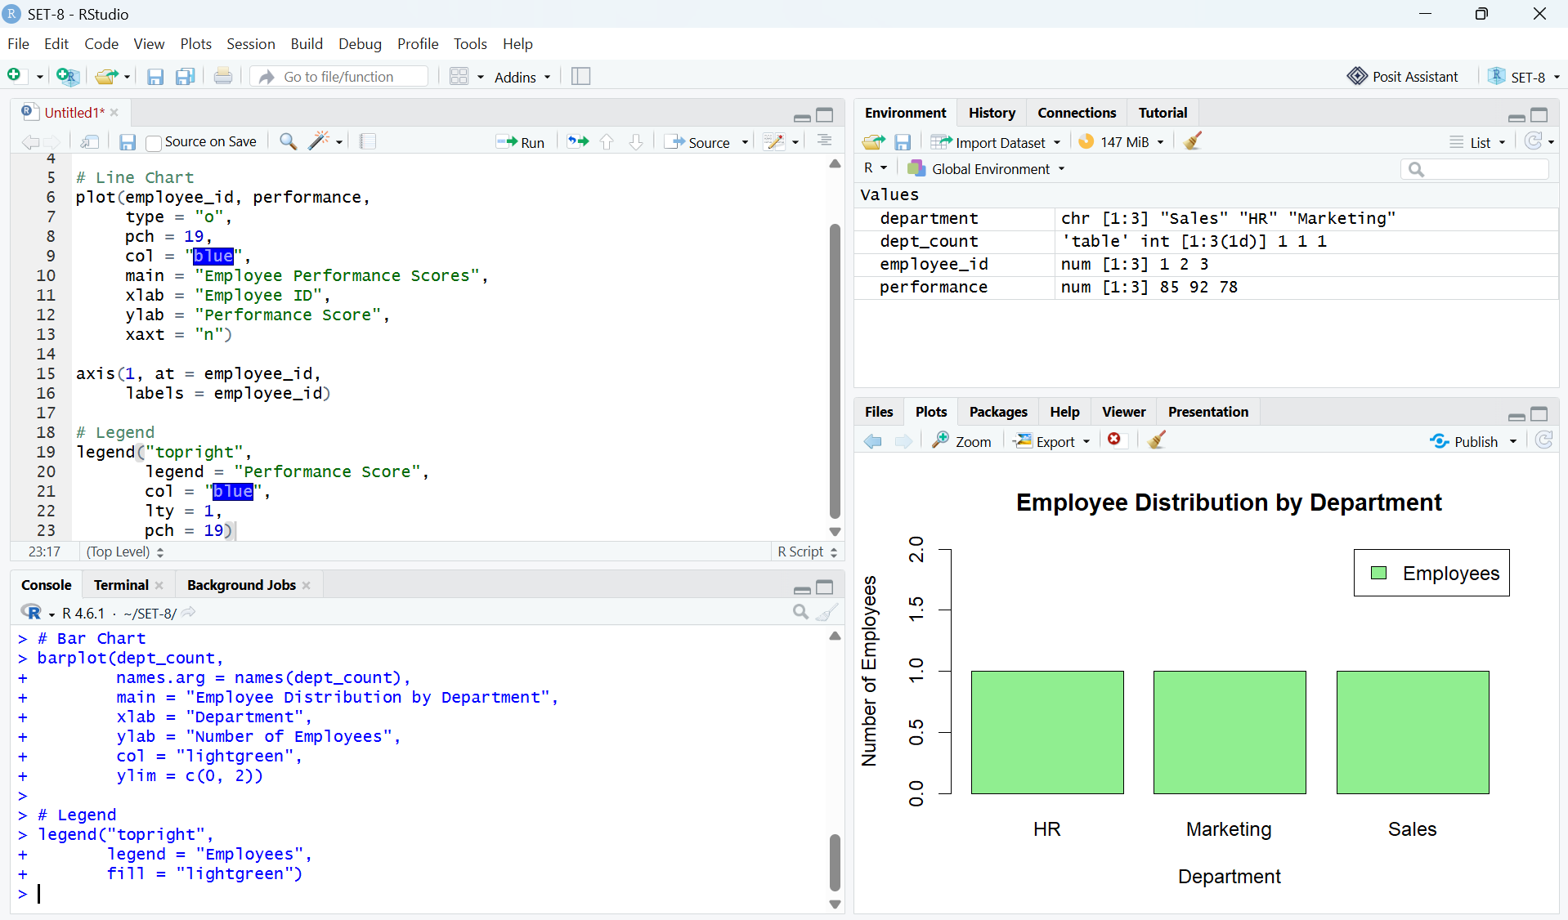Output 2: Employee Distribution by Department
Observation: Each department contains one employee in the supplied dataset. Therefore, Sales, HR, and Marketing have equal representation.
PROGRAM 3: Employee Performance Table
Build a table to display the performance data for each employee. Label the table elements.
# Dataset
employee_id <- c(1, 2, 3)
department <- c("Sales", "HR", "Marketing")
years <- c(5, 3, 7)
performance <- c(85, 92, 78)
# Create data frame
employee_data <- data.frame(
Employee_ID = employee_id,
Department = department,
Years_of_Service = years,
Performance_Score = performance
)
# Display table
print(employee_data, row.names = FALSE)
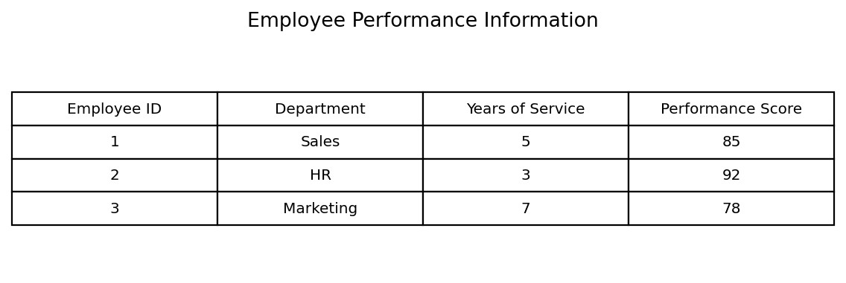
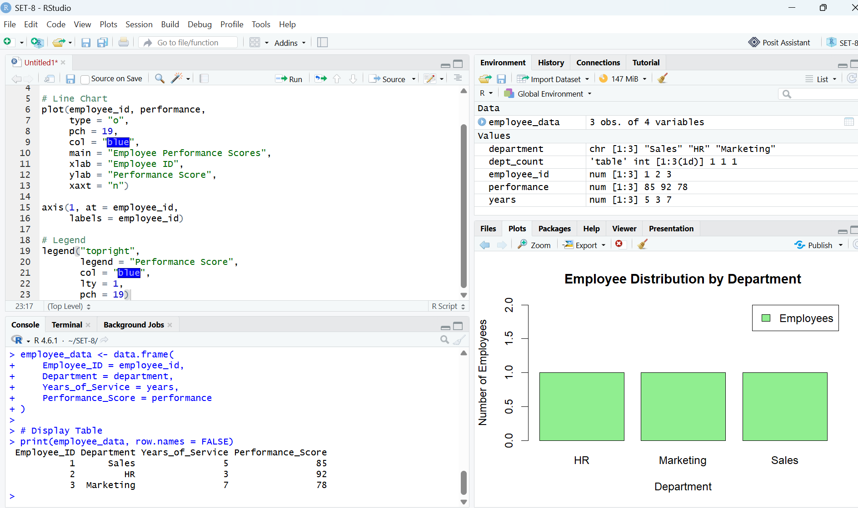Output 3: Employee Performance Information Table
Observation: The table displays Employee ID, Department, Years of Service, and Performance Score for all three employees. Years of service range from 3 to 7 years, while performance scores range from 78 to 92.

PROGRAM 4: Tableau Dashboard
Develop a Tableau dashboard combining the line chart, bar chart, and the table for interactive exploration of employee performance data.
Procedure in Tableau
- Open Tableau Desktop or Tableau Public and connect to the Employee Performance dataset.
- Create a worksheet named Employee Performance Line Chart. Drag Employee ID to Columns and Performance Score to Rows. Select Line from the Marks card and add data labels.
- Create a worksheet named Department Distribution. Drag Department to Columns and Employee ID to Rows. Change the aggregation to COUNT and select Bar.
- Create a worksheet named Employee Performance Table. Add Employee ID, Department, Years of Service, and Performance Score to the view.
- Create a new Dashboard and drag the three worksheets onto the dashboard canvas.
- Add Department and Years of Service filters and apply them to the relevant worksheets.
- Enable tooltips so users can inspect employee performance details interactively.
- Save the workbook as a Tableau workbook or publish it using the available Tableau option.
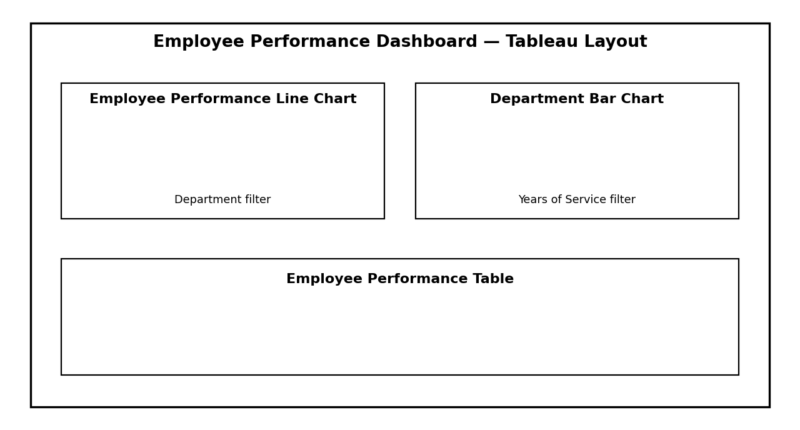
Output 4: Suggested Tableau Dashboard Layout (Illustrative)
Note: The dashboard layout above is an illustrative layout guide created for the practical record; it is not a screenshot of a live Tableau workbook.

Set 8 Procedure
- Create the employee performance data with Employee ID, Department, Years of Service, and Performance Score.
- Use plot() to visualize the employee performance scores with Employee ID on the x-axis, including labels and a legend.
- Use table() and barplot() to calculate and display the distribution of employees across departments.
- Create a data frame and print it as the employee performance information table.
- Import the data into Tableau and create separate worksheets for the performance line chart, department bar chart, and performance table.
- Combine the worksheets in a Tableau dashboard and add suitable filters and tooltips for interactive exploration.
Set 8 Result
The employee performance data was successfully visualized using a line chart for employee performance scores, a bar chart for department distribution, and a tabular representation of employee performance information. The procedure for combining these visualizations into an interactive Tableau dashboard was also completed. Since the supplied dataset contains no dates, the line chart represents employee-wise comparison rather than a true performance trend over time.
Key R Functions Used
Function | Purpose
plot() | Creates the employee performance line chart.
axis() | Adds custom x-axis labels.
legend() | Adds a legend to the performance chart.
table() | Calculates department frequencies.
barplot() | Creates the department distribution bar chart.
data.frame() | Creates the employee performance table.
print() | Displays the performance table in the R console.

