LAB EXPERIMENT RECORD
SET 7: CUSTOMER DEMOGRAPHICS ANALYSIS
Field | Details
Department | AI & ML
Course Code / Course Name | DSA0602 / Data Handling and Visualization
Experiment | Data Visualization using R
Name | KURUBA VANNUR SWAMY
Register Number | 192525265
Date | 03 October 2026
Day | Saturday
SET 7: CUSTOMER DEMOGRAPHICS ANALYSIS
Dataset: Customer Demographics
Customer ID | Age | Gender | Income ($)
1 | 28 | Female | 50000
2 | 35 | Male | 60000
3 | 42 | Female | 75000
PROGRAM 1: Customer Age Bar Chart
Create a bar chart to visualize the distribution of customer ages. Label the axes and title the chart.
# Dataset
customer_id <- c(1, 2, 3)
age <- c(28, 35, 42)
# Bar Chart
barplot(age,
names.arg = customer_id,
main = "Distribution of Customer Ages",
xlab = "Customer ID",
ylab = "Age (Years)",
col = "skyblue",
ylim = c(0, 50))
legend("topleft",
legend = "Customer Age",
fill = "skyblue")
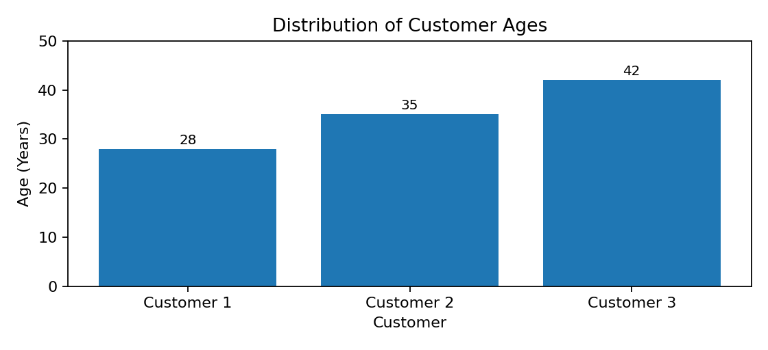
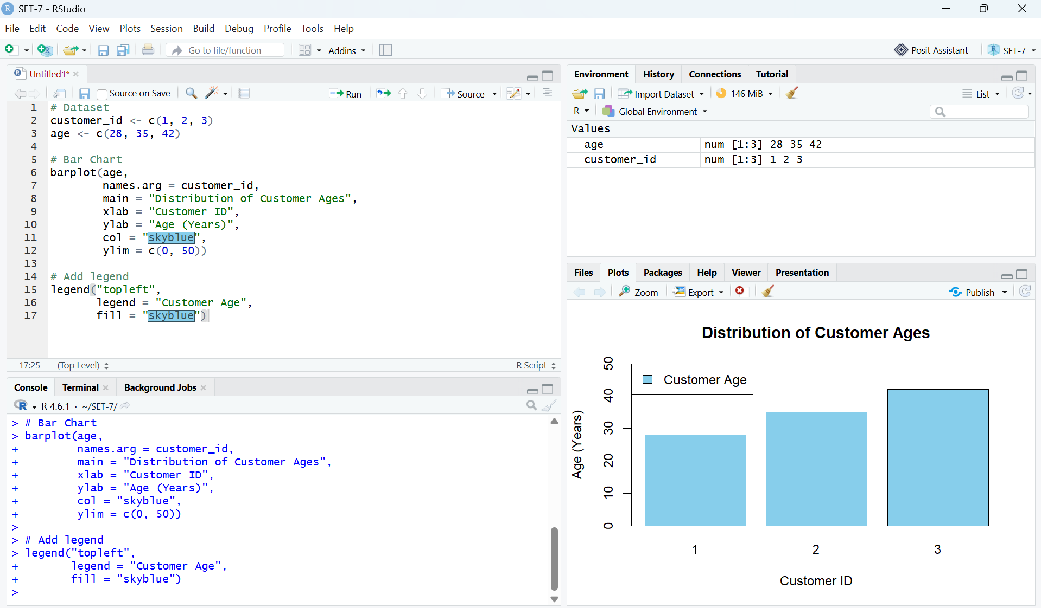
Output 1: Customer Age Bar Chart
Observation: The bar chart compares the ages of the three customers. Customer 3 is the oldest at 42 years, while Customer 1 is the youngest at 28 years.

PROGRAM 2: Customer Gender Distribution
Generate a pie chart to represent the distribution of customers by gender.
# Gender data
gender <- c("Female", "Male", "Female")
# Calculate frequency
gender_count <- table(gender)
# Pie Chart
pie(gender_count,
labels = paste0(names(gender_count), " (",
round(100 * gender_count / sum(gender_count), 2),
"%)"),
main = "Customer Gender Distribution",
col = c("pink", "skyblue"))
legend("topright",
legend = names(gender_count),
fill = c("pink", "skyblue"))
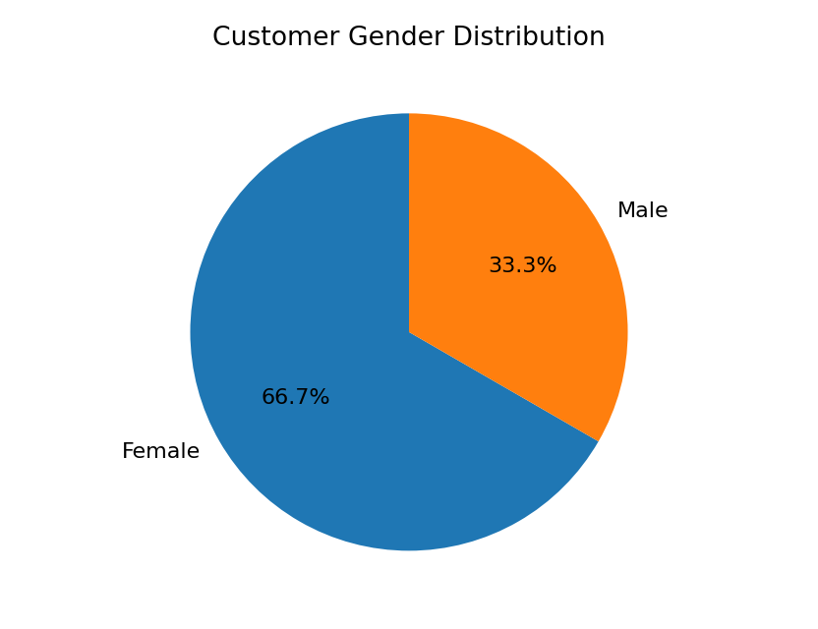

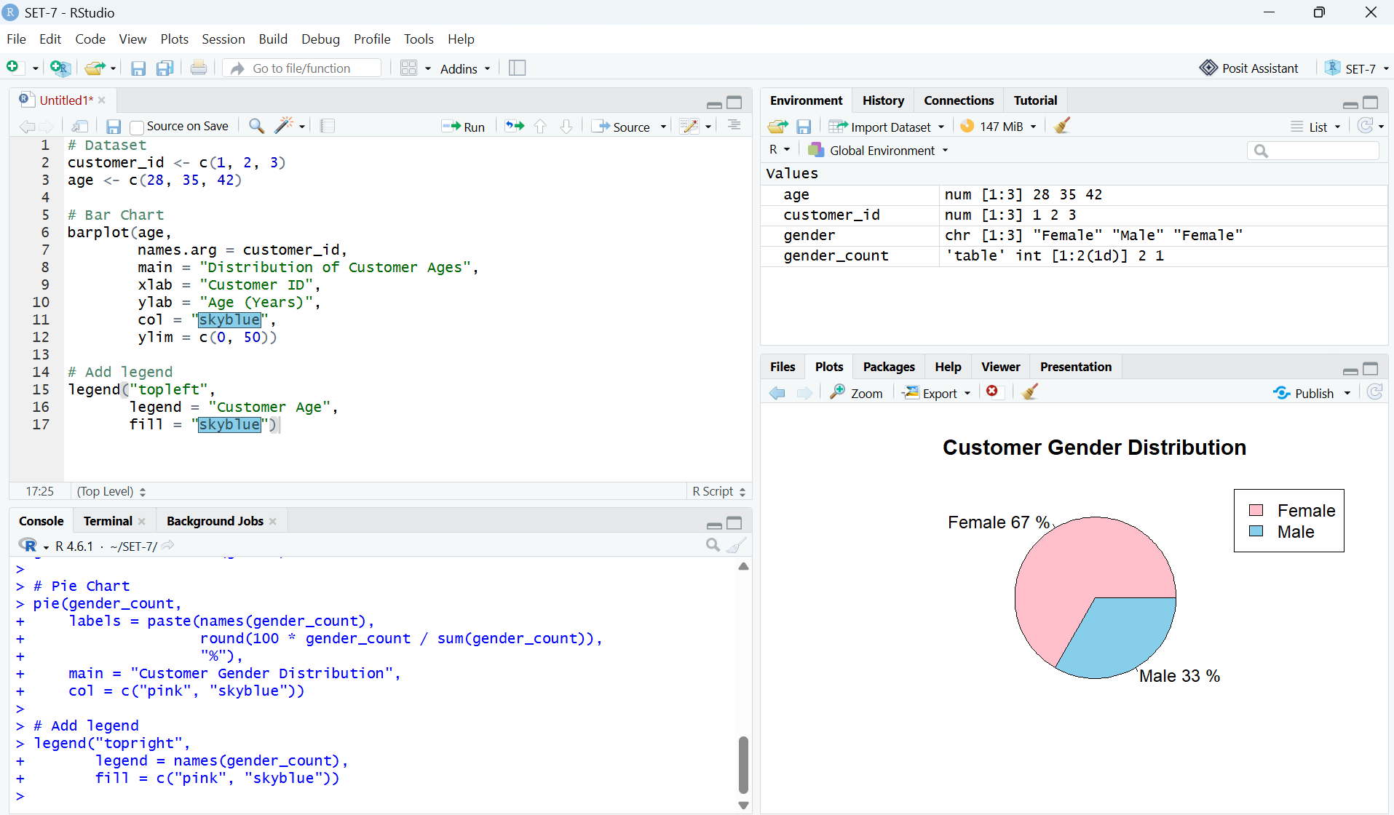Output 2: Customer Gender Distribution Pie Chart
Observation: There are 2 female customers and 1 male customer. Therefore, females represent 66.67% of the supplied dataset and males represent 33.33%.
PROGRAM 3: Customer Demographic Table
Build a table to display the demographic information for each customer. Label the table elements.
# Dataset
customer_id <- c(1, 2, 3)
age <- c(28, 35, 42)
gender <- c("Female", "Male", "Female")
income <- c(50000, 60000, 75000)
# Create data frame
customer_data <- data.frame(
Customer_ID = customer_id,
Age = age,
Gender = gender,
Income = income
)
# Display table
print(customer_data, row.names = FALSE)
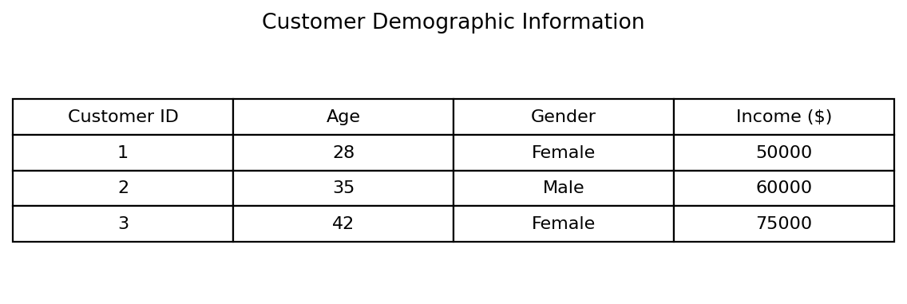

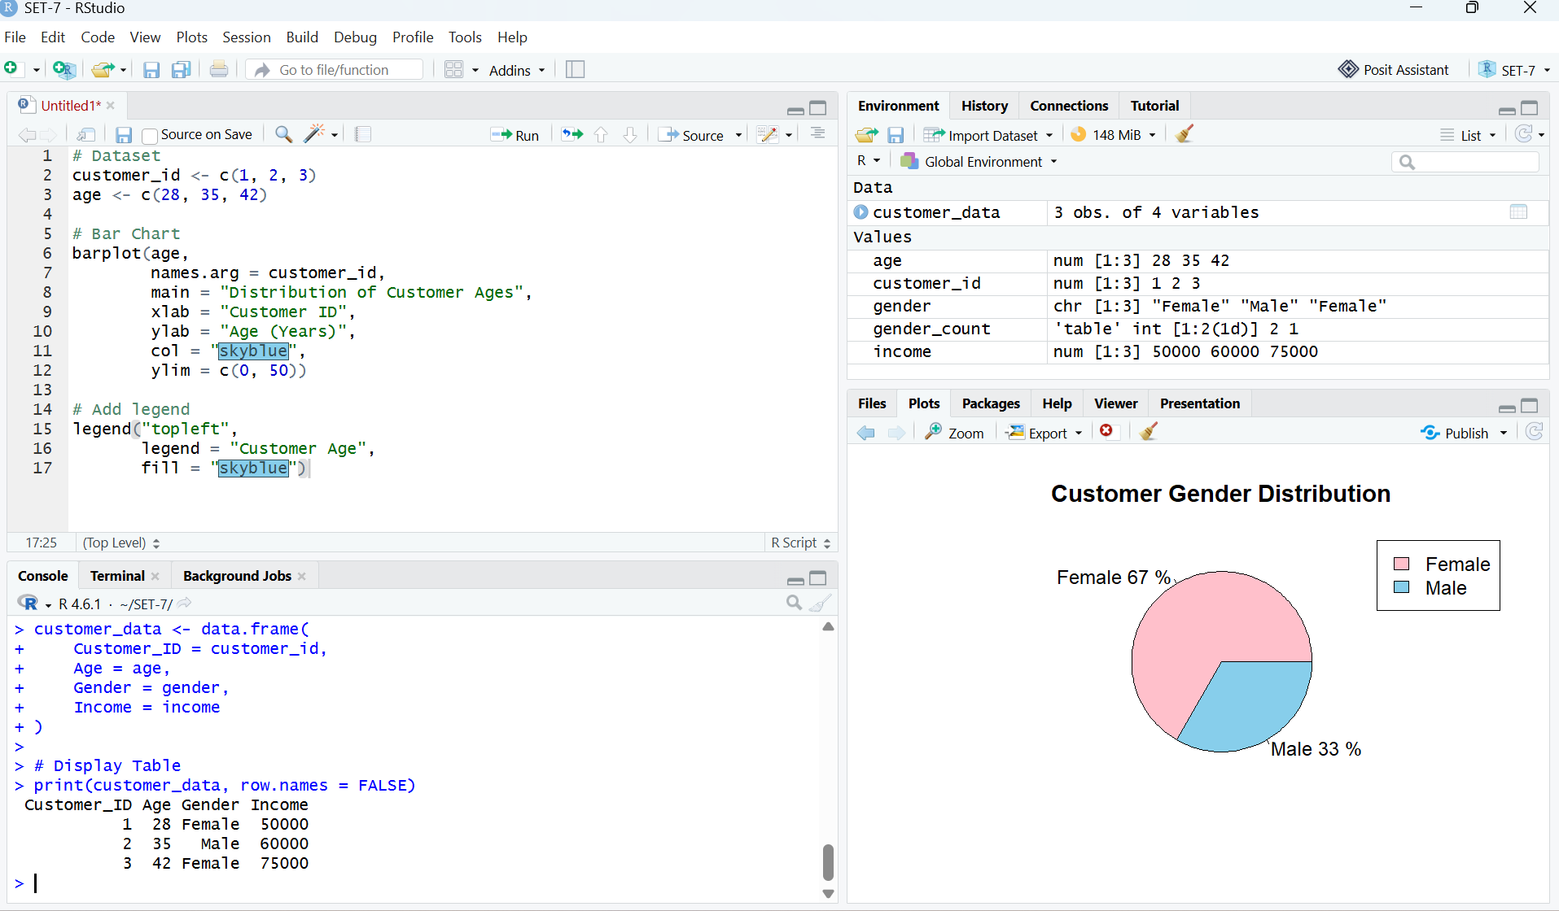Output 3: Customer Demographic Information Table
Observation: The table displays Customer ID, age, gender, and income for all three customers. The supplied incomes range from $50,000 to $75,000.

PROGRAM 4: Tableau Dashboard
Develop a Tableau dashboard combining the bar chart, pie chart, and demographic table for interactive exploration of customer demographics.
Procedure in Tableau
- Open Tableau Desktop or Tableau Public and connect to the Customer Demographics dataset.
- Create a worksheet named Customer Age Bar Chart. Drag Customer ID to Columns and Age to Rows. Select Bar from the Marks card and add data labels.
- Create a worksheet named Gender Distribution. Drag Gender to Color and Number of Records to Angle. Select Pie and enable percentage labels.
- Create a worksheet named Customer Demographic Table. Add Customer ID, Age, Gender, and Income to the view.
- Create a new Dashboard and drag the three worksheets onto the dashboard canvas.
- Add Age and Gender filters and apply them to the relevant worksheets.
- Enable tooltips so that users can inspect customer details interactively.
- Save the workbook as a Tableau workbook or publish it using the available Tableau option.
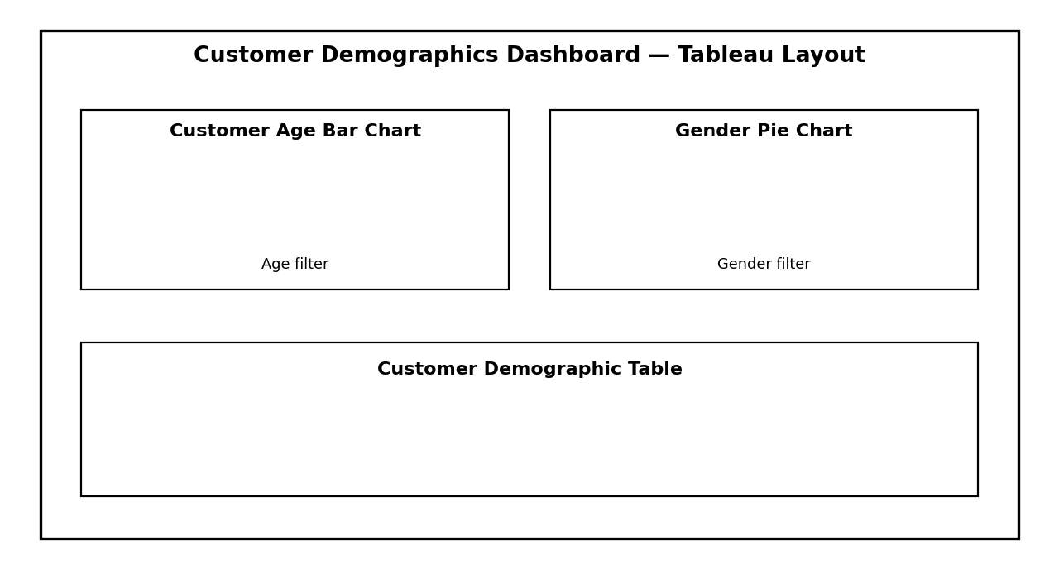
Output 4: Suggested Tableau Dashboard Layout (Illustrative)
Note: The dashboard layout above is an illustrative layout guide created for the practical record; it is not a screenshot of a live Tableau workbook.

Set 7 Procedure
- Create the customer demographic data with Customer ID, Age, Gender, and Income.
- Use barplot() to visualize the age of each customer.
- Use table() and pie() to calculate and display the gender distribution.
- Create a data frame and print it as the demographic information table.
- Import the data into Tableau and create separate worksheets for the age bar chart, gender pie chart, and demographic table.
- Combine the worksheets in a Tableau dashboard and add suitable filters and tooltips for interactive exploration.
Set 7 Result
The customer demographic data was successfully visualized using a bar chart for customer ages, a pie chart for gender distribution, and a tabular representation of the demographic information. The procedure for combining these visualizations into an interactive Tableau dashboard was also completed.
Key R Functions Used
Function | Purpose
barplot() | Creates the customer age bar chart.
table() | Calculates gender frequencies.
pie() | Creates the gender distribution pie chart.
data.frame() | Creates the demographic data table.
print() | Displays the demographic table in the R console.

