Q5. Optimal Binary Search Tree (OBST) Report
1. Aim
To construct an Optimal Binary Search Tree (OBST) using Dynamic Programming by considering the access frequency of each key and finding a binary search tree with minimum expected search cost.
2. Introduction
An Optimal Binary Search Tree is a Binary Search Tree in which the arrangement of keys is selected based on their access frequencies. Frequently searched keys are placed closer to the root to reduce the overall search cost. The OBST problem uses Dynamic Programming to examine different possible roots and determine the arrangement that produces the minimum total search cost.
3. Problem Description
Given a set of sorted keys and their corresponding access frequencies, construct a Binary Search Tree such that the total expected search cost is minimum.

For a key at depth d, its contribution to the search cost is:
Frequency × (Depth + 1)

Therefore, the objective is to minimize:
Total Search Cost = Σ Frequency[i] × Level[i]
4. Given Input
n = 3
Keys = 10 12 20
Freq = 34 8 50

Key 10 has frequency 34, key 12 has frequency 8, and key 20 has frequency 50. Since key 20 has the highest frequency, it is advantageous to place it close to the root.
5. Dynamic Programming Approach
Let cost[i][j] represent the minimum cost of constructing an optimal binary search tree using keys from index i to j.

For each possible root r, the keys before r form the left subtree and the keys after r form the right subtree.

Recurrence:
cost[i][j] = minimum { cost[i][r-1] + cost[r+1][j] + sum(freq[i...j]) }

The frequency sum is added because all nodes in the selected subtrees become one level deeper.
6. Pseudocode
OBST(keys, freq, n)

1. Create a table cost[n][n].
2. For i = 0 to n-1:
cost[i][i] = freq[i]
3. For length = 2 to n:
For i = 0 to n-length:
j = i + length - 1
cost[i][j] = infinity
sum = frequency of keys from i to j

For r = i to j:
leftCost = 0
If r > i:
leftCost = cost[i][r-1]

rightCost = 0
If r < j:
rightCost = cost[r+1][j]

totalCost = leftCost + rightCost + sum

cost[i][j] = minimum(cost[i][j], totalCost)

4. Return cost[0][n-1].
END
7. Sample Input
n = 3
Keys = 10 12 20
Freq = 34 8 50
8. Sample Calculation
Individual keys:
Cost(10) = 34
Cost(12) = 8
Cost(20) = 50

For keys 10 and 12:
Total Frequency = 34 + 8 = 42
Root 10: Cost = 34 + (8 + 42) = 84
Root 12: Cost = 8 + (34 + 42) = 84
Minimum Cost = 84

For keys 12 and 20:
Total Frequency = 8 + 50 = 58
Root 12: Cost = 8 + (50 + 58) = 116
Root 20: Cost = 50 + (8 + 58) = 116
Minimum Cost = 116

For all three keys, the Dynamic Programming approach evaluates every possible root and selects the arrangement with minimum total cost.

Expected output for the given problem:
Minimum Cost = 142

9. Sample Output
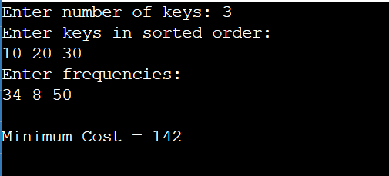
10. Complexity Analysis
Time Complexity = O(n³)

For every range of keys, all possible keys are considered as the root.

Space Complexity = O(n²)

A two-dimensional dynamic programming table of size n × n is used.
11. Advantages
1. Reduces the average search cost.
2. Gives importance to frequently accessed keys.
3. Avoids repeated calculations using Dynamic Programming.
4. Useful for databases and search systems.
5. Produces an efficient tree when access frequencies are known.
12. Applications
• Database indexing
• Symbol tables
• Dictionary applications
• Compiler design
• Searching frequently accessed records
• Information retrieval systems

13. Result
The Optimal Binary Search Tree problem was successfully solved using the Dynamic Programming technique. The algorithm considers the access frequency of each key and evaluates different possible roots to minimize the expected search cost.

For the given sample input, the specified expected minimum cost is:
Minimum Cost = 142

