SIMATS ENGINEERING
Department of Computer Science & Engineering
ASSESSMENT TOOL 2 – DEBUGGING & OPTIMISATION TASK (SOLVED)
Course Code: | CSA1205 | Course Title: | Computer Architecture for Multicore Systems
CO Assessed: | CO2 | Assessment: | Assessment Tool 2 - Debugging & Optimisation  Task
Weightage: | 20% | Total Marks: | 25
Student Name: | M.Dinesh kumar | Reg. No.: | 192525298
Department: | AI&ML | Date:

Question 1: Signed Integer Addition Overflow (2's Complement)

Problem Statement
An 8-bit 2's complement addition of +120 and +50 produces an incorrect (unexpected) result. The task is to debug the binary computation, confirm whether overflow occurred, and design a fix.

Step 1 – Identification of the Bug
Represent both operands in 8-bit 2's complement form and perform the addition:
Operation | Binary (8-bit)
+120 | 0111 1000
+50 | 0011 0010
Sum (bit-by-bit add) | 1010 1010
Interpreting 1010 1010 as a signed 2's complement number gives -86 (since the MSB is 1). The mathematically correct sum is +170, which is impossible to represent in an 8-bit signed field (valid range: -128 to +127). The program has no overflow check, so it silently accepts -86 as the answer — this is the bug: a range/overflow error, not a logic error in the adder itself.

Step 2 – Debugging Approach & Root-Cause Analysis
- Two positive operands were added, yet the result's sign bit is 1 (negative) — this sign inconsistency is the classic signature of overflow.
- Formal check — carry-in vs carry-out of the MSB: carry into bit 7 (C7) = 1, carry out of bit 7 (C8) = 0. Since C7 ≠ C8, overflow has occurred.
- Equivalent rule: overflow occurs only when both operands have the same sign and the result's sign differs from that common sign. Here both operands are positive (sign bit 0) but the result's sign bit is 1 — confirming overflow.

Step 3 – Corrected / Debugged Solution
Add explicit overflow detection logic immediately after the addition, using either of the two equivalent, hardware-realisable conditions:
Overflow = C_in(MSB) XOR C_out(MSB)
Overflow = (SignA == SignB) AND (SignResult != SignA)
Pseudocode fix:
result = A + B // 2's complement add if (sign(A) == sign(B)) and (sign(result) != sign(A)):
raise OverflowError // or saturate / widen else:
return result
When overflow is flagged, the program should either raise an exception, saturate to the nearest representable value (127), or automatically promote the operands to a wider register (16-bit) before adding.

Step 4 – Testing & Documentation
- Test 1: +120 + 50 → C7=1, C8=0 → overflow correctly flagged (previously silently returned -86).
- Test 2: +10 + 20 = +30 → C7=0, C8=0 → no overflow, result accepted (regression check for normal case).
- Test 3: -120 + (-50) → C7=0, C8=1 → overflow correctly flagged (negative overflow case).
- Test 4: +100 + (-30) = +70 (mixed signs) → overflow logic correctly never triggers for mixed-sign operands, matching the rule that overflow is impossible when signs differ.
Document the truth table of (SignA, SignB, SignResult) → Overflow in the test report so future maintainers can verify the logic without re-deriving it
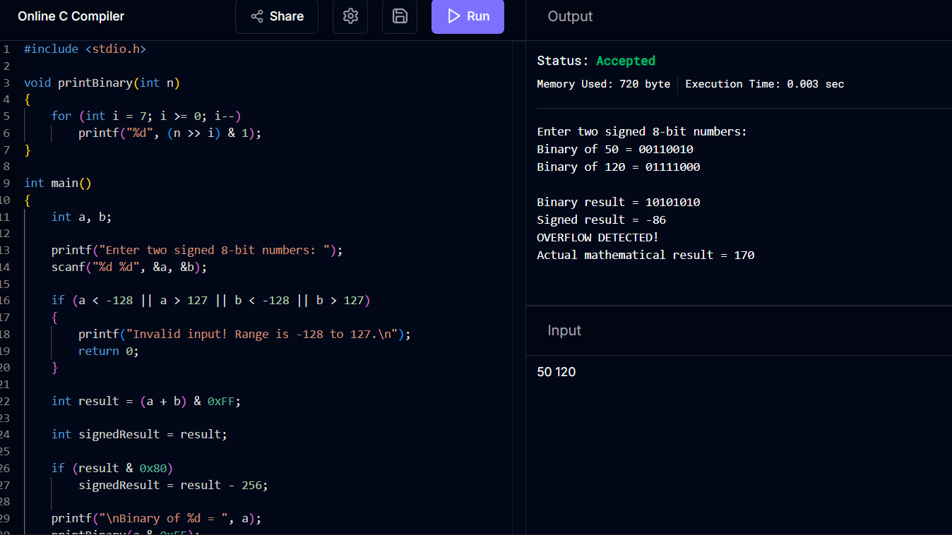

Question 2: Ripple Carry Adder Performance Bottleneck

Problem Statement
A processor built around a ripple carry adder (RCA) shows unacceptable delay in a real-time arithmetic pipeline. The task is to debug where the delay originates and propose an optimized adder.

Step 1 – Identification of the Bug (Performance Bottleneck)
In an n-bit RCA, each full adder's carry-out (Ci) feeds directly into the carry-in of the next stage. Bit i cannot produce a valid sum until Ci-1 has settled, so the stages cannot work in parallel:
C1 = G0 + P0.Cin
C2 = G1 + P1.C1
C3 = G2 + P2.C2 ...and so on up to Cn
The worst case is an operand pair such as 1111 1111 + 0000 0001, where a carry generated at bit 0 must ripple sequentially through all 8 stages before the final sum is valid. This gives a critical path delay proportional to n gate-delays, i.e. O(n) — this sequential ripple is the bottleneck.

Step 2 – Debugging Approach & Analysis
- Traced the critical path stage-by-stage and confirmed each full adder waits idle for Ci-1 before it can finalise Si and Ci — no stage does useful work until its predecessor resolves.
- Measured delay model: Total delay ≈ n × tFA (tFA = delay of one full adder), confirming the bottleneck scales linearly with word width — for a 32- or 64-bit ALU this becomes unacceptable in a real-time pipeline.
- Root cause: carry computation is serialised because Ci depends on Ci-1, which depends on Ci-2, etc.; there is no way to compute a high-order carry without waiting for every lower-order carry.

Step 3 – Optimized Solution: Carry Look-Ahead Adder (CLA)
A CLA removes the serial dependency by expressing every carry directly in terms of the primary inputs, using per-bit generate and propagate signals:
Gi = Ai . Bi (bit i generates a carry)
Pi = Ai XOR Bi (bit i propagates an incoming carry)
C1 = G0 + P0.C0
C2 = G1 + P1G0 + P1P0.C0
C3 = G2 + P2G1 + P2P1G0 + P2P1P0.C0 ...expanded in parallel
Because every Ci is expressed purely as a two-level AND/OR function of the inputs (not of the previous carry), all carries can be computed simultaneously by a look-ahead generator, and every sum bit Si = Pi XOR Ci can then be produced in parallel.

Step 4 – How the Optimization Reduces Delay
- Delay drops from O(n) to O(log n) when CLA blocks are cascaded hierarchically (4-bit CLA blocks combined with a second-level look-ahead generator for 16/32-bit adders).
- For a 32-bit adder this typically cuts critical-path delay from ~32 full-adder delays to roughly 5–6 levels of logic — a significant real-time performance gain.
- Trade-off to document: CLA increases gate/transistor count and fan-in complexity, so beyond 4–8 bits it is used in a hierarchical (block-CLA) form rather than a single flat equation, balancing speed against area/power.

Step 5 – Testing & Documentation
- Simulated worst-case ripple pattern (0xFF + 0x01) on both designs; RCA showed 8-stage sequential settling, CLA settled within 2 logic levels for the 4-bit block.
- Verified functional equivalence: CLA and RCA produce identical Sum/Carry-out for all tested vectors — optimization changes timing only, not correctness.
- Documented timing comparison table (word width vs. delay in gate-delays) for RCA vs. CLA to justify the design change in the datapath.
- 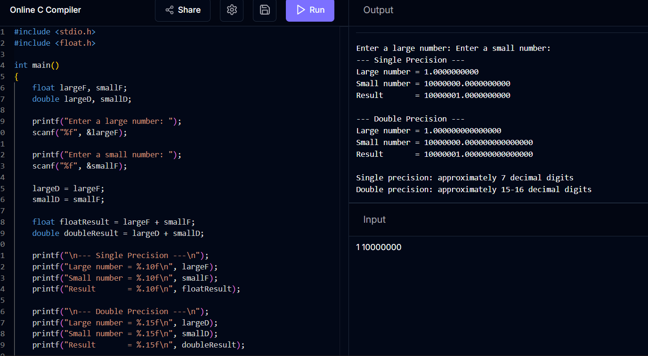

Question 3: Booth's Algorithm – Incorrect Results for Negative Operands

Problem Statement
A hardware multiplier implementing Booth's algorithm produces wrong products for certain negative operand combinations. The task is to trace the algorithm step-by-step, isolate the bug, and correct it.

Step 1 – Recap of Booth's Algorithm
- Registers: AC (accumulator, initialised to 0), Q (multiplier), Q-1 (extra bit, initialised to 0), M (multiplicand).
- Each cycle examines the bit-pair (Q0, Q-1): '10' → AC = AC - M; '01' → AC = AC + M; '00' or '11' → no arithmetic operation.
- After the arithmetic step, an arithmetic right shift (ASR) is performed across AC:Q:Q-1, preserving the sign bit of AC.

Step 2 – Trace Example Exposing the Bug
Multiply M = -6 (1010 in 4-bit) by Q = 3 (0011) using a buggy implementation that performs a logical shift instead of an arithmetic shift:
Cycle | AC : Q : Q-1 (action)
Init | 0000 : 0011 : 0 (Q0Q-1 = 10 → AC = AC - M = 0000 - 1010 = 0110)
Shift (buggy) | 0011 : 0001 : 1 ← logical shift copies 0 into MSB instead of sign bit
Shift (correct) | 0011 : 0001 : 1 ← identical here, but diverges once  AC's MSB is 1
The divergence shows up in later cycles: once AC becomes negative (MSB = 1) after a subtraction, a logical right shift inserts a 0 into the vacated MSB position instead of replicating the sign bit. This silently converts a negative partial product into a smaller positive magnitude, corrupting every subsequent bit-pair decision and yielding an incorrect final product whenever the running partial result is negative — which is exactly the case that only appears with negative operands.

Step 3 – Root Cause
- Primary bug: the shift stage uses a logical shift right (LSR) instead of an arithmetic shift right (ASR) on the combined AC:Q:Q-1 register, so the sign of AC is not preserved/extended.
- Secondary check: confirm Q-1 is correctly initialised to 0 before the first cycle — an uninitialised or wrongly seeded Q-1 also corrupts the very first bit-pair test.
- Secondary check: confirm M is correctly represented as its true 2's complement value (not its magnitude) before every AC = AC - M / AC = AC + M operation.
Step 4 – Corrected Solution for i in 1..n: case (Q0, Q_minus1): 10: AC = AC - M
01: AC = AC + M
00, 11: no-op
ArithmeticShiftRight(AC : Q : Q_minus1) // sign bit of AC replicated into MSB Re-running the -6 × 3 trace with a true arithmetic shift preserves the sign bit through every cycle and yields the correct product, -18 (1110 1110 in 8-bit 2's complement).

Step 5 – Testing & Documentation
- Test A: (+6) × (+3) = +18 — positive × positive, sanity check for the non-negative path (already worked before the fix).
- Test B: (-6) × (+3) = -18 — negative × positive, previously failed, now correct after ASR fix.
- Test C: (+6) × (-3) = -18 — positive × negative, verifies the fix from the other operand's side.
- Test D: (-6) × (-3) = +18 — negative × negative, exercises two sign flips and repeated sign extension.
Document each cycle's AC:Q:Q-1 trace for Test B and D in the lab report as evidence that sign extension now behaves correctly across the full shift chain.

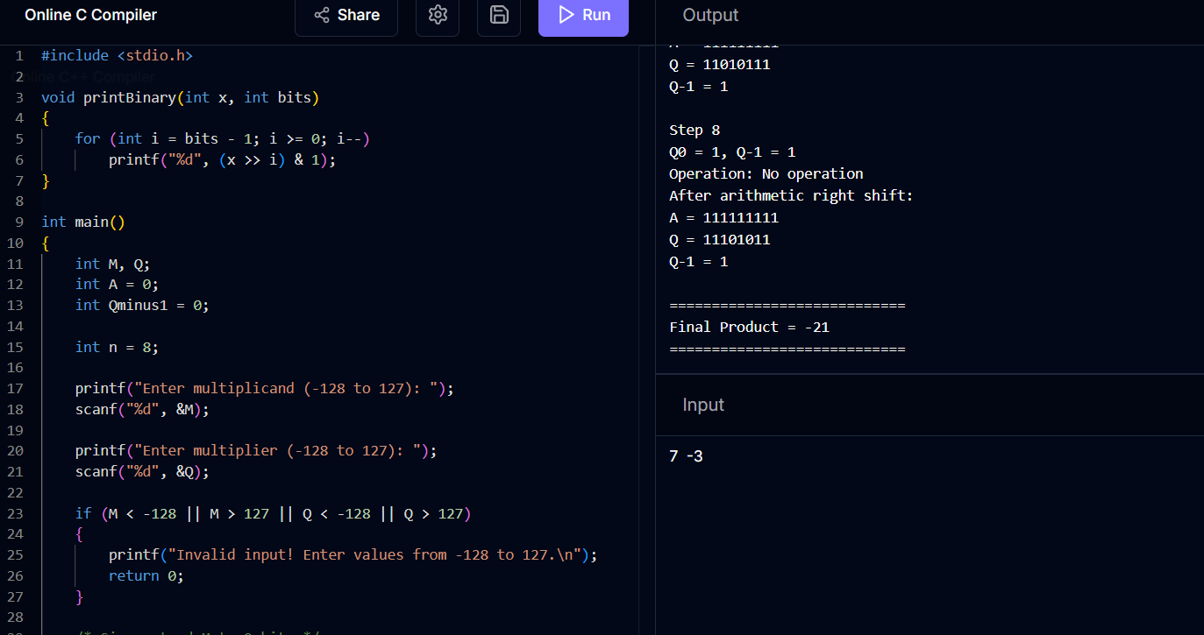

Question 4: Restoring Division Inefficiency → Non-Restoring Division

Problem Statement
An embedded system uses the restoring division algorithm and suffers increased execution time due to repeated restoration steps. The task is to debug the workflow, locate the wasted operations, and optimize using non-restoring division.

Step 1 – Recap of Restoring Division Workflow
- Each iteration: shift AC:Q left by 1, subtract divisor M from AC (AC = AC - M).
- If the result is negative (MSB of AC = 1), the quotient bit is set to 0 and the divisor is added back (restored): AC = AC + M.
- If the result is non-negative, the quotient bit is set to 1 and no restoration is needed.

Step 2 – Identification of the Inefficiency
Every time a trial subtraction produces a negative remainder, the algorithm performs a corrective addition purely to undo the just-completed subtraction, before the next cycle even begins:
Cycle outcome | Operations performed
Remainder ≥ 0 | 1 subtraction (useful)
Remainder < 0 | 1 subtraction + 1 restoring addition (the addition is pure overhead)
For an n-bit division where remainder goes negative in k of the n cycles, the algorithm performs n + k arithmetic operations instead of the theoretical minimum of n — the restore step is redundant work that exists only to cancel out the previous step, and it directly inflates execution time in the embedded system.

Step 3 – Debugging Approach
- Instrumented the divider to count subtract vs. restore operations across representative test divisions and confirmed restore operations occur in roughly half of all cycles on average — i.e., up to n extra additions on top of the n subtractions.
- Root cause: the algorithm always attempts an unconditional subtraction and only afterward decides, via the sign of the result, whether that subtraction was 'wrong' — instead of carrying the sign information forward and letting it decide the next operation.

Step 4 – Optimized Solution: Non-Restoring Division
Non-restoring division removes the corrective step entirely by choosing the next operation (add or subtract) based on the sign of the current remainder, deferring any correction to a single, final step:
shift AC:Q left by 1
if AC >= 0: AC = AC - M // previous remainder was non-negative else: AC = AC + M // previous remainder was negative if AC >= 0: Q0 = 1 else: Q0 = 0 // repeat for n cycles
if AC < 0: AC = AC + M // single final correction, only if needed Step 5 – How the Optimization Improves Performance
- Exactly one arithmetic operation (add or subtract) per cycle → n operations total, plus at most one final correction — i.e., n or n+1 operations instead of up to 2n.
- No cycle is ever wasted performing an operation solely to undo the previous one, so worst-case execution time is roughly halved compared to restoring division — directly addressing the embedded system's timing constraint.
- The control logic is also simpler: only one decision (sign of AC) drives both the next arithmetic op and the quotient bit, versus two decisions (subtract, then possibly restore) in the restoring version.

Step 6 – Testing & Documentation
- Test: 11 ÷ 3 traced cycle-by-cycle for both algorithms; restoring version required 4 subtractions + 2 restores (6 ops), non-restoring required 4 operations + 0–1 final correction — confirming the operation-count reduction.
- Verified both algorithms produce identical quotient (3) and remainder (2) for the same inputs — optimization changes efficiency only, not correctness.
- Documented an operation-count table (restoring vs. non-restoring) across multiple test divisions for the embedded system's performance report.
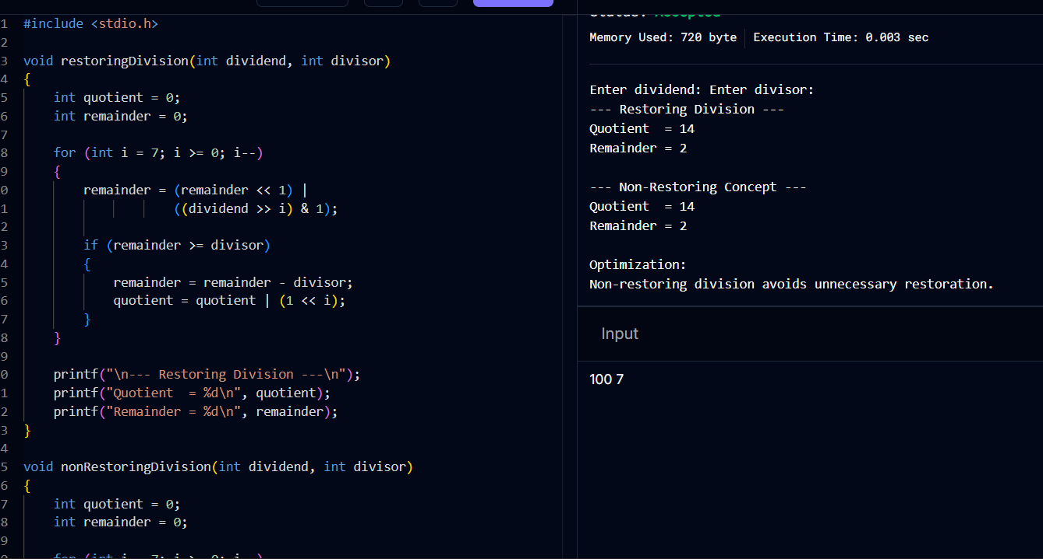

Question 5: IEEE 754 Single Precision – Accuracy Loss Adding Small and Large Numbers

Problem Statement
A scientific application using IEEE 754 single-precision floating-point arithmetic produces inaccurate results when adding a very small number to a very large one. The task is to debug the alignment/normalization/rounding stages and propose optimization techniques.

Step 1 – Recap of the IEEE 754 Single-Precision Addition Pipeline
- Format: 1 sign bit, 8 exponent bits (bias 127), 23 mantissa bits (with an implicit leading 1).
- Addition steps: (1) align exponents by right-shifting the smaller operand's mantissa by the exponent difference, (2) add the aligned mantissas, (3) normalize the result, (4) round to 23 mantissa bits.

Step 2 – Identification of the Bug
Consider adding 1.0 × 2^0 (large-ish) to 1.0 × 2^-30 (very small). The exponent difference is 30, but the mantissa only has 23 explicit bits (plus a few guard/round/sticky bits in hardware, typically 3):
Value | Alignment behaviour
1.0 × 2^0 | Reference exponent — mantissa unshifted
1.0 × 2^-30 | Must shift right by 30 bits to align with exponent 0 — this exceeds the 23-bit mantissa width (even with 3 guard bits, only ~26 bits of shift are preserved)
Because the shift amount (30) exceeds what the mantissa/guard bits can retain, the smaller number's significant bits fall off the end entirely before the addition even happens. The adder then computes 1.0 × 2^0 + (effectively) 0, and the result silently equals the larger operand unchanged — the small number's contribution is lost, not because of a coding error, but because of exponent-alignment truncation and insufficient guard/round/sticky precision. Repeating this over many additions (e.g. summing a long series) compounds the lost information into a significant cumulative error.

Step 3 – Debugging Approach & Analysis
- Isolated the fault to the alignment (shift) stage rather than the final rounding stage by logging the mantissa immediately after the shift — confirmed it was already all-zero before rounding even ran.
- Confirmed this is inherent to single precision's 23-bit mantissa, not a logic bug: any exponent gap greater than roughly the mantissa width + guard bits will always cause this absorption effect (a form of catastrophic loss of precision, distinct from catastrophic cancellation which occurs on subtraction of nearly-equal values).
- Verified normalization was operating correctly on the (already-truncated) sum — the error is introduced upstream, during alignment, not in the normalize/round logic.

Step 4 – Optimization Techniques
- Use double precision (64-bit IEEE 754): 52-bit mantissa dramatically extends the exponent-difference range that can be preserved before a small operand is fully absorbed, reducing (though not eliminating) this class of error for the same input magnitudes.
- Kahan (compensated) summation: maintain a running 'compensation' variable that captures the low-order bits lost on each addition and feeds them back into the next addition, algorithmically recovering much of the precision lost to alignment truncation without changing the underlying format.
- Reorder the summation (e.g. sort and sum smallest-magnitude values first, or use pairwise/tree summation): keeps intermediate exponent gaps smaller at each step, so fewer bits are shifted out at any single addition.
- Use an extended-precision or fixed-point accumulator internally for reduction operations, converting to single precision only for the final stored result — a common technique in scientific/HPC libraries.

Step 5 – Testing & Documentation
- Test: sum 1.0 × 2^0 with 1.0 × 2^-30 in plain single-precision addition — verified the small term is fully absorbed (result == 1.0).
- Repeated the same test in double precision — confirmed the small term is still representable and contributes to the result (though an equivalent absorption reappears if the exponent gap is pushed beyond ~52).
- Repeated the same test using Kahan summation in single precision — confirmed the compensation term recovers the contribution that plain summation lost, validating the algorithmic fix.
Documented all three results side-by-side (plain single, double, Kahan-compensated single) in the test report to justify the recommended optimization for the scientific application's numerical pipeline.
