SIMATS ENGINEERING
CSA15 – CLOUD COMPUTING AND BIG DATA ANALYTICS
ASSIGNMENT 1 – CO1 | COMPLETE ANSWERS
Design, Analyse and Validate a Cloud-Based Solution for Migrating a Legacy University Management System
Student Name: k .chandrika Register No.:192525299
Department/Section: BTech AI/ML Faculty: MD.Boomija
Academic Year/Semester: ___________ Submission Date: ________________

Scenario and Design Assumptions
The university operates SIS, LMS, Library, Exam Portal and Email on 12 dedicated physical servers. Average CPU utilisation is 15%, peaks exceed 95%, and procurement takes 6–8 weeks. It serves 25,000 students and 2,000 staff across four campuses. Applications are monolithic, lack public APIs and have no disaster recovery (DR) site. The proposed strategy is hybrid during migration and public-cloud oriented thereafter.
Planning assumptions: server workloads are initially treated as equal for the consolidation calculation; costs are illustrative INR estimates, not provider quotations; staff salaries, taxes and exceptional traffic are excluded. Actual capacity, prices and implementation evidence must be verified.

TASK 1 – Cloud Computing and Scenario Mapping (3 Marks)

Definition and five characteristics
Cloud computing provides convenient, on-demand network access to a shared pool of configurable computing resources (servers, storage, networks and applications) that can be provisioned and released rapidly with limited management effort.
Characteristic | Meaning | University mapping
On-demand self-service | Provision through portal/API without manual provider interaction. | Avoid 6–8 week server procurement; provision in minutes.
Broad network access | Services available over standard networks/devices. | Serve four campuses, browsers and mobile devices.
Resource pooling | Provider pools resources and allocates dynamically. | Reduce idle capacity across 12 dedicated servers.
Rapid elasticity | Scale capacity up/down with demand. | Handle admissions, results and exam peaks.
Measured service | Usage monitored and metered. | Track consumption, budgets and chargeback.

Model | Description | Suitability
Public | Provider-owned shared infrastructure with logical isolation. | Best for elastic web/API, DB and SaaS workloads.
Private | Dedicated cloud for one organisation. | Sensitive/legacy workloads, but expensive to maintain.
Hybrid | Integrated private/on-premises and public cloud. | Recommended transition: retain legacy temporarily, connect securely to public cloud.
Community | Shared by organisations with common requirements. | Possible consortium service for colleges with agreed governance.

Three key problems and remedies: (1) Low utilisation/high CapEx—pooling and measured service improve efficiency. (2) Seasonal overload and slow procurement—elasticity and self-service add capacity quickly. (3) Campus access and no DR—network access plus multi-zone/secondary-region recovery improves reach and resilience. Benefits include agility, lower initial capital, elasticity, managed services and recovery options. Limitations include variable bills, internet dependency, lock-in, privacy/residency concerns, skills gaps and provider outages.

TASK 2 – Evolution and Hardware Evolution

Stage | Evolution / limitation solved
Mainframes | Centralised computing; powerful but expensive and limited access.
Minicomputers | Smaller departmental systems reduced mainframe dependence.
PCs | Affordable individual computing; computing became distributed.
Client–server | Shared server data/services improved central administration.
Clusters | Connected commodity machines provided scale and availability.
Grid computing | Distributed resources across locations for large workloads.
Utility computing | Metered computing resembling a pay-for-use utility.
Cloud | Virtualised pooled resources, self-service and elasticity over networks.

Hardware enablers: multi-core CPUs execute concurrent workloads; commodity servers reduce scale-out costs; high-capacity SSD/HDD/object storage holds records and backups; high-speed Ethernet/fibre reduces transfer bottlenecks; redundant data-centre power, cooling and networks support resilience; Intel VT-x/AMD-V hardware extensions improve virtualisation. The university is currently a traditional dedicated client–server/on-premises data-centre model: monolithic applications run on separate physical servers with little pooling or elasticity

TASK 3 – Internet Software Evolution
Stage | Explanation and university relevance
Static web | Fixed HTML pages; suitable for notices, not interactive records.
Dynamic web | Server logic/database generate personalised pages for login, marks and fees.
Web 2.0 | Interactive user experiences and collaboration.
AJAX | Asynchronous HTTP data exchange without full page reload; dashboards.
SOA | Reusable services with defined contracts and interoperable interfaces.
Mashups | Combine services/data, e.g. library availability and campus maps.
Cloud applications | Applications hosted on elastic infrastructure/managed platforms.
APIs | Interfaces enable mobile apps and partner-college integration.
Browsers render HTML/CSS/JavaScript; HTTP/HTTPS carries requests; AJAX exchanges data asynchronously; APIs expose operations in JSON/XML. Desktop software is installed and updated per device. Client–server software centralises data but may depend on thick clients and fixed servers. Web-delivered software uses browsers/mobile clients, central updates and network access. The university should modularise monoliths gradually, separate UI/business/data layers, expose REST APIs, use HTTPS and identity tokens, and never expose direct database access

TASK 4 – Server Virtualisation (5 Marks)

Hypervisors and techniques
A hypervisor abstracts CPU, memory, storage and network resources, creates isolated VMs, schedules resources and mediates hardware access. Type-1 runs on hardware (VMware ESXi, Hyper-V, Xen); Type-2 runs above a host OS (VirtualBox, VMware Workstation), convenient for labs but less suitable for production
Technique | Description | Trade-off
Full virtualisation | Guest sees virtual hardware; unmodified OS can run. | Flexible; some overhead.
Para-virtualisation | Guest knows virtualisation and uses hypercalls/drivers. | Efficient I/O; guest support may be needed.
OS-level containers | Processes share host kernel; namespaces/cgroups isolate. | Lightweight/fast; kernel compatibility constraint.
Hardware-assisted | CPU extensions support guest execution. | Improves VM performance/isolation; hypervisor still required.
Placement: run SIS and legacy monoliths in VMs where separate OS environments are required. New stateless web/API services run in containers managed by Kubernetes or a container platform. Prefer managed DB services for databases; if self-hosted, use dedicated VMs/storage and strict isolation. Email is suitable for SaaS

Consolidation calculation
Assumption: 12 servers contribute equal workload at 15% CPU each. Total demand = 12 × 0.15 = 1.8 full-server CPU capacities. At 70% target utilisation, hosts required = 1.8 ÷ 0.70 = 2.571; round up to 3 physical hosts (CPU-only mathematical minimum). This excludes memory, IOPS, network, N+1 and peak demand. A practical production cluster may use 4 or more hosts for maintenance/failure tolerance
Benefits: live migration moves VMs with limited downtime; snapshots permit rollback but are not backups; cautious over-commitment improves average utilisation. Risks: noisy neighbours, host/hypervisor failure affecting many VMs, isolation vulnerabilities, over-commitment at peaks and shared storage bottlenecks. Mitigate through N+1 capacity, patching, segmentation, reservations/limits, monitoring and tested backups
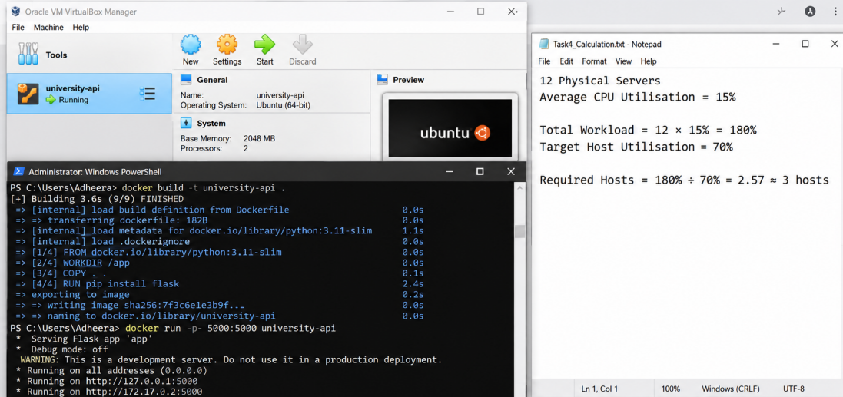

TASK 5 – Web Services
Web services expose machine-readable functions over a network. SOA treats them as reusable services with contracts. SOAP is an XML messaging protocol often described using WSDL and supports enterprise standards such as WS-Security. WSDL defines operations/messages/endpoints. UDDI is a service registry/discovery concept. REST is an architectural style using resource URLs and HTTP methods (GET, POST, PUT/PATCH, DELETE), commonly JSON, and suits mobile/web APIs
Function | Endpoint/method | Sample request | Sample response | Choice
Result lookup | GET /api/v1/students/{id}/results | GET …/students/STU100/results | {"studentId":"STU100","semester":5,"results":[{"course":"CS501","grade":"A"}]} | REST: read-only, JSON, cacheable.
Fee payment | POST /api/v1/fees/payments | {"studentId":"STU100","amount":25000,"currency":"INR","idempotencyKey":"abc123"} | {"paymentId":"PAY9001","status":"PENDING","redirectUrl":"..."} | REST + HTTPS/gateway; SOAP possible for legacy bank integration.
Library search | GET /api/v1/library/search?q=cloud | GET …/library/search?q=cloud | {"items":[{"title":"Cloud Computing","available":true}]} | REST: simple query and JSON.
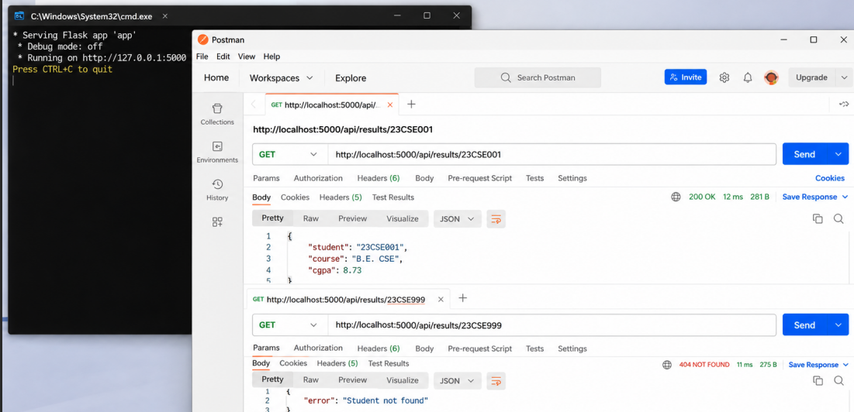
Secure APIs with authentication, authorisation, validation, rate limits, audit logs and versioning. Partner colleges should use scoped OAuth2 credentials and access only their authorised students

TASK 6 – IaaS, PaaS and SaaS (5 Marks)
IaaS supplies VMs, networks and storage; customer manages OS, middleware, runtime, apps and data. PaaS supplies managed OS/runtime/middleware; customer manages application code and data. SaaS supplies a complete application; provider manages the stack while university configures users, policies and data governance
Layer | On-prem |  | IaaS customer | PaaS customer |  | SaaS customer
Physical/DC/network | University |  | Provider | Provider |  | Provider
Virtualisation | University |  | Provider | Provider |  | Provider
OS | University |  | University | Provider |  | Provider
Middleware/runtime | University |  | University | Provider |  | Provider
Application | University |  | University | University |  | Provider
Data/config | University |  | University | University |  | Shared/configuration
Application |  | Model |  |  | Reason
SIS |  | PaaS for new modules; legacy IaaS temporarily |  |  | Custom data/business logic needs control; reduce OS burden during refactoring.
LMS |  | SaaS |  |  | Mature functionality, updates and scale; configure courses/identity.
Library |  | SaaS |  |  | Standard cataloguing/circulation; vendor maintenance and API integration.
Exam Portal |  | PaaS + autoscaled containers |  |  | Custom logic needs control; elastic compute handles exam peaks.
Email |  | SaaS |  |  | Commodity service benefits from provider scale and managed security.
IaaS gives most control but highest administration. PaaS lowers maintenance and speeds deployment with moderate control and runtime lock-in. SaaS minimises maintenance but offers less customisation and can create data/export dependence. All can scale; PaaS/SaaS shift more operations to provider. Examples: AWS EC2 (IaaS), Azure App Service (PaaS), Microsoft 365 (SaaS)

TASK 7 – XaaS (3 Marks)
XaaS means technology capabilities delivered as network services, generally subscription/usage based. Variants:
- DBaaS: managed databases, patching, backups and scaling.
- DRaaS: replicated recovery environment and failover.
- FaaS: event-triggered functions without server management.
- MBaaS/BaaS: mobile backend, authentication and push notifications.
- DaaS: centrally delivered virtual desktops.
- Security-as-a-Service: managed WAF, threat detection or identity security.
Recommended DBaaS for SIS/API data (automated patching, backups and replication; use private networking and encryption) and DRaaS for recovery (replicate critical data to another region and test failover). Multiple providers can cause inconsistent IAM, integration complexity, egress fees, fragmented logs, SLA gaps and lock-in. Use standards-based APIs, central identity/logging, export tests and clear contracts

TASK 8 – Cloud Solution Architecture (5 Marks)
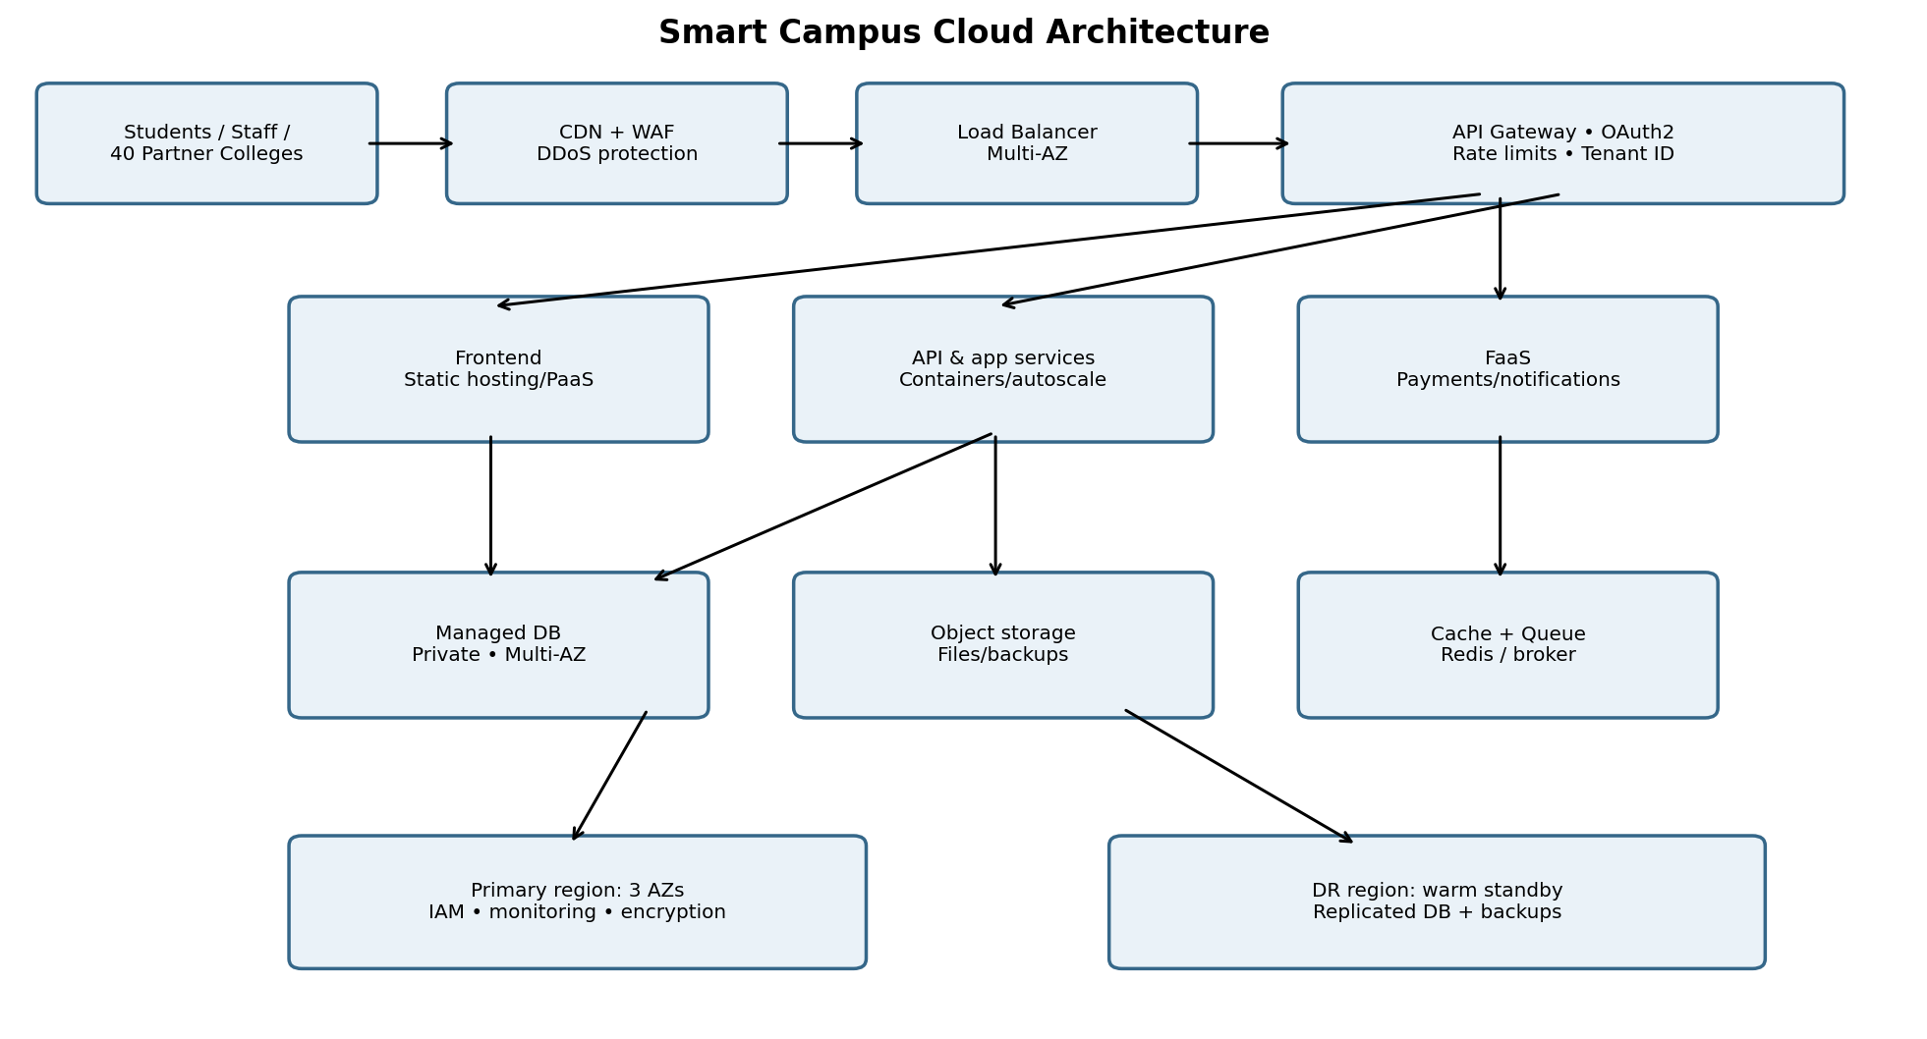
Figure 1. Proposed Smart Campus architecture
Deployment is hybrid during transition, public cloud for elastic services. CDN/WAF/API gateway/load balancer are managed services; frontend is static hosting/PaaS; APIs run as container PaaS/orchestrated containers; notifications/payment callbacks can use FaaS; SIS uses managed DBaaS; documents/backups use object storage; email/LMS/library use SaaS; DR uses cross-region replication and backups
- Edge: DNS/CDN and WAF protect traffic; TLS and load balancer distribute requests across zones.
- API gateway authenticates tokens, checks tenant scope, rate-limits and routes versioned APIs.
- Stateless containers scale horizontally across at least three availability zones using CPU, request rate, latency and queue depth.
- Managed relational DB in private subnet uses multi-zone replication, backups and connection pooling; object storage holds files/immutable backups.
- Security: least-privilege IAM, MFA, OAuth2/OIDC, tenant-aware authorisation, encryption in transit/at rest, secrets manager, audit logs and network segmentation.
- Availability: health checks, multi-zone deployment, rolling releases, monitoring, tested restore and warm-standby DR region. Define RPO/RTO and drill twice yearly.
- Admissions/exam peaks: scheduled pre-scaling, autoscaling, caching read-heavy data, queues/back-pressure and budget ceilings.
Separating stateless compute from durable data allows independent scaling. Multi-zone deployment handles zone failures; DR region addresses regional failure. Capacity tests should refine this architecture

TASK 9 – Hands-on Implementation and Documentation (4 Marks)
The following is a reproducible proof-of-concept procedure. Commands and expected results are examples, not claims of execution. Add authentic screenshots/output after running on your system

A. Flask REST API (app.py)
from flask import Flask, jsonify
app = Flask(__name__)
@app.get("/health")
def health():
return jsonify(status="ok", service="smart-campus-api")
@app.get("/api/v1/library/search")
def search():
return jsonify(query="cloud", results=[
{"title":"Cloud Computing Fundamentals","available":True}])
@app.get("/api/v1/students/<student_id>/results")
def results(student_id):
if student_id != "STU100":
return jsonify(error="student_not_found"), 404
return jsonify(studentId=student_id, semester=5,
results=[{"course":"CS501","grade":"A"}])
if __name__ == "__main__":
app.run(host="0.0.0.0", port=5000)
requirements.txt: flask==3.0.3
Dockerfile:
FROM python:3.12-slim
WORKDIR /app
COPY requirements.txt .
RUN pip install --no-cache-dir -r requirements.txt
COPY app.py .
EXPOSE 5000
CMD ["python", "app.py"]

B. Build, run and test
docker build -t smart-campus-api .\ndocker run --rm -p 5000:5000 smart-campus-api
In another terminal run:
curl http://localhost:5000/health\ncurl http://localhost:5000/api/v1/library/search\ncurl http://localhost:5000/api/v1/students/STU100/results\ncurl -i http://localhost:5000/api/v1/students/UNKNOWN/results
Test | Expected (verify by executing)
GET /health | HTTP 200; status=ok
Library search | HTTP 200; sample item
STU100 results | HTTP 200; semester 5, grade A
UNKNOWN results | HTTP 404; student_not_found

C. PaaS and screenshots
Deploy the container/API to Azure App Service, AWS App Runner or Google Cloud Run: create service, configure image/source, port and environment variables, enable HTTPS, configure secrets and access restrictions. Optionally create a managed database or static site. Never place credentials in code
- Screenshot 1: Docker build/image completed.
- Screenshot 2: Container running with port mapping 5000:5000.
- Screenshot 3: /health in browser/Postman showing HTTP 200 and JSON.
- Screenshot 4: library/results successful response.
- Screenshot 5: unknown student request showing HTTP 404.
- Screenshot 6: PaaS dashboard with deployment status/HTTPS URL (hide secrets).
Record actual errors such as port conflicts, build/dependency errors, configuration issues or cold starts. Expected output here is not execution evidence; authentic screenshots must be added

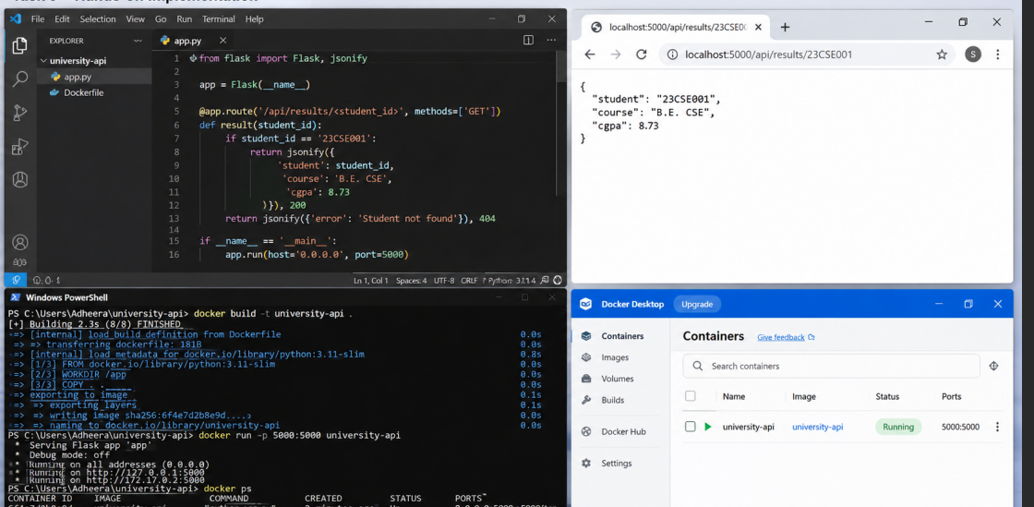

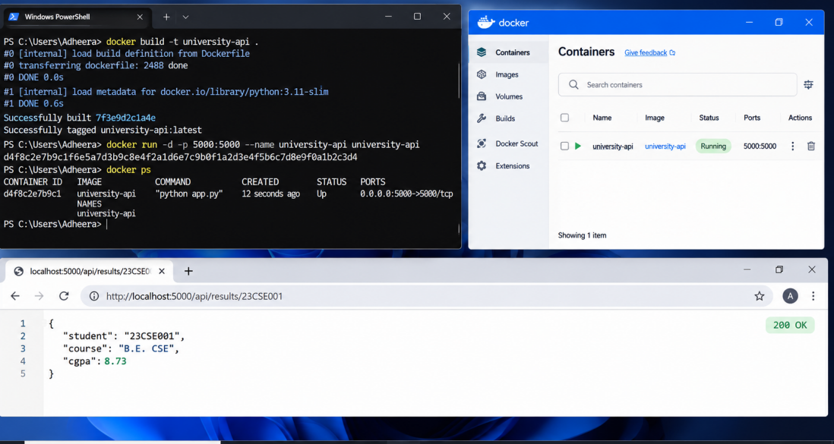

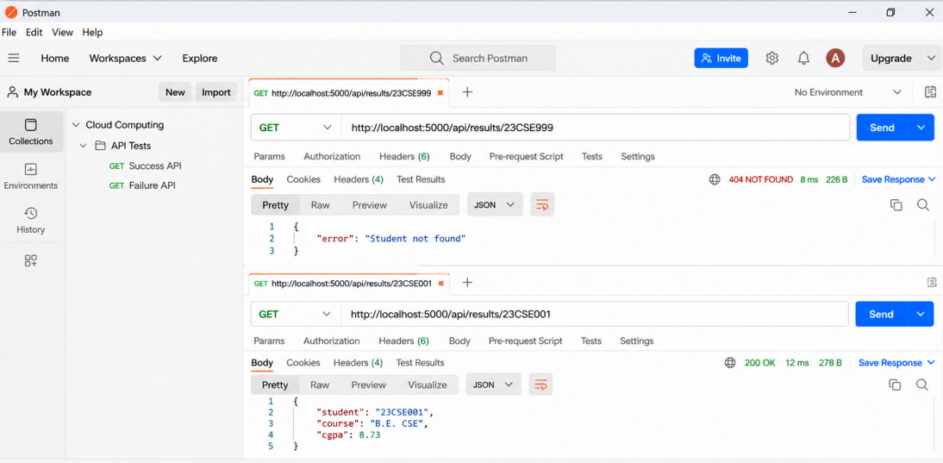

TASK 10 – Evaluate and Recommend Final Solution (7 Marks)
Criterion | On-premises | IaaS | PaaS/SaaS
Cost | High upfront CapEx, power/cooling/support. | Lower initial CapEx; recurring compute/storage/network and admin. | Usage/subscription OpEx; less infrastructure labour.
Scale | 6–8 week procurement; fixed capacity. | VM scaling, but OS/capacity management remains. | Fast autoscaling/managed capacity; quotas apply.
Availability | Single site/no DR. | Customer configures multi-zone/region. | Provider platform resilience; app/data config remains.
Security | Physical control; university patches all. | Shared responsibility; customer secures OS/apps/data. | Provider secures platform; university manages access/data.
Effort | High facilities/hardware maintenance. | Medium-high operations. | Lower infrastructure effort; integration/governance remain.
Illustrative three-year cost assumptions (INR lakh; not vendor quotes):
Option | Assumptions | Year 1 | 3 years
On-prem | ₹36L hardware + ₹12L/year operations + ₹6L year-3 contingency | 48 | 78
IaaS | ₹8L setup + ₹18L/year cloud + ₹6L/year operations | 32 | 80
PaaS/SaaS | ₹8L migration + ₹20L/year platform + ₹8L/year licences | 36 | 92
Calculations: On-prem = 36 + (12×3) + 6 = ₹78L. IaaS = 8 + (18+6)×3 = ₹80L. PaaS/SaaS = 8 + (20+8)×3 = ₹92L. Figures exclude taxes, salaries, major redevelopment and exceptional traffic; obtain provider quotes and usage measurements. Managed services may cost more in this simplified cash model but reduce operations and speed delivery
Risk | Mitigation
Vendor lock-in | Open APIs/containers, portable data, infrastructure-as-code, exit clauses and export tests.
Privacy/residency | Classify data, verify region/contracts, encrypt, minimise data and audit.
Downtime | Multi-zone design, monitoring, backups, DR runbooks and failover drills.
Skills gap | Training, managed services, cloud centre of excellence and documentation.
Cost overrun | Budgets/alerts, tags, quotas, rightsizing, autoscaling limits and reserved capacity.
Security breach | MFA, least privilege, secure SDLC, patching, WAF, logs and incident exercises.
Phase | Roadmap
0 Discover | Inventory dependencies/data, classify risk, baseline performance and governance.
1 Foundation | Landing zone, IAM/MFA, network, logging, budgets, backup and connectivity.
2 Low-risk | Move email to SaaS and library/static front end; validate identity/support.
3 Pilot | Containerise non-critical API/library search; test CI/CD and security.
4 Core | Migrate SIS modules/data with replication, reconciliation and rollback.
5 LMS/Exam | LMS SaaS; exam services with pre-scaling, load tests and monitoring.
6 Optimise | Tune cost/performance, retire servers, DR drills and SLA review.
Recommendation: phased hybrid-to-cloud, not one-time lift-and-shift. SaaS for commodity email/LMS/library, PaaS/containers for custom APIs/exam modules, DBaaS for data, and IaaS only for legacy dependencies

TASK 11 – Day-4 Design Challenge (8 Marks)

Impact analysis (2 marks)
New requirements: mobile app, 40 affiliated colleges, student-record/fee APIs, 10× previous peak, 99.9% availability and limited budget. Assumptions about campus-only trusted users and modest API traffic change. APIs become critical for controlled, versioned integration; they need OAuth2, scopes, rate limits, idempotent payment operations, audit trails and compatibility. Multi-tenancy requires tenant identity bound to authenticated college, row/object-level checks, separate quotas, audit logs and tests proving College A cannot access College B. Never trust a tenant ID only from request body

Evaluate original design (2 marks)
Containers/PaaS and autoscaling are directionally suitable, but 10× load also needs gateway capacity, database scaling, cache, queues, connection limits and load tests. One region—even with multiple zones—cannot protect against regional failure. 99.9% permits 0.1% downtime: 365×24×60×0.001 = 525.6 minutes = 8.76 hours/year. Autoscaling costs can grow sharply; use request/latency/CPU/queue triggers, bounds, caching and quotas

Adaptation/redesign (2 marks)
Decision: MODIFY rather than replace. Retain hybrid foundation and managed services, strengthen API and resilience:
- Managed API gateway: OAuth2/OIDC, college credentials, scopes, rate limits, quotas, validation, versioning and WAF.
- Stateless containers across three zones, autoscaling and rolling/blue-green releases; FaaS for sporadic notifications/callbacks.
- Multi-zone DBaaS, read replicas for read-heavy lookups, connection pooling/indexes and careful caching; transactional/idempotent payment writes.
- Queues for notifications/non-critical work; back-pressure and circuit breakers protect databases.
- Cross-region warm standby, replication, immutable backups, DNS/traffic failover and recovery objectives.
- Retain SaaS for LMS/email/library; avoid unnecessary multi-cloud because complexity and cost increase.

Evidence-based defence (2 marks)
Capacity: if measured baseline peak is P requests/second, new peak is 10P. Load-test at 10P plus 20% headroom (12P), measuring p95 latency, errors, DB connections and payment correctness. Illustration only: if P=500 RPS, test 5,000 RPS nominal and 6,000 RPS headroom; this is not actual university traffic
Availability: 99.9% = 525.6 minutes/year maximum downtime. Multi-zone protects zone failure; cross-region DR reduces regional outage impact. Proposed RTO 60 minutes and RPO 5 minutes must be approved and validated through failover drills
Cost element | Original illustrative | Modified illustrative
Annual baseline | ₹24L | ₹24L base
10× API/scale additions | Not provisioned | ₹8–15L/year
DR/replication | Basic backup | ₹4–6L/year
Total | ₹24L/year | ₹36–45L/year
Modified design costs an illustrative ₹12–21L/year more, but adds API protection, capacity and regional recovery. Actual cost depends on traffic duration, egress, database size, SaaS licences and discounts. Budget alerts, autoscaling ceilings and load tests control spending. Trade-offs include complexity, migration/testing and managed-service lock-in; mitigate through portable containers, OpenAPI, data-export tests, infrastructure-as-code and exit plans

Conclusion
The university should migrate in phases to hybrid-ready public cloud: SaaS for commodity services, PaaS/containers for custom services, DBaaS for managed data and DRaaS/warm standby for recovery. Day-4 requirements demand a modified architecture with API gateway, strict tenant isolation, multi-zone scaling, database read capacity and cross-region recovery. Cost figures and test outputs are planning examples and must be verified with provider quotes, workload measurements and authentic implementation evidence

References
- NIST, The NIST Definition of Cloud Computing, SP 800-145.
- AWS Well-Architected Framework; Microsoft Azure Architecture Center; Google Cloud Architecture Framework (consult current versions).
- CSA15 Cloud Computing and Big Data Analytics, Assignment 1 – CO1 brief.

