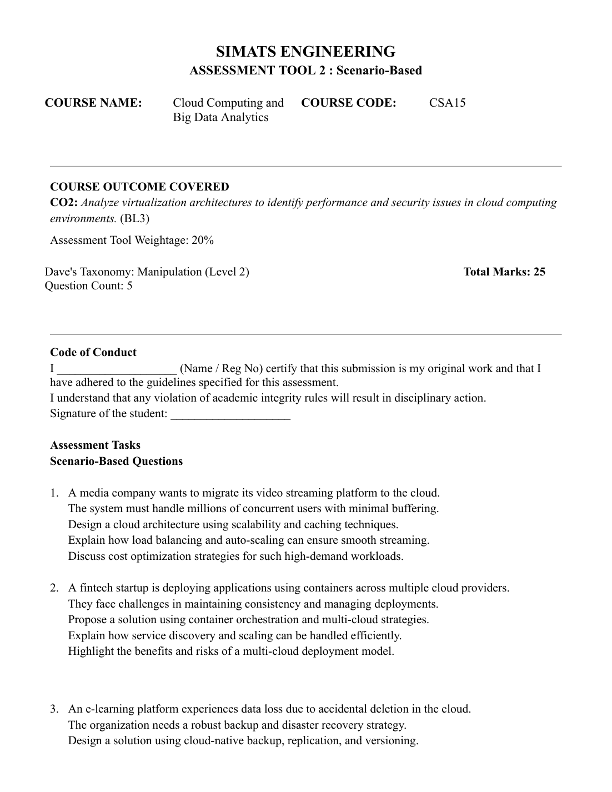

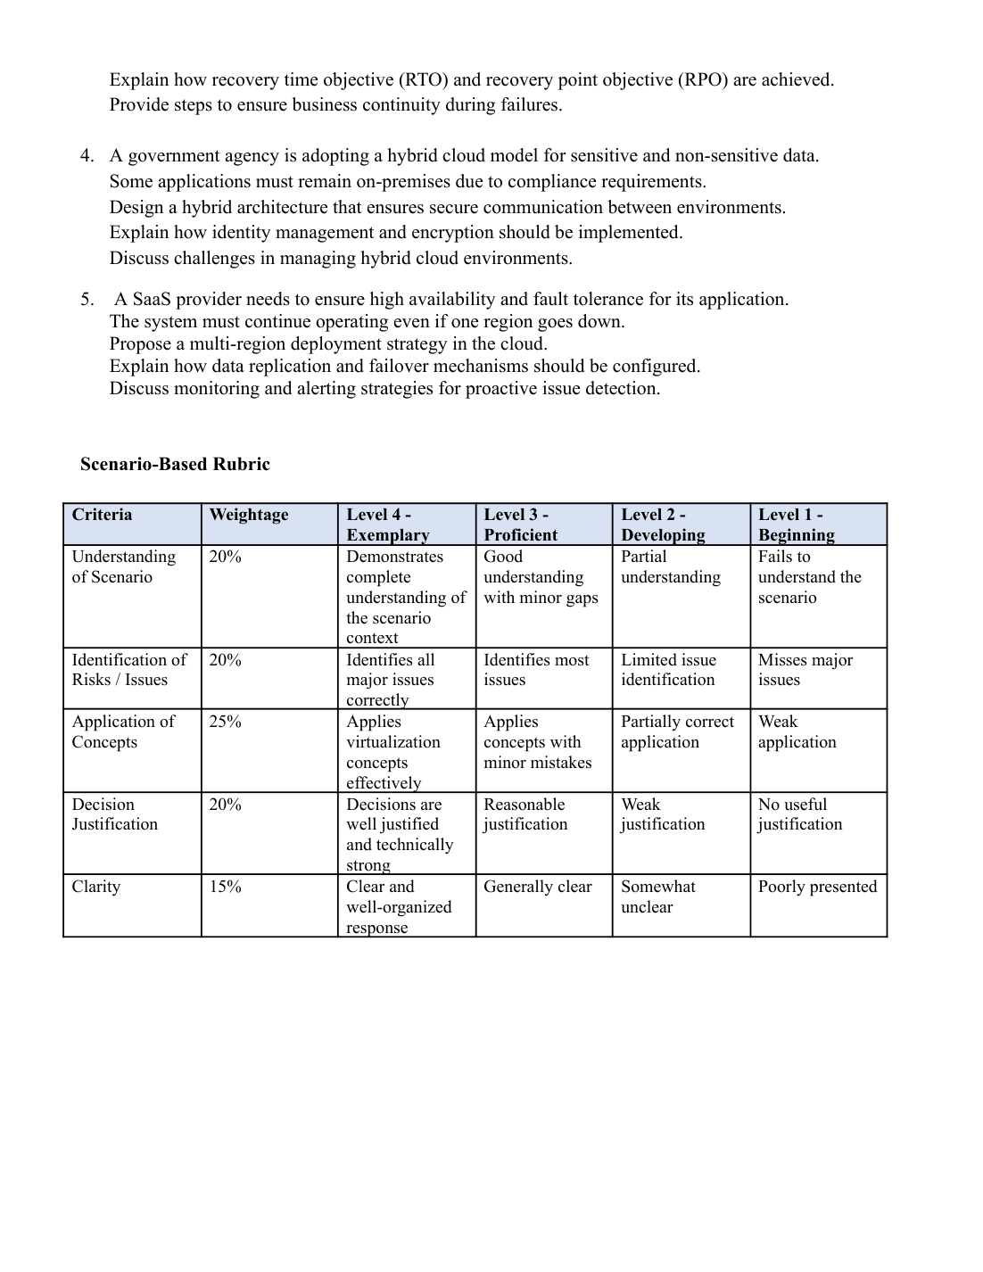

Answer 1: Cloud Video Streaming Platform
Cloud architecture
- Store videos in scalable cloud object storage.
- Transcode videos into different resolutions and bitrates.
- Use a Content Delivery Network (CDN) to cache popular video segments near users.
- Place stateless application servers behind a load balancer. Use a managed database for metadata and a cache for frequently accessed information.
Load balancing and auto-scaling
- The load balancer distributes requests among healthy servers and avoids overloading one server.
- Health checks remove failed servers from service.
- Auto-scaling adds instances when traffic or CPU usage increases and removes extra instances when demand decreases.
- CDN caching reduces latency, buffering, and requests to the origin servers. Deploy across multiple availability zones for resilience.
Cost optimization
- Use CDN caching to reduce origin bandwidth costs.
- Move rarely used videos to lower-cost storage tiers.
- Use auto-scaling to avoid paying for idle servers.
- Use discounts for predictable workloads, monitor spending, and set budget alerts.
Conclusion
- A CDN-first design, load balancing, auto-scaling, multi-zone deployment, and tiered storage provide smooth streaming at controlled cost.
Answer 2: Containers Across Multiple Cloud Providers
Proposed solution
- Package applications and dependencies into versioned container images.
- Use Kubernetes in each cloud to deploy, schedule, restart, and manage containers.
- Use version-controlled deployment manifests or Helm charts and a CI/CD pipeline to build, test, scan, and deploy the same image across clouds.
- Keep configuration and secrets separate from container images.
Service discovery and scaling
- Use Kubernetes Services and cluster DNS to provide stable service names.
- Use an ingress controller or API gateway for external traffic.
- Configure horizontal pod autoscaling using CPU, memory, or application metrics.
- Use cluster autoscaling to add or remove worker nodes as needed.
Benefits and risks
- Benefits: reduced dependence on one provider, improved resilience, and flexibility in choosing services.
- Risks: greater operational complexity, different provider services, transfer costs, latency, and inconsistent security.
- Mitigate risks through common deployment standards, least-privilege access, encryption, centralized logging, cost monitoring, and regular failover tests.
Conclusion
- Container orchestration and automated CI/CD improve consistency; multi-cloud requires common security, monitoring, and governance.
Answer 3: Cloud Backup and Disaster Recovery
Backup design
- Enable object versioning to restore earlier versions after accidental changes or deletion.
- Use soft delete or deletion protection where available.
- Schedule automated backups of databases, virtual machines, and important files.
- Replicate critical data to a separate region or account and maintain an isolated or immutable backup copy.
- Encrypt backups, restrict deletion permissions, and monitor backup jobs.
RTO and RPO
- Recovery Time Objective (RTO) is the maximum acceptable time to restore service.
- Recovery Point Objective (RPO) is the maximum acceptable amount of data loss measured in time.
- Frequent snapshots, replication, and transaction logs reduce RPO.
- Pre-provisioned recovery infrastructure, automated restoration, and documented runbooks reduce RTO.
Business continuity steps
- Identify critical systems and define RTO/RPO targets.
- Automate backups, versioning, replication, and backup verification.
- Monitor failures and activate the recovery plan when needed.
- Restore data and services, validate integrity, and redirect users.
- Inform users of service status and regularly test recovery procedures.
Conclusion
- Versioning, isolated backups, replication, and tested recovery procedures protect data and support business continuity.
Answer 4: Secure Hybrid Cloud for a Government Agency
Hybrid architecture
- Keep regulated applications and sensitive data on-premises where required.
- Run approved non-sensitive workloads in the public cloud.
- Connect environments using a private dedicated connection or site-to-site VPN, with redundant links.
- Use network segmentation, firewalls, private endpoints, and API gateways to allow only approved traffic.
- Centralize logging and monitoring across both environments.
Identity management and encryption
- Use a central identity provider and federated single sign-on.
- Enforce multi-factor authentication, role-based access control, and least privilege.
- Secure service identities and rotate secrets regularly.
- Encrypt data in transit with TLS and data at rest with managed or agency-controlled keys.
- Audit access to encryption keys and retain security logs.
Challenges and solutions
- Different tools and policies: use common standards and automation.
- Network delays or failures: use redundant links and monitoring.
- Compliance and data residency: classify data and document where it is stored and processed.
- Complex operations and costs: train staff, use unified monitoring, patch systems, and conduct regular audits.
Conclusion
- A segmented hybrid architecture with secure connectivity, centralized identity, encryption, and unified monitoring protects sensitive workloads.
Answer 5: Multi-Region High Availability for SaaS
Deployment strategy
- Deploy application services in at least two cloud regions and multiple availability zones.
- Use a global load balancer or DNS traffic manager to direct users to healthy regions.
- Keep application servers stateless where possible and deploy consistently using infrastructure-as-code and CI/CD.
- Choose active-active deployment when both regions serve traffic, or active-passive when one region is a standby.
Replication and failover
- Configure supported cross-region database replication.
- Synchronous replication may increase latency; asynchronous replication may allow some recent data loss.
- Define a single-writer or conflict-resolution strategy for active-active databases.
- Keep independent backups because replication can also copy accidental deletion or corruption.
- Automate or document database promotion, traffic switching, recovery, and failback. Test these regularly.
Monitoring and alerting
- Monitor latency, error rates, request volume, CPU, memory, database health, replication lag, and availability.
- Centralize logs, traces, and audit events from every region.
- Alert on failed health checks, high latency, rising errors, low capacity, and replication lag.
- Use synthetic tests for critical user journeys and provide on-call staff with clear runbooks.
Conclusion
- Multi-region deployment, tested failover, independent backups, and actionable monitoring help the SaaS application continue during a regional outage.

