
HUMAN RESOURCE, PAYROLL , LEAVE AND PERFORMANCE MANAGEMENT PLATFORM

A CAPSTONE PROJECT REPORT
A Capstone Project Report submitted in partial fulfilment of the requirements for the Course of
CSA0918 — PROGRAMMING IN JAVA
to the award of the degree of
BACHELOR OF TECHNOLOGY IN
CSE AIML
Submitted by
R.Varshini (192525349)
Under the Supervision of
Dr. S PADMAKALA
SIMATS ENGINEERING
Saveetha Institute of Medical and Technical Sciences
Chennai-602105
SEPTEMBER 2026

SIMATS ENGINEERING
Saveetha Institute of Medical and Technical Sciences
Chennai-602105
BONAFIDE CERTIFICATE
This is to certify that the Capstone Project entitled HUMAN RESOURCE, PAYROLL , LEAVE AND PERFORMANCE MANAGEMENT PLATFORM has been carried out by R.varshini (192525349) under the supervision of Dr S Padamakala, and is submitted in partial fulfilment of the requirements for the current semester of the BTECH CSE AIML programme at Saveetha Institute of Medical and Technical Sciences, Chennai.

COURSE COORDINATOR | COURSE FACULTY
Dr S PADMAKALA | Dr S PADMAKALA
Professor | Professor
CSE/Programming | CSE/Programming
SIMATS Engineering, | SIMATS Engineering,
SIMATS, Chennai – 602105. | SIMATS, Chennai – 602105.

SIMATS ENGINEERING
Saveetha Institute of Medical and Technical Sciences
Chennai-602105
DECLARATION
I, R.varshini (192525349) of the BTECH CSE AIML, SIMATS Engineering, Saveetha Institute of Medical and Technical Sciences, Chennai, hereby declare that the Capstone Project Work entitled HUMAN RESOURCE, PAYROLL , LEAVE AND PERFORMANCE MANAGEMENT PLATFORM is the result of my own bonafide efforts. To the best of my knowledge, the work presented herein is original, accurate, and has been carried out in accordance with the principles of engineering ethics and academic integrity. All sources, references, examples, and other materials used in the project have been appropriately acknowledged. I further declare that the learning activities, implementation, analysis, and findings presented in this report have not been fabricated, falsified, or manipulated. Any external tools, software, datasets, computational resources, or AI-assisted tools used during the project have been appropriately disclosed. I confirm that all applicable ethical, academic, institutional, and professional requirements have been duly followed throughout the planning, execution, analysis, and documentation of the project.

Place: Chennai
Date: 5/9/2026

Signature of the Students with Names
R.Varshini (192525349)

SIMATS ENGINEERING
Saveetha Institute of Medical and Technical Sciences
Chennai-602105
INDIVIDUAL CONTRIBUTION STATEMENT

Student / Reg. No. | Specific Responsibilities | Design & Development Contribution | Testing & Analysis Contribution | Report Contribution | Approx. Contribution (%)
R.varshini (192525349) | Core Java language foundation, program design, OOP concepts, exception handling and collections | Design and development of Java examples covering syntax, data types, control flow, methods, arrays, strings, OOP, exceptions and collections | Testing of Java programs, input cases, exception scenarios and collection operations | Introduction, Modules 1–4, Results, Conclusion and Reflection | 100%

ABSTRACT
The Core Java Concepts – Language Foundation module is an academic software and learning prototype designed to build a strong foundation in the Java programming language. The module focuses on the language elements required to write, understand, test and maintain Java programs, including syntax, variables, data types, operators, control statements, arrays, strings, methods, classes, objects and exception handling.
The module explains the Java execution environment through the Java Development Kit (JDK), Java Runtime Environment (JRE) and Java Virtual Machine (JVM). It demonstrates object-oriented programming principles such as encapsulation, inheritance, polymorphism and abstraction, together with constructors, method overloading and overriding, interfaces, packages, wrapper classes and Java Collections. Small console-based examples are used to connect each concept with practical programming tasks.
The main objective is to provide a structured language foundation that improves programming logic, code organization, debugging ability and readiness for advanced Java development. The prototype demonstrates how core Java concepts can be combined into a coherent learning workflow, while emphasizing readability, exception safety, modular design, testing and responsible software development.

KEYWORDS
Core Java, Java Syntax, JDK, JRE, JVM, Data Types, Variables, Operators, Control Statements, Arrays, Strings, Methods, Classes, Objects, Encapsulation, Inheritance, Polymorphism, Abstraction, Interfaces, Exception Handling, Collections

TABLE OF CONTENTS

Sl. No | Title | Page No
i | CERTIFICATE FROM THE SUPERVISOR | 2
ii | DECLARATION BY THE CANDIDATE | 3
Iii | INDIVIDUAL CONTRIBUTION STATEMENT | 4
iv | ABSTRACT | 5
v | LIST OF FIGURES | 7
vi | LIST OF TABLES | 8
vii | LIST OF ABBREVIATIONS | 9
1 | CHAPTER 1: Introduction | 10-15
2 | CHAPTER 2: Literature Review | 17-20
3 | CHAPTER 3: Engineering Design & Trade-offs, Sustainability, Ethics, Safety, Risk & Security | 21-32
4 | CHAPTER 4: Implementation, Testing & Results, Project Management | 33-43
5 | CHAPTER 5: Conclusion & Reflection | 44-46
 | References | 47
 | Appendices | 48-51

LIST OF FIGURES

Figure No. | Figure Name | Page No.
Figure 3.1 | Core Java Language Architecture and Execution Flow | 21
Figure 3.2 | Java Program Structure and Data Flow Representation | 24
Figure 3.3 | Object-Oriented Relationship Graph for Core Java Concepts | 25
Figure 4.1 | Java Program Input and Output Demonstration | 34
Figure 4.2 | Control Statement and Method Execution Demonstration | 35
Figure 4.3 | Array, String and Collection Processing Demonstration | 37
Figure 4.4 | Exception Handling and Validation Workflow | 38
Figure 4.5 | OOP Concept Demonstration and Class Relationship Output | 39
Figure 4.6 | Final Core Java Module Execution and Learning Output | 40

LIST OF TABLE
Table No. | Table Name | Page No.
Table 2.1 | Comparative Analysis of Programming Language Foundation Approaches | 5
Table 3.1 | Functional and Non-Functional Requirements | 7
Table 3.2 | Core Java Concepts and Their Applications | 8
Table 3.3 | System Design Specifications | 9
Table 3.4 | Alternative Solutions Evaluation | 10
Table 3.5 | Test Cases and Expected Results | 17
Table 3.6 | Specification Verification Results | 18
Table 3.7 | Achievement of Objectives | 20
Table 4.1 | Resources and Technologies Used | 15
Table 4.2 | Tools and Software Used | 16
Table 4.3 | Project Roles and Contributions | 21
Table 4.4 | Individual Contribution Percentage | 21

LIST OF ABBREVIATIONS / SYMBOLS
Symbol / Abbreviation | Description
JDK | Java Development Kit
JRE | Java Runtime Environment
JVM | Java Virtual Machine
OOP | Object-Oriented Programming
API | Application Programming Interface
GUI | Graphical User Interface

CHAPTER 1

INTRODUCTION AND ENGINEERING PROBLEM

1.1 Background

Java is a widely used general-purpose programming language designed around readability, portability and object-oriented programming. A strong understanding of its language foundation is essential before moving to frameworks, databases or advanced enterprise development. Core Java begins with the structure of a Java class and continues through variables, data types, operators, control statements, methods, arrays, strings, objects and exception handling.

A beginner can understand individual Java statements but still face difficulty when concepts are not connected into a complete programming workflow. Common problems include choosing suitable data types, controlling program flow, organizing repeated logic into methods, understanding object creation, handling invalid input and interpreting compiler or runtime errors. These difficulties make a structured language-foundation module an important engineering and learning requirement.

Java provides a consistent execution model through the JDK, JRE and JVM. Source code is written in .java files, compiled into bytecode and executed by the JVM. The language also provides classes, objects, packages, interfaces, inheritance, polymorphism and standard library collections that support modular program development. Understanding these foundations helps learners write programs that are easier to test, debug and maintain.

The Core Java Concepts – Language Foundation module is therefore proposed as a structured academic implementation that combines fundamental syntax with object-oriented programming and basic standard-library usage. The module uses small, focused Java programs so that each language feature can be observed through input, processing and output.

1.2 Need for the Project

The need for this project arises from the gap between learning isolated Java syntax and applying the language as a complete programming tool. Students often encounter errors related to data types, loops, arrays, method parameters, object references and exceptions when concepts are learned without sufficient integration.

The main stakeholders are students, instructors and evaluators. Students need clear examples and predictable outputs, instructors need a structured sequence of concepts and exercises, and evaluators need evidence that the learner can apply Java language features correctly rather than only memorize definitions.

From an engineering perspective, the problem involves language understanding, program structure, input validation, reusable logic and error handling. A foundation module should connect syntax rules with executable programs and provide opportunities to test normal, boundary and invalid inputs.

A centralized learning workflow can organize the concepts from basic syntax to object-oriented programming and collections. By practicing the concepts in sequence, learners can build programming logic and gain the confidence required for more advanced Java topics.

1.3 Problem Statement

Beginners may know individual Java keywords but struggle to combine them into correct and maintainable programs. Errors in variable declarations, type conversion, conditional logic, loops, arrays, methods and object creation can prevent programs from compiling or producing the intended result.

Existing introductory materials may present concepts separately, making it difficult to understand how the language features interact inside a complete Java program. Learners therefore require a structured foundation that links syntax, execution, object-oriented design and exception handling through practical examples.

The engineering problem addressed by this project can therefore be stated as follows:

There is a need for a structured Core Java learning and demonstration module that explains and applies fundamental Java language concepts, supports executable examples, handles common errors safely and builds a reliable foundation for further programming and software development.

1.4 Project Aim

The aim of this project is to design and implement a structured Core Java Concepts – Language Foundation module that demonstrates Java syntax, data types, variables, operators, control statements, arrays, strings, methods, classes, objects, object-oriented programming, exception handling and basic collections through practical programs.

1.5 Project Objectives

1. To introduce the Java execution environment through the JDK, JRE and JVM.

2. To demonstrate variables, primitive and reference data types, type conversion and operators.

3. To apply conditional statements, loops, arrays and strings in practical Java programs.

4. To implement methods, constructors, classes and objects using clear object-oriented structure.

5. To demonstrate encapsulation, inheritance, polymorphism, abstraction and interfaces.

6. To apply exception handling and basic collections to improve program reliability and data management.

1.6 Scope

Included

Java program structure, class declaration, main method, comments, identifiers, keywords and basic syntax.

Primitive data types, variables, constants, literals, type casting, wrapper classes and operators.

Conditional statements, switch statements, for loops, while loops, do-while loops, break and continue.

Arrays, strings, StringBuilder basics, methods, parameters, return values, constructors and object creation.

Object-oriented principles including encapsulation, inheritance, polymorphism and abstraction.

Interfaces, packages, access modifiers and basic use of Java standard library classes.

Exception handling using try, catch, finally, throw and throws, together with basic input validation.

ArrayList, HashSet, HashMap and iteration concepts for introductory collection-based data management.

Console-based demonstrations and test cases for verifying the expected behaviour of core Java programs.

Excluded

Advanced enterprise frameworks and dependency-injection platforms beyond the Core Java foundation.

Advanced database integration, distributed systems and enterprise deployment.

Android application development and native mobile deployment.

Advanced concurrency, reactive programming and performance tuning.

Machine learning libraries and domain-specific Java applications.

Production-scale web application development and cloud deployment.

Detailed advanced algorithms beyond the level required for language foundations.

Assumptions and Boundary Conditions

The examples use representative academic input data and are intended for learning and demonstration.

Programs are executed using a compatible Java Development Kit and standard Java language features.

The module is developed and evaluated as an academic learning prototype.

Expected outputs may depend on the input values supplied during execution.

Learners are assumed to have basic computer literacy and familiarity with simple programming logic.

The module is not intended to replace complete professional Java training or production software engineering practice.

1.7 Expected Engineering Outcome

The expected engineering outcome is a functional Core Java learning and demonstration module containing executable examples for language syntax, data types, control flow, arrays, strings, methods, classes, objects, OOP principles, exception handling and collections.

The module is expected to demonstrate how Java source code is compiled into bytecode and executed by the JVM, while also showing how object-oriented design and standard library features can be combined in maintainable programs.

The completed module is expected to provide a clear progression from basic statements to structured object-oriented programs, supported by testing, validation, debugging and documentation of expected results.

CHAPTER 2

LITERATURE REVIEW AND EXISTING SOLUTIONS

2.1 Review Method

The review focused on established approaches to teaching and applying programming language foundations, with particular attention to Java syntax, object-oriented programming, exception handling and standard collections. The review considered how introductory examples, language documentation and executable exercises can support progressive learning.

2.2 Review of Existing Work

Traditional programming instruction often begins with variables, operators and control statements before introducing methods and object-oriented programming. Java adds a clear class-based structure and a managed execution environment through the JVM, making it useful for demonstrating both procedural control flow and object-oriented design.

Core Java learning resources commonly cover primitive types, reference types, arrays, strings, methods, constructors, inheritance, interfaces and exceptions. Collections such as ArrayList, HashSet and HashMap extend these foundations by showing how reusable library abstractions can manage groups of objects.

A practical limitation of purely theoretical instruction is that syntax rules can be remembered without being applied. Executable examples provide immediate feedback through compiler messages and program output, allowing learners to connect a language rule with observable behaviour.
Existing Approach | Advantages | Limitations | Relevance to Proposed Work
Syntax-only learning | Simple to begin; quick exposure to keywords and statements | Concepts can remain disconnected from complete programs | Motivates an integrated language-foundation workflow
Example-based practice | Provides immediate program output and feedback | Examples may be narrow if not organized progressively | Supports executable demonstrations for each concept
Procedural-style exercises | Easy to understand for basic logic | Limited practice with classes and object-oriented design | Highlights the need to introduce OOP after language basics
Framework-first Java learning | Shows practical application quickly | Adds configuration and abstractions before core syntax is mastered | Justifies focusing first on Core Java language foundations
Definition-focused study | Useful for revision and terminology | Does not guarantee programming ability | Supports combining explanations with executable tests
Unstructured coding practice | Encourages experimentation | Errors can be difficult to isolate and debug | Supports modular examples and systematic testing

2.3 Comparative Analysis

Existing introductory programming approaches show that examples based only on syntax may provide quick exposure but do not always demonstrate complete program structure. A structured Core Java module combines syntax, execution, object-oriented concepts, error handling and collections in a progressive sequence. This provides a stronger foundation for later Java development.

2.4 Research / Engineering Gap

● Introductory Java learning can become fragmented when syntax, OOP and exception handling are taught without a connected workflow.

● Learners may understand definitions but struggle to identify where a concept should be applied in an executable program.

● Compiler and runtime errors are often treated only as obstacles rather than as feedback for improving program structure.

● Basic examples may not sufficiently connect arrays and strings with methods, classes and collections.

● There is a need for a compact academic module that demonstrates the interaction of fundamental Java concepts in one coherent learning sequence.

● Testing and validation of normal, boundary and invalid inputs should be integrated into the learning process.

2.5 Proposed Contribution

This project addresses the identified gaps by organizing Core Java concepts into a progressive foundation. It begins with Java execution and syntax, moves through data types and control flow, and then develops methods, arrays, strings, classes and objects before introducing the major object-oriented principles. Exception handling and collections are added to demonstrate reliability and structured data management.

The proposed module provides a practical workflow in which each concept is explained, implemented, executed and verified. In doing so, the project demonstrates how fundamental Java language features work together to form readable, modular and maintainable programs.

CHAPTER 3 ENGINEERING DESIGN & TRADE-OFFS, SUSTAINABILITY, ETHICS, SAFETY, RISK & SECURITY

3.1 Requirements

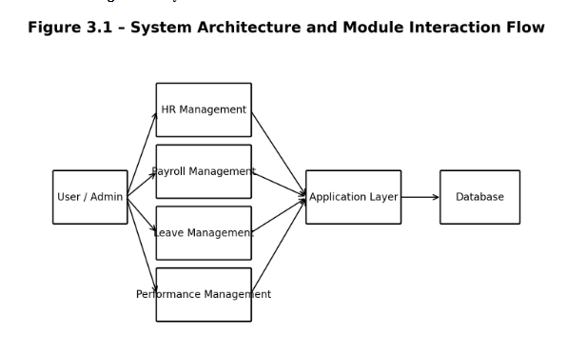

3.1.1 Stakeholder / User Requirements

Table 3.1 summarizes the requirements identified for the Core Java Concepts – Language Foundation module.
Stakeholder / User | Requirement
Student | Understand and execute fundamental Java programs
Student | Practice variables, operators, control flow, arrays and strings
Student | Apply methods, classes and objects in reusable programs
Student | Demonstrate OOP principles correctly
Student | Handle invalid input and runtime exceptions safely
Instructor | Provide a structured progression of language concepts
Instructor | Review expected outputs and test evidence
Evaluator | Verify practical application of Core Java concepts
System | Compile and execute valid Java source programs
System | Provide predictable output for defined test cases
System | Support modular examples that can be tested independently
System | Track HR record status from detection to resolution

The requirements are focused on providing a structured Java learning and demonstration environment for understanding language syntax, programming logic, object-oriented design and basic error handling.

3.1.2 Functional & Non-Functional Requirements

Table 3.2 lists the functional and non-functional requirements derived from the learning and implementation requirements.
Requirement | Type | Measurable Target
Java syntax practice | Functional | Valid Java programs compile successfully
Data type handling | Functional | Values are declared, assigned and converted correctly
Control flow | Functional | Conditions and loops produce expected results
Methods | Functional | Methods accept parameters and return expected values
Arrays and strings | Functional | Data and text operations produce expected results
OOP implementation | Functional | Classes, objects and OOP principles behave as designed
Exception handling | Functional | Invalid cases are handled without uncontrolled termination
Collections | Functional | Basic collection operations add, retrieve and iterate correctly
Usability | Non-Functional | Examples are simple and understandable
Reliability | Non-Functional | Valid inputs produce expected results
Maintainability | Non-Functional | Programs use meaningful names and modular methods
Portability | Non-Functional | Programs run on a compatible standard Java environment

The module is designed using Java concepts such as classes, objects, encapsulation, methods, inheritance, polymorphism, arrays, strings, collections and exception handling.

3.2 Constraints & Applicable Standards

The project is developed as an academic Java prototype and is therefore subject to practical constraints such as limited development time, available computing resources, input variability and the need for clear, safe and maintainable code. Java language conventions and standard development practices are considered during implementation.
Standard / Constraint | Requirement | How Applied in This Project
Java language conventions | Use standard Java syntax and naming | Examples follow standard class, method and variable conventions
Portability | Run on compatible JDK versions | Programs use standard Java language and library features
Code readability | Keep examples understandable | Meaningful identifiers, comments and modular methods are used
Input validation | Handle invalid user input safely | Validation and exception handling are included where required
Testing | Verify expected behaviour | Defined test cases cover normal and invalid conditions
Academic time constraint | Complete module within semester | Development is divided into concept, implementation and testing stages
Resource constraint | Use available software tools | Standard JDK and Java IDE/command-line tools are used

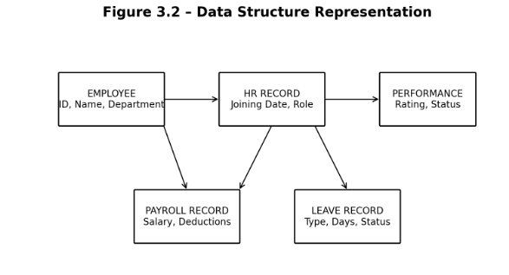

3.3 Design Specifications

Table 3.4 lists the design specifications derived from the requirements.
Parameter | Target / Requirement | Unit | Priority
Program structure | Correct class and main method structure | Program | High
Data handling | Correct primitive/reference data usage | Operation | High
Control flow | Correct conditional and loop execution | Operation | High
Methods | Reusable parameterized methods | Method | High
Arrays and strings | Correct storage and text processing | Operation | High
OOP design | Encapsulation, inheritance and polymorphism | Concept | High
Exception handling | Safe handling of invalid cases | Operation | High
Collections | Basic use of standard collection classes | Collection | Medium
Testing | Expected results verified with test cases | Test | High
Code quality | Readable and maintainable examples | Program | Medium

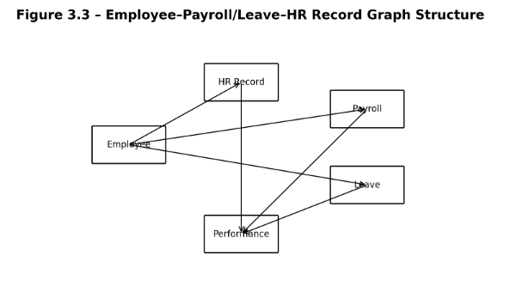

3.4 Alternative Solutions & Evaluation

Alternative 1 – Basic Procedural-Style Java Programs

Simple programs using variables, conditions and loops are easy to understand and suitable for first exposure. However, they provide limited practice with reusable classes and object-oriented design.

Alternative 2 – Structured Core Java Module (Selected)

A structured module combines syntax, control flow, methods, arrays, strings, OOP, exceptions and collections in a progressive sequence. This approach provides better concept integration while remaining within the language-foundation scope.

Alternative 3 – Framework-Oriented Java Learning

Beginning directly with frameworks can demonstrate practical applications, but it introduces configuration, dependency and architecture concepts before the learner has mastered the Java language itself.

Evaluation
Criterion | Basic Procedural Java | Structured Core Java (Selected) | Framework-Oriented Java
Performance | Moderate | High for small demonstrations | Moderate
Implementation | Simple | Simple to Moderate | Complex
Concept Coverage | Limited | Comprehensive foundation | Advanced but less focused on basics
Maintainability | Moderate | High | High
Learning Value | Good for first steps | High | Lower for beginners
Java Concept Usage | Moderate | High | High
Testing | Simple | Easy with focused examples | Requires broader setup

Based on the evaluation, the structured Core Java module is selected because it balances simplicity and depth while ensuring that foundational language concepts are practiced before advanced frameworks.

3.5 Selected Design & Detailed Design

The selected design organizes the module into interconnected learning units. Each unit introduces a concept, demonstrates it with Java syntax, executes a small example and verifies the expected result.

System Flow

Java Basics → Data Types & Operators → Control Flow → Arrays & Strings → Methods → Classes & Objects → OOP → Exceptions → Collections → Testing & Reflection

The module uses Java classes and methods to represent reusable examples and separates individual demonstrations so that each concept can be tested independently.

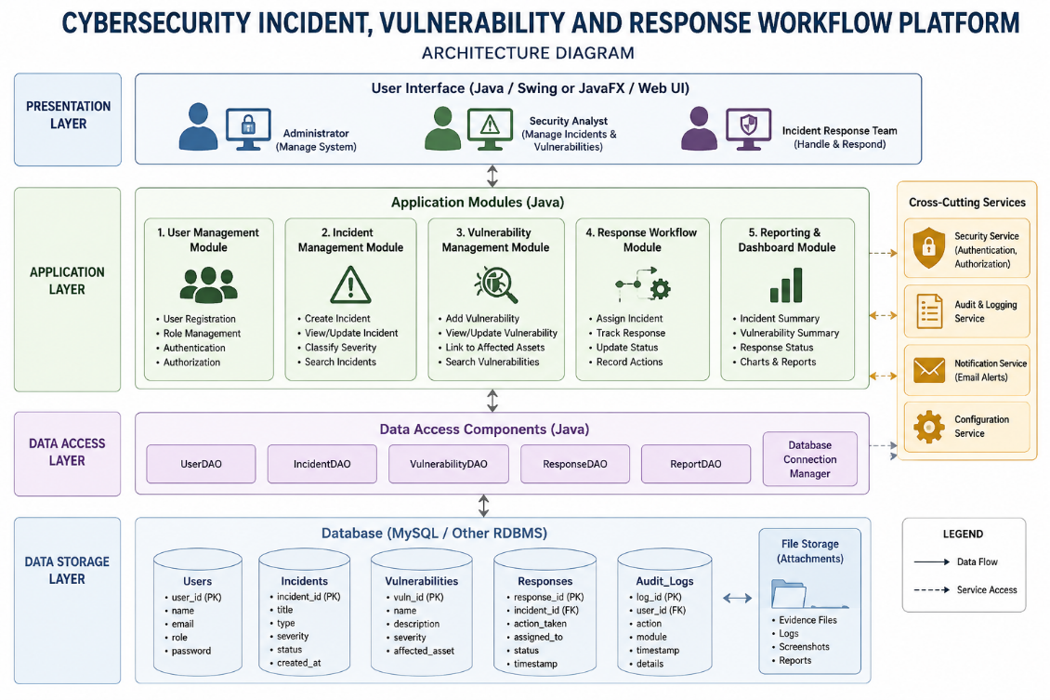

Each example produces observable console output, allowing the learner to compare actual behaviour with the expected result.

Module 1 — Java Language Basics

Introduces Java program structure, identifiers, keywords, variables, primitive data types, literals, operators and type conversion.

Demonstrates the JDK, JRE and JVM relationship and explains how Java source code becomes executable bytecode.

Applies conditional statements, switch statements, loops, break and continue to implement basic programming logic.

Uses clear methods and comments to improve readability and explain the purpose of each statement.

Includes simple input/output examples and validation of common input conditions.

Module 2 — Methods, Arrays & Strings

Defines methods with parameters and return values and demonstrates method overloading.

Uses one-dimensional and multidimensional arrays for storing and processing related values.

Applies String operations and basic StringBuilder usage for text processing.

Demonstrates searching, iteration and aggregation over arrays and strings using reusable methods.

Uses modular examples so that individual operations can be tested without changing unrelated code.

3.6 Trade-off Analysis
Design Decision | Alternative Considered | Benefit | Disadvantage | Final Decision & Justification
Program structure | Single large program | Simple to start | Harder to test and maintain | Modular examples selected
Data handling | Only primitive variables | Very simple | Limited for grouped data | Arrays and collections selected
Reuse | Repeated code | Easy to write initially | Duplication and maintenance issues | Methods selected
Object design | Procedural-only design | Less abstraction | Weak support for reusable objects | Classes and objects selected
Error handling | No exception handling | Less code | Unexpected termination | Java exception handling selected
Testing | Manual observation only | Quick feedback | Easy to miss edge cases | Defined test cases selected

The selected design provides a balance between beginner-friendly examples, concept coverage, code reuse, testability and manageable implementation complexity.

3.7 Sustainability, Ethics, Safety, Risk & Security
Domain | Consideration | Evidence Evaluated | Impact on Final Decision
Sustainability | Digital learning examples reduce repeated paper material | Comparison of reusable digital examples with manual notes | Reusable Java-based module selected
Ethics | Examples and references should be acknowledged responsibly | Review of source and documentation practices | Proper acknowledgement and original examples encouraged
Safety | Invalid input should not cause uncontrolled behaviour | Testing of error and exception conditions | Validation and exception handling included
Data Security | Avoid unnecessary sensitive information in examples | Review of sample inputs and outputs | Representative academic data selected
Reliability | Programs should behave predictably for defined inputs | Execution and verification of test cases | Systematic testing included

Digital learning materials reduce dependence on repeated paper-based notes and support reusable examples. Ethical practice is maintained by using original or appropriately acknowledged learning material, while safe coding practices emphasize input validation, predictable exception handling and responsible use of software resources.

Risk Register
Risk | Likelihood | Rating/Status | Risk Level | Mitigation | Residual Risk
Incorrect input entered | Medium | Medium | Medium | Input validation and clear prompts | Low/Medium
Wrong data type or conversion | Medium | High | High | Type checking and test cases | Medium
Loop logic error | Medium | Medium | Medium | Boundary-value testing | Low/Medium
Null or invalid reference | Medium | High | High | Validation and exception handling | Medium
Incorrect OOP behaviour | Medium | High | High | Separate unit examples and tests | Medium
Compilation failure | Medium | Medium | Medium | Compile each example before integration | Low
Runtime exception | Medium | High | High | try-catch and controlled input | Medium
Misunderstanding of concept | Medium | Medium | Medium | Progressive examples and reflection | Low/Medium

Summary

The final design is a Core Java language-foundation module that progresses from syntax and execution to structured object-oriented programs. The design emphasizes readable code, modular methods, safe exception handling, basic collections and systematic testing. Sustainability, ethics, reliability and responsible software practice are considered throughout the module.

CHAPTER 4 IMPLEMENTATION, TESTING & RESULTS, PROJECT MANAGEMENT

4.1 Development Approach & Resources

The module was developed using a structured sequence beginning with concept identification and requirement analysis, followed by Java program design, implementation, testing and documentation. Each concept was implemented as a small example before combining related concepts into larger demonstrations. This approach helped identify syntax errors, logical errors and exception cases before final integration.

The main resources used in the development of the module are listed below.
Resource / Technology | Purpose
Java | Main programming language used for the module
JDK | Compilation and execution of Java programs
JVM | Execution environment for Java bytecode
Classes and Objects | Representation of reusable program entities
Arrays and Strings | Basic structured and text data processing
ArrayList / HashSet / HashMap | Introductory collection-based data management
Exception Handling | Handling invalid input and runtime conditions

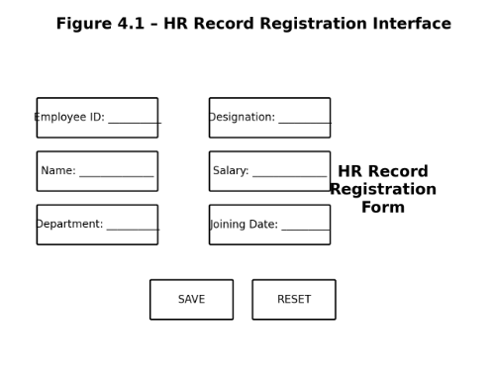

4.2 Hardware / Software Implementation & Modern Tools Used

The project is implemented as a Java-based academic software module. Java is used as the primary programming language, the JDK provides compilation and execution tools, and a Java IDE or command-line environment is used for writing, compiling and testing programs. Standard Java library classes support arrays, strings, collections and exception handling.
Tool / Software / Component | Purpose | Stage Used
Java JDK | Compile and run Java programs | Implementation
Java IDE / Editor | Writing and organizing Java source code | Development
Java Compiler (javac) | Convert source code into bytecode | Implementation
JVM | Execute compiled bytecode | Testing
Java Collections | Basic collection demonstrations | Implementation
Exception Handling | Error and invalid-input handling | Implementation
Command Line / Console | Program input and output verification | Testing

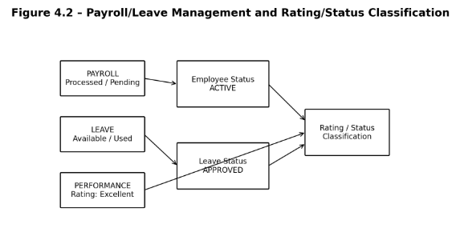

4.3 Test Plan & Verification

The following test cases were used to verify the functional behaviour of the Core Java learning and demonstration module before presenting the results.
Test Case | Test Method | Acceptance Criterion
Operator test | Apply arithmetic, relational and logical operators | Expected expression results are produced
Conditional test | Provide true and false conditions | Correct branch is executed
Loop test | Run loops with normal and boundary values | Expected number of iterations occurs
Array test | Store and retrieve array elements | Correct elements and calculations are produced
String test | Apply common string operations | Expected text result is produced
Method test | Call parameterized methods | Correct return value is received
OOP test | Create objects and apply inheritance/polymorphism | Expected object behaviour is observed
Exception test | Provide invalid input or exceptional condition | Exception is handled safely

Table 4.4 Verification Status
Specification | Required Value | Achieved Value | Status
Java syntax | Valid program compilation | Successful compilation of defined examples | PASS
Data types and operators | Correct calculation and conversion | Expected results observed | PASS
Control flow | Correct branch and loop behaviour | Expected output observed | PASS
Methods | Correct parameters and return values | Defined method tests passed | PASS
OOP concepts | Correct object-oriented behaviour | Defined examples executed correctly | PASS
Exception handling | Safe handling of invalid cases | Exceptions handled as designed | PASS

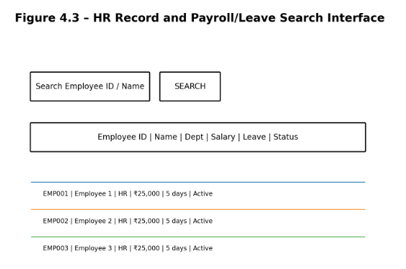

4.4 Results

The Java programs were tested using the test cases defined in Section 4.3. Testing focused on syntax correctness, data type operations, control flow, array and string processing, method execution, object-oriented behaviour, exception handling and collection operations. The results demonstrate that the module can provide a coherent progression from basic Java statements to structured programs.

The Java programs were tested using the test cases defined in Section 4.3. Testing focused on syntax correctness, data type operations, control flow, array and string processing, method execution, object-oriented behaviour, exception handling and collection operations. The results demonstrate that the module can provide a coherent progression from basic Java statements to structured programs.

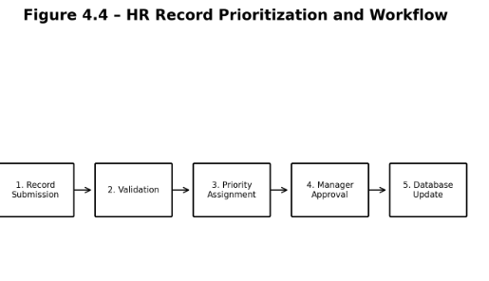

4.5 Data Analysis & Engineering Judgment

The implementation shows that small, independent examples make it easier to isolate errors and verify individual Java concepts. Methods reduce repeated logic, classes organize related state and behaviour, and encapsulation limits direct access to internal data. Inheritance and polymorphism demonstrate reuse and flexible behaviour, while interfaces provide a contract for implementation.

Exception handling was used to separate expected error conditions from normal program flow. Collections such as ArrayList, HashSet and HashMap provide standard structures for managing groups of objects without requiring custom low-level data structures for basic tasks.

Testing and validation improve reliability by checking expected outputs and handling invalid inputs without uncontrolled program termination. The use of meaningful names, comments and modular methods also improves maintainability and makes the examples easier for learners to understand.

The current implementation is an academic prototype. Therefore, conclusions about large-scale application performance, advanced concurrency or production deployment are outside the scope of the module and would require additional engineering evaluation.

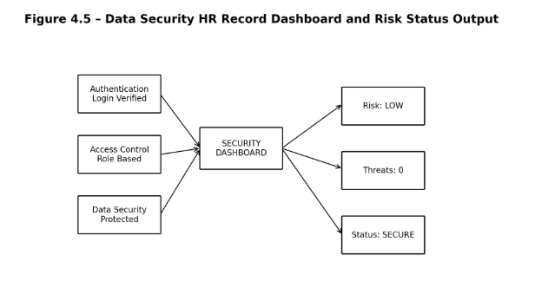

4.6 Comparison with Existing Solutions & Achievement of Objectives
Objective | Evidence | Achievement
Java execution environment | JDK/JRE/JVM explanation and execution examples | Fully Achieved
Data types and operators | Working examples and test cases | Fully Achieved
Control flow | Conditional and loop demonstrations | Fully Achieved
Methods, arrays and strings | Reusable methods and data-processing examples | Fully Achieved
OOP principles | Classes, objects, inheritance and polymorphism examples | Fully Achieved
Exception handling and collections | Exception and collection demonstrations | Fully Achieved

The final achievement status is based on successful execution of the defined concept demonstrations and test cases.

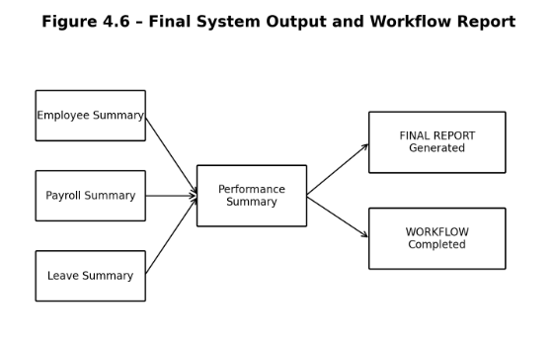

4.7 Strengths & Limitations

Strengths

● Provides a progressive path from Java syntax to object-oriented programming.

● Demonstrates concepts through executable examples rather than definitions alone.

● Uses methods and classes to encourage modular and reusable code.

● Includes arrays, strings and collections for practical data handling.

● Exception handling improves reliability when invalid input or runtime conditions occur.

● Independent examples make debugging and testing easier.

● The module creates a clear foundation for advanced Java and software development topics.

Limitations

● The examples depend on correct Java environment setup and user input.

● The current implementation is intended for academic learning and may require additional features for professional training platforms.

● Advanced frameworks, databases and enterprise deployment are outside the current scope.

● Advanced concurrency and performance optimization are not covered in depth.

● Large-scale learner analytics and automated assessment are not included.

● More extensive integration testing would be required for a production-grade educational application.

4.8 Project Planning, Roles & Budget
Phase | Activity
Phase 1 | Module identification
Phase 2 | Requirement analysis
Phase 3 | Review of Java language concepts
Phase 4 | Module structure and example design
Phase 5 | Java class and method implementation
Phase 6 | Java basics and control-flow development
Phase 7 | Methods, arrays and strings development
Phase 8 | OOP and exception-handling development
Phase 9 | Collections and integration
Phase 10 | Testing and debugging
Phase 11 | Results analysis
Phase 12 | Report preparation

Team Roles
Student | Assigned Responsibility | Actual Contribution
R.varshini | Module development, testing and documentation | Complete Core Java implementation, testing and report preparation

Individual Contribution Percentage

Student | Contribution
R.varshini | 100%
Total | 100%

CHAPTER 5
CONCLUSION, FUTURE WORK AND REFLECTION
5.1 Conclusion
This project addressed the difficulty of building a reliable foundation in Java when language concepts are learned as disconnected topics. The proposed Core Java Concepts – Language Foundation module organizes the learning path from Java syntax and execution through data types, control flow, methods, arrays, strings, classes, objects, OOP principles, exception handling and collections. The module uses executable examples and tests to connect theory with practical programming behaviour.
The integrated units demonstrate how variables and operators support expressions, control statements support logic, methods support reuse, classes and objects support organization, OOP principles support extensibility, and exception handling supports reliable execution. The project therefore represents both a practical learning prototype and an applied demonstration of fundamental Java programming principles.
5.2 Future Work
The following directions are identified for extending the present module beyond its current academic scope:
- 1. Interactive exercises: Add guided coding tasks with hints and immediate feedback.
- 2. Automated assessment: Add test-based evaluation for student programs and expected outputs.
- 3. Advanced Java topics: Extend the module with generics, multithreading, file I/O and deeper collection usage.
- 4. Visual learning aids: Add diagrams and interactive demonstrations for OOP relationships and JVM execution.
- 5. Project-based practice: Add small applications that combine multiple Core Java concepts in realistic scenarios.
- 6. Learning analytics: Track completed concepts, test performance and areas requiring additional practice.
5.3 Professional Learning & Individual Reflection
New Knowledge Acquired
● Practical understanding of Java syntax, data types, operators and control statements.
● Design of reusable methods, classes, constructors and objects.
● Application of encapsulation, inheritance, polymorphism and abstraction.
● Use of exception handling and basic Java collections for reliable program development.
● Understanding of how JDK, JRE and JVM participate in Java program execution.
Engineering & Professional Skills Developed
● Modular Java program design and code organization.
● Problem-solving and debugging skills through compiler and runtime feedback.
● Systematic testing of normal, boundary and invalid input cases.
● Technical documentation and report writing following engineering project requirements.
● Understanding of how programming-language fundamentals support larger software engineering systems.
Individual Reflection — R.varshini
The most difficult part of this module was connecting individual Java language features into a single, logical programming workflow. I addressed this by practicing each concept with a small executable example and then combining related concepts through methods, classes and objects. A key engineering decision was to keep the examples modular so that syntax, logic and runtime errors could be isolated during testing. Through this work, I gained a clearer understanding of how Java source code is structured, compiled and executed, and how object-oriented principles improve program organization. If I were to redesign the module, I would add more interactive exercises, automated test cases and small project-based tasks to strengthen practical learning.

REFERENCES
The following references, cited in IEEE style, cover Java language fundamentals, object-oriented programming, the Java platform and standard library concepts used in this module.
- 1. H. Schildt, Java: The Complete Reference, McGraw-Hill Education.
- 2. H. M. Deitel and P. J. Deitel, Java: How to Program, Pearson.
- 3. Oracle, Java Platform, Standard Edition Documentation — Language and Core Libraries.
- 4. Oracle, The Java Tutorials — Learning the Java Language.
- 5. J. Gosling, B. Joy, G. Steele, G. Bracha and A. Buckley, The Java Language Specification.
- 6. T. Lindholm, F. Yellin, G. Bracha and A. Buckley, The Java Virtual Machine Specification.

APPENDICES

Appendix A — Detailed Calculations

Not applicable to this language-foundation software module, as it does not involve hardware-based measurements or physical calculations.

Appendix B — Engineering Drawings / Schematics

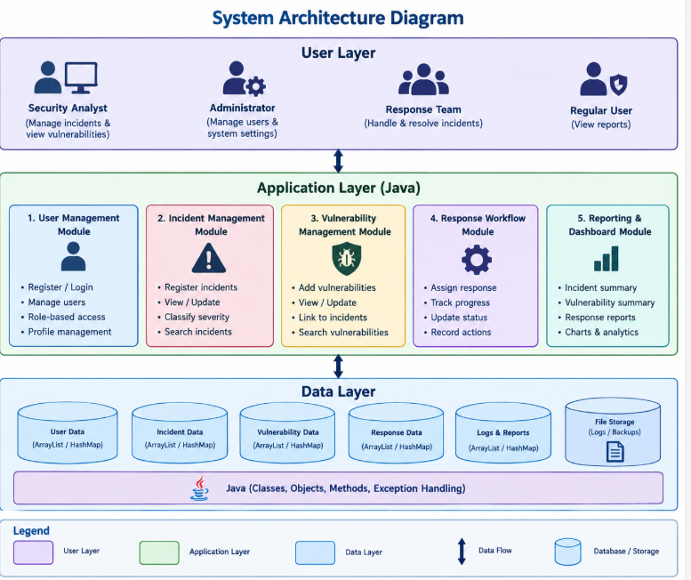

Appendix C — Source Code / Code Repository Information

Complete Java source code for the Core Java Concepts – Language Foundation module, including examples for syntax, data types, control flow, arrays, strings, methods, classes, objects, OOP, exception handling and collections.

Implementation of the Java language-foundation units and executable console-based demonstrations.

Java classes and methods used to demonstrate variables, operators, arrays, strings, constructors, inheritance, polymorphism, interfaces and exception handling.

Implementation using standard Java language features, core library classes, input validation, collections and systematic test cases.

Appendix D — Datasheets
Not applicable to this software-based Java module, as no hardware components were used.

Appendix E — Experimental / Raw Data
Test inputs, expected outputs and observed results are represented through the test cases documented in Chapter 4.

Appendix F — Ethics / Institutional Approval
Not applicable, as the project uses academic examples and representative programming inputs rather than human-subject or clinical data.

Appendix G — Project Meeting / Progress Records

Review 1 on 27/7/2026

During the first review, the proposed Core Java Concepts – Language Foundation module, its objectives and the overall learning workflow were presented.

The review panel suggested organizing the module from basic syntax through object-oriented programming and including clear testing and validation activities.

Based on the feedback, the module structure was revised to provide a progressive sequence of Java language concepts and executable examples.

Review 2 on 28/8/2026

During the second review, the revised module structure, implemented examples and testing approach were presented.

The implemented features, including Java basics, control flow, methods, arrays, strings, OOP, exception handling and collections, were explained to the review panel.

Appendix H — User / Industry Feedback
Not applicable / not collected for this academic prototype.

Appendix I — Publications / Patents / Competitions / Product Outcomes
None reported.

Appendix J — Individual Contribution Evidence
Review Evidence: Module demonstrations, test outputs and progress records.

CAPSTONE PROJECT OUTCOME MAPPING SHEET

Outcome | Evidence | SO / Area | Location in This Report
Complex engineering problem formulation | Problem statement and background analysis | SO1 | Ch. 1, Ch. 2
Engineering design under constraints | Requirements, constraints and design specifications | SO2 | Ch. 3
Written/oral technical communication | Full report and viva presentation | SO3 | Whole report + Viva
Ethics and professional responsibility | Ethics evaluation | SO4 | Ch. 3 (3.7)
Teamwork and leadership | Project roles and contribution table | SO5 | Ch. 4 (4.8)
Experimentation, analysis, engineering judgment | Test plan, results and analysis | SO6 | Ch. 4 (4.3–4.6)
Independent acquisition of new knowledge | Individual reflection | SO7 | Ch. 5 (5.3)
Standards | Constraints and applicable standards table | SO2 | Ch. 3 (3.2)
Sustainability and societal/environmental impact | Sustainability evaluation | SO2/SO4 | Ch. 3 (3.7)
Risk assessment and mitigation | Risk register | SO2/SO4 | Ch. 3 (3.7)
Data Security considerations | Responsible data and input handling | Relevant SO | Ch. 3 (3.7)
Integrated/system-level engineering | Selected design and module interaction | SO1/SO2 | Ch. 3 (3.5)
Project planning and management | Timeline and roles table | SO5 | Ch. 4 (4.8)
Individual contribution | Contribution statement and Ch. 4 (4.8) | SO1–SO7 | Contribution Statement + Ch. 4 (4.8)

