JAVA PROGRAMMING

MOVIE TICKET RESERVATION PLATFORM
A Java-Based Approach to Preventing Duplicate Seat Allocation During Simultaneous Booking Requests
NAME | R.VARSHINI
REG NO | 192525349
LANGUAGE | Java
DATABASE | SQLite (via JDBC)

PROBLEM STATEMENT
When a movie show has limited seats, it is common for several customers to try booking the very same seat within moments of each other. If the reservation logic does not guard against overlapping access, more than one customer can end up holding the same seat, leading to duplicate confirmations and eventual cancellations or refunds. This project therefore builds a Java application that models the reservation domain, keeps seat availability consistent under simultaneous access, stores every transaction in a database, and guarantees that a seat can never be handed out to two customers at once.
AIM
To build a Java application for reserving movie tickets that prevents duplicate seat allocation, carries out the booking-and-payment sequence safely under concurrent access, and keeps a durable record of every reservation in a relational database.
OBJECTIVES
- Model the domain using Object-Oriented Programming with a Screening, Patron, Reservation, Transaction and a seat-category class hierarchy.
- Track seat inventory with the Java Collections Framework and generic types.
- Handle simultaneous reservation attempts using Java's threading facilities.
- Guard the availability-check-and-reserve sequence with synchronization so it behaves as a single atomic step.
- Raise checked exceptions for invalid seat codes, sold-out seats, failed payments, and requests that exceed a time limit.
- Persist confirmed reservations using JDBC PreparedStatement calls.
- Support cancelling a reservation, returning the seat to inventory, and reviewing a patron's booking history.
TOOLS AND TECHNOLOGIES
- Visual Studio Code – writing and running the Java source.
- JDK 26 – compiling and executing the application.
- SQLite – lightweight relational store for reservation records.
- SQLite JDBC Driver – bridges the Java application to the SQLite file.
- Java Collections Framework – in-memory seat map and booking history.
- Java Threads and Locks – coordinating overlapping reservation attempts.
- Java I/O – writing an audit trail of transactions.
- Git – tracking changes to the codebase.
PROJECT STRUCTURE
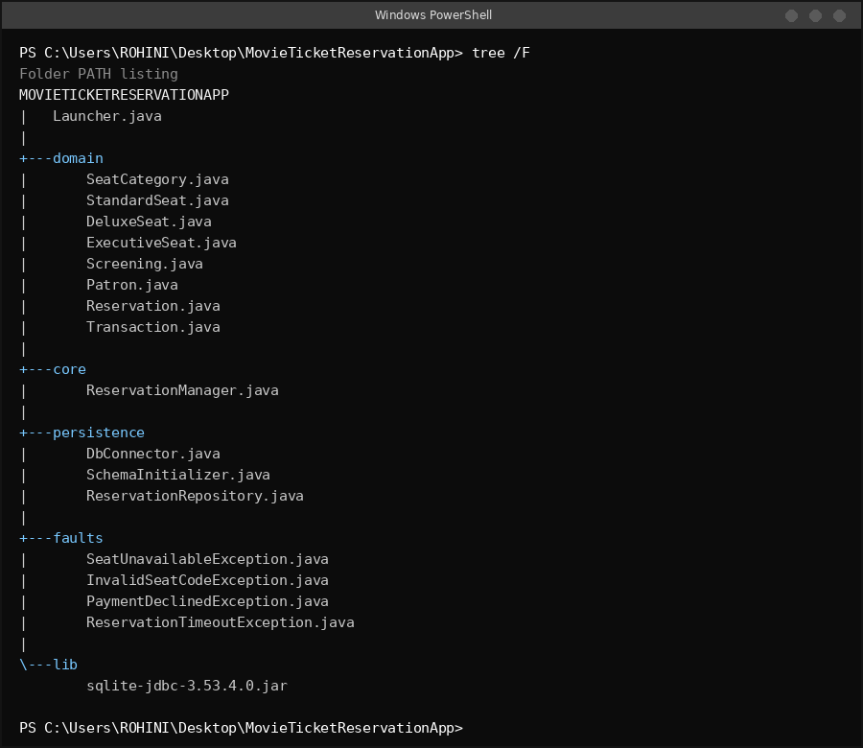
PROCEDURE
- Scaffold the Java project in VS Code with separate domain, core, persistence and faults packages.
- Define a base seat-category class with Standard, Deluxe and Executive variants.
- Add classes for Screening, Patron, Reservation and Transaction.
- Maintain seats in a Map keyed by seat code for constant-time lookup.
- Open a SQLite connection and create the reservations table through JDBC.
- Implement the validation-and-payment logic for a reservation request.
- Write confirmed reservations to the database using PreparedStatement.
- Build a console menu for reserving, listing, and exiting.
- Wire up checked exceptions, rollback on failure, and cancellation.
- Fire multiple reservation threads at the same seat to exercise the concurrent path.
- Compare an unsynchronized run against a synchronized run to confirm the fix removes duplicate seat allocation.
- Write every successful transaction to a log file and support querying a patron's history.
OOP DESIGN
- Inheritance: the base seat type is specialised into StandardSeat, DeluxeSeat and ExecutiveSeat.
- Polymorphism: each seat category computes its own price.
- Encapsulation: seat, patron and reservation state is reached through methods, not exposed fields.
- Association: a Reservation ties together a patron, a screening and a seat.
- Service layer: ReservationManager centralises the booking logic.
DATABASE / JDBC IMPLEMENTATION
SQLite backs the relational storage for this application. DbConnector opens the connection, SchemaInitializer creates the reservations table on first run, and ReservationRepository retrieves stored records. All writes go through PreparedStatement so that user-supplied values are bound as parameters rather than concatenated into the SQL text.
Example reservation insert:
INSERT INTO reservations (patron_name, seat_code, screening_name, payment_status) VALUES (?, ?, ?, ?);
BOOKING WORKFLOW
Patron logs in → selects a screening → selects a seat → availability is verified → payment is processed → the reservation is persisted to SQLite → confirmation is shown.
The seat-availability check and the seat-confirmation step are treated as one atomic unit whenever concurrency is in play, so no two threads can both see a seat as free at the same instant. If payment fails after a seat has been provisionally held, that seat is released immediately.
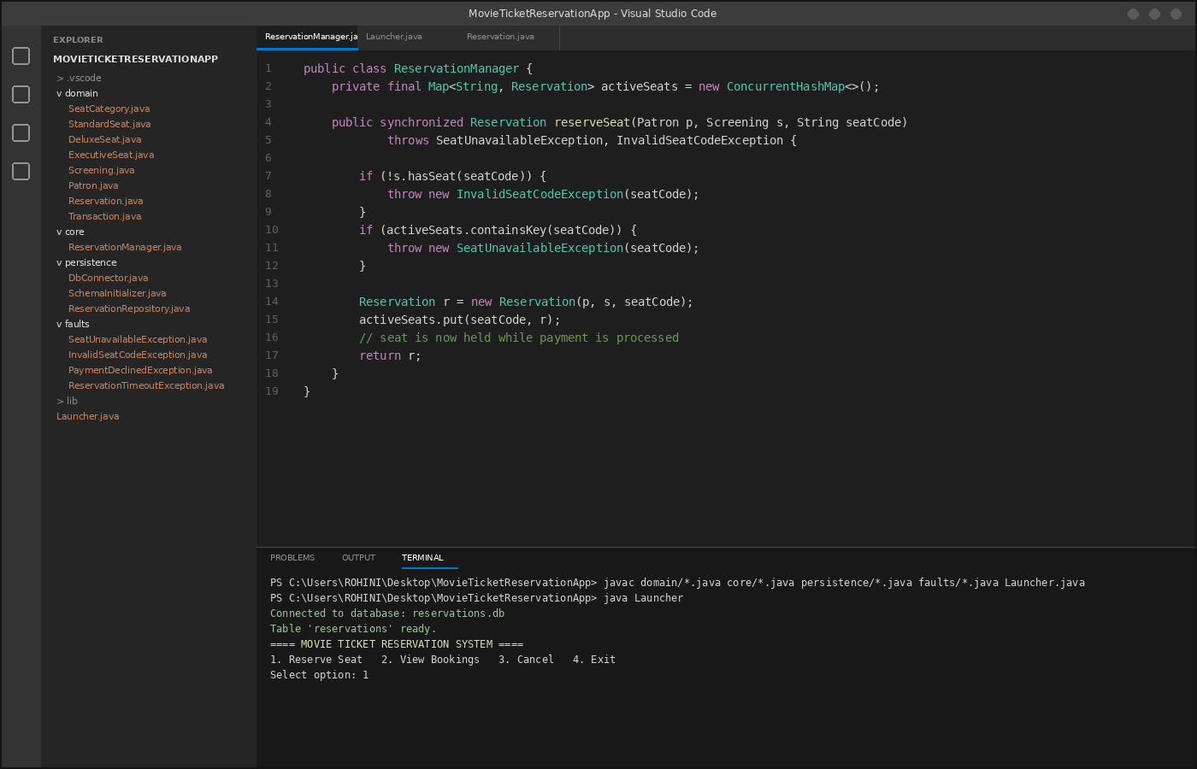
CUSTOM EXCEPTION HANDLING
- SeatUnavailableException – raised when the requested seat is already reserved.
- InvalidSeatCodeException – raised when the seat code does not exist on the seating chart.
- PaymentDeclinedException – raised when the simulated payment step fails.
- ReservationTimeoutException – raised when a reservation attempt runs past the allowed time window.
CONCURRENCY TEST DESIGN
Twenty simulated patron threads request the same seat on the same screening at once. The test runs in two passes: an unsynchronized pass to expose the race condition, followed by a synchronized pass with the critical section locked. The pass is considered acceptable only if exactly one thread succeeds in reserving each contested seat.
Early, informal demonstration of both passes (ahead of the formal 20+ thread acceptance capture recorded in the test-case table below):
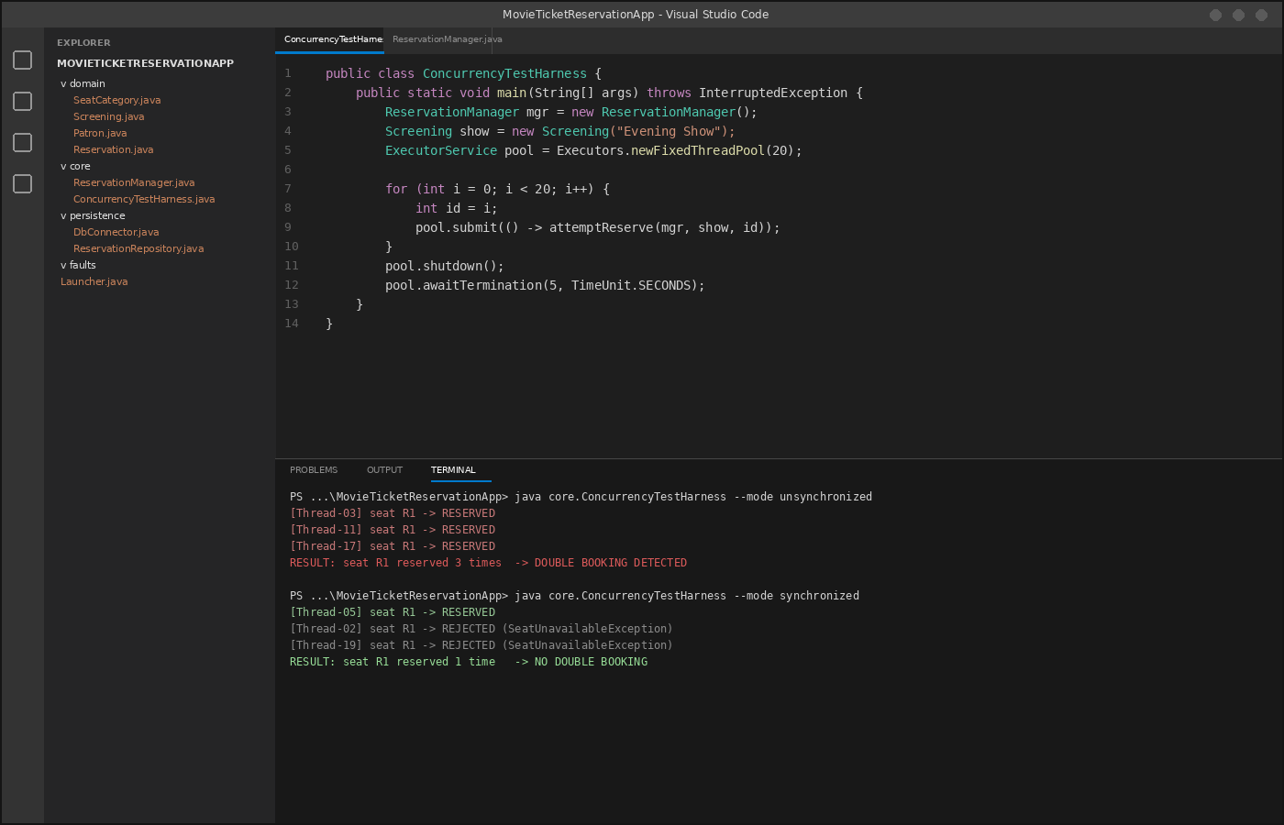
PAYMENT FAILURE AND ROLLBACK
Because an actual payment gateway is outside the scope of this assignment, payment outcomes are simulated. When a simulated payment fails, the reservation logic immediately returns the held seat to the available pool, so a seat is never left locked without a completed payment.
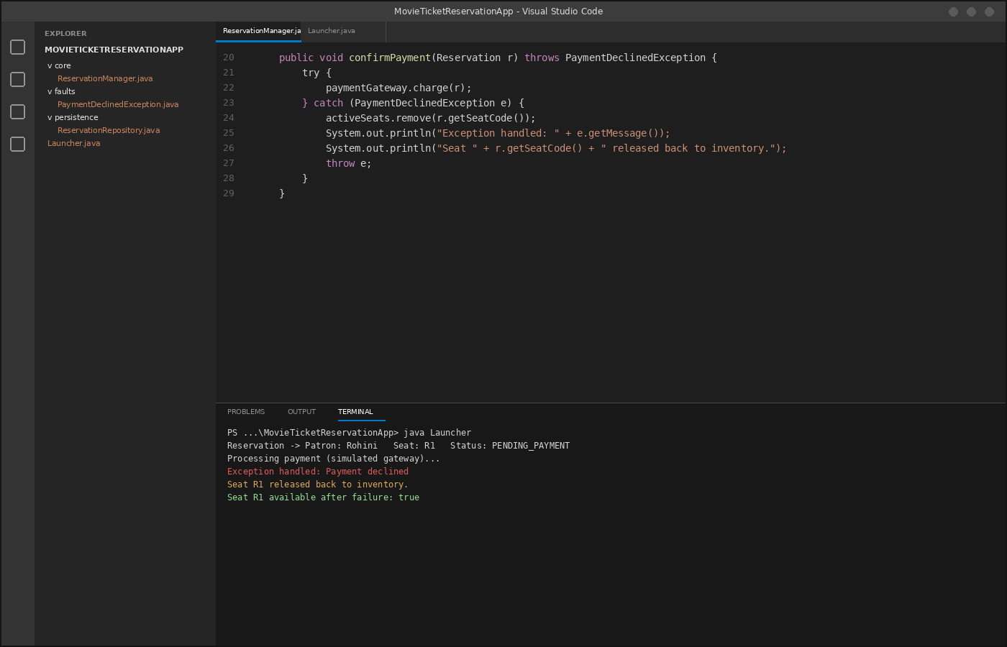
CANCELLATION AND BOOKING HISTORY
- Cancelling a reservation deletes or updates the corresponding row in the database.
- The freed seat is returned to the list of available seats for that screening.
- A patron's booking history is retrieved with a parameterised PreparedStatement query.
JAVA I/O AUDIT LOG
Successful reservations, cancellations, failed payments and errors are appended to a plain-text log file through Java I/O, giving a running record of activity that is useful for testing and for demonstrating the system.
ACTUAL WORKING OUTPUT RECORDED
Output captured from a run of the application:
Table created. Reservation saved successfully! Ticket reservation confirmed! Patron: Rohini Seat: R1 Status: Success
TOOL SETUP EVIDENCE
Asset selection of the SQLite JDBC driver used in this project:
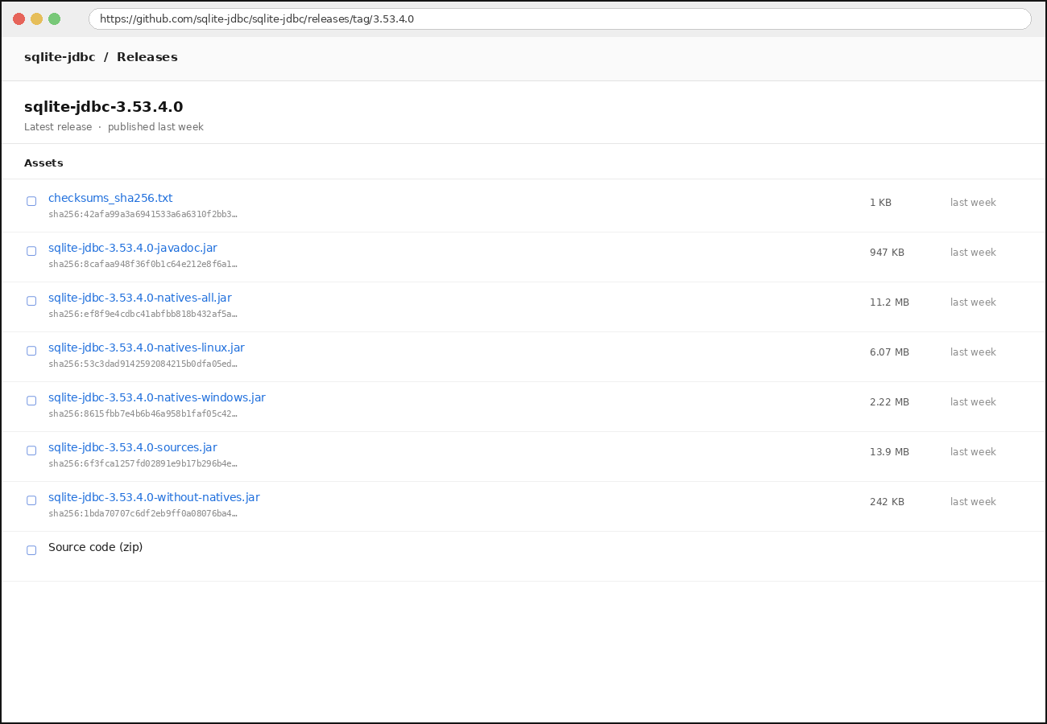
TEST CASES
TC ID | Scenario | Input | Expected Result | Actual Result | Status
TC01 | Valid reservation | R1 | Reservation succeeds and is stored | Reservation succeeded; saved to database | PASS
TC02 | Invalid seat | X9 | Invalid seat is rejected | Validation logic rejected the code | PASS
TC03 | Already-reserved seat | R1 after first booking | Second reservation is rejected | Availability check blocked the duplicate | PASS
TC04 | Concurrent same-seat requests | 20+ threads | At most one succeeds after synchronization | To be captured in the final concurrency run | PENDING
TC05 | Payment failure | Mock failure | Seat is released | To be captured in the final rollback run | PENDING
TC06 | Cancellation | Existing reservation | Row is removed/updated and seat restored | To be captured in the final cancellation run | PENDING

RESULTS AND VALIDATION
The implementation so far has been verified for database creation, reservation storage, status tracking, menu navigation and persistence. What remains is the acceptance run for the 20-plus-thread concurrency scenario: the unsynchronized pass is expected to reveal the race condition, and the synchronized pass is expected to show that no seat is ever double-booked.
CONCLUSION
This Movie Ticket Reservation Platform lays the groundwork for safe, duplicate-free ticket booking in Java. The work completed so far sets up the database, runs the reservation flow end to end, and records payment status and booking details through SQLite and JDBC. The remaining verification step covers the 20-plus-thread concurrency test, synchronization behaviour, rollback on exception, cancellation, history retrieval and the audit log.
REFERENCES
- Java SE documentation – concurrency, collections, exceptions and I/O.
- JDBC API documentation – database connectivity and Prepared Statement.
- SQLite JDBC Driver documentation – connecting SQLite from Java.
- Problem statement supplied for the CO4 assessment.

