SIMATS ENGINEERING
ASSESSMENT TOOL 1

COURSE NAME: Artificial Intelligence COURSE CODE: CSA17

COURSE OUTCOME COVERED

CO1: Apply AI basics such as intelligent agents and uninformed search methods to solve problems effectively. (BL3)

Assessment Tool Weightage: 35%

QUESTIONS: 5 Duration : 1 Hour
Total Marks:50

Annexure A

Analytical Problem Solving

Code of Conduct:

I, Attar Mohammad Rehan (Reg No: 192525354) certify that this submission is my original work and that I have adhered to the guidelines specified for this assessment.
I understand that any violation of academic integrity rules will result in disciplinary action.

Signature of the student:
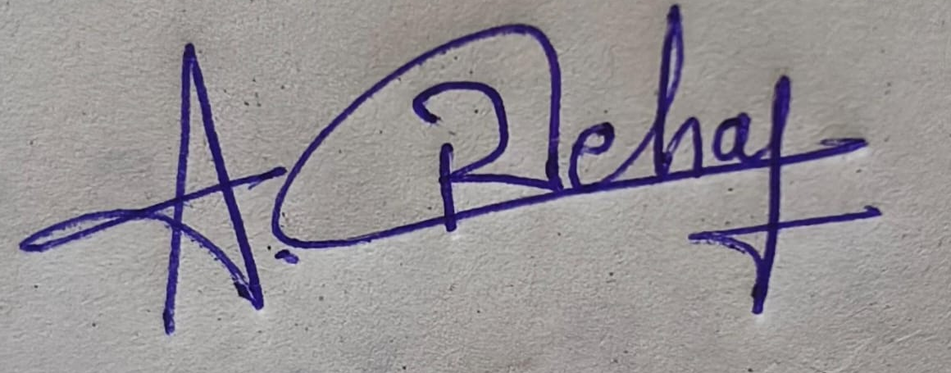
Student Signature
Question 1: Water Jug Problem
Problem: Given an unmarked 4-gallon jug and an unmarked 3-gallon jug, obtain exactly 2 gallons in the 4-gallon jug using only filling, emptying, and pouring operations.

State representation and assumptions
Represent a state as (x, y), where x is the amount of water in the 4-gallon jug and y is the amount in the 3-gallon jug. The initial state is (0, 0), and the goal condition is x = 2. The capacities are fixed at 4 and 3 gallons. Water may be filled from the pump, emptied onto the ground, or transferred between jugs until the source is empty or the destination is full.

Step-by-step solution
Step | State (x, y) | Operation / explanation
0 | (0, 0) | Both jugs are empty.
1 | (0, 3) | Fill the 3-gallon jug.
2 | (3, 0) | Pour the 3 gallons into the 4-gallon jug.
3 | (3, 3) | Fill the 3-gallon jug again.
4 | (4, 2) | Pour from the 3-gallon jug into the 4-gallon jug until the 4-gallon jug is full. One gallon transfers, leaving 2 gallons in the 3-gallon jug.
5 | (0, 2) | Empty the 4-gallon jug.
6 | (2, 0) | Pour the remaining 2 gallons from the 3-gallon jug into the 4-gallon jug.
Result: The final state is (2, 0). Therefore, exactly 2 gallons are present in the 4-gallon jug. The method succeeds because the difference between the jug capacities can be used to measure the required amount through controlled transfers.

Question 2: Mars Rover as an Intelligent Agent
A Mars rover is an autonomous or semi-autonomous intelligent agent that senses its surroundings, makes decisions, and performs actions to explore the Martian surface and investigate samples. Communication delays and environmental uncertainty mean that it must perform many tasks without continuous human control.

i. Percepts
- Camera images and visual features of rocks, terrain, slopes, and obstacles.
- Range, proximity, and navigation sensor readings used to estimate distance and detect hazards.
- Scientific instrument measurements such as chemical composition, mineral signatures, temperature, and sample properties.
- Internal-state information: battery level, wheel condition, arm position, memory, and system health.
- Commands and mission updates received from Earth, when communication is available.

ii. Operating environment
The environment is partially observable because sensors provide incomplete information about the terrain and subsurface. It is stochastic: wheel slip, dust, lighting, and unexpected obstacles can make outcomes uncertain. It is sequential because each movement affects later navigation and sampling decisions. It is dynamic, since conditions and rover state can change while operating. It is continuous in location, movement, and many sensor values, although the rover may use discrete internal states. It is a single-agent environment for local decision-making, with Earth-based operators acting as external collaborators.

iii. Actions
- Move forward or backward, turn, stop, and select a safe route.
- Aim or operate cameras and scientific sensors to inspect targets.
- Extend and position the robotic arm; collect, transfer, or analyze samples.
- Avoid obstacles, choose a safe resting location, and manage power.
- Transmit data, receive instructions, and enter a safe mode when a fault is detected.

iv. Performance evaluation
Performance can be evaluated using measurable mission objectives: successful completion of planned traverses; distance covered without damage; number and scientific value of samples examined; accuracy and usefulness of collected data; energy and time consumed; communication and data-transfer success; and safety, reliability, and compliance with mission constraints. A good rover maximizes useful scientific results while minimizing risk, delay, and resource consumption.

v. Suitable agent architecture
A model-based, goal-based agent with utility-based decision-making is most suitable. A model-based component maintains an internal map and estimates rover state from percept history, which is essential in a partially observable environment. Goal-based planning selects actions that achieve mission targets such as reaching a rock or collecting a sample. A utility measure helps compare alternatives by

Question 3: Eight-Queens Problem and Search Space
Problem: Place eight queens on an 8 × 8 chessboard so that no two queens attack one another. Since a queen attacks along its row, column, and diagonals, a valid arrangement must avoid all three types of conflict.

Problem formulation
- Initial state: An empty chessboard, with no queens placed.
- State: A partial assignment of queen positions. A convenient representation places at most one queen in each column; the state can be written as a sequence of row numbers for the columns already filled.
- Actions: Place a queen in a safe square in the next column, such that it does not share a row or diagonal with any previously placed queen.
- Transition model: Add the selected row/column position to the partial assignment.
- Goal test: Eight queens have been placed and no pair shares a row, column, or diagonal.
- Path cost: Often each placement is assigned unit cost. For this constraint-satisfaction problem, the main objective is to find any state satisfying the goal test rather than minimize a travel cost.

Search strategy and conflict test
Backtracking depth-first search is effective: place one queen in the next column, test whether the placement is safe, and continue. If no row is safe in a column, undo the most recent placement and try another row. For queens at (r1, c1) and (r2, c2), a conflict exists when r1 = r2 or |r1 − r2| = |c1 − c2|. With one queen per column, column conflicts are prevented by construction.
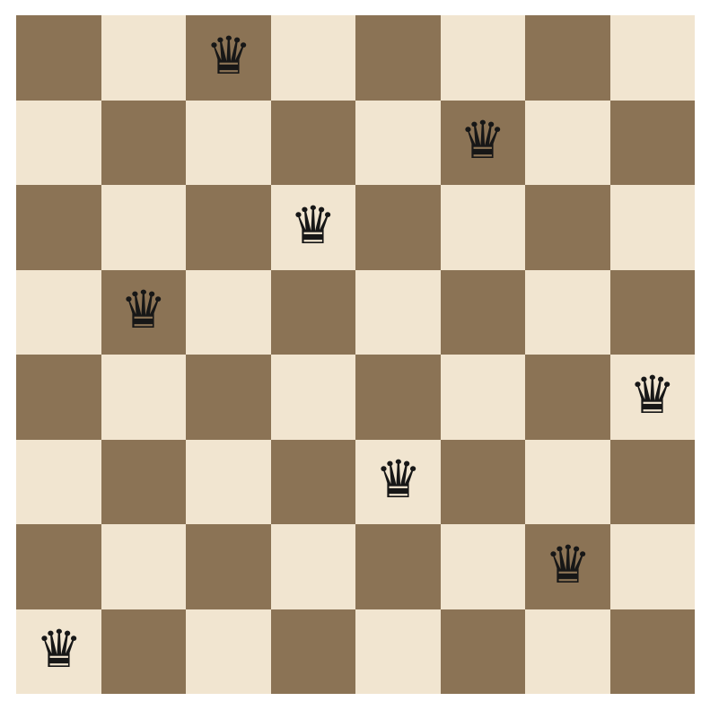
Figure: One valid eight-queens arrangement (row positions by column: 1, 5, 8, 6, 3, 7, 2, 4).
The illustrated arrangement is a goal state because every queen occupies a different row and the diagonal-conflict test is false for every pair. Search explores alternatives systematically and backtracks whenever a partial arrangement cannot be extended.

Question 4: OLA Cab Booking as a Problem-Solving Agent
The customer wants to travel from a source to a destination and can choose among cab categories such as Mini, Micro, Sedan, Shared, or Prime. A goal-based problem-solving agent can identify a suitable booking option by defining the destination as the goal and evaluating available actions. A utility-based element is useful when comfort, fare, waiting time, and sharing preference must be balanced.

Problem components
- Initial state: Customer is at the pickup location; destination and preferences are entered.
- Goal state: A suitable cab is selected and a booking request is successfully placed.
- Actions: Enter or confirm locations, select a cab category, view fare/ETA, choose an option, and confirm booking.
- Constraints/preferences: Budget, passenger count, comfort, shared/private ride preference, availability, and estimated arrival time.
- Evaluation: A valid option should reach the destination while satisfying the customer’s constraints and preferences.

Pseudocode
BEGIN
INPUT pickup_location, destination
INPUT preferences (budget, comfort, passengers, ride_type)
IF pickup_location = destination THEN
DISPLAY "Pickup and destination must be different"
STOP
ENDIF
available_cabs ← GET_AVAILABLE_CABS(pickup_location)
suitable_cabs ← EMPTY_LIST
FOR each cab IN available_cabs DO
fare ← ESTIMATE_FARE(cab, pickup_location, destination)
eta ← ESTIMATE_ARRIVAL(cab)
IF cab.capacity >= passengers
AND fare <= budget
AND MATCHES_PREFERENCES(cab, preferences) THEN
ADD (cab, fare, eta) TO suitable_cabs
ENDIF
ENDFOR
IF suitable_cabs IS EMPTY THEN
DISPLAY "No suitable cab available"
OFFER_ALTERNATIVES()
ELSE
DISPLAY suitable_cabs
selected_cab ← CUSTOMER_SELECTS(suitable_cabs)
DISPLAY fare and pickup estimate
IF CUSTOMER_CONFIRMS() THEN
booking ← CREATE_BOOKING(selected_cab)
DISPLAY booking confirmation
ELSE
DISPLAY "Booking cancelled"
ENDIF
ENDIF
END
Explanation: The agent first gathers the trip details, then filters the available cabs using capacity and customer preferences. It presents feasible choices rather than selecting blindly. The customer makes the final choice and explicitly confirms the booking. In a real application, fare and availability must be refreshed before confirmation because they can change over time.

Question 5: Uniform Cost Search for Warehouse Delivery
Uniform Cost Search (UCS) finds a least-cost path by expanding the frontier node with the smallest cumulative path cost g(n). Unlike breadth-first search, it accounts for different route costs. The given network has start node S and goal node G.
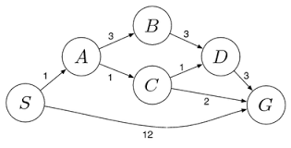
Figure: Weighted delivery network supplied in the assessment.
Edges and costs shown: S–A = 1, S–G = 12, A–B = 3, A–C = 1, B–D = 3, C–D = 1, C–G = 2, and D–G = 3.

UCS expansion
Iteration | Expanded node | Relevant frontier / updates | Decision
1 | S | A(1), G(12) | A
2 | A (cost 1) | C(2), B(4), G(12) | C
3 | C (cost 2) | D(3), G(4), B(4) | D
4 | D (cost 3) | B(4), G(6), G(4) | B or G(4) next
5 | B (cost 4) / G (cost 4) frontier | Goal G is selected at cost 4 | Stop when G is removed from priority queue
The key candidate paths are S → G with cost 12; S → A → C → G with cost 1 + 1 + 2 = 4; and S → A → C → D → G with cost 1 + 1 + 1 + 3 = 6. The least-cost route is S → A → C → G, with total cost 4.

UCS pseudocode
UCS(start, goal):
frontier ← priority queue containing (cost=0, start)
best_cost[start] ← 0
parent[start] ← NONE
WHILE frontier is not empty:
(cost, node) ← REMOVE_MIN(frontier)
IF cost > best_cost[node]: CONTINUE
IF node = goal: RETURN reconstruct_path(parent, goal), cost
FOR each neighbor v of node:
new_cost ← cost + edge_cost(node, v)
IF v is unseen OR new_cost < best_cost[v]:
best_cost[v] ← new_cost
parent[v] ← node
INSERT (new_cost, v) INTO frontier
RETURN "No path found"
Conclusion: UCS returns the path with the minimum accumulated route cost when edge costs are non-negative. In this network, the optimal delivery route costs 4 units. The direct route is shorter in number of edges but more expensive, showing why cost-based search is appropriate.

