SIMATS ENGINEERING

ASSESSMENT TOOL 3: Application Based Questions

COURSE NAME: Cloud Computing and COURSE CODE: CSA15
Big Data Analytics

COURSE OUTCOME COVERED
CO2: Analyze virtualization architectures to identify performance and security issues in cloud computing environments. (BL3)

Dave's Taxonomy: Manipulation (Level 2) Total Marks: 25
Question Count: 5

Code of Conduct
I M Sanjay Krishna(192525421_ (Name / Reg No) certify that this submission is my original work and that I have adhered to the guidelines specified for this assessment.
I understand that any violation of academic integrity rules will result in disciplinary action.

Signature of the student: M Sanjay

Assessment Tasks: Application Based Questions
1. A company experiences unpredictable traffic spikes during seasonal sales. Explain how cloud auto-scaling and load balancing can handle this demand efficiently. How does this approach reduce downtime and improve user experience? What role do monitoring tools play in this setup? Relate your answer to a real-world e-commerce scenario.
2. An organization wants to store large volumes of backup data securely in the cloud. Discuss how cloud storage solutions ensure durability and data redundancy. How can encryption and access control protect sensitive backup data? Explain the cost advantages compared to traditional storage systems. Provide an example of a disaster recovery use case.
3. A mobile app company plans to deploy its application globally. Explain how content delivery networks (CDNs) improve performance and reduce latency. How do edge servers enhance user experience across regions? Discuss how cloud providers support global availability. Relate this to a real-time streaming or gaming application.
4. A financial institution requires strict compliance and data security in cloud usage. Explain how cloud providers support regulatory compliance and auditing. What role do logging, monitoring, and encryption play in security? How can the company ensure data sovereignty requirements are met? Give an example involving sensitive financial transactions.
5. A development team wants to adopt containerization for application deployment. Explain how containers differ from virtual machines in terms of performance and resource usage. How does orchestration (like Kubernetes) simplify deployment and scaling? Discuss portability benefits across different cloud environments. Provide an example of a microservices-based application.
Application Based Questions Rubric
Criteria | Weight | Level 4 - Exemplary | Level 3 - Proficient | Level 2 - Developing | Level 1 - Beginning
Relevance to Application | 25% | Response directly addresses the given use case with strong relevance | Mostly relevant response | Partially relevant | Weak relevance
Use of Cloud Concepts | 25% | Applies appropriate concepts accurately | Mostly accurate application | Basic application only | Incorrect concept usage
Practical Insight | 20% | Shows strong real-world understanding | Shows reasonable practical understanding | Limited practical insight | No practical insight
Completeness | 15% | Response covers all required aspects | Covers most aspects | Covers only basic aspects | Incomplete response
Clarity | 15% | Clear and concise answer | Generally clear | Some confusion in expression | Poor clarity
Total Marks Awarded: ________

ANSWERS
Question 1: Auto-Scaling and Load Balancing for Seasonal Traffic
Introduction
Seasonal sales such as Black Friday, Diwali or end-of-season offers create sudden and unpredictable traffic that can be many times higher than normal. A fixed number of servers either crashes under this load or sits idle most of the year. Cloud computing solves this with elasticity: auto-scaling changes the number of servers automatically, and load balancing shares the traffic among them. Monitoring tools connect the two by measuring demand and triggering action.
How load balancing handles the demand
- Single entry point: All users connect to the load balancer's address, which forwards each request to one of many identical servers.
- Distribution algorithms: Round robin (servers in turn), least connections (the least busy server) and weighted methods (bigger servers get more traffic).
- Health checks: The balancer regularly tests each server; a failed or slow server is removed from rotation automatically and added back when healthy.
- Layer 4 and Layer 7: Layer 4 balancing works on TCP/UDP connections and is very fast; Layer 7 (application) balancing can route by URL, for example /checkout to payment servers and /images to a cache.
- Session handling: Sessions (such as shopping carts) are kept in a shared cache like Redis instead of on one server, so any server can serve any user and servers can be added or removed freely.
- Multi-AZ: The balancer spreads traffic over several Availability Zones, so a data center failure does not stop the site.
How auto-scaling handles the demand
- Scale out and scale in: When load rises, new servers are launched from a ready-made machine image or container image and registered with the load balancer; when load falls, extra servers are removed.
- Minimum and maximum limits: A minimum keeps the site always available and a maximum prevents unexpected cost.
- Warm-up and cooldown: New servers get time to start before receiving full traffic, and a cooldown avoids repeatedly adding and removing servers.
Scaling policy | How it works | Best used for
Target tracking | Keeps a metric near a target, e.g. average CPU at 60% | Everyday, general-purpose scaling
Step scaling | Adds more servers as the metric rises further above thresholds | Sharp, sudden spikes
Scheduled scaling | Changes capacity at set times | Known events such as a 12 AM sale launch
Predictive scaling | Uses past patterns to scale ahead of time | Repeating daily or weekly peaks

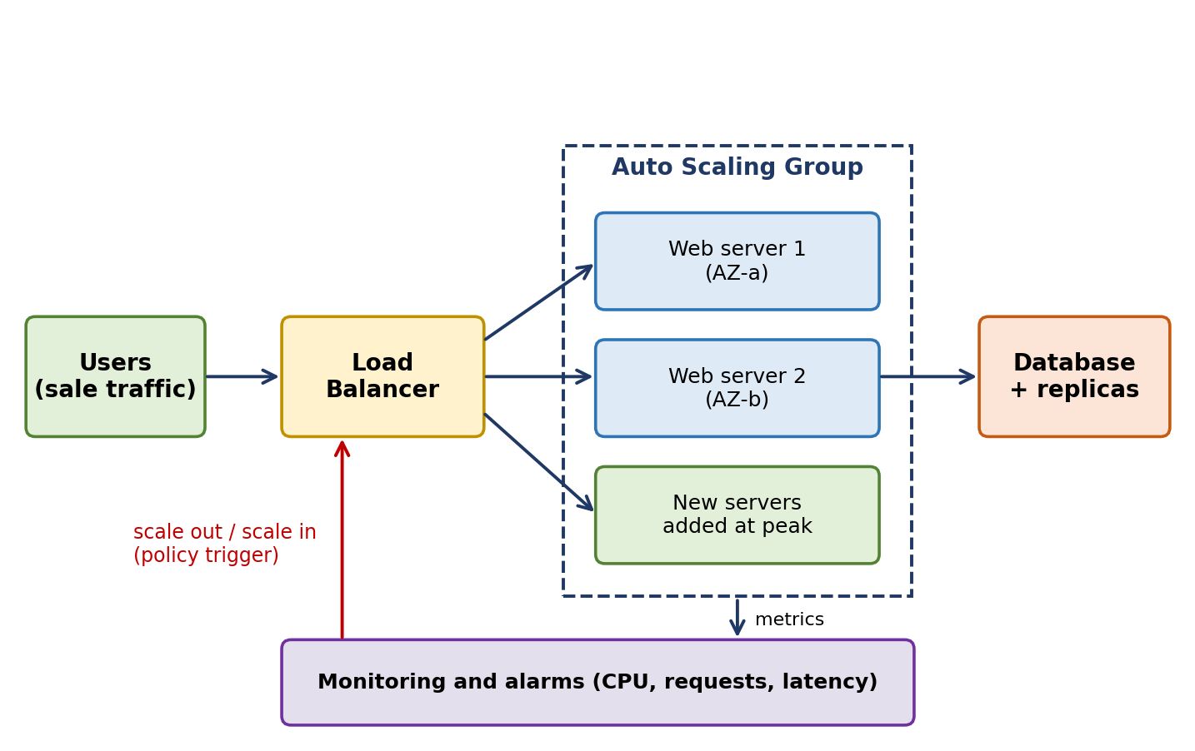
Fig 1: Load balancer and auto-scaling group controlled by monitoring.
Reducing downtime
- No single point of failure: Many servers in several zones mean one failure only removes a small share of capacity.
- Self-healing: Failed servers are detected by health checks and replaced automatically.
- Protection from overload: Extra capacity is added before servers reach their limit, so they do not crash or time out.
- Safe releases: Rolling or blue-green deployments and connection draining allow updates during a sale without taking the site offline.
Improving user experience
- Fast response: Pages, search and checkout stay quick because no server is overloaded.
- Reliability: Customers do not see errors or lose their carts and payments during peak time.
- Consistency: Response time stays almost the same at normal and peak load; this reduces abandoned carts and protects revenue and reputation.
- Further speed-ups: A CDN for images and static files, a cache for product data, and database read replicas reduce load on the servers.
Role of monitoring tools
- Metrics: CPU use, memory, requests per second, response time, error rate, queue length and database connections.
- Alarms and automation: Tools such as Amazon CloudWatch, Azure Monitor, Google Cloud Monitoring or Prometheus raise alarms that directly trigger scaling policies.
- Logs and tracing: Application logs and distributed traces show the exact cause of slow responses, such as a slow database query or payment gateway.
- Dashboards and alerts: Real-time dashboards for the operations team and alerts by email, SMS or chat before customers are affected.
- Synthetic monitoring: Automated test users run through search, add-to-cart and checkout every minute to confirm the site really works.
- Capacity planning and cost: Historical data shows how much capacity the next sale needs and how much money scaling saves.
Real-world e-commerce scenario
An online fashion store plans a 24-hour mega sale beginning at midnight. Normally 4 web servers handle the traffic. The team sets a scheduled action to raise the minimum to 20 servers at 11:30 PM, and a target-tracking policy to keep CPU near 60% with a maximum of 80 servers. At midnight, traffic jumps about 15 times. The load balancer spreads the visitors, the CPU alarm fires, and more servers join within a few minutes. Product pages and images come from a CDN, sessions and carts from Redis, and the database uses read replicas.
During the sale, dashboards show response time stays under 2 seconds and the error rate below 1%. When one server fails, health checks remove it and the group replaces it without any visible effect. After the sale, traffic falls, servers scale in, and the store pays only for the capacity actually used. This is how large retailers run events such as Amazon Prime Day or Flipkart Big Billion Days.
Challenges and best practices
- Challenges: Server start-up delay, database becoming the bottleneck, wrong thresholds, and cost surprises from runaway scaling.
- Best practices: Design stateless applications, pre-scale before known events, load-test before the sale, scale the database with replicas or caching, set maximum limits and budget alerts.
Conclusion
Auto-scaling gives the right amount of capacity, load balancing shares the work and removes failed servers, and monitoring provides the data that drives both. Together they reduce downtime, keep the user experience fast and keep costs proportional to demand.
Question 2: Secure Cloud Backup Storage
Introduction
Backups are the last line of defence against hardware failure, human error, ransomware and disasters. Cloud storage is attractive for backup because it is practically unlimited, geographically distributed, secure and billed only for what is used. The main requirements are durability (data is not lost), redundancy (multiple copies exist), security (only authorized people can read or delete it) and cost efficiency.
Durability and data redundancy
- Multiple copies: Object storage (Amazon S3, Azure Blob Storage, Google Cloud Storage) automatically stores each object on several devices in at least three Availability Zones.
- Cross-region replication: Objects can be copied to another region, protecting against the loss of an entire region.
- Erasure coding and checksums: Data is split and encoded so it can be rebuilt if drives fail; checksums are checked regularly and damaged data is repaired from good copies.
- High durability: Leading services are designed for 99.999999999% durability (eleven nines), meaning the chance of losing an object is extremely small.
- Versioning and immutability: Versioning keeps earlier copies after overwrites or deletes; Object Lock (WORM) prevents deletion or change for a set period, which defeats ransomware.
- Storage classes: Standard, infrequent-access and archive classes (such as Glacier) keep the same durability at different prices.
Term | Meaning | How the cloud provides it
Durability | Data is not lost or corrupted over time | Replication, erasure coding, checksums, repair
Availability | Data can be accessed when needed | Multi-AZ design, SLA of about 99.9% to 99.99%
Redundancy | More than one copy exists | Copies in several zones and regions

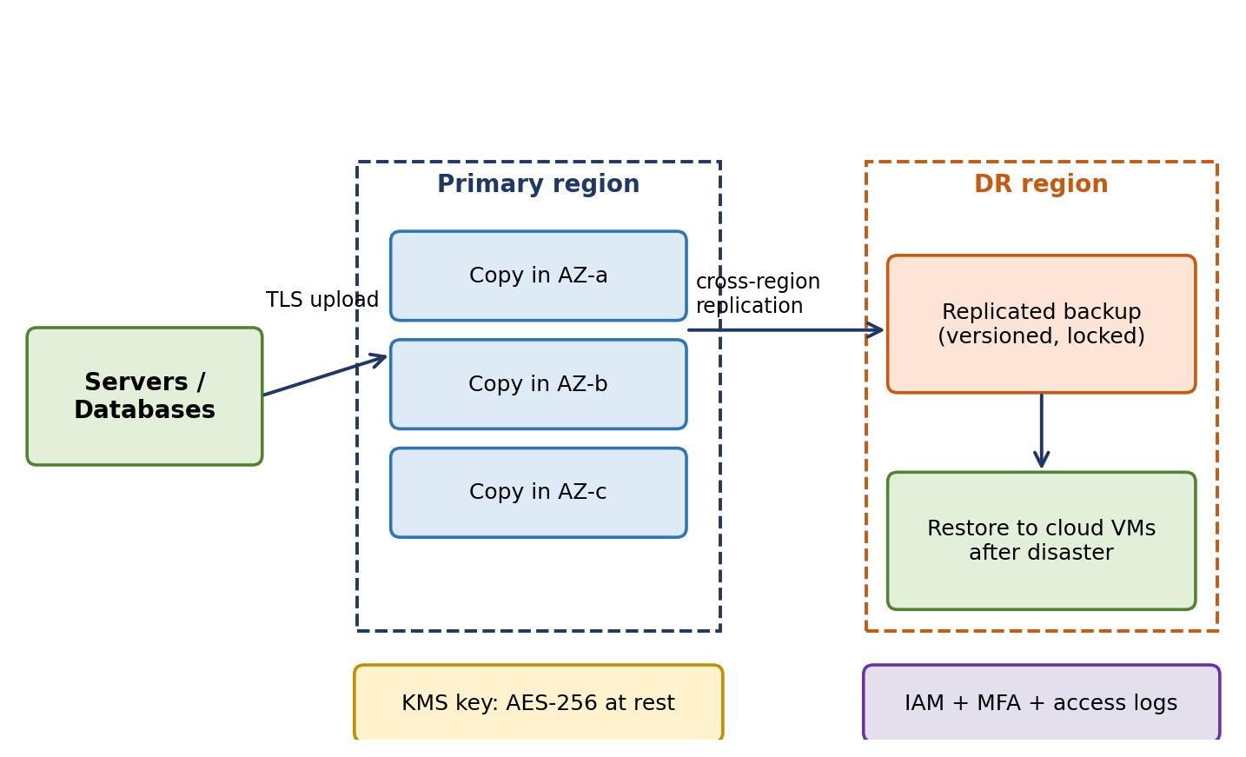
Fig 2: Encrypted backup replicated across regions for disaster recovery.
Encryption
- In transit: TLS protects backup data while it is uploaded and restored.
- At rest: AES-256 encryption of all objects, enabled by default on most services.
- Key management: Keys are stored in a Key Management Service or HSM; customers can use their own keys (customer-managed keys), rotate them regularly and disable them to make data unreadable.
- Client-side encryption: Data can be encrypted before upload so the provider never sees the plain data.
- Envelope encryption: Data keys encrypt the data and a master key encrypts the data keys, making key rotation efficient.
Access control
- IAM least privilege: Only the backup service role may write; only a few administrators may restore or delete.
- MFA and MFA-delete: Multi-factor authentication is required for sensitive operations such as deleting a bucket or a version.
- Bucket policies and private access: Block all public access and use private endpoints or VPN so backups are not reachable from the internet.
- Separate account: Keep backups in a different cloud account so a compromised production account cannot erase them.
- Audit and alerts: Access logs (CloudTrail) and alerts record every read, change and delete.
Cost advantages over traditional storage
Factor | Traditional storage (disks, tape, own data center) | Cloud storage
Upfront cost | Large capital expense for arrays, tape libraries and software | None; pay-as-you-go
Capacity planning | Must buy for future growth; often over-provisioned | Grows automatically; pay only for used space
Redundancy and offsite copy | Extra hardware and a second site or tape transport | Built in; replication is a setting
Maintenance | Staff, power, cooling, space, hardware refresh | Handled by the provider
Old data | Stays on expensive disks | Lifecycle rules move it to low-cost archive tiers
Recovery speed | Slow tape retrieval and restore | Fast online restore

Disaster recovery use case
A hospital group backs up its patient database and VM images every night to cloud object storage with versioning and Object Lock, and the bucket replicates to a second region. One day ransomware encrypts the main servers and the primary data center loses power.
- Step 1: The IT team isolates the infected systems and declares a disaster.
- Step 2: They launch virtual machines in the DR region from stored images, using infrastructure-as-code templates.
- Step 3: They restore the last clean version of the database from before the attack, because the locked backups could not be altered.
- Step 4: DNS is switched to the recovered environment, and service resumes within the Recovery Time Objective (for example 2 hours), with data loss limited to the Recovery Point Objective (for example 24 hours, or minutes with continuous replication).
- Step 5: After the original site is repaired, data is synchronized back and normal operation resumes.
Best practices and conclusion
- Best practices: Follow the 3-2-1 rule (three copies, two media types, one offsite), test restores regularly, use lifecycle policies and monitor backup jobs.
Cloud storage provides highly durable, redundant, encrypted and cost-effective backup. With strong access control and tested recovery procedures, an organization can survive failures and attacks with minimal data loss.
Question 3: Global Mobile App Deployment with CDN
Introduction
When an app has users on every continent, a single server location gives far users a slow experience because data takes longer to travel and crosses many network hops. This delay is called latency. A Content Delivery Network (CDN) and a global cloud infrastructure bring the app's content and services closer to users, improving speed, reliability and scalability.
How CDNs improve performance and reduce latency
- How it works: A CDN is a network of servers in many cities. On the first request for a file, the edge server fetches it from the origin and keeps a copy; later users nearby receive the cached copy directly.
- Lower latency: Distance is shorter, so round-trip time falls, for example from about 250 ms to under 30 ms.
- Less load on origin: Most requests are answered at the edge, so the origin needs fewer servers and less bandwidth.
- Faster connections: Edge servers keep connections open to the origin, finish TLS handshakes close to the user and use HTTP/2 or HTTP/3.
- Optimization: Compression, image resizing, caching rules and smart routing over fast backbone links.
- Resilience: Traffic spikes and DDoS attacks are absorbed by many edge locations instead of one server.
Without CDN | With CDN
All users reach one origin region | Users reach the nearest edge location
High latency for distant users | Low latency everywhere
Origin overloaded at peak | Origin load reduced by caching
Higher data transfer cost from origin | Lower origin egress cost
Single location is a bottleneck | Distributed and resilient

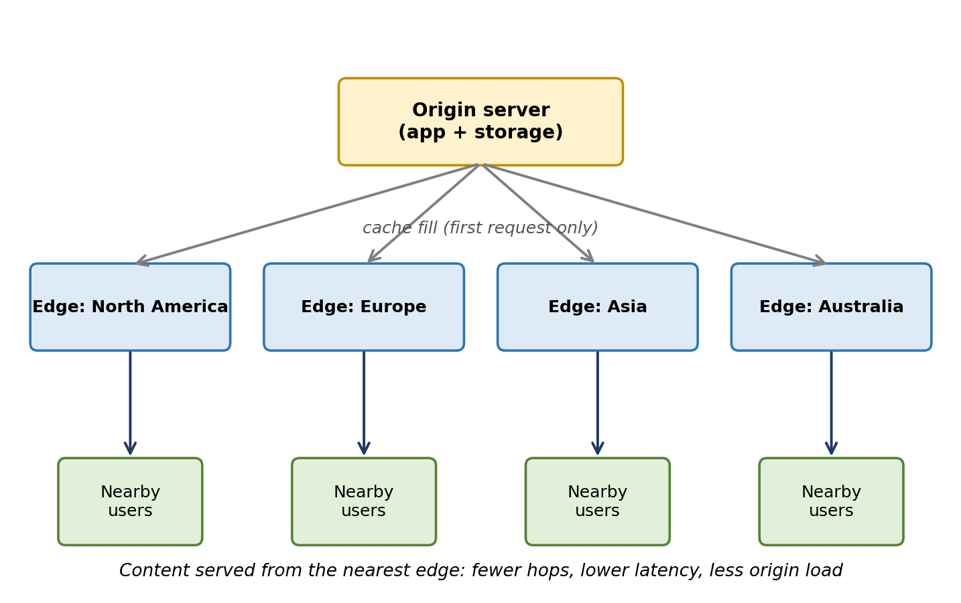
Fig 3: A CDN serves users from the nearest edge location.
How edge servers enhance user experience across regions
- Proximity: A user in Chennai is served from an Asian edge, a user in London from a European one; everyone sees similar speed.
- Faster app start and downloads: Images, videos, app updates and configuration files load quickly, reducing waiting and drop-offs.
- Edge computing: Small pieces of code (such as authentication checks, A/B testing, redirects or personalization) run at the edge for instant responses.
- Local regulations and content: Edge rules can show region-specific content or block certain countries.
- Quality of service: Fewer hops mean less packet loss and jitter, which matters for video and games.
How cloud providers support global availability
- Regions and Availability Zones: Providers operate dozens of regions, each with several isolated zones, allowing apps to be deployed near users and survive local failures.
- Global network backbone: Private high-speed links between regions are faster and more reliable than the public internet.
- Global traffic management: Global DNS, anycast IP addresses and global load balancers route users to the nearest healthy region and fail over automatically.
- Data replication: Multi-region databases and object storage keep data available and close to users (for example DynamoDB Global Tables, Cosmos DB, Cloud Spanner).
- Service level agreements: Providers publish uptime commitments, and multi-region design can exceed them.
- Edge locations: Hundreds of points of presence for CDN, DNS and security services.
Real-time streaming and gaming application
- Video streaming: A streaming app encodes videos in several qualities and splits them into small segments (HLS or DASH). The segments are cached at edge servers, so each viewer downloads from the nearest edge, buffering is reduced, and the player switches quality smoothly (adaptive bitrate) as the connection changes. A popular show is requested millions of times, but the origin serves each segment only a few times.
- Online gaming: The CDN delivers game installers, patches, maps and textures from the edge, so downloads are fast. The live match runs on game servers deployed in the region closest to the players, and matchmaking picks the lowest-ping server. Real-time game state is not cached; it is handled by regional servers connected through the provider's fast backbone, and extra regions are started as the player base grows.
- Result: Lower latency (ping), fewer lags and disconnections, and the same experience for players in India, Europe and America.
Conclusion
CDNs and edge servers bring content close to users and cut latency, while global cloud regions and traffic management provide availability and resilience. Together they let a mobile app company offer a fast, reliable experience worldwide without building its own global infrastructure.
Question 4: Compliance and Data Security for a Financial Institution
Introduction
Financial institutions handle money and personal data, so they must follow strict rules such as PCI DSS (card data), SOX, GDPR (privacy), central bank and local data-protection regulations. Moving to the cloud does not remove these duties. The institution must choose providers and design controls that prove compliance, protect data and keep data in permitted locations.
How cloud providers support regulatory compliance and auditing
- Certified infrastructure: Providers are audited against standards such as ISO 27001, SOC 1/2/3, PCI DSS, HIPAA and regional frameworks, and they publish the reports to customers (for example AWS Artifact, Azure Trust Center, Google Compliance Reports Manager).
- Shared responsibility model: The provider secures the physical data centers, hardware and core services; the customer secures its data, identities, configuration and applications. Both parts must be documented for auditors.
- Compliance tools: Services such as AWS Config, Security Hub, Azure Policy and Google Security Command Center check resources against rules and show where they do not comply.
- Audit trails: Every API call and administrative action is recorded (AWS CloudTrail, Azure Activity Log) to give evidence to auditors.
- Governance features: Role-based access, resource tagging, policy enforcement, landing zones and templates ensure every new resource follows the standard.
- Regional presence: Providers offer regions in many countries and specialized government or financial offerings.
Role of logging, monitoring and encryption in security
- Logging: Records who did what, when and from where: logins, data access, configuration changes and transactions. Logs are stored in a protected, tamper-proof location with set retention. They support investigations and audits and prove compliance.
- Monitoring: Continuous analysis of logs and metrics with a SIEM and threat-detection services (such as GuardDuty or Microsoft Sentinel) finds unusual behaviour: logins from strange places, large data transfers, repeated failed logins or fraud patterns. Real-time alerts allow quick response.
- Encryption in transit: TLS 1.2 or higher protects data moving between customers, services and data centers.
- Encryption at rest: AES-256 for databases, files and backups.
- Key management: Keys are kept in KMS or HSM, access to keys is separate from access to data, keys are rotated, and the institution can hold its own keys.
- Together: Encryption makes stolen data useless, logging provides evidence, and monitoring gives early warning, forming a layered (defence-in-depth) approach.
Meeting data sovereignty requirements
Data sovereignty means data is subject to the laws of the country where it is stored, and some regulations require financial data to stay inside the country.
- Choose approved regions: Deploy and store data only in regions inside the required country or jurisdiction.
- Restrict with policies: Use organization policies (such as AWS Service Control Policies or Azure Policy) to prevent creating resources or replicating backups outside approved regions.
- Control the keys: Use customer-managed keys or external key stores in the country, so the provider cannot decrypt data without the institution's permission.
- Check replication and support access: Confirm that backups, logs and support tools do not move data abroad; use provider sovereign or dedicated cloud options where available.
- Contracts and audits: Include data location and processing terms in the agreement, and audit regularly with reports as evidence.
Example involving sensitive financial transactions
A bank launches a mobile payments service in an in-country cloud region. A customer sends a transfer:
- Step 1: The app connects through TLS to an API gateway protected by a web application firewall.
- Step 2: The user is authenticated with multi-factor authentication, and the payment service checks permissions.
- Step 3: Account and card numbers are tokenized, and the transaction record is stored in a database encrypted with a customer-managed key held in an HSM.
- Step 4: Every access and change is logged, and the logs are sent to an immutable store and a SIEM.
- Step 5: The monitoring system flags unusual transfers (for example very large or from a new country) for fraud review and may block them automatically.
- Step 6: Policies prevent copying data outside the approved region, and compliance tools produce PCI DSS and central bank audit reports.
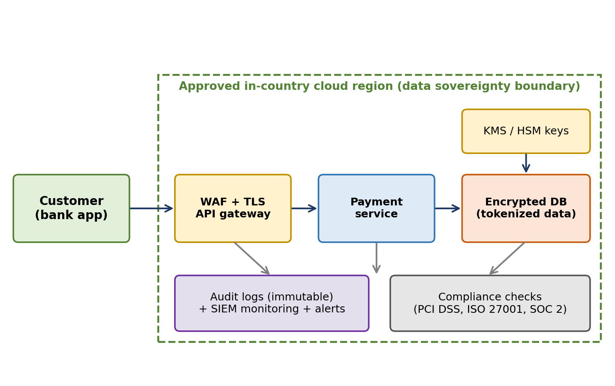
Fig 4: Secure payment processing inside an approved region.
Conclusion
Providers supply certified infrastructure and compliance tools, but the institution remains responsible for configuration and data. Logging, monitoring and encryption protect and prove security, and region control with key ownership satisfies data sovereignty rules.
Question 5: Containers, Kubernetes and Microservices
Introduction
Containerization packages an application with everything it needs (code, runtime, libraries and settings) into a single lightweight unit called a container image. Containers run the same way on any system that has a container runtime such as Docker or containerd. They are the basis of modern cloud-native and microservices development.
Containers compared with virtual machines
Aspect | Virtual Machine | Container
Architecture | Full guest OS per VM on a hypervisor | Share the host OS kernel; only app and libraries packaged
Size | Gigabytes | Megabytes
Start-up time | Minutes | Seconds or milliseconds
Performance | Some overhead from hypervisor and guest OS | Near-native performance, very low overhead
Resource usage | High memory and CPU per instance; fewer per host | Light; many more per host, so better utilization
Isolation | Strong (separate kernels) | Process-level isolation; shared kernel is a larger risk
Scaling | Slow | Fast and fine-grained
Best for | Different operating systems, strong isolation, legacy apps | Microservices, CI/CD, scalable cloud-native apps

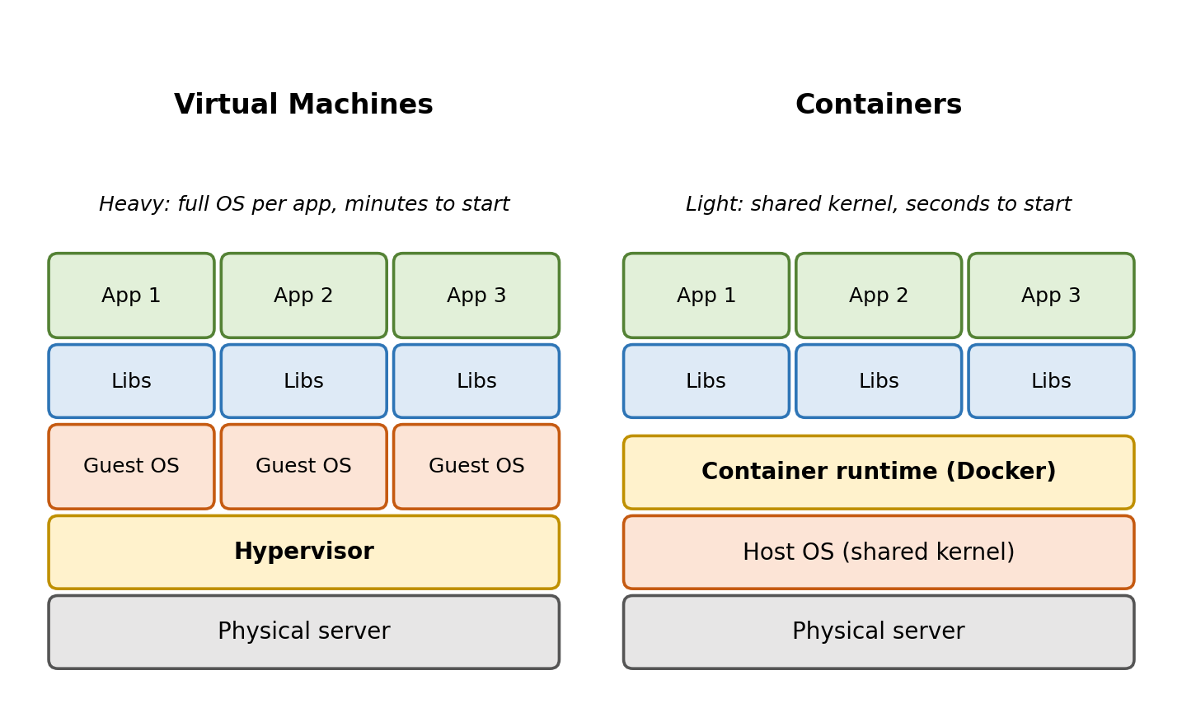
Fig 5: Virtual machines and containers compared.
How orchestration (Kubernetes) simplifies deployment and scaling
Running a few containers is easy, but hundreds across many servers need automation. Kubernetes is an orchestration platform that manages them.
- Declarative deployment: You write a YAML file that states the desired state (image, number of replicas, resources), and Kubernetes creates and maintains it.
- Scheduling: Chooses the best node for each container according to available CPU and memory.
- Automatic scaling: The Horizontal Pod Autoscaler changes the number of containers with load, and the Cluster Autoscaler adds or removes servers.
- Self-healing: Restarts crashed containers, replaces failed nodes and removes unhealthy containers from service.
- Rolling updates and rollback: New versions are released gradually with no downtime, and can be reverted quickly if there is a problem.
- Service discovery and load balancing: Services get stable names and addresses, and traffic is shared among healthy containers.
- Configuration and secrets: Settings and passwords are stored separately from images.
- Storage orchestration: Attaches persistent storage to containers when needed.
Portability benefits across different cloud environments
- Build once, run anywhere: The image contains all dependencies, so it behaves identically on a developer laptop, a test server, on-premises servers and public clouds (AWS, Azure, Google Cloud).
- Consistent environments: The common problem of 'it works on my machine' disappears.
- Avoid vendor lock-in: Docker/OCI images and Kubernetes are open standards, and managed services (EKS, AKS, GKE) offer the same interface, so workloads can move between providers.
- Hybrid and multi-cloud: The same deployment files can run on-premises and in several clouds for resilience, compliance or cost reasons.
- Faster CI/CD: The same image moves through build, test and production, improving speed and reliability.
- Challenges: Differences in provider networking, storage and IAM still need attention, and images must be kept secure and updated.
Example of a microservices-based application
An online shopping platform is split into independent services, each in its own container:
- User service: Registration, login and profiles.
- Catalog service: Product details and search.
- Cart service: Items selected by the customer.
- Order service: Creates and tracks orders.
- Payment service: Talks to the payment gateway.
- Notification service: Sends emails and SMS.
Each service has its own database and communicates through REST APIs or a message queue, behind an API gateway. Kubernetes runs several copies of each service. During a sale, only the catalog and cart services are scaled up. If the payment service has a bug, it is updated or rolled back independently, and the rest of the application keeps running. This gives faster releases, fault isolation and efficient resource use.
Conclusion
Containers are lighter and faster than virtual machines, Kubernetes automates deployment, scaling and recovery, and container images give true portability across clouds. Together they allow development teams to build and release microservices applications quickly and reliably.

