SIMATS ENGINEERING
ASSESSMENT TOOL 1: Analytical Problem Solving
Item | Details
Course Name | Cloud Computing and Big Data Analytics
Course Code | CSA15
Course Outcome | CO2: Analyze virtualization architectures to identify performance and security issues in cloud computing environments (BL3)
Total Marks / Duration | 50 Marks / 60 Minutes

Code of Conduct
I _M Sanjay Krishna (192525421)_ (Name / Reg No) certify that this submission is my original work and that I have adhered to the guidelines specified for this assessment. I understand that any violation of academic integrity rules will result in disciplinary action.

Signature of the student: _____M Sanjay_

Assessment Tasks
Analytical Problem Solving
1. Compare Type-1 and Type-2 hypervisors for a cloud datacenter hosting mission-critical applications. Analyze performance, security, and manageability, then justify the better choice.
2. A cloud provider must isolate workloads belonging to finance, healthcare, and student portals on the same hardware. Analyze how virtualization architecture supports isolation and identify two major attack surfaces.
3. Study the following VM host utilization snapshot and recommend corrective actions: CPU 92%, memory 88%, storage I/O latency 35 ms, average VM boot time 170 s. Explain the likely bottlenecks.
4. Analyze how Software Defined Datacenter architecture improves agility compared with a traditional datacenter. Support your answer with compute, storage, and network virtualization considerations.
5. A multi-cloud federation project fails due to identity mismatches between providers. Analyze the issue and propose a secure identity and privacy design using federation concepts.
Equivalent Steps in VMware Workstation Pro
- Library pane showing multiple VMs = multiple instances/regions.
- VM → Snapshot → Take Snapshot, then Snapshot Manager = backup/versioning demonstration.
- Edit → Virtual Network Editor to show NAT/Host-only/Bridged networks = hybrid or multi-cloud connectivity.
- VM → Manage → Clone = replica/auto-scaling demonstration.
Tip: Paste each screenshot directly under the relevant question in this document (Insert → Picture in Word) before final submission, with a one-line caption explaining what it demonstrates.

Analytical Problem Solving Rubric
Criteria | Weight | Level 4 - Exemplary | Level 3 - Proficient | Level 2 - Developing | Level 1 - Beginning
Problem Interpretation | 20% | Interprets all technical requirements accurately | Interprets most requirements correctly | Partial interpretation | Misinterprets the problem
Analytical Reasoning | 25% | Strong reasoning with clear cause-effect analysis | Good reasoning with minor gaps | Basic analysis only | Weak or no analysis
Method Selection | 20% | Chooses highly appropriate virtualization and security concepts | Chooses mostly suitable concepts | Partially suitable concepts | Inappropriate approach
Solution Quality | 20% | Provides feasible and technically sound solution | Reasonable solution with minor issues | Basic solution with limitations | Unclear or invalid solution
Presentation of Analysis | 15% | Well-structured and technically precise | Generally clear | Somewhat unclear | Difficult to follow
Total Marks Awarded: ________

ANSWERS
Question 1: Type-1 vs Type-2 Hypervisors for Mission-Critical Cloud Datacenter
A Type-1 (bare-metal) hypervisor such as VMware ESXi, KVM, Xen or Hyper-V runs directly on the physical hardware. A Type-2 (hosted) hypervisor such as VMware Workstation or VirtualBox runs as an application on top of a host operating system.
Criteria | Type-1 (Bare-metal) | Type-2 (Hosted)
Performance | Direct access to CPU, memory and I/O; no host OS layer; low overhead and latency; supports hardware-assisted virtualization (Intel VT-x / AMD-V), SR-IOV and NUMA tuning. | Every request passes through the host OS before reaching hardware; extra overhead; host OS processes compete with VMs for resources.
Security | Small attack surface (thin, purpose-built kernel); no general-purpose OS to attack; strong VM isolation; fewer patches. | Large attack surface: a vulnerability in the host OS, its drivers or other apps can compromise all VMs.
Manageability | Centralized management (vCenter, OpenStack), live migration, HA, DRS/load balancing, snapshots, templates, automation via API; scales to hundreds of hosts. | Managed individually on one machine; no clustering, HA or live migration; manual scaling.
Reliability | Hardware fault handling, failover and clustering; suited to 24x7 operation. | A host OS crash or reboot brings down all VMs.
Typical use | Production datacenters and public/private clouds. | Development, testing, training and desktop labs.
Justification
For a datacenter hosting mission-critical applications, the Type-1 hypervisor is the better choice. It gives near-native performance, a smaller attack surface, stronger isolation between tenants, and the high-availability and centralized management features (live migration, HA clusters, resource scheduling) that are needed to meet uptime and SLA requirements. Type-2 is suitable only for testing and learning environments.
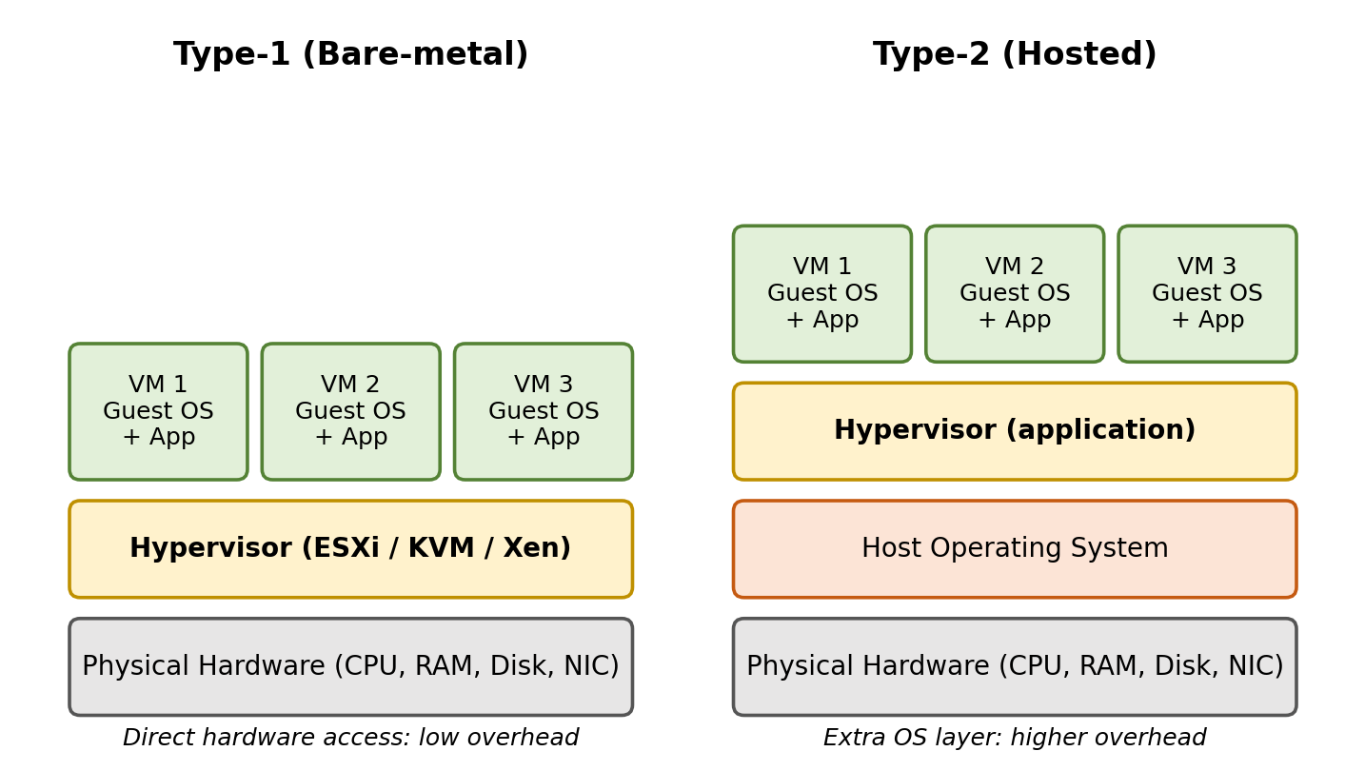
Fig 1: Type-1 (bare-metal) and Type-2 (hosted) hypervisor architecture.
Question 2: Workload Isolation for Finance, Healthcare and Student Portals
How the virtualization architecture supports isolation
- Hypervisor-level VM isolation: Each portal runs in its own VM with its own guest OS, virtual CPU, memory, disk and virtual NIC. A fault or compromise in one VM does not directly affect others.
- Memory and CPU isolation: The hypervisor uses hardware memory virtualization (EPT/NPT) so one VM cannot read another VM's memory.
- Network isolation: Separate virtual switches/port groups, VLAN or VXLAN segments and virtual firewalls (micro-segmentation) keep finance, healthcare and student traffic apart.
- Storage isolation: Separate virtual disks or datastores per tenant with encryption at rest; access controlled by RBAC.
- Resource control: CPU shares/limits, memory reservations and I/O limits prevent a noisy VM from starving others. Anti-affinity rules or dedicated hosts/clusters can be used for the highly regulated healthcare and finance workloads.
Two major attack surfaces
1. Hypervisor and its management plane (VM escape). Bugs in the hypervisor, virtual device emulation, or in management interfaces (management console, APIs) can let an attacker escape from one VM and gain control of the host and all VMs on it. Mitigation: timely patching, hardened and isolated management network, MFA and RBAC for administrators, disabling unused virtual devices.
2. Shared hardware resources (co-residency and side-channel attacks). VMs from different tenants share CPU caches, memory and the virtual network. A malicious co-resident VM can use cache-timing or speculative-execution side channels (e.g., Spectre/Meltdown type attacks) or VM-to-VM network sniffing/VLAN hopping to leak data. Mitigation: dedicated hosts for sensitive tenants, microcode/firmware updates, memory encryption, network segmentation and encrypted traffic.
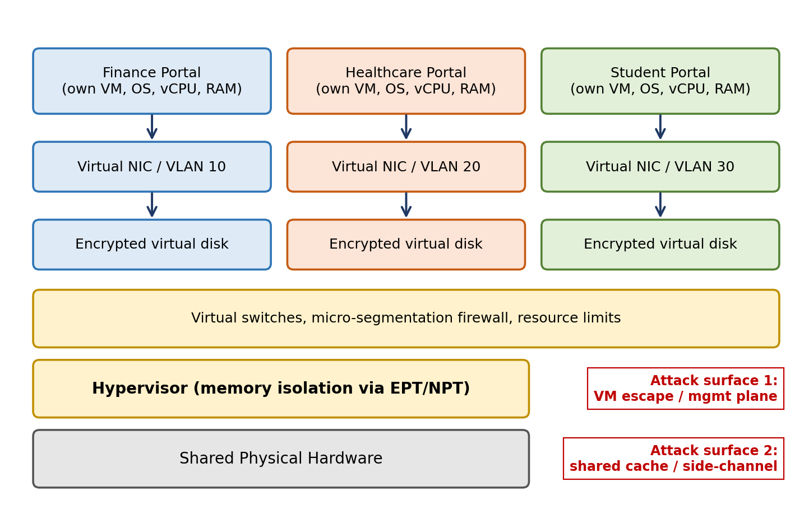
Fig 2: Isolation of finance, healthcare and student workloads on shared hardware, with the two attack surfaces.
Question 3: VM Host Utilization Analysis
Metric | Observed | Assessment | Likely bottleneck
CPU | 92% | Very high (healthy is below about 70-80%) | CPU overcommitment; VMs waiting for CPU (high ready time)
Memory | 88% | High; close to the limit | Memory overcommit leading to ballooning/swapping
Storage I/O latency | 35 ms | Above the usual 10-20 ms target | Overloaded shared datastore / slow disks
Average VM boot time | 170 s | Much longer than normal (about 30-60 s) | Result of the three problems above, mainly storage (boot storm)
Explanation of likely bottlenecks
- CPU: The host has too many vCPUs allocated compared with physical cores, so VMs queue for CPU time and respond slowly.
- Memory: At 88%, any further demand forces the hypervisor to use ballooning, page compression or swapping to disk, which increases disk I/O and slows VMs.
- Storage (primary bottleneck): 35 ms latency means many VMs are sharing the same datastore or slow disks; swapping from memory pressure adds more load.
- Boot time: Booting reads the OS image from disk. With high disk latency and a busy CPU and memory, each boot takes much longer, especially when many VMs start together.
Corrective actions
- CPU: Migrate some VMs to other hosts (vMotion/live migration, DRS load balancing); right-size VMs by reducing unnecessary vCPUs; lower the vCPU-to-core ratio; add hosts to the cluster.
- Memory: Reduce memory over-allocation, use reservations for critical VMs, remove idle VMs, and add physical RAM if demand stays high.
- Storage: Move high-I/O VMs to SSD/NVMe or tiered storage, spread VMs over multiple datastores, use multipathing and storage I/O control, and add caching.
- Boot time: Use templates with linked clones, SSD-backed boot volumes and staggered startup to avoid boot storms.
- Monitoring: Set alerts (CPU > 80%, latency > 20 ms) and monitor trends for capacity planning.
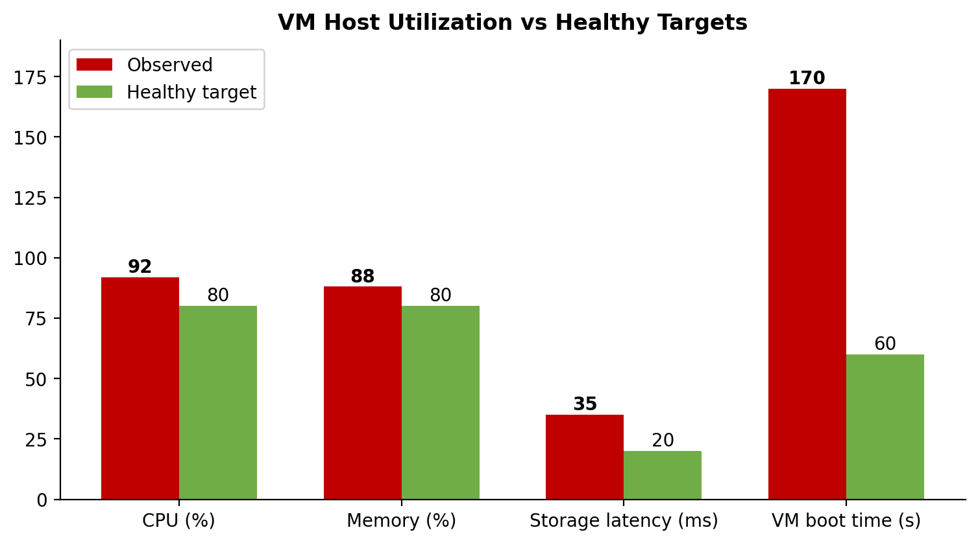
Fig 3: Observed host utilization compared with healthy targets.
Question 4: Software Defined Datacenter (SDDC) vs Traditional Datacenter
In an SDDC, compute, storage, networking and security are virtualized, pooled and controlled by software through policies and APIs. In a traditional datacenter, these are tied to specific hardware and configured manually, which makes change slow.
Aspect | Traditional Datacenter | Software Defined Datacenter
Provisioning | Days or weeks: order hardware, rack, cable, configure manually | Minutes: automated, self-service through templates and APIs
Resource use | Dedicated servers, low utilization; silos | Pooled resources, high utilization through sharing
Scaling | Manual, hardware purchase needed | Elastic scale-up/out and auto-scaling
Change/Config | Device-by-device, error-prone | Policy-based, centralized, consistent
Recovery | Hardware-dependent, slow | Snapshots, replication, live migration, fast recovery
Cost | High CAPEX, vendor lock-in | Commodity hardware, lower OPEX
Virtualization considerations that improve agility
- Compute virtualization: Hypervisors abstract CPU and memory into VMs/containers. New servers are created from templates or clones in minutes, and live migration and resource schedulers balance load without downtime.
- Storage virtualization: Physical disks are pooled (e.g., SAN/vSAN/software-defined storage) and presented as virtual disks. Storage is allocated by policy (performance, redundancy), with thin provisioning, snapshots and replication, so capacity is added without changing servers.
- Network virtualization: Software Defined Networking separates the control plane from the data plane. Virtual switches, routers, VLAN/VXLAN overlays and virtual firewalls are created by software, allowing new networks and security policies to be applied instantly and following the VM when it moves.
Overall, an SDDC is more agile because all three layers are provisioned, scaled and secured through one automated, policy-driven management layer, whereas the traditional datacenter needs separate manual work on each hardware layer.
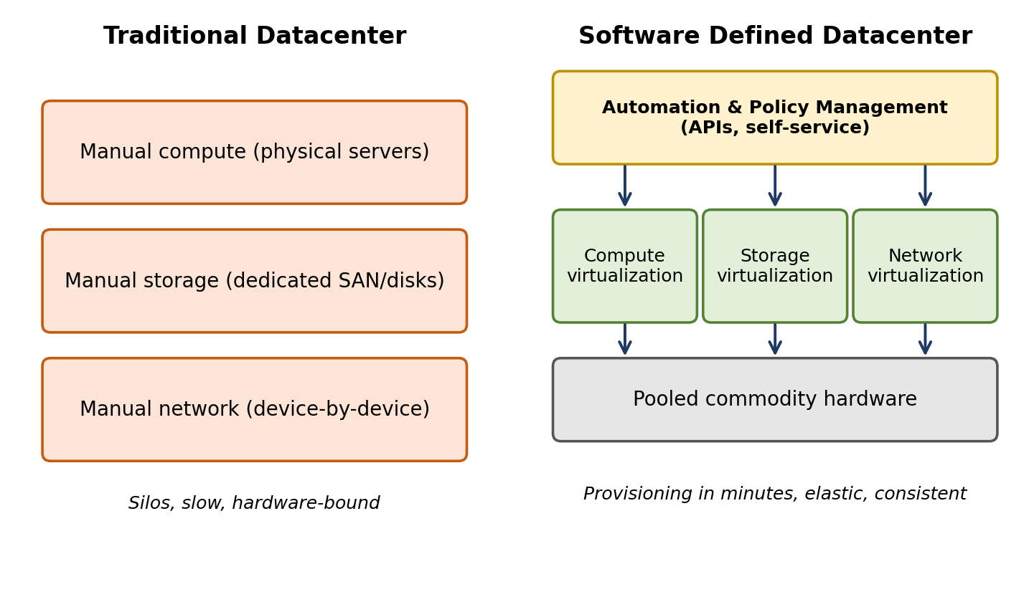
Fig 4: Traditional datacenter compared with Software Defined Datacenter.
Question 5: Multi-Cloud Federation Identity Failure
Analysis of the issue
In multi-cloud federation, each provider usually has its own identity system, so the same user or service appears differently in each cloud. The project failed because of identity mismatches such as:
- Inconsistent identifiers: different user ID formats and naming (e.g., email vs. UUID vs. username), so one user is not recognized as the same person.
- Protocol and token incompatibility: providers use different protocols/tokens (SAML, OpenID Connect/OAuth 2.0, proprietary IAM), and cannot understand each other's assertions.
- Different attribute and role models: roles, groups and attributes are named and structured differently, so permissions cannot be mapped correctly (access is denied or excessive).
- No established trust: no common trust relationship or shared identity provider; separate credentials and manual user accounts in each cloud.
- Inconsistent provisioning and privacy policies: accounts are not created, updated or removed together, leaving orphan accounts and security risks; privacy rules differ between regions.
Proposed secure identity and privacy design using federation
- 1. Federated Identity Provider and trust: Use one trusted Identity Provider (IdP) for authentication (e.g., the organization's directory), with each cloud acting as a Service Provider (SP) that trusts the IdP through exchanged metadata and certificates (trust framework).
- 2. Standard protocols and SSO: Use standard protocols: SAML 2.0 or OpenID Connect with OAuth 2.0 for single sign-on. Assertions/tokens are digitally signed, encrypted and short-lived.
- 3. Identity mapping and provisioning: Define a common attribute schema and a claims-mapping layer to translate each provider's attributes and roles to a common RBAC model. Use SCIM for automatic provisioning and de-provisioning across clouds.
- 4. Security controls: Multi-factor authentication at the IdP; least privilege; token expiry and revocation; TLS for all traffic; centralized logging and auditing.
- 5. Privacy protection: Release only the minimum required attributes to each provider (data minimization); use pseudonymous or per-provider identifiers so users cannot be tracked across clouds; obtain user consent; respect data residency and regulations such as GDPR; encrypt personal data.

Result: a user authenticates once at the IdP, receives a signed token containing only the needed attributes, and gains access to each cloud according to mapped roles. This removes identity mismatches while keeping access secure and personal data protected.
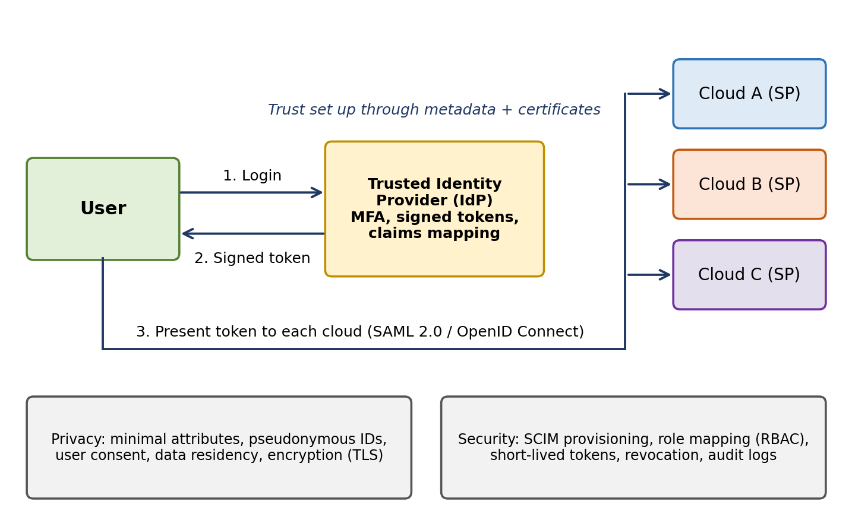
Fig 5: Federated identity design for a multi-cloud environment.

