SIMATS ENGINEERING
ASSESSMENT TOOL III – PENETRATION TESTING TASK

COURSE: CO3

Student Name: RAJANEDI DATI PRAVALLIKA
Register Number: 192525473

Experiment 1 – Reconnaissance Using theHarvester

Aim
To perform authorized reconnaissance against tesla.com and identify publicly available email addresses, subdomains, hostnames, IP addresses, URLs, and other relevant infrastructure information.

Command
theHarvester -d tesla.com -b all
For a specific search source:
theHarvester -d tesla.com -b google

Procedure
- Open Kali Linux and start the Terminal.
- Run theHarvester against the authorized domain.
- Collect discovered email addresses, subdomains, hostnames, IP addresses, and URLs.
- Organize the results and identify the most valuable reconnaissance findings.
- Assess how the collected information contributes to the external attack surface.
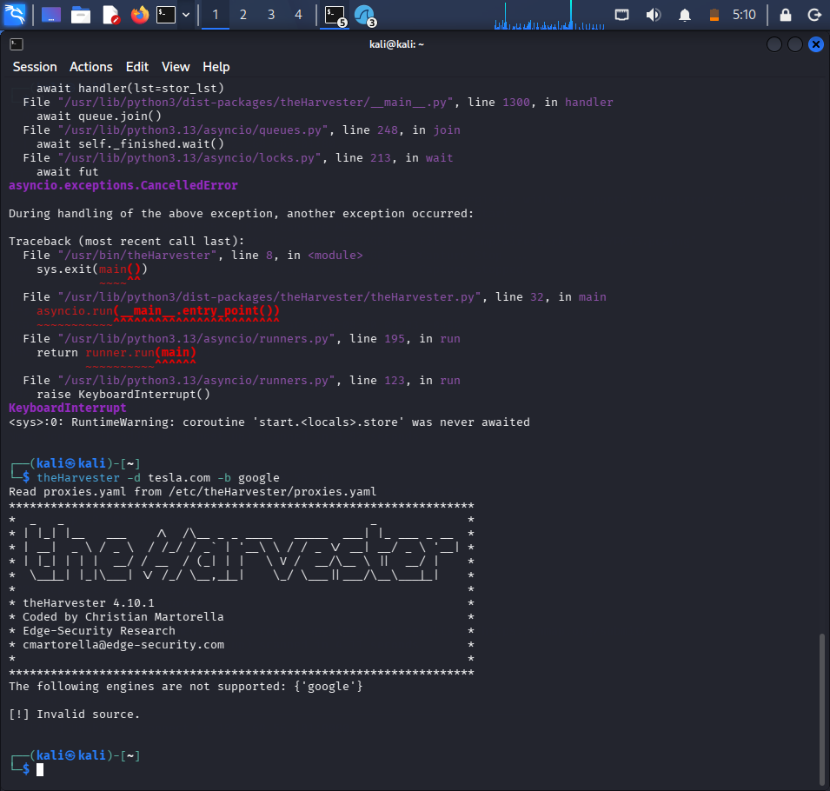

Observation / Analysis
Information | Possible Value to Attacker | Risk
Email addresses | May support phishing or credential attacks | Medium/High
Subdomains | Reveal additional Internet-facing systems | Medium/High
Hostnames | Reveal server naming and service roles | Medium
IP addresses | Identify reachable infrastructure | Medium/High
URLs | Reveal applications and services | Medium

Recommendations
- Remove unnecessary public DNS records and subdomains.
- Disable unused external services.
- Minimize unnecessary information exposure on public websites.
- Continuously monitor the organization's Internet-facing assets.
- Use appropriate email security and anti-phishing controls.

Result
TheHarvester provides a view of publicly available information that can contribute to an organization's external attack surface. The most valuable findings should be validated during subsequent penetration-testing phases.

Experiment 2 – Web Assessment Using Nikto

Aim
To assess the authorized web application testphp.vulnweb.com using Nikto and identify potentially exposed files and directories, insecure HTTP methods, server configuration weaknesses, information disclosure, outdated components, and other potential weaknesses.

Commands
nikto -h http://testphp.vulnweb.com
nikto -h http://testphp.vulnweb.com -o nikto_result.txt

Procedure
- Open the Kali Linux Terminal.
- Run the Nikto scan against the authorized web application.
- Save the scan output as evidence.
- Review significant findings and classify them as confirmed vulnerabilities, configuration weaknesses, information disclosure, or items requiring manual validation.
- Prepare remediation recommendations and repeat the scan after remediation.
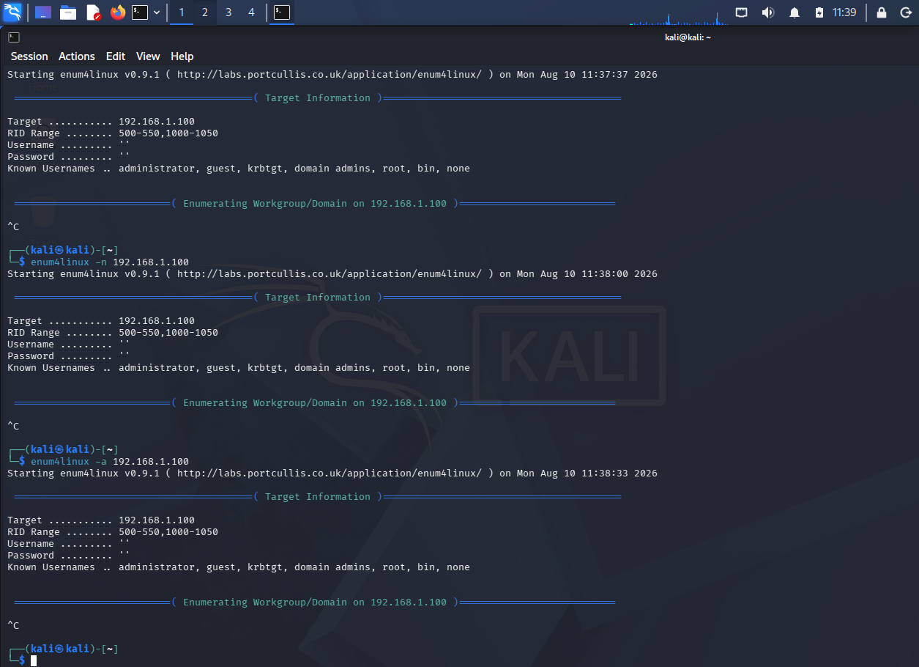

Findings to Assess
Finding | Classification | Potential Risk
Server-version disclosure | Information disclosure | Medium
Exposed files | Potential vulnerability | High
Directory listing | Configuration weakness | Medium/High
Dangerous files | Potential vulnerability | High
Insecure HTTP methods | Configuration weakness | Medium
Outdated components | Potential vulnerability | High

Evidence Collection
nikto -h http://testphp.vulnweb.com -o nikto_result.txt
cat nikto_result.txt

Remediation
- Remove unnecessary files from the web server.
- Disable directory listing where it is not required.
- Disable unnecessary HTTP methods.
- Update outdated software and components.
- Minimize unnecessary server-version disclosure.
- Review web-server configuration regularly.

Result
Nikto can identify potentially exposed files, directories, HTTP methods, server configuration weaknesses and information-disclosure issues. Findings should be manually validated before being treated as confirmed vulnerabilities.

Experiment 3 – DNS Enumeration Using Dig

Aim
To perform DNS enumeration against the authorized target zonetransfer.me, identify relevant DNS records and authoritative servers, and assess whether an unauthorized DNS zone transfer can be requested.

Commands
dig zonetransfer.me A
dig zonetransfer.me AAAA
dig zonetransfer.me MX
dig zonetransfer.me NS
dig zonetransfer.me CNAME
dig zonetransfer.me TXT
dig zonetransfer.me SOA
dig zonetransfer.me ANY
dig zonetransfer.me NS +short
dig @<authoritative-server> zonetransfer.me AXFR

DNS Record Types
Record | Purpose
A | IPv4 address
AAAA | IPv6 address
MX | Mail server
NS | Authoritative name server
CNAME | Alias of another hostname
TXT | Text/security information
SOA | Zone administration information

Zone Transfer Analysis
If an AXFR request is accepted by an unauthorized client, the zone transfer may expose hostnames, IP addresses, mail infrastructure, service relationships, and other DNS records. This information can improve an attacker's understanding of the target infrastructure.
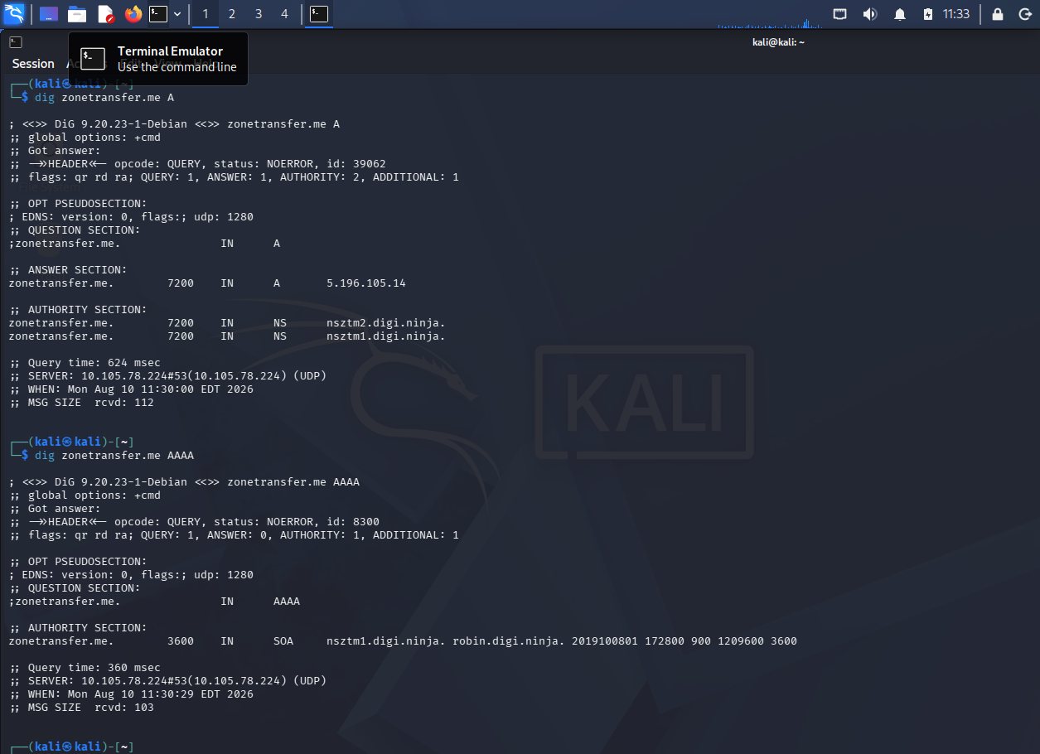

Recommendations
- Restrict AXFR to authorized secondary DNS servers.
- Use DNS access-control lists.
- Monitor DNS queries and zone-transfer activity.
- Remove unnecessary DNS records.
- Periodically audit DNS configuration.

Result
Dig can enumerate DNS records and authoritative servers and can be used to test whether an unauthorized AXFR request is accepted.

Experiment 4 – SMB Enumeration Using Enum4linux

Aim
To assess the authorized Windows/SMB target 192.168.1.100 and identify users, groups, shared resources, domain/workgroup information, OS details, password-policy information, NetBIOS information, and other exposed SMB configuration details.

Commands
enum4linux 192.168.1.100
enum4linux -U 192.168.1.100
enum4linux -G 192.168.1.100
enum4linux -S 192.168.1.100
enum4linux -o 192.168.1.100
enum4linux -P 192.168.1.100
enum4linux -n 192.168.1.100
enum4linux -a 192.168.1.100

Information and Security Impact
Information | Security Relevance | Risk
Users | May support credential attacks | Medium/High
Groups | Shows privilege relationships | Medium
Shares | May expose sensitive files | High
Domain/workgroup | Reveals network structure | Medium
OS information | Supports system fingerprinting | Medium
Password policy | May reveal authentication weaknesses | Medium
Anonymous access | May permit unauthorized enumeration | High

Recommendations
- Disable unnecessary anonymous or null-session SMB access.
- Apply least privilege to SMB shares.
- Use strong password policies.
- Keep Windows systems patched.
- Restrict SMB access using firewall rules.
- Use network segmentation to reduce lateral movement.
- Monitor SMB authentication and access activity.
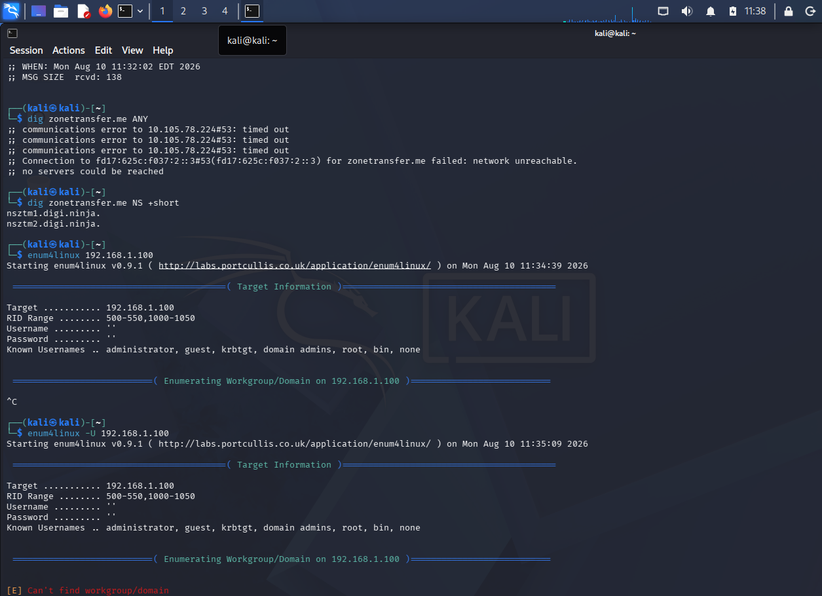
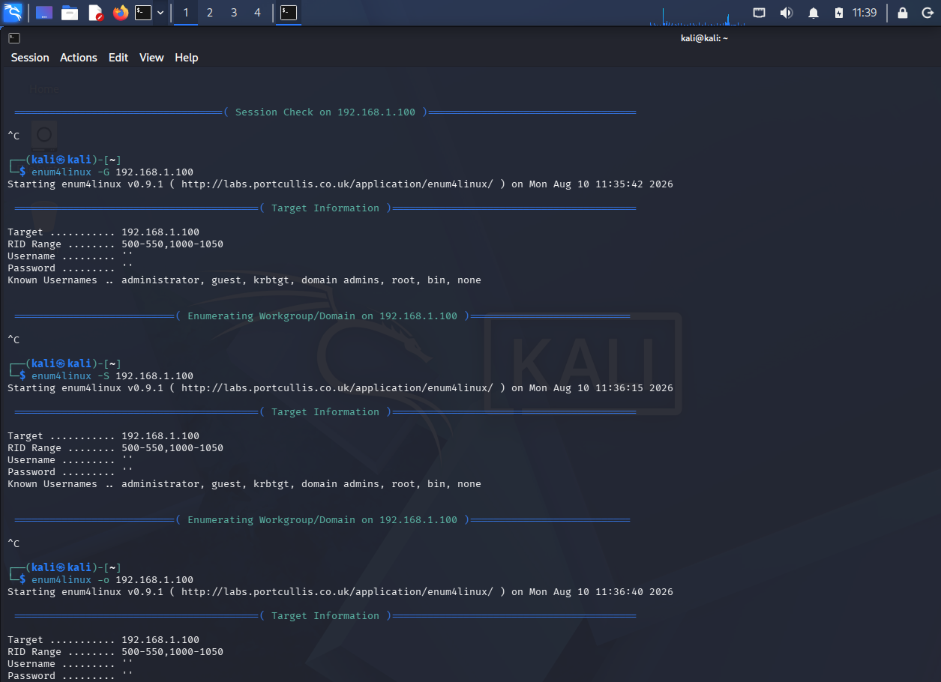

Result
Enum4linux can reveal users, groups, shares, domain information, OS details and SMB configuration. Such information may facilitate credential attacks, privilege escalation, unauthorized access to shares, vulnerability identification, or lateral movement.

Experiment 5 – Service Banner Enumeration Using Netcat

Aim
To use Netcat (nc) against the authorized target scanme.nmap.org to connect to accessible TCP services and collect service responses and banner information.

Commands
nc -v scanme.nmap.org <port>
nc -v scanme.nmap.org 22
nc -v scanme.nmap.org 80

HTTP Banner Test
After connecting to port 80, enter:
HEAD / HTTP/1.0
Press Enter twice and record the actual response returned by the target.
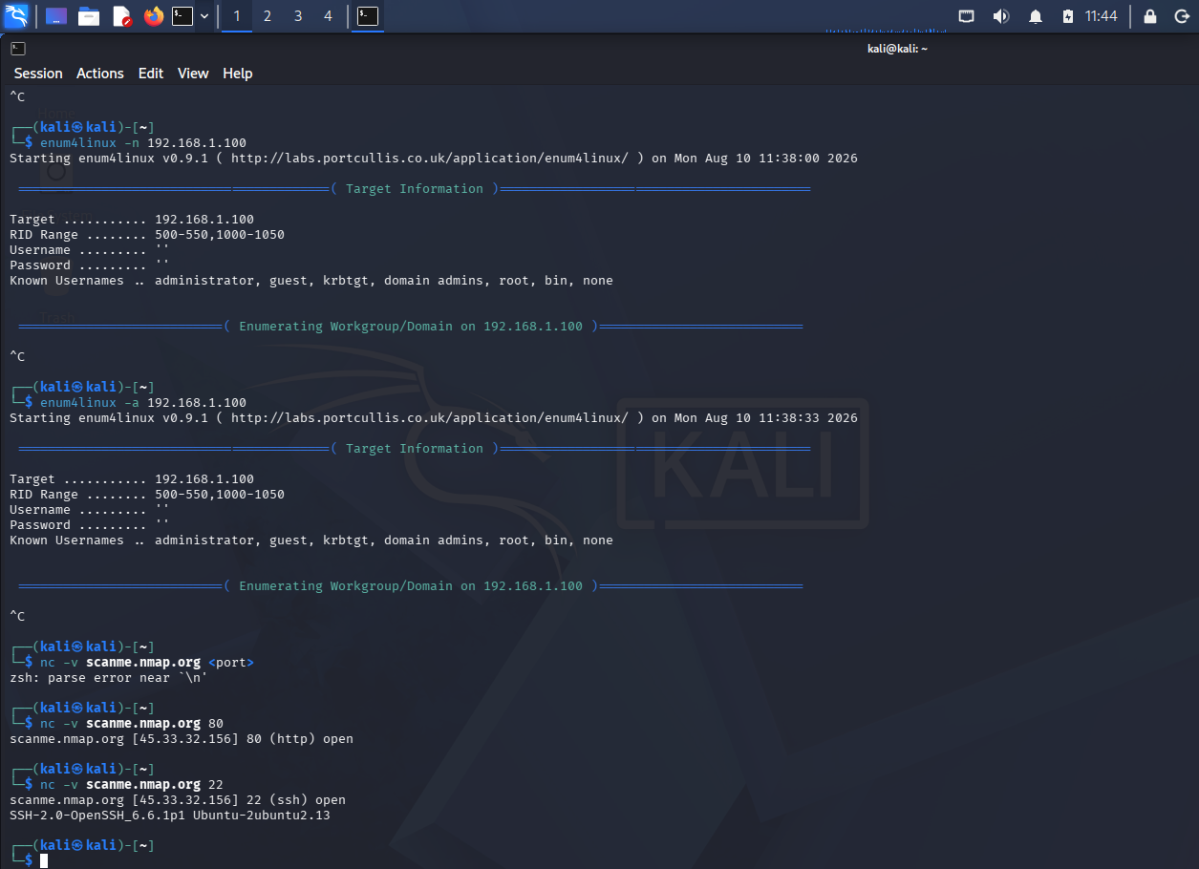

Information to Observe
Observation | Purpose | Security Significance
Service name | Identify running service | Fingerprinting
Protocol | Identify communication protocol | Target profiling
Software/version | Identify implementation | May correlate with known vulnerabilities
HTTP headers | Identify web-server details | Information disclosure
OS clues | Infer operating system | Improves fingerprinting
Service banner | Collect voluntary response | May enable targeted attacks

Classification
A disclosed server or service version is not automatically a confirmed vulnerability. It is generally an information-disclosure finding until the disclosed version and its associated weaknesses are manually validated.

Recommendations
- Minimize unnecessary service-banner information.
- Disable unused services.
- Keep exposed services updated.
- Restrict unnecessary Internet-facing ports with firewall rules.
- Monitor and periodically reassess externally exposed services.

Result
Netcat can collect responses and banner information from accessible TCP services. Accurate service fingerprinting can make subsequent attacks more targeted, so exposed services should be monitored and periodically reassessed.

9. Overall Security Assessment
The five experiments demonstrate different stages of authorized security assessment. theHarvester identifies publicly available external information; Nikto assesses web-server exposure; Dig examines DNS information and zone-transfer configuration; Enum4linux assesses SMB/NetBIOS exposure; and Netcat collects service responses and banners. Information from these activities can be combined by an attacker to build a more accurate picture of an organization's infrastructure. Therefore, unnecessary information exposure, weak access controls, outdated components, unnecessary services, and excessive network visibility should be reduced and periodically reassessed.

10. Prioritized Remediation Plan
Priority | Recommended Action
1 – High | Remove or restrict exposed sensitive files, shares, services, and unnecessary access.
2 – High | Patch outdated web and network components and manually validate reported vulnerabilities.
3 – High | Restrict unauthorized DNS zone transfers and anonymous SMB enumeration.
4 – Medium | Minimize unnecessary server, service, hostname, and version information disclosure.
5 – Medium | Continuously monitor and periodically reassess Internet-facing infrastructure.

11. Conclusion
The penetration-testing tasks demonstrate how reconnaissance and enumeration can reveal information about network services and infrastructure. The findings from these tools should be treated as assessment evidence and validated within the authorized testing scope. Organizations can reduce exposure through least-privilege access, secure DNS configuration, patched systems, restricted services, network segmentation, and continuous security monitoring.

