Social Engineering Simulation Report
R.DATI PRAVALLIKA(192525473)

Question 1: OSINT using theHarvester

Aim
Perform the activity according to the assessment.

Introduction
This experiment demonstrates reconnaissance/social engineering awareness in a controlled lab.

Tools Required
Kali Linux, Internet, required software.

Commands
theHarvester -d tesla.com -b bing
theHarvester -d tesla.com -b google
theHarvester -d tesla.com -f tesla_report.html

Procedure
1. Open Kali Linux.
2. Execute the commands.
3. Observe output.
4. Save results.
5. Capture screenshots.

Screenshot
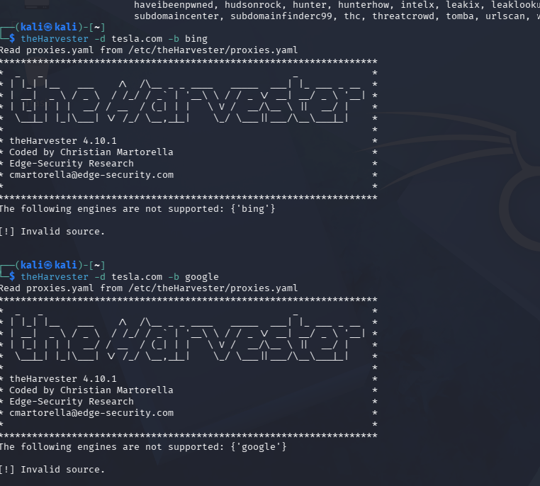
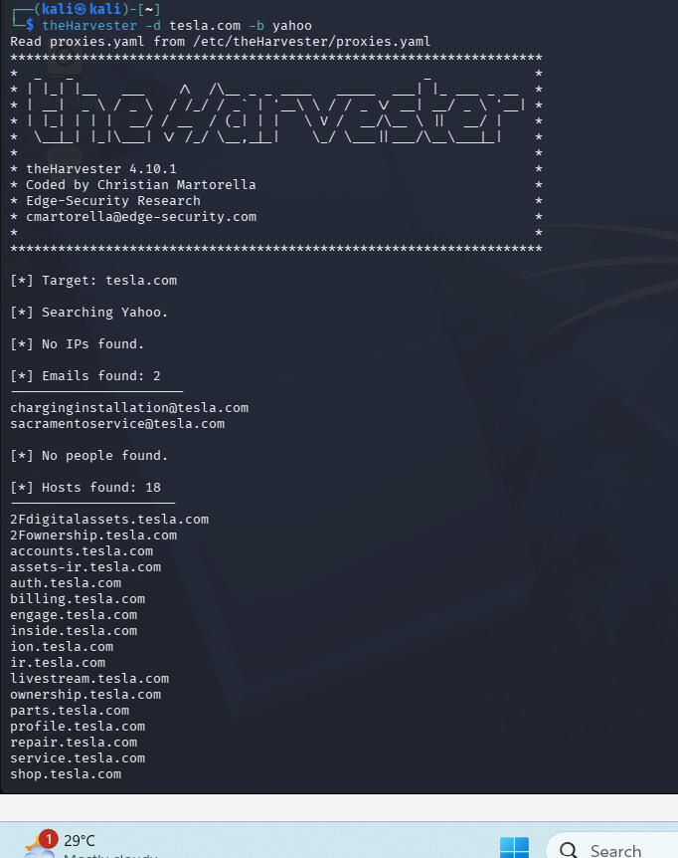
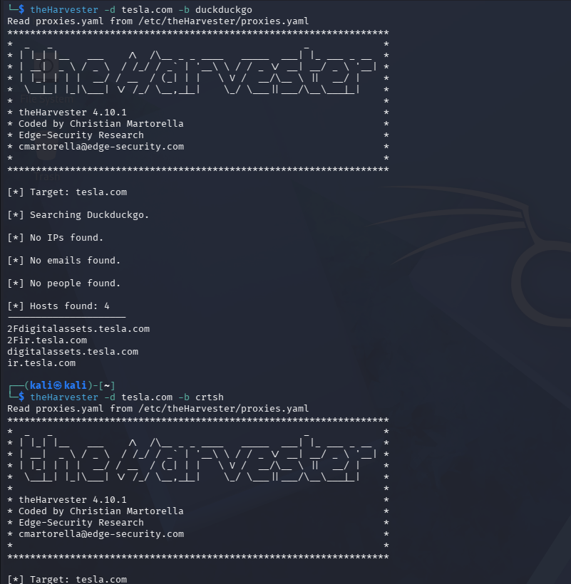
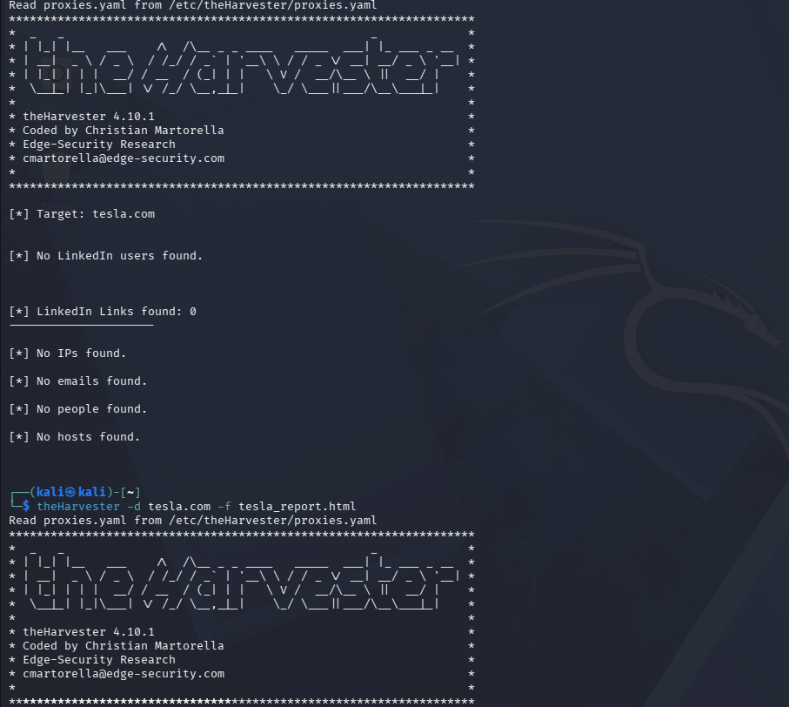

Findings
Document the observed results from execution.

Risk Analysis
Explain how attackers could misuse the information collected.

Countermeasures
Use MFA, awareness training, email filtering, least privilege, DNS hardening, regular audits.

Conclusion
The experiment demonstrates ethical reconnaissance and security best practices.

Question 2: Phishing Awareness using GoPhish

Aim
Perform the activity according to the assessment.

Introduction
This experiment demonstrates reconnaissance/social engineering awareness in a controlled lab.

Tools Required
Kali Linux, Internet, required software.

Commands
sudo gophish
Open https://127.0.0.1:3333
Create users, template, campaign and review results.

Procedure
1. Open Kali Linux.
2. Execute the commands.
3. Observe output.
4. Save results.
5. Capture screenshots.

Screenshot
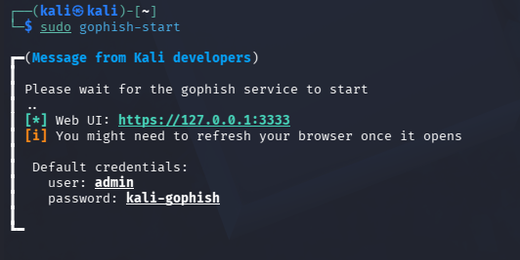

Findings
Document the observed results from execution.

Risk Analysis
Explain how attackers could misuse the information collected.

Countermeasures
Use MFA, awareness training, email filtering, least privilege, DNS hardening, regular audits.

Conclusion
The experiment demonstrates ethical reconnaissance and security best practices.
Question 3: Nmap Aggressive Scan

Aim
Perform the activity according to the assessment.

Introduction
This experiment demonstrates reconnaissance/social engineering awareness in a controlled lab.

Tools Required
Kali Linux, Internet, required software.

Commands
nmap -A scanme.nmap.org
nmap -A -oN nmap_report.txt scanme.nmap.org

Procedure
1. Open Kali Linux.
2. Execute the commands.
3. Observe output.
4. Save results.
5. Capture screenshots.Screenshot
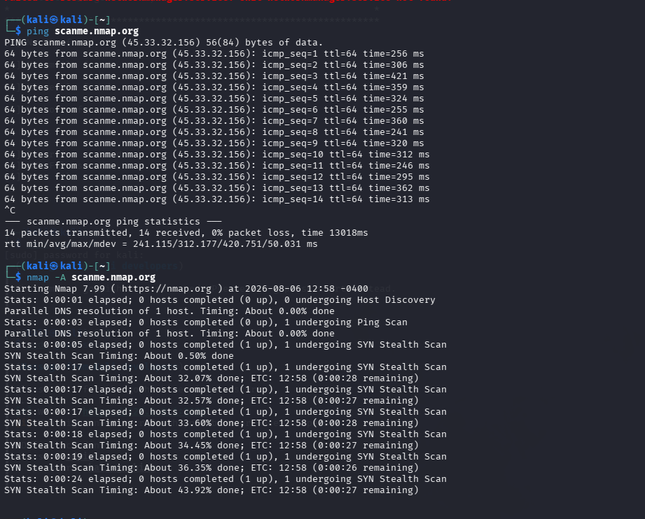

Findings
Document the observed results from execution.

Risk Analysis
Explain how attackers could misuse the information collected.

Countermeasures
Use MFA, awareness training, email filtering, least privilege, DNS hardening, regular audits.

Conclusion
The experiment demonstrates ethical reconnaissance and security best practices.

