**1.Write a program to find the length of a string without using strlen ()**

#include <stdio.h>

void main()

{

char str[100];

int i = 0;

printf("Enter a string: ");

gets(str);

while (str[i] != '\0')

{

i++;

}

printf("Length of the string = %d\n", i);

// Output length

return ;

}

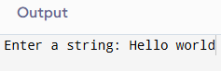

**2. Write a program to copy one string to another.**

#include <stdio.h>

void main()

**{**

char str1[100], str2[100];

int i = 0;

printf("Enter a string: ");

gets(str1);

while (str1[i] != '\0') {

str2[i] = str1[i];

i++;

}

str2[i] = '\0';

printf("Copied string: %s\n", str2);

return ;

}

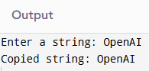

**3. Write a program to concatenate two strings.**

#include <stdio.h>

void main()

{

char str1[100], str2[100];

int i = 0, j = 0;

printf("Enter first string: ");

gets(str1);

printf("Enter second string: ");

gets(str2);

while (str1[i] != '\0') i++;

while (str2[j] != '\0') {

str1[i] = str2[j];

i++;

j++;

}

str1[i] = '\0';

printf("Concatenated string: %s\n", str1);

return ;

}

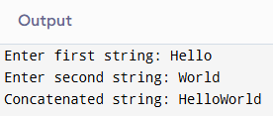

**4. Write a program to compare two strings.**

#include <stdio.h>

void main()

{

char str1[100], str2[100];

int i = 0, flag = 0;

printf("Enter first string: ");

gets(str1);

printf("Enter second string: ");

gets(str2);

while (str1[i] != '\0' || str2[i] != '\0') {

if (str1[i] != str2[i]) {

flag = 1;

break;

}

i++;

}

if (flag == 0)

printf("Strings are equal.\n");

else

printf("Strings are not equal.\n");

return ;

}

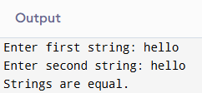

**5.Write a program to count vowels and consonants in a string.**

#include <stdio.h>

void main()

{

char str[100];

int vowels = 0, consonants = 0, i = 0;

printf("Enter a string: ");

gets(str);

while (str[i] != '\0') {

char ch = str[i];

// Check if character is an alphabet

if ((ch >= 'a' && ch <= 'z') || (ch >= 'A' && ch <= 'Z')) {

// Check if it is a vowel

if (ch == 'a' || ch == 'e' || ch == 'i' || ch == 'o' || ch == 'u' ||

ch == 'A' || ch == 'E' || ch == 'I' || ch == 'O' || ch == 'U')

vowels++;

else

consonants++;

}

i++;

}

printf("Vowels: %d, Consonants: %d\n", vowels, consonants);

return ;

}

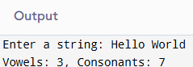

**6.Write a program to convert lowercase to uppercase and vice versa.**

#include <stdio.h>

void main()

{

char str[100];

int i = 0;

printf("Enter a string: ");

gets(str);

while (str[i] != '\0') {

if (str[i] >= 'a' && str[i] <= 'z')

str[i] = str[i] - 32;

else if (str[i] >= 'A' && str[i] <= 'Z')

str[i] = str[i] + 32;

i++;

}

printf("Converted string: %s\n", str);

return;

}

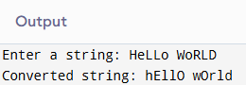

**7. Write a program to check if a string is palindrome.**

#include <stdio.h>

void main()

**{**

char str[100];

int i = 0, len = 0, flag = 0;

printf("Enter a string: ");

gets(str);

while (str[len] != '\0') len++;

for (i = 0; i < len / 2; i++) {

if (str[i] != str[len - 1 - i]) {

flag = 1;

break;

}

}

if (flag == 0)

printf("String is a palindrome.\n");

else

printf("String is not a palindrome.\n");

return ;

}

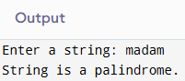

**8. Write a program to reverse a string.**

#include <stdio.h>

void main()

{

char str[100], rev[100];

int i = 0, len = 0;

printf("Enter a string: ");

gets(str);

while (str[len] != '\0') len++;

// Reverse the string

for (i = 0; i < len; i++) {

rev[i] = str[len - 1 - i];

}

rev[i] = '\0';

printf("Reversed string: %s\n", rev);

return ;

}

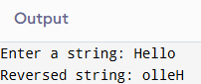

**9.Write a program to count words in a string.**

#include <stdio.h>

void main()

{

char str[100];

int i = 0, words = 1;

printf("Enter a string: ");

gets(str);

while (str[i] != '\0') {

if (str[i] == ' ' && str[i + 1] != ' ' && str[i + 1] != '\0')

words++;

i++;

}

printf("Total words: %d\n", words);

return ;

}

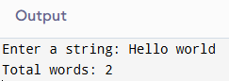

**10.Write a program to find the frequency of each character in a string.**

#include <stdio.h>

void main()

{

char str[100];

int freq[256] = {0};

int i = 0;

printf("Enter a string: ");

gets(str);

while (str[i] != '\0') {

freq[(unsigned char)str[i]]++;

i++;

}

printf("Character frequencies:\n");

for (i = 0; i < 256; i++) {

if (freq[i] > 0)

printf("%c = %d\n", i, freq[i]);

}

return ;

}

